4-1 – 12
402 (New), 402.1 (New)

Proposed Change as Submitted

Proponent: Kim Paarlberg, International Code Council

Revise as follows:

402 Accessible means of egress

402.1 General. Means of egress shall comply with Section 1007 of the International Building Code.

EXCEPTIONS:

1. Where means of egress are permitted by local building or life safety codes to share a common path of egress travel, accessible means of egress shall be permitted to share a common path of egress travel.
2. Areas of refuge shall not be required in detention and correctional facilities.

Reason: The quantity of change proposals submitted by International Code Council is reflective of three elements of our work: 1. ICC is the Secretariat for the Standard and some changes reflect inconsistencies or improvements suggested by staff; 2. ICC develops and publishes a Commentary on the standard and writing the commentary illuminates issues of the text and figures; and 3. ICC provides an interpretation service for the standard which results in the observation of provisions the users find most confusing.
The committee often says that other codes than IBC adopt A117.1. The A117.1 should refer to IBC for means of egress to be consistent with ADA 207.1 and to include safe egress in the technical criteria in this standard. I do not want to reference the older editions of the IBC. The latest IBC exceeds the requirements in the editions references.
The proposed language matches ADA 207.1. However, in my opinion, the exceptions are not needed.

0000.doc

Committee Action

Disapproved

Committee Reason: The Committee was concerned that the proposal would set up an unintended conflict between the IBC and the Standard, especially where they had not yet been coordinated. The proposal also takes on the feeling of being scoping.

4-2 – 12
402.2

Proposed Change as Submitted

Proponent: Ed Roether, representing the ADA/A117 Harmonization Task Group

Revise as follows:

402.2 Components. Accessible routes shall consist of one or more of the following components: Walking surfaces with a running slope not steeper than 1:20, doors and doorways, ramps, curb ramps excluding the flared sides, elevators, and platform lifts. All components of an accessible route shall comply with the applicable portions of this standard.

Reason: The ADA/A117 Harmonization Task Group (HTG) was created as a task group of the A117.1 Committee to compare the 2010 ADA with the 2009 A117.1 Standard. The HTG has recommend a series of changes through a set of change proposals. The HTG is recommending changes, for the most part, address where the ADA was viewed as more stringent than the A117. Where the A117 contained provisions not addressed in the ADA, these were not considered a conflict needing action to amend the A117. In addition there are a number of places where the ADA and A117.1 are different as a result of specific actions, by the A117.1 Committee during the development of the 2009 edition, to remain or create a difference where, in the judgment of the committee the ADA was deficient.

Reason: for 402.2. To provide consistent language with ADA Section 403.3.
0000.doc

Committee Action

Approved

Committee Reason: To provide consistency between the Standard and the 2010 ADA.

4-3 – 12
402.2 (New)
Proposed Change as Submitted

Proponent: Melanie J. Hughes, VA Department for the Blind and Vision Impaired, representing Association for the Education and Rehabilitation of the Blind and Visually Impaired (AER)

Add new text as follows:

402.2. Conflict with Vehicular Routes. Accessible routes shall not overlap vehicular routes except at crossings.

Reason: Lack of protected accessible routes to shopping centers, malls and other public spaces separated from the roadway by large parking lots present a barrier to those who are dependent upon public transportation and pedestrian modes of travel. The need to walk through parking lots to get from public transportation stops, public streets, or sidewalks, makes it difficult and unsafe for persons who have visual impairments or mobility impairments and persons of short stature, including children, to access many facilities.
0000.doc

Committee Action

Disapproved

Committee Reason: The Committee felt this proposal was too vague and didn’t provide sufficient information to allow compliance. However the many are sympathetic to the issue. Persons using wheelchairs will generally need to use the accessible route to gain access, persons with vision impairments can use other routes to get from one location to another. Thus this proposal won’t necessarily make those with visual impairments any safer. Many of the Committee believe this issue needs more attention.

4-4 – 12
402.4 (New)

Proposed Change as Submitted

Proponent: Carroll Lee Pruitt, FAIA, NCARB, APA, representing Accessibility Professionals Association

Add new text as follows:

402.4. Parking. Accessible routes shall be located so that users are not required to wheel or walk behind parked vehicles or in traffic lanes.

Exceptions:

1. Users are permitted to wheel or walk behind the vehicle from which they exited.

Reason: This code change provides a safer path of travel for wheelchair users access to the building entrance. Allowing the accessible route to be in the drive makes the route more susceptible to civil drainage control considerations. This is currently in the California Code and was in the Texas Code from 1994 to 2010. It is extremely difficult for drivers of SUV's and Pick-Up Trucks to see wheel chair users when backing out.
0000.doc

Committee Action

Disapproved

Committee Reason: The Committee acknowledged that a well-designed parking facility can accomplish the goal of this proposal, that the space is not always available. The exception is trying to permit an activity which is beyond the scope of a design standard. The Committee was also concerned that the proposal would be difficult to enforce as it would appear to be trying to control driving, parking, and pedestrian movement.

4-5 – 12
403.5
Proposed Change as Submitted

Proponent: Ed Roether, representing the ADA/A117 Harmonization Task Group

Revise as follows:

403.5 Clear Width. Except as provided in 403.5.2 and 403.5.3, the clear width of an accessible route shall be 36 inches (915 mm) minimum.

Reason: The ADA/A117 Harmonization Task Group (HTG) was created as a task group of the A117.1 Committee to compare the 2010 ADA with the 2009 A117.1 Standard. The HTG has recommend a series of changes through a set of change proposals. The HTG is recommending changes, for the most part, address where the ADA was viewed as more stringent than the A117. Where the A117 contained provisions not addressed in the ADA, these were not considered a conflict needing action to amend the A117. In addition there are a number of places where the ADA and A117.1 are different as a result of specific actions, by the A117.1 Committee during the development of the 2009 edition, to remain or create a difference where, in the judgment of the committee the ADA was deficient.

Reason for 403.5. To provide consistent language with the ADA. This is a simple addition of text directing the users of the standard to provisions where the width is required to be other than 36 inches. A117.1 has the corresponding provisions, but not the text helping the users get to them.
0000.doc

Committee Action

Approved

Committee Reason: The proposal provides clear reference to locations in the Standard where wider widths are required.

4-6 – 12
403.5, Figure 403.5, 403.5.1, Figure 403.5.1(c) (New), 403.5.2

Proposed Change as Submitted

Proponent: Edward Steinfeld, IDEA Center, School of Architecture and Planning, University at Buffalo, State University of New York

Revise as follows:

403.5 Clear Width. The clear width of an accessible route shall be 36 inches (915 mm) minimum.

EXCEPTION: The clear width shall be permitted to be reduced to 32 34 inches (815 860 mm) minimum for a length of 24 inches (610 mm) maximum provided the reduced width segments are separated by segments that are 48 54 inches (1220 1370 mm) minimum in length and 36 inches (915 mm) minimum in width.

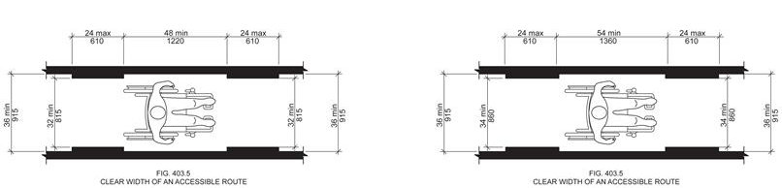

403.5.1 Clear Width at 180 Degree Turn Around Object. Where an accessible route makes a 180 degree turn around an object that is less than 48 inches (1220 mm) in width, clear widths shall be 42 inches (1065 mm) minimum approaching the turn, 48 inches (1220 mm) minimum during the turn, and 42 inches (1065 mm) minimum leaving the turn.

EXCEPTIONS:

- Section 403.5.1 shall not apply where the clear width during the turn is 60 inches
(1525 mm) minimum.

- Section 403.5.1 shall not apply where a minimum clear width of 43 inches (1090 mm) is provided approaching, during, and leaving the turn.

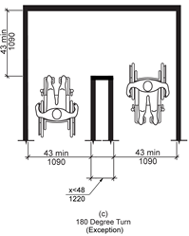
FIG. 403.5.1 ( c )
403.5.2 Passing Space. An accessible route with a clear width less than 60 64 inches (1525 1625 mm) shall provide passing spaces at intervals of 200 feet (61 m) maximum. Passing spaces shall be either a 60-inch (1525 mm) minimum by 60-inch 64-inch (1525 1625 mm) minimum space, or an intersection of two walking surfaces that provide a T-shaped turning space complying with Section 304.3.2, provided the base and arms of the T-shaped space extend 48 54 inches (1220 1360 mm) minimum beyond the intersection.

Reason: Many of the technical requirements of the ICC/ANSI A117.1 (2009) Accessible and Usable Buildings and Facilities (ICC/ANSI) designed to accommodate wheeled mobility users are based on research completed from 1974 to 1978 using a research sample that included about 60 individuals who used manual wheelchairs (Steinfeld et al., 1979).
The Center for Inclusive Design and Environmental Access (IDeA) at the University at Buffalo, SUNY recently completed an anthropometric study of 500 wheeled manual and powered mobility device users (Steinfeld, et al., 2010). Measurements of body and device size were captured in three dimensions. The functional anthropometric measurements required measuring reaching ability, grip strength and the minimum space needed for turning. It is the most extensive anthropometric study of wheeled mobility device users in the United States. Additional information about the study can be found at http://www.udeworld.com/ansi-standards-review. The proposed revisions are based on new anthropometric information that was generated from the database of anthropometric measurements developed as part of the study.

Analysis

Clear floor space represents the space required for a stationary wheeled mobility device. This area is typically depicted as a rectangular space the dimensions of which are based on measurements of occupied length and occupied breadth of wheeled mobility devices, which are defined as follows:
- Occupied length: measured as the horizontal distance between the forward-most point and the rear-most point on the wheelchair or occupant.
- Occupied width: measured as the horizontal distance between the side-most points of the wheelchair or participant on the right and left sides.
The results of our analysis suggest that the existing standard on clear floor space (48” length, 30” width) does not accommodate the occupied lengths and widths of the wheeled mobility user population and excludes powered wheeled mobility device users disproportionately as compared to manual device users. A length of 48” accommodates the occupied length of 75% of manual wheelchair users and only about 50% of powered chair and scooter users. A width of 30” accommodates the occupied width of 90% of manual wheeled mobility device users and only 75% of powered chair users.
We have taken the position that the clear floor space standards should accommodate the occupied lengths and widths of at least 90% of manual and powered wheeled mobility device users. A length of 54” accommodates the occupied lengths of 95% of manual chair users, and 90% of the powered chair users. A width of 32” accommodates the occupied widths of over 95% of manual wheeled mobility device users and 90% of the powered wheelchair users. Proposed changes to subsections 403 (Walking Surfaces) would accommodate an occupied length of 54 inches and occupied width of 32 inches (adjusted to 34 inches to be consistent with the 2 inch increase in the standard to accommodate width changes related to movement) for those parts of the standard based on occupied length and width.
A new exception is proposed for the 180-degree turns, based on an analysis also completed for the Anthropometry of Wheeled Mobility report. The analysis suggested that 95% of manual wheelchair users, as well as 95% of power chair and scooter users could accomplish a turn around a barrier when all three sides of the turn were 43 inches (Steinfeld, et al., 2010, pg. 166).
The analysis was summarized in the Final Project Report to the U.S. Access Board and in a memorandum entitled “Evaluation of Clear Floor Space Requirements,” that was submitted to the ICC/ANSI A117 Task Force on Anthropometry of Wheeled Mobility Subcommittee on Clear Floor Space Clearances.

References (See http://www.udeworld.com/ansi-standards-review)

Paquet, V. (2012). Evaluation of Clear Floor Space Requirements. A memorandum submitted to the ICC/ANSI A117 Task Force on Anthropometry of Wheeled Mobility Subcommittee on Clear Floor Space Clearances.

Steinfeld, E., Paquet, V., D’Souza, C., Joseph, C, and Maisel, J. (2010). Final Report: Anthropometry of Wheeled Mobility Project. Washington, DC: U.S. Access Board.

Steinfeld, E. Schroeder, S. and Bishop, M. (1979). Accessible buildings for people with walking and reaching limitations. Washington, DC: U.S. Department of Housing and Urban Development.
0000.doc

Committee Action

Approval as Modified

Modification – The original proposal is replaced with the following

403.5 Clear Width. The clear width of an accessible route shall be 36 inches (915 mm) minimum.

EXCEPTION: The clear width shall be permitted to be reduced to 32 inches (815 mm) minimum for a length of 24 inches (610 mm) maximum provided the reduced width segments are separated by segments that are 48 52 inches (1220 ???? mm) minimum in length and 36 inches (915 mm) minimum in width.

403.5.2 Passing Space. An accessible route with a clear width less than 60 inches (1525 mm) shall provide passing spaces at intervals of 200 feet (61 m) maximum. Passing spaces shall be either a 60-inch (1525 mm) minimum by 60-inch (1525 mm) minimum space, or an intersection of two walking surfaces that provide a T-shaped turning space complying with Section 304.3.2, provided the base and arms of the T-shaped space extend 48 52 inches (1220 ???? mm) minimum beyond the intersection.

Committee Reason: The Committee agreed to a revised clear floor space of 30 by 52 inches in Proposal 3-13-12. The original proposal here assumed a larger clear floor space, therefore the Committee approved only changes needed to address the 30 by 52 dimensions. Changes to Section 403.5.1 were not approved because the Committee felt the changes approved in proposal 4-8-12 were more appropriate.

4-7 – 12
403.5, 406.1, 406.4, 406.7, 406.10, 705.5.4

Proposed Change as Submitted

Proponent: Gina Hilberry, United Cerebral Palsy Association

Revise as follows:

403.5 Clear Width. The clear width of an interior accessible route shall be 36 inches (915 mm) minimum. The clear width of an exterior accessible route shall be 48 inches (1220 mm) minimum.

Exceptions:

1. The clear width shall be permitted to be reduced to 32 inches (815 mm) minimum for a length of 24 inches (610 mm) maximum provided the reduced width segments are separated by segments that are 48 inches (1220 mm) minimum in length and 36 inches (915 mm) minimum in width.

2. The clear width of an exterior ramp shall be permitted to be reduced to 36 inches (915 mm) minimum.

406.1 General. Curb ramps on accessible routes shall comply with Sections 406, 405.2, 405.3, and 405.10.

Exceptions:

1. The curb ramp running slope shall not exceed 8.3 percent maximum but shall not required the ramp length to exceed 15.0 feet (4.5 m).

2. The running slope of blended transitions shall be 5 percent maximum.

406.4 Width. Curb ramps shall be 36 inches (915 mm) 48 inches (1220 mm) minimum in width, exclusive of flared sides.

406.7 Landings. Landings shall be provided at the tops of curb ramps. The clear length of the landing
shall be 36 inches (915 mm) 48 inches (1220 mm) minimum. The clear width of the landing shall be at least as wide as the curb ramp, excluding flared sides, leading to the landing. Where the turning space or landing is constrained at the back-of-sidewalk, the landing shall be 48 inches (1220 mm) wide minimum and 60 inches (1550 mm) deep minimum.

Exception: In alterations, where there is no landing at the top of curb ramps, curb ramp flares shall be provided and shall not be steeper than 1:12.

406.10 Diagonal Curb Ramps. Diagonal or corner-type Curb ramps with returned curbs or other well-defined edges shall have the edges parallel to the direction of pedestrian flow. The bottom of diagonal curb ramps shall have 48 inches (1220 mm) minimum clear space outside active traffic lanes of the roadway. Diagonal Curb ramps provided at marked crossings shall provide the 48 inches (1220 mm) minimum clear space within the markings. Diagonal Curb ramps with flared sides shall have a segment of curb 24 inches (610 mm) minimum in length on each side of the curb ramp and within the marked crossing.

705.5.4 Alignment. Truncated domes shall be aligned in a square or radial grid pattern.

Reason: These proposals all relate to current best practices in the Public Right-of-Way and exterior environments.
Section 403.5 Width of exterior accessible route: this change matches the current language in the PROW guidelines. The edges of sidewalks and other accessible routes are clearly different from the edges of hallways and corridors and similar interior surfaces. Dropping off the edge of a sidewalk can have serious consequences. Passing oncoming pedestrians on 36 inch wide is impossible.
Section 406.4 Width of curb ramps and Section 406.7 Landings. These changes bring A117.1 into harmony with the current PROW guidelines.
Section 406.10 Diagonal ramps are no longer recommended design layouts. Deletion of the word diagonal allows the requirements to remain largely in place but to be applied to other curb ramps plan types.
Section 705.5.4 At blended transitions where the slope of the surface is at 5% maximum, it is important that the truncated domes align with the path of travel. Adding "or radial" permits the installation of domes aligned with the path of travel.
0000.doc

Committee Action

Approval as Modified

Modification – Only the revisions to Section 403.5 were accepted.

403.5 Clear Width. The clear width of an interior accessible route shall be 36 inches (915 mm) minimum. The clear width of an exterior accessible route shall be 48 inches (1220 mm) minimum.

Exceptions:

1. The clear width shall be permitted to be reduced to 32 inches (815 mm) minimum for a length of 24 inches (610 mm) maximum provided the reduced width segments are separated by segments that are 48 inches (1220 mm) minimum in length and 36 inches (915 mm) minimum in width.

2. The clear width of an exterior ramp shall be permitted to be reduced to 36 inches (915 mm) minimum.

Committee Reason: The proposal was reduced to just addressing the width of exterior accessible routes. A few states already have adopted a greater exterior width. Ramps need to be exempted because of how ramps and their handrails located on both sides are used. Some members of the Committee expressed concern that changing the width from 36 to 48 moves the standard away from providing only the minimum needed for accessibility. It was questioned whether there is simply a need for better edge protection of such routes and not simply widening them.

4-8 – 12
403.5.1

Proposed Change as Submitted

Proponent: Gina Hilberry and David Collins, Co-Chairs Wheeled Mobility Task Group

Revise as follows:

403.5.1 Clear Width at 180 Degree Turn. Where an accessible route makes a 180 degree turn around an object that is less than 48 inches (1220 mm) in width, clear widths shall be 42 inches (1065 mm) minimum approaching the turn, 48 inches (1220 mm) minimum during the turn and 42 (1065 mm) inches minimum leaving the turn 52 inches (1320 mm) in width minimum, clear widths shall be as permitted for turn complying with 405.5.1. Where an accessible route makes a 180 degree turn around an object that is less than 52 inches (1320 mm) inches, the clear widths approaching the turn, during the turn and leaving the turn, shall be one of the following sets of dimensions:

1. Approaching 36 inches (915 mm) minimum, during 60 inches (1525 mm) minimum, and leaving 36 inches (915 mm) minimum.
2. Approaching 42 (1065 mm) inches minimum, during 48 inches (1220 mm) minimum, and leaving 42 (1065 mm) inches minimum.
3. Approaching 43 inches (1090 mm) minimum, during 43 inches (1090 mm) minimum, and leaving 43 inches (1090 mm) minimum.

Reason: The Wheeled Mobility Task Group (WMTG) was created as a task group of the A117.1 Committee to analyze the results of the anthropometric study of a variety of mobility device users conducted by The Center for Inclusive Design and Environmental Access (IDeA) at the University at Buffalo, SUNY recently completed an anthropometric study of 500 wheeled manual and powered mobility device users. The study indicates that the technical provisions contained in the A117.1 standard do not address the needs of the full range of users of mobility devices. The work of the WMTG is ongoing, but it has submitted a series of proposed changes to the base building blocks of the A117.1 standard. If the changes to the building blocks are adopted by the Committee, then additional changes will need to be made in other portions of the standard.
0000.doc

Committee Action

Approval as Modified

Modification

403.5.1 Clear Width at 180 Degree Turn. Where an accessible route makes a 180 degree turn around an object that is less equal to or greater than 48 inches (1220 mm) in width, clear widths shall be 42 inches (1065 mm) minimum approaching the turn, 48 inches (1220 mm) minimum during the turn and 42 (1065 mm) inches minimum leaving the turn 52 inches (1320 mm) in width, the clear widths in the turn shall comply with Section 405.5.1. Where an accessible route makes a 180 degree turn around an object that is less than 52 inches (1320 mm) inches in width, the clear widths approaching the turn, during the turn and leaving the turn, shall be one of the following sets of dimensions:

1. Approaching width is 36 inches (915 mm) minimum, during width is 60 inches (1525 mm) minimum, and leaving width is 36 inches (915 mm) minimum.

2. Approaching width is 42 (1065 mm) inches minimum, during width is 48 inches (1220 mm) minimum, and leaving width is 42 (1065 mm) inches minimum.

3. Approaching width is 43 inches (1090 mm) minimum, during width is 43 inches (1090 mm) minimum, and leaving width is 43 inches (1090 mm) minimum.

EXCEPTION: Section 403.5.1 shall not apply where the clear width during the turn is 60 inches (1525 mm) minimum.

Committee Reason: The Committee looked at the geometries of the L-turn; 180 degree turn and the T-turn. This represents the options of the 180 degree turn. The Committee recognized that between these specific measurements are likely to be additional combinations that do provide adequate space. The text may be better presented in a table format.

4-9 – 12
403.5.2 (NEW)

Proposed Change as Submitted

Proponent: Gina Hilberry and David Collins, Co-Chairs Wheeled Mobility Task Group

Revise as follows:

403.5.2 Clear Width at 90 Degree Turn. Where an accessible route makes a 90 degree turn the clear widths approaching the turn and leaving the turn shall be one of the following sets of dimensions:

1. Both legs of the turn shall be 40 inches (1016 mm) minimum.
2. Where one leg of the turn is 40 inches (1016 mm) minimum for a distance of 68 inches (1727 mm) from the interior corner of the turn, the other leg shall be 36 inches (915 mm) minimum.
3. Where the interior corners of the turn are chamfered for 8 inches minimum along both walls, both legs of the turn shall be 36 inches (915 mm) minimum.

Reason: The Wheeled Mobility Task Group (WMTG) was created as a task group of the A117.1 Committee to analyze the results of the anthropometric study of a variety of mobility device users conducted by The Center for Inclusive Design and Environmental Access (IDeA) at the University at Buffalo, SUNY recently completed an anthropometric study of 500 wheeled manual and powered mobility device users. The study indicates that the technical provisions contained in the A117.1 standard do not address the needs of the full range of users of mobility devices. The work of the WMTG is ongoing, but it has submitted a series of proposed changes to the base building blocks of the A117.1 standard. If the changes to the building blocks are adopted by the Committee, then additional changes will need to be made in other portions of the standard.
0000.doc

Committee Action

Approval as Modified

Modification

403.5.2 Clear Width at 90 Degree Turn. Where an accessible route makes a 90 degree turn the clear widths approaching the turn and leaving the turn shall be one of the following sets of dimensions:

- Both legs of the turn shall be 40 inches (1016 mm) minimum.in width

2. Where one leg of the turn is 40 inches (1016 mm) minimum in width for a distance of 68 inches (1727 mm) minimum in length from the interior corner of the turn, the other leg shall be 36 inches (915 mm) minimum in width.

2. Where the interior corners of the turn are chamfered for 8 inches minimum (205 mm) along both walls, both legs of the turn shall be 36 inches (915 mm) minimum in width.

Committee Reason: This WMTG, and the Committee concluded that the Standard needed to more clearly address how a 90 turn occurs in an accessible route. The options considered addressed the range of equipment used. After considerable evaluation of the geometry and use mechanics of various dimensions, the Committee concluded that the 2 options provided for a range of compliant designs.

4-10 – 12
403.5.3 (New)

Proposed Change as Submitted

Proponent: Jonathan White, representing himself

Add new text as follows:

403.5.3 Clear Width at 90 Degree Turn. Where an accessible route makes a 90 degree turn, the clear width shall be 40 inches (1015 mm) minimum. At least one leg of the turn shall be clear of obstructions for a length of 14 inches (355 mm) minimum with the other leg clear of obstructions for at least 28 inches (710 mm) minimum.

EXCEPTIONS:

1. Where one leg of the turn is 42 inches (1065 mm) minimum in width, the other shall be permitted to be 38 inches (965 mm) minimum in width, with the narrower leg being clear of obstructions for a length of 26 inches (660 mm) minimum, and the other leg being clear of obstructions for a length of 15 inches (380 mm) minimum.

2. Where one leg of the turn is 44 inches (1115 mm) minimum in width, the other shall be permitted to be 36 inches (915 mm) minimum in width, with the narrower leg being clear of obstructions for a length of 24 inches (610 mm) minimum, and the other leg being clear of obstructions for a length of 16 inches (405 mm) minimum.

Reason: Many of the technical requirements of the ICC/ANSI A117.1 (2009) Accessible and Usable Buildings and Facilities (ICC/ANSI) designed to accommodate wheeled mobility users are based on research completed from 1974 to 1978 using a research sample that included about 60 individuals who used manual wheelchairs (Steinfeld et al., 1979).
The Center for Inclusive Design and Environmental Access (IDeA) at the University at Buffalo, SUNY recently completed an anthropometric study of 500 wheeled manual and powered mobility device users (Steinfeld, et al., 2010). Measurements of body and device size were captured in three dimensions. The functional anthropometric measurements required measuring reaching ability, grip strength and the minimum space needed for turning. It is the most extensive anthropometric study of wheeled mobility device users in the United States. Additional information about the study can be found at http://www.udeworld.com/ansi-standards-review. The proposed revisions are based on new anthropometric information that was generated from the database of anthropometric measurements developed as part of the study.

Analysis

The results of our analysis suggest that the existing standard on a 90-degree turn does not accommodate the occupied lengths and widths of the wheeled mobility user population and excludes powered wheeled mobility device users disproportionately as compared to manual device users. This is based on the IDEA center’s 90-degree turn data in Final Report: Anthropometry of Wheeled Mobility Project. Fewer than 75% of manual and power wheelchair users could negotiate a L-turn that was 36 inches width (pg. 154). A width of 40 inches would accommodate 94% of manual wheelchair users, 99% of power wheelchair users, and 92% of scooter users.
The exceptions are the results of estimated percentages by the IDEA center in a memorandum by Edward Steinfeld, to the ANSI subcommittee on Turning. The estimated percentages for Option B, C and D are the actual percentages for the narrower 90 degree turns. In other words, we tested a 90 degree turn of 38 x 38 without a chamfer. We are using that data to estimate the minimum percentage accommodated by the chamfered version. Thus, this is a conservative estimate because widening one side and adding the chamfer would clearly increase the percentage accommodated.
The table in the memorandum is below:
Proportion of the sample accommodated in each of the four alternatives for a L-turn

% Accommodated | Data Source | Manual (n=208) | Power (n=150) | Scooter (n=23)
Option A (40”x40”) | Measured data for 40” x 40” | 94% | 99% | 92%
Option B (42”x38”) | Estimate based on data for 38”x38” | Min. 85% | Min. 87% | Min. 67%
Option C (44”x36”) | Estimate based on data for 36”x36” | Min. 71% | Min. 71% | Min. 46%
Option D (36”x36” w/chamfer) | Estimate based on data for 36”x36” | Min. 71% | Min. 71% | Min. 46%

The analysis was summarized in the Final Project Report to the U.S. Access Board and in a memorandum entitled “Evaluation of Clear Floor Space Requirements,” that was submitted to the ICC/ANSI A117 Task Force on Anthropometry of Wheeled Mobility Subcommittee on Clear Floor Space Clearances.

References (See http://www.udeworld.com/ansi-standards-review)

Steinfeld, E. (2012). Summary of Turning Discussion and Responses and Recommended Dimensions for Turning Spaces. A memorandum submitted to the ICC/ANSI A117 Task Force on Anthropometry of Wheeled Mobility Subcommittee on Turning Spaces.

Steinfeld, E., Paquet, V., D’Souza, C., Joseph, C, and Maisel, J. (2010). Final Report: Anthropometry of Wheeled Mobility Project. Washington, DC: U.S. Access Board.

Steinfeld, E. Schroeder, S. and Bishop, M. (1979). Accessible buildings for people with walking and reaching limitations. Washington, DC: U.S. Department of Housing and Urban Development.
0000.doc

Committee Action

Approval as Modified

Modification

403.5.3 Clear Width at 90 Degree Turn. Where an accessible route makes a 90 degree turn, the clear width shall be 40 inches (1015 mm) minimum. At least one leg of the turn shall be clear of obstructions for a length of 14 inches (355 mm) minimum with the other leg clear of obstructions for at least 28 inches (710 mm) minimum. The width of each leg of the turn shall be maintained for 28 inches minimum from the inner corner.

EXCEPTIONS:

1. Where one leg of the turn is 42 inches (1065 mm) minimum in width, the other shall be permitted to be 38 inches (965 mm) minimum in width, with the narrower leg being clear of obstructions for a length of 26 inches (660 mm) minimum, and the other leg being clear of obstructions for a length of 15 inches (380 mm) minimum.

2. Where one leg of the turn is 44 inches (1115 mm) minimum in width, the other shall be permitted to be 36 inches (915 mm) minimum in width, with the narrower leg being clear of obstructions for a length of 24 inches (610 mm) minimum, and the other leg being clear of obstructions for a length of 16 inches (405 mm) minimum.

Committee Reason: The Committee approved both Proposal 4-9-12 and 4-10-12 as providing optional geometries for accomplishing a 90 degree turn in an accessible route. It was the Committee’s intent that 4-9 and 4-10 both be reflected in the standard. The committee recognized that merged text of these 2 proposals may be best presented in a table format. The Committee hopes the Editorial Task Group can develop the table format. Figures would also be helpful in presenting this information.

4-11 – 12
404, 404.1, 404.2, 404.2.3, 404.2.3.2, 404.2.3.4, 404.2.3.5, 404.2.4.1, 404.2.5, 404.2.6, 404.2.7, 404.2.8, 404.2.9, 404.2.10, 404.3, 404.3.2, 404.3.4

Proposed Change as Submitted

Proponent: Ed Roether, representing the ADA/A117 Harmonization Task Group

Revise as follows:

404 Doors, and Doorways and Gates

404.1 General. Doors, and doorways and gates that are part of an accessible route shall comply with Section 404.

EXCEPTION: Doors, doorways, and gates designed to be operated only by security personnel shall not be required to comply with 404.2.3, 404.2.6, 404.2.7, 404.2.8, 404.3.2 and 404.3.4 through 404.3.6.

404.2 Manual Doors, Doorways and Manual Gates. Manual doors and doorways, and manual gates, intended for user passage including ticket gates, shall comply with Section 404.2.

EXCEPTION: Doors, doorways, and gates designed to be operated only by security personnel shall not be required to comply with Sections 404.2.6, 404.2.7, and 404.2.8.

404.2.3 Maneuvering Clearances. Minimum maneuvering clearances at doors and gates shall comply with Section 404.2.3.and shall include the full clear opening width of the doorway and the required latch side or hinge side clearance. Required door maneuvering clearances shall not include knee and toe clearance.

404.2.3.2 Swinging Doors and Gates. Swinging doors and gates shall have maneuvering clearances complying with Table 404.2.3.2.

Fig. 404.2.3.2
Maneuvering Clearance at Manual Swinging Doors and Gates

Table 404.2.4.1 Maneuvering Clearances at Manual Swinging Doors and Gates
Table 404.2.3.2—Maneuvering Clearances at Manual Swinging Doors and Gates
TYPE OF USE |  | MINIMUM MANEUVERING CLEARANCES
Approach  Direction | Door or Gate Side | Perpendicular to Doorway | Parallel to Doorway (beyond latch unless noted)
From front | Pull | 60 inches (1525 mm) | 18 inches (455 mm)
(Balance of table is not changes)

404.2.3.4 Doorways without Doors or Gates. Doorways without doors or gates that are less than 36 inches (915 mm) in width shall have maneuvering clearances complying with Table 404.2.3.3

Fig. 404.2.3.4
Maneuvering Clearance at Doorways without Doors or Gates

Table 404.2.3.4—Maneuvering Clearances for Doorways without Doors or Gates
Approach Direction | MINIMUM MANEUVERING CLEARANCES  Perpendicular to Doorway
From front | 48 inches (1220 mm)

404.2.3.5 Recessed Doors and Gates. Where any obstruction within 18 inches (455 mm) of the latch side of a doorway projects more than 8 inches (205 mm) beyond the face of the door or gate, measured perpendicular to the face of the door, maneuvering clearances for a forward approach shall be provided.

Fig. 404.2.3.5
Maneuvering Clearance at Recessed Doors and Gates

404.2.5 Two Doors and Gates in Series. Distance between two hinged or pivoted doors or gates in series shall be 48 inches (1220 mm) minimum plus the width of any door or gate swinging into the space. The space between the doors shall provide a turning space complying with Section 304

Fig. 404.2.5
Two Doors or Gates in a Series

404.2.6 Door and Gate Hardware. Handles, pulls, latches, locks, and other operable parts on accessible doors and gates shall have a shape that is easy to grasp with one hand and does not require tight grasping, pinching, or twisting of the wrist to operate. Operable parts of such hardware shall be 34 inches (865 mm) minimum and 48 inches (1220 mm) maximum above the floor. Where sliding doors are in the fully open position, operating hardware shall be exposed and usable from both sides.

EXCEPTION: Locks used only for security purposes and not used for normal operation shall not be required to comply with Section 404.2.6.

404.2.7 Closing Speed. Door and gate closing speed shall comply with 404.2.8.

404.2.7.1 Door Closers and Gate Closers. Door closers and gate closers shall be adjusted so that from an open position of 90 degrees, the time required to move the door to an open position of 12 degrees shall be 5 seconds minimum.

404.2.7.2 Spring Hinges. Door and gate spring hinges shall be adjusted so that from an open position of 70 degrees, the door or gate shall move to the closed position in 1.5 seconds minimum.

404.2.8 Door and Gate Opening Force. Fire doors shall have the minimum opening force allowable by the appropriate administrative authority. The force for pushing or pulling open doors or gates other than fire doors shall be as follows:

1.Interior hinged doors and gates: 5.0 pounds (22.2 N) maximum
.
2.Sliding or folding doors: 5.0 pounds (22.2 N) maximum

These forces do not apply to the force required to retract latch bolts or disengage other devices that hold the door or gate in a closed position.

404.2.9 Door and Gate Surface. Door and gate surfaces within 10 inches (255 mm) of the floor, measured vertically, shall be a smooth surface on the push side extending the full width of the door or gate. Parts creating horizontal or vertical joints in such surface shall be within ¹/₁₆ inch (1.6 mm) of the same plane as the other. Cavities created by added kick plates shall be capped.

EXCEPTIONS:

(Exceptions 1 and 2 are not changed)

3. Doors and gates that do not extend to within 10 inches (255 mm) of the floor shall not be required to comply with Section 404.2.9.

404.2.10 Vision Lites. Doors, gates and sidelites adjacent to doors or gates containing one or more glazing panels that permit viewing through the panels shall have the bottom of at least one panel on either the door or an adjacent sidelite 43 inches (1090 mm) maximum above the floor.

(Exception is not changed)

404.3 Automatic Doors and Power-Assisted Doors and Gates. Automatic doors and automatic gates shall comply with Section 404.3. Full powered automatic doors shall comply with ANSI/BHMA A156.10 listed in Section 105.2.4. Power–assist and low–energy doors shall comply with ANSI/BHMA A156.19 listed in Section 105.2.3.

EXCEPTION: Doors, doorways, and gates designed to be operated only by security personnel shall not be required to comply with Sections 404.3.2, 404.3.4, and 404.3.5.

404.3.2 Maneuvering Clearances. Maneuvering clearances at power–assisted doors and gates shall comply with Section 404.2.3.

404.3.4 Two Doors or Gates in Series. Doors or gates in series shall comply with Section 404.2.5.

Reason: The ADA/A117 Harmonization Task Group (HTG) was created as a task group of the A117.1 Committee to compare the 2010 ADA with the 2009 A117.1 Standard. The HTG has recommend a series of changes through a set of change proposals. The HTG is recommending changes, for the most part, address where the ADA was viewed as more stringent than the A117. Where the A117 contained provisions not addressed in the ADA, these were not considered a conflict needing action to amend the A117. In addition there are a number of places where the ADA and A117.1 are different as a result of specific actions, by the A117.1 Committee during the development of the 2009 edition, to remain or create a difference where, in the judgment of the committee the ADA was deficient.

Reason for 404 To provide consistent language with the ADA. ADA consistently uses gates when discussing doors. The amendments through this section are simply providing consistent coverage. The exception to Section 404.1 is relocating an existing exception found in A117.1 Section 404.2 and others to a location similar to ADA.
0000.doc

Committee Action

Approved

Committee Reason: The change provides consistency in terminology between the Standard and the ADA.

4-12 – 12
404.2.2, Figure 404.2.2

Proposed Change as Submitted

Proponent: Edward Steinfeld, IDEA Center, School of Architecture and Planning, University at Buffalo, State University of New York

Revise as follows:

404.2.2 Clear Width. Doorways shall have a clear opening width of 32 34 inches (815 865 mm) minimum. Clear opening width of doorways with swinging doors shall be measured between the face of door and stop, with the door open 90 degrees. Openings more than 24 inches (610 mm) in depth at doors and doorways without doors shall provide a clear opening width of 36 inches (915 mm) minimum. There shall be no projections into the clear opening width lower than 34 inches (865 mm) above the floor. Projections into the clear opening width between 34 inches (865mm) and 80 inches (2030 mm) above the floor shall not exceed 4 inches (100 mm).

EXCEPTIONS:

- Door closers and door stops shall be permitted to be 78 inches (1980 mm) minimum above the floor.

- In alterations, a projection of 5/8 inch (16 mm) maximum into the required clear opening width shall be permitted for the latch side stop.

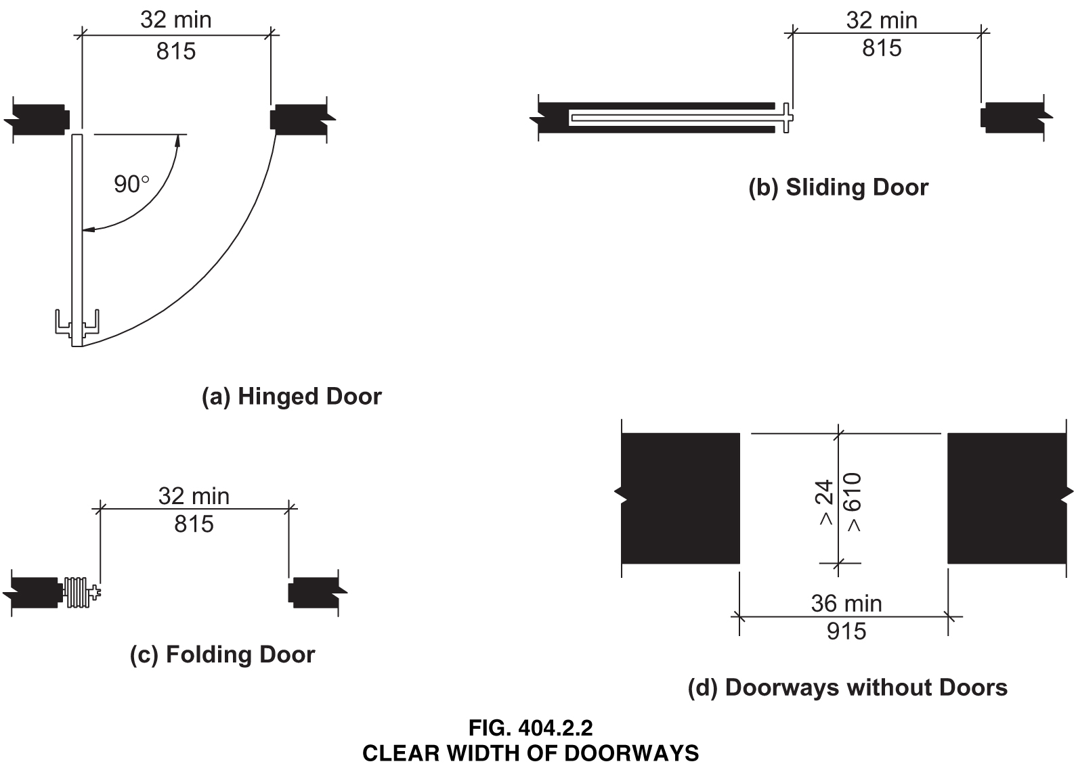

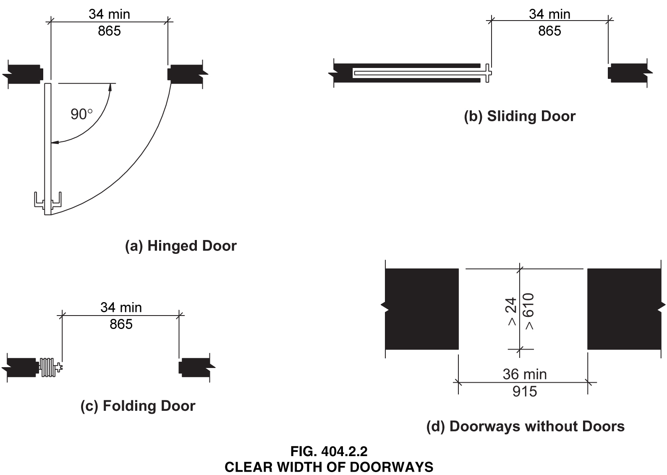
Reason: Many of the technical requirements of the ICC/ANSI A117.1 (2009) Accessible and Usable Buildings and Facilities (ICC/ANSI) designed to accommodate wheeled mobility users are based on research completed from 1974 to 1978 using a research sample that included about 60 individuals who used manual wheelchairs (Steinfeld et al., 1979).
The Center for Inclusive Design and Environmental Access (IDeA) at the University at Buffalo, SUNY recently completed an anthropometric study of 500 wheeled manual and powered mobility device users (Steinfeld, et al., 2010). Measurements of body and device size were captured in three dimensions. The functional anthropometric measurements required measuring reaching ability, grip strength and the minimum space needed for turning. It is the most extensive anthropometric study of wheeled mobility device users in the United States. Additional information about the study can be found at http://www.udeworld.com/ansi-standards-review. The proposed revisions are based on new anthropometric information that was generated from the database of anthropometric measurements developed as part of the study.

Analysis

Clear floor space represents the space required for a stationary wheeled mobility device. This area is typically depicted as a rectangular space the dimensions of which are based on measurements of occupied length and occupied breadth of wheeled mobility devices, which are defined as follows:
- Occupied length: measured as the horizontal distance between the forward-most point and the rear-most point on the wheelchair or occupant.
- Occupied width: measured as the horizontal distance between the side-most points of the wheelchair or participant on the right and left sides.
The results of our analysis suggest that the existing standard on clear floor space (48” length, 30” width) does not accommodate the occupied lengths and widths of the wheeled mobility user population and excludes powered wheeled mobility device users disproportionately as compared to manual device users. A length of 48” accommodates the occupied length of 75% of manual wheelchair users and only about 50% of powered chair and scooter users. A width of 30” accommodates the occupied width of 90% of manual wheeled mobility device users and only 75% of powered chair users.
We have taken the position that the clear floor space standards should accommodate the occupied lengths and widths of at least 90% of manual and powered wheeled mobility device users. A length of 54” accommodates the occupied lengths of 95% of manual chair users, and 90% of the powered chair users. A width of 32” accommodates the occupied widths of over 95% of manual wheeled mobility device users and 90% of the powered wheelchair users. Proposed changes to subsection 404 (Doors and Doorways) would accommodate an occupied length of 54 inches and occupied width of 32 inches (adjusted to 34 inches to be consistent with the 2 inch increase in the standard to accommodate width changes related to movement) for those parts of the standard based on occupied length and width.
The analysis was summarized in the Final Project Report to the U.S. Access Board and in a memorandum entitled “Evaluation of Clear Floor Space Requirements,” that was submitted to the ICC/ANSI A117 Task Force on Anthropometry of Wheeled Mobility Subcommittee on Clear Floor Space Clearances.

References (See http://www.udeworld.com/ansi-standards-review)

Paquet, V. (2012). Evaluation of Clear Floor Space Requirements. A memorandum submitted to the ICC/ANSI A117 Task Force on Anthropometry of Wheeled Mobility Subcommittee on Clear Floor Space Clearances.

Steinfeld, E., Paquet, V., D’Souza, C., Joseph, C, and Maisel, J. (2010). Final Report: Anthropometry of Wheeled Mobility Project. Washington, DC: U.S. Access Board.

Steinfeld, E. Schroeder, S. and Bishop, M. (1979). Accessible buildings for people with walking and reaching limitations. Washington, DC: U.S. Department of Housing and Urban Development.
0000.doc

Committee Action

Disapproved

Committee Reason: The Committee has decided to retain the 30 inch width of the clear floor space. Increasing the minimum clear width of doors has not be justified based on current information. Changing to 34 inches would make most standard 3’0” doors not workable.

4-13 – 12
404.2.3
Proposed Change as Submitted

Proponent: Ed Roether, representing the ADA/A117 Harmonization Task Group

Revise as follows:

404.2.3 Maneuvering Clearances. Minimum maneuvering clearances at doors shall comply with Section 404.2.3. Maneuvering clearances and shall include the full clear opening width of the doorway and the required latch side or hinge side clearance. Required door maneuvering clearances shall not include knee and toe clearance.

EXCEPTION: Entry doors to hospital patient rooms shall not be required to provide the clearance beyond the latch side of the door.

Reason: The ADA/A117 Harmonization Task Group (HTG) was created as a task group of the A117.1 Committee to compare the 2010 ADA with the 2009 A117.1 Standard. The HTG has recommend a series of changes through a set of change proposals. The HTG is recommending changes, for the most part, address where the ADA was viewed as more stringent than the A117. Where the A117 contained provisions not addressed in the ADA, these were not considered a conflict needing action to amend the A117. In addition there are a number of places where the ADA and A117.1 are different as a result of specific actions, by the A117.1 Committee during the development of the 2009 edition, to remain or create a difference where, in the judgment of the committee the ADA was deficient.

Reason for 404.2.3: The added text is ADA language not currently in A117.1. The text that is being struck out was an attempt in the standard to allow maneuvering clearances to go under some objects where the knees/toes of a wheelchair user would still have adequate space to operate the door. However, the text is unclear. Further, current interpretation of the ADA is that maneuvering spaces must be clear for the full height of 80 inches. The exception is also found in the IBC, but adding it here provides clarity as well as consistency with the ADA.
0000.doc

Committee Action

Approval as Modified

Modification

404.2.3 Maneuvering Clearances. Minimum maneuvering clearances at doors shall comply with Section 404.2.3. Maneuvering clearances shall include the full clear opening width of the doorway and the required latch side or hinge side clearance.

EXCEPTION: Entry doors to hospital patient rooms shall not be required to provide the clearance beyond the latch side of the door.

Committee Reason: The Committee previously deleted this exception and keeping it out of the Standard will simply make the Standard more stringent than the ADA – not in conflict. The issue is centered on operational standards of hospital where historically patient room doors have remained open, therefore negating the need for this clearance. The Committee does not believe that such operational standards are universal and feels that the maneuvering clearances should be provided.

4-14 – 12
Table 404.2.3.2
Proposed Change as Submitted

Proponent: Kim Paarlberg, International Code Council

Revise as follows:

TABLE 404.2.3.2—MANEUVERING CLEARANCES AT MANUAL SWINGING DOORS
TYPE OF USE |  | MANEUVERING CLEARANCES AT MANUAL SWINGING DOORS
Approach Direction | Door Side | Perpendicular to Doorway | Parallel to Doorway  (beyond latch unless noted)
From front | Pull | 60 inches (1525 mm) | 18 inches (455 mm)
From front | Push | 48 inches (1220 mm) | 0 inches (0 mm)³
From hinge side | Pull | 60 inches (1525 mm) | 36 inches (915 mm)
From hinge side | Pull | 54 inches (1370 mm) | 42 inches (1065 mm)
From hinge side | Push | 42 inches (1065 mm)¹ | 22 inches (560 mm)^{3 & 4}
From latch side | Pull | 48 inches (1220 mm)¹ | 24 inches (610 mm)
From latch side | Push | 42 inches (1065 mm)² | 24 inches (610 mm)
¹Add 6 inches (150 mm) if closer and latch provided.
²Add 6 inches (150 mm) if closer provided.
³Add 12 inches (305 mm) beyond latch if closer and latch provided.
⁴Beyond hinge side.

Reason: The quantity of change proposals submitted by International Code Council is reflective of three elements of our work: 1. ICC is the Secretariat for the Standard and some changes reflect inconsistencies or improvements suggested by staff; 2. ICC develops and publishes a Commentary on the standard and writing the commentary illuminates issues of the text and figures; and 3. ICC provides an interpretation service for the standard which results in the observation of provisions the users find most confusing.
Coordination with the 2012 ADA Standards for Accessible Design.
The A117.1 requires there 12 inches beyond the latch side on this door if both a closer and a latch are provided on the door. The ADA does not have this 12 inch requirement.
This requirement was added to the A117.1 standard between the 1998 and 2003 editions by proposal 4-015 and was modified by public comment that cleaned up the footnote reference for it. The proponent’s reason statement said that figure (b) the front approach push side and figure (e) the hinge approach push side are similar situations and that having the 12 inches on the forward approach should also be provided on the hinge approach.
Because this extra requirement creates a discrepancy between the A117.1 and ADA which is not readily apparent and well known, the elimination of the footnote reference would help to coordinate the two standards and make this basic issue of door maneuvering clearances consistent. It seems that the addition of this requirement was probably not well justified when it was added into the 2003 A117.1 standard and with the change made in Section 404.2.3 of the 2009 edition which prevented door maneuvering clearances from including knee and toe clearance it made the difference between the A117.1 and the federal requirements that much greater. With some of the task groups looking at changing the ‘building blocks’ which could further affect maneuvering clearances, it would seem that this difference between the two standards should be eliminated or better justification should be provided so that it could be added into the federal requirements and coordinated that way.
The graphic representations of the various layouts are provided to better illustrate the differences. In the 2009 standard it is Fig 404.2.3.2(e) and in the 2010 ADA it is Figure 404.2.4.1(g). See ADA figure 404.2.4.1(f) for base condition.
The following is Figure 404.2.3.2(e) from the A117.1-2009 standard.

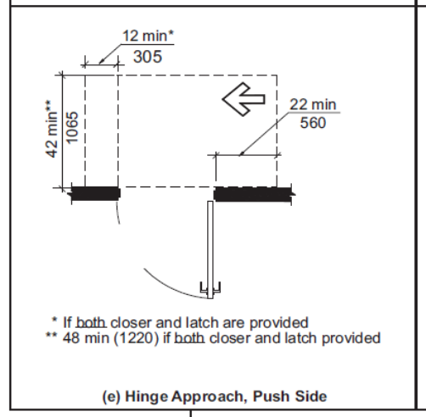

The following is Figure 404.2.4.1(g) from the 2010 ADA Standards for Accessible Design. This is the comparable requirement for the door shown in Figure 404.2.3.2(e) from the A117.1-2009 standard.

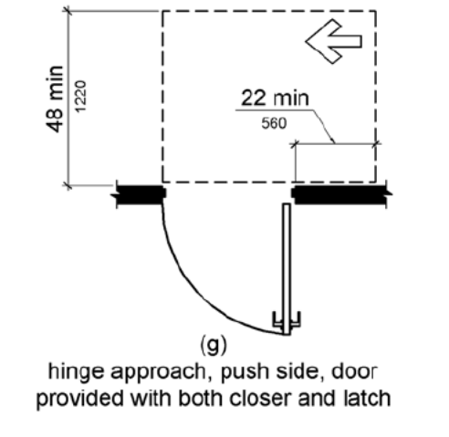
The following is Figure 404.2.4.1(f) from the 2010 ADA Standards for Accessible Design. This is the comparable base requirement for the door shown in Figure 404.2.3.2(e) from the A117.1-2009 standard (hinge approach/push side of door which does not have BOTH a closer and a latch).

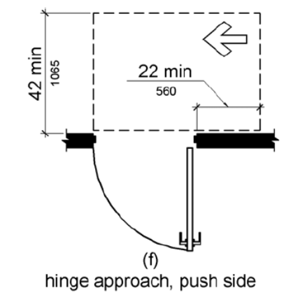
0000.doc

Committee Action

Approval as Modified

Modification

TABLE 404.2.3.2—MANEUVERING CLEARANCES AT MANUAL SWINGING DOORS
TYPE OF USE |  | MANEUVERING CLEARANCES AT MANUAL SWINGING DOORS
Approach Direction | Door Side | Perpendicular to Doorway | Parallel to Doorway  (beyond latch unless noted)
From front | Pull | 60 inches (1525 mm) | 18 inches (455 mm)
From front | Push | 48 52 inches (1220 mm) | 0 inches (0 mm)³
From hinge side | Pull | 60 inches (1525 mm) | 36 inches (915 mm)
From hinge side | Pull | 54 inches (1370 mm) | 42 inches (1065 mm)
From hinge side | Push | 42 inches (1065 mm)¹ | 22 inches (560 mm)⁴
From latch side | Pull | 48 inches (1220 mm)¹ | 24 inches (610 mm)
From latch side | Push | 42 inches (1065 mm)² | 24 inches (610 mm)
¹Add 6 inches (150 mm) if closer and latch provided.
²Add 6 inches (150 mm) if closer provided.
³Add 12 inches (305 mm) beyond latch if closer and latch provided.
⁴Beyond hinge side.

Committee Reason: The original purpose of the proposal was to eliminate the 12 inch beyond the latch requirement (footnote 3) from the provision of doors approached from the hinge side/push side. Such requirement isn’t in the ADA. The proposal was amended to be consistent with earlier actions to increase the clear floor space to a length of 52 inches (see Proposal 3-13-12).

4-15 – 12
Figure 404.2.3.2, Table 404.2.3.2, Figure 404.2.3.3(a), Table 404.2.3.3, Table 404.2.3.4, Figure 404.2.3.4, Figure 404.2.3.5 (b), (c)

Proposed Change as Submitted

Proponent: Edward Steinfeld, IDEA Center, School of Architecture and Planning, University at Buffalo, State University of New York

Delete and substitute as follows:

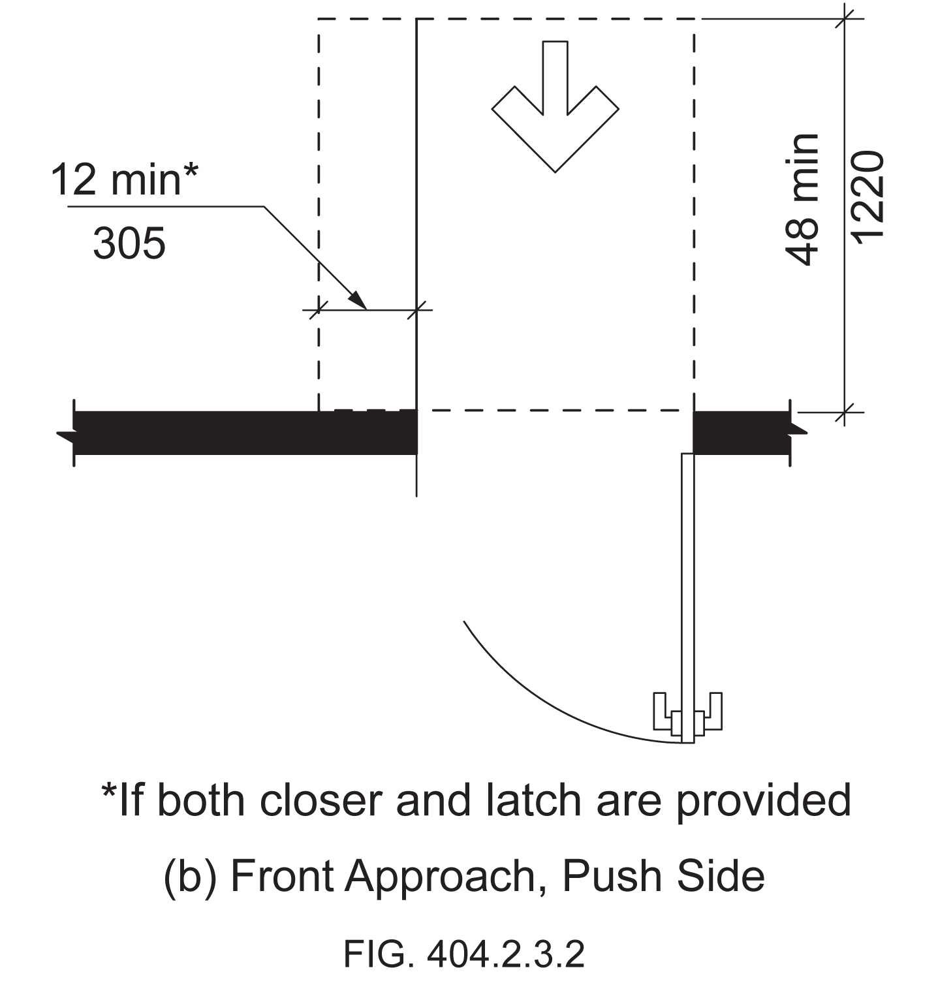

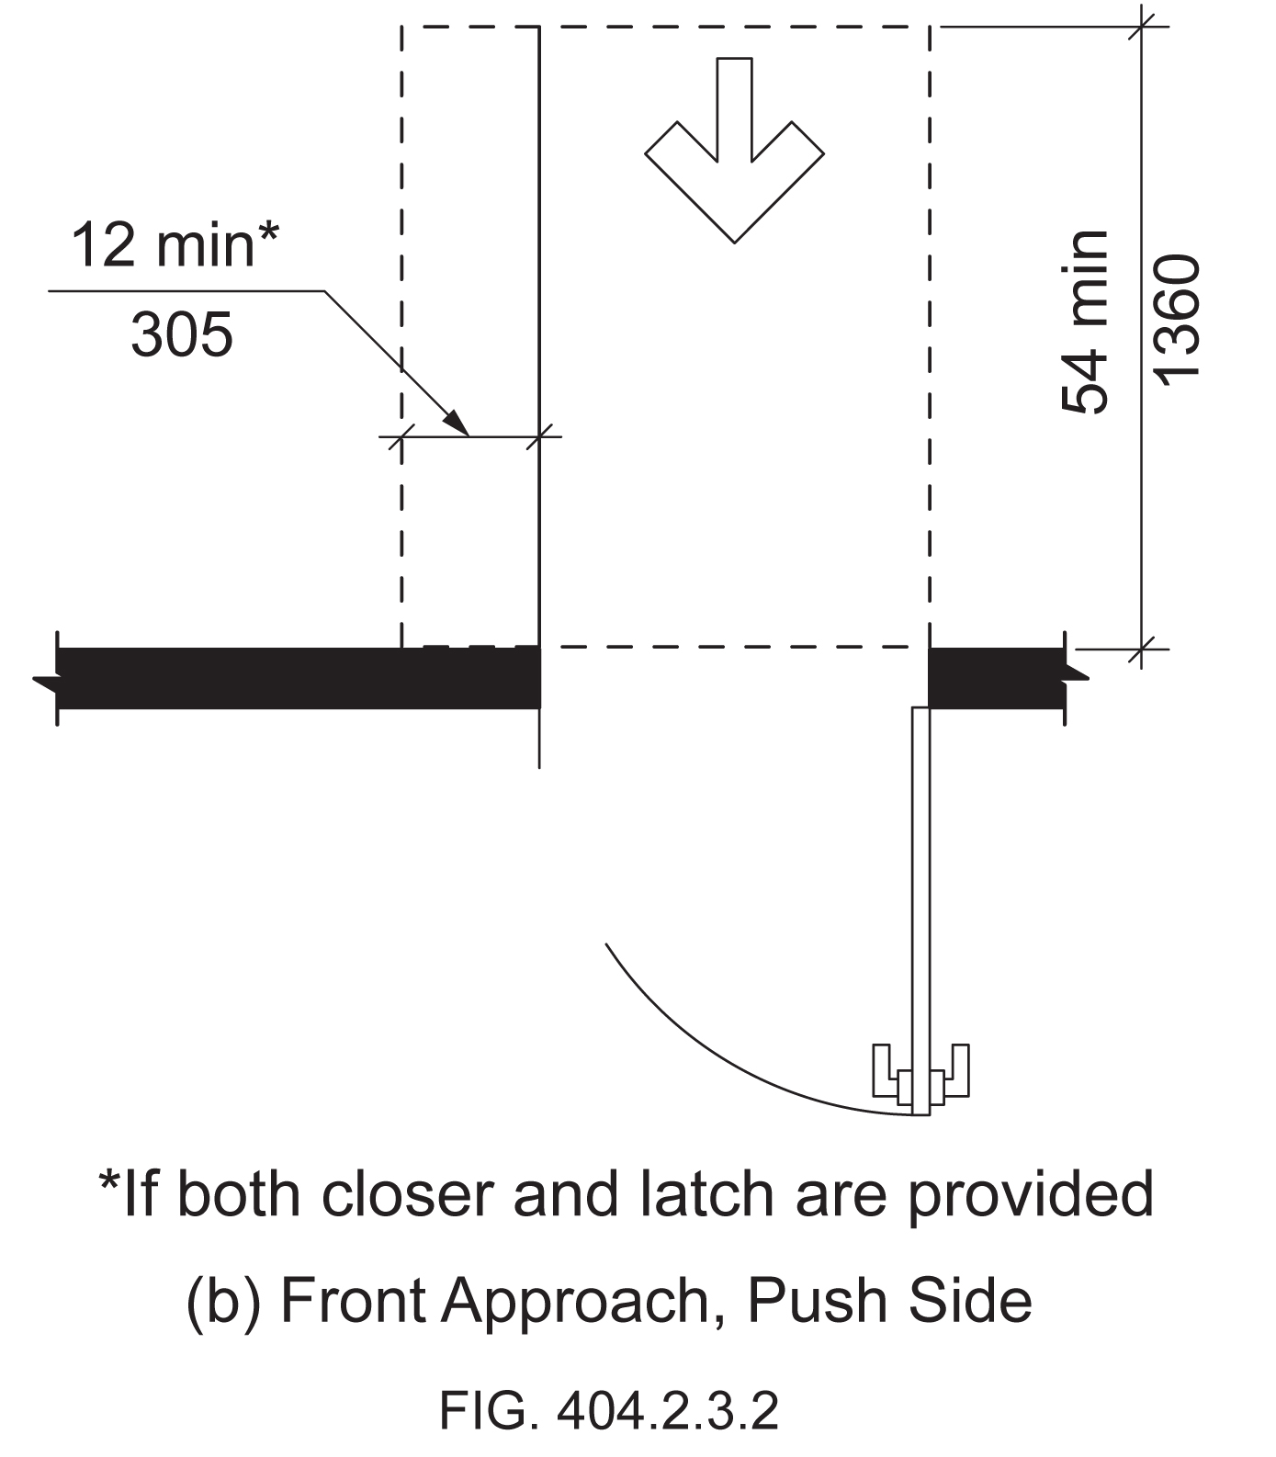

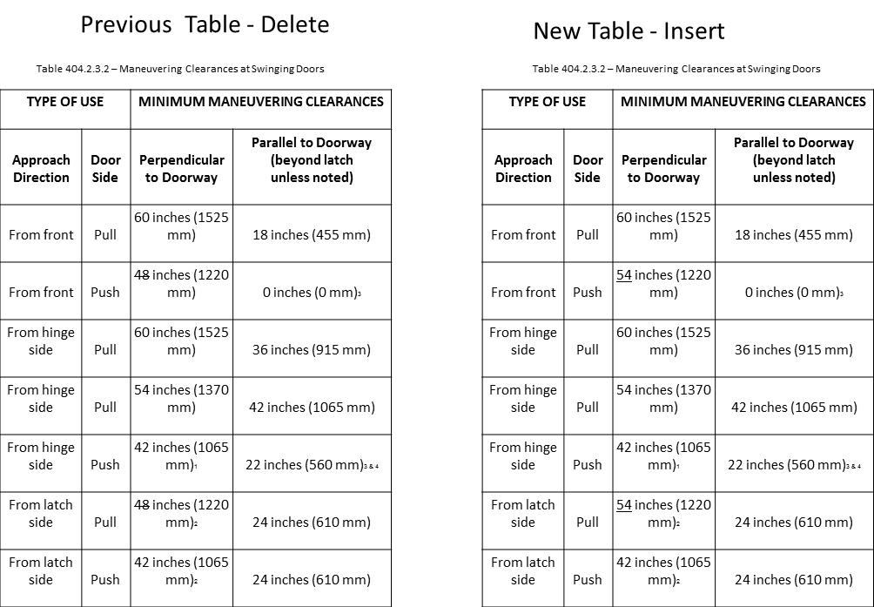

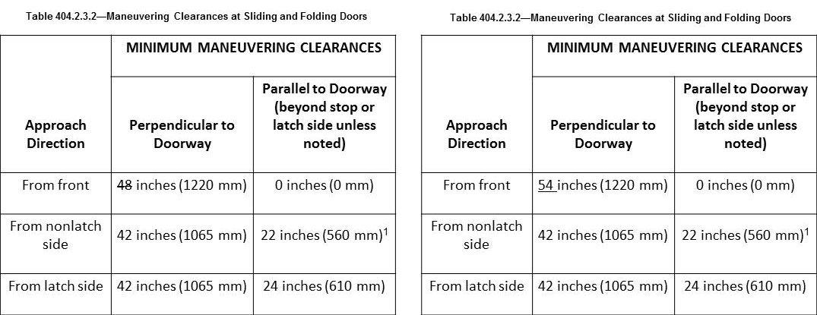

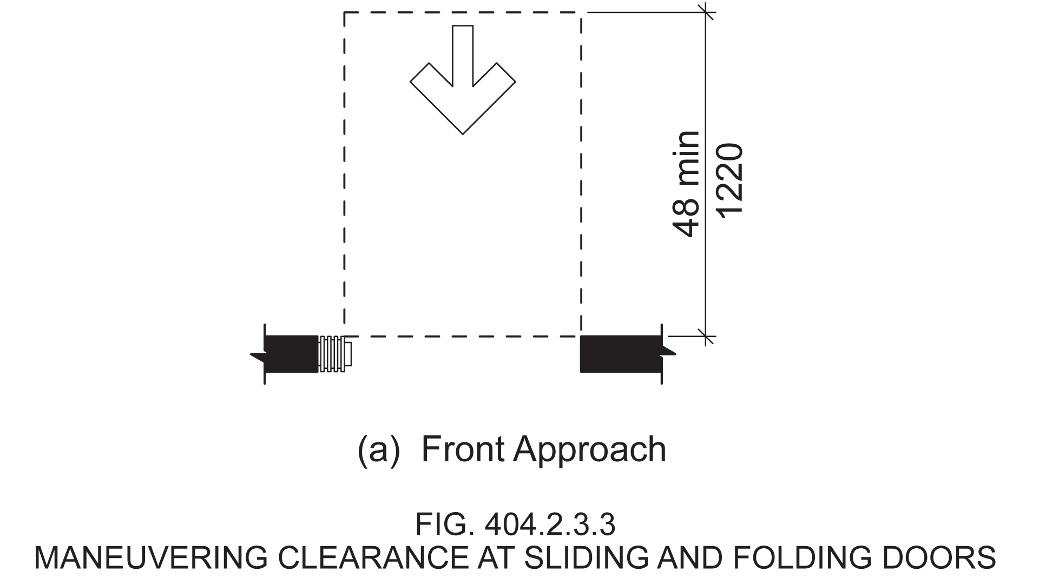

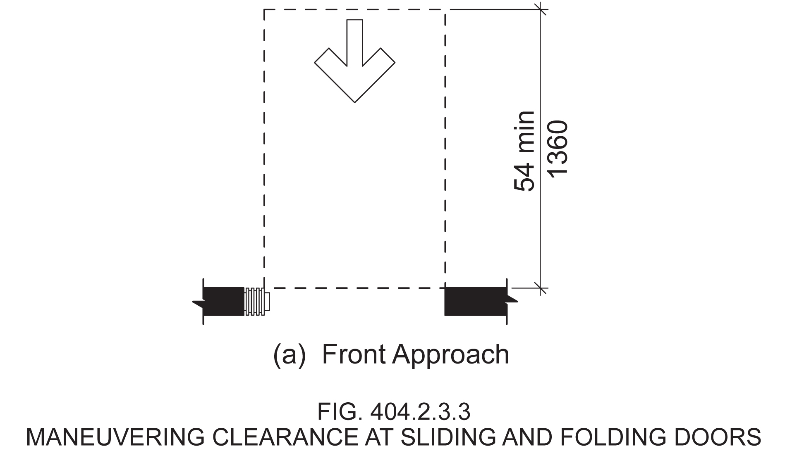

Revise Table as follows:

TABLE 404.2.3.4 - MANEUVERING CLEARANCES FOR DOORWAYS WITHOUT DOORS
Approach direction | MINIMUM MANEUVERING CLEARANCES  Perpendicular to Doorway
From front | 48 54 inches (1220 1370 mm)
From side | 42 inches (1065 mm)

Delete and substitute Figure as follows:

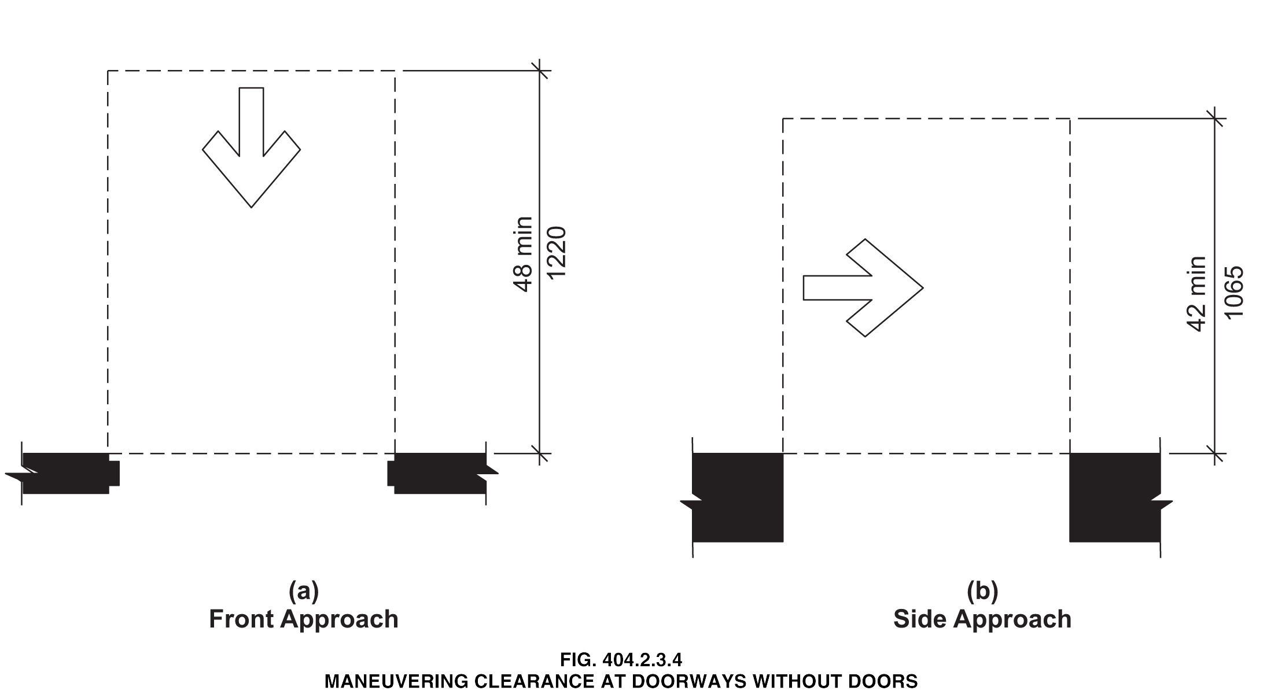

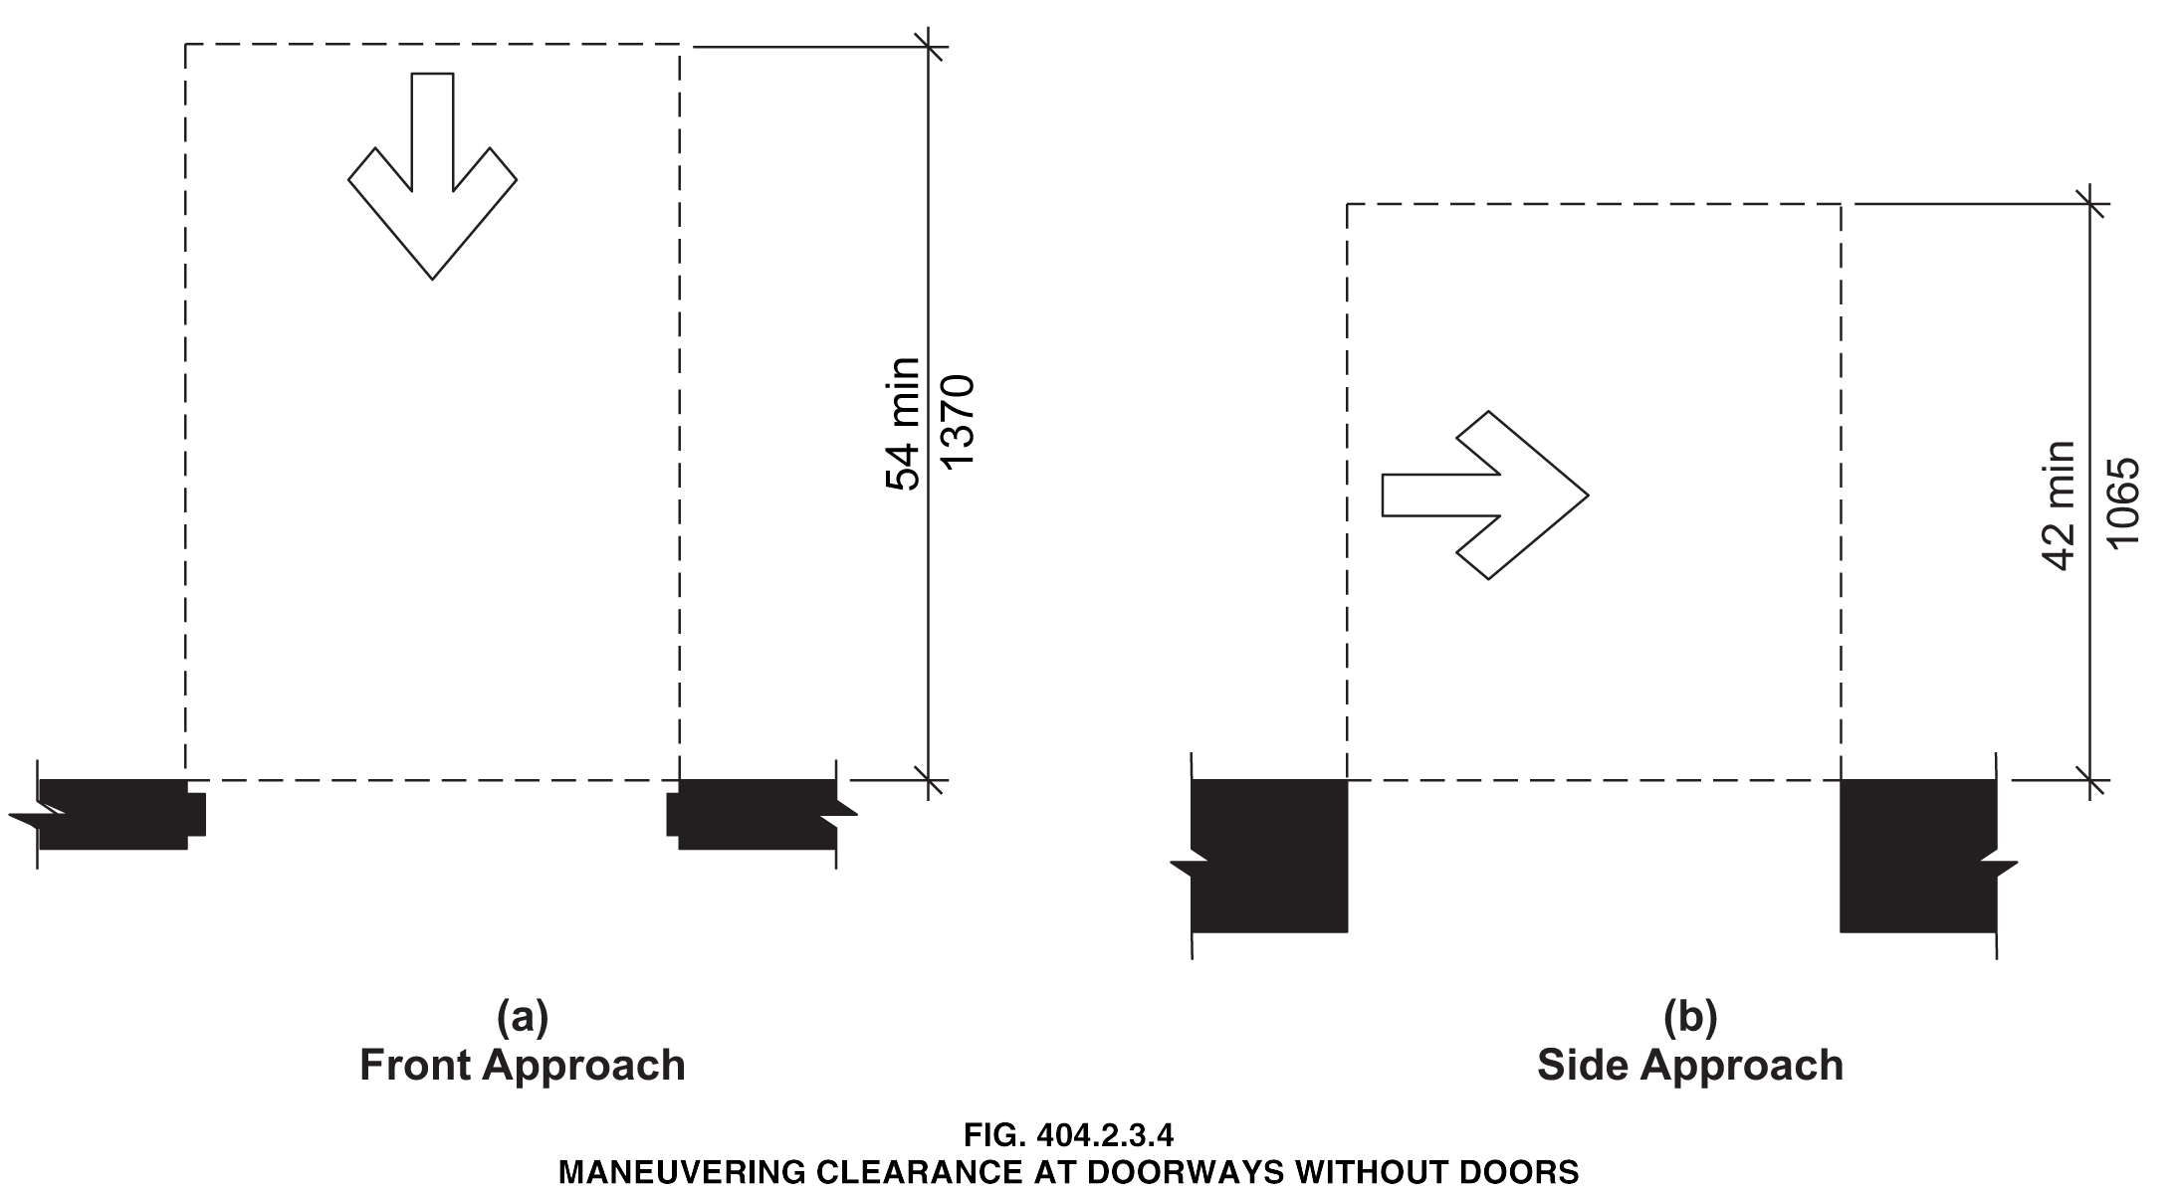

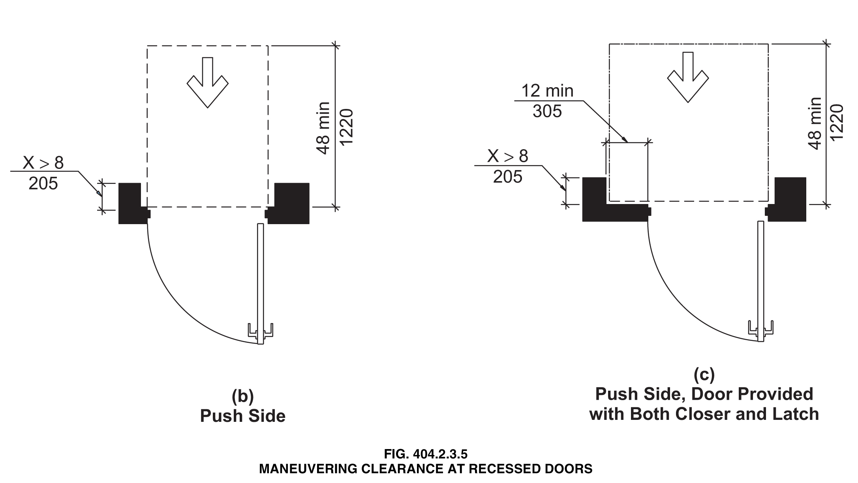

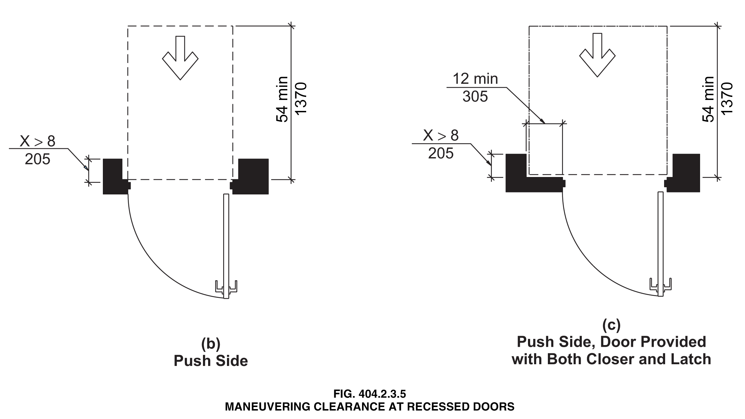

Reason: Many of the technical requirements of the ICC/ANSI A117.1 (2009) Accessible and Usable Buildings and Facilities (ICC/ANSI) designed to accommodate wheeled mobility users are based on research completed from 1974 to 1978 using a research sample that included about 60 individuals who used manual wheelchairs (Steinfeld et al., 1979).
The Center for Inclusive Design and Environmental Access (IDeA) at the University at Buffalo, SUNY recently completed an anthropometric study of 500 wheeled manual and powered mobility device users (Steinfeld, et al., 2010). Measurements of body and device size were captured in three dimensions. The functional anthropometric measurements required measuring reaching ability, grip strength and the minimum space needed for turning. It is the most extensive anthropometric study of wheeled mobility device users in the United States. Additional information about the study can be found at http://www.udeworld.com/ansi-standards-review. The proposed revisions are based on new anthropometric information that was generated from the database of anthropometric measurements developed as part of the study.

Analysis

Clear floor space represents the space required for a stationary wheeled mobility device. This area is typically depicted as a rectangular space the dimensions of which are based on measurements of occupied length and occupied breadth of wheeled mobility devices, which are defined as follows:
- Occupied length: measured as the horizontal distance between the forward-most point and the rear-most point on the wheelchair or occupant.
- Occupied width: measured as the horizontal distance between the side-most points of the wheelchair or participant on the right and left sides.
The results of our analysis suggest that the existing standard on clear floor space (48” length, 30” width) does not accommodate the occupied lengths and widths of the wheeled mobility user population and excludes powered wheeled mobility device users disproportionately as compared to manual device users. A length of 48” accommodates the occupied length of 75% of manual wheelchair users and only about 50% of powered chair and scooter users. A width of 30” accommodates the occupied width of 90% of manual wheeled mobility device users and only 75% of powered chair users.
We have taken the position that the clear floor space standards should accommodate the occupied lengths and widths of at least 90% of manual and powered wheeled mobility device users. A length of 54” accommodates the occupied lengths of 95% of manual chair users, and 90% of the powered chair users. A width of 32” accommodates the occupied widths of over 95% of manual wheeled mobility device users and 90% of the powered wheelchair users. Proposed changes to subsection 404 (Doors and Doorways) would accommodate an occupied length of 54 inches and occupied width of 32 inches for those parts of the standard based on occupied length and width.
The calculation used to determine the appropriate clearances are based on the three-dimensional database of wheeled mobility device user dimensions developed by the IDEA Center for the Anthropometry of Wheeled Mobility Project. The analysis was summarized in the Final Project Report to the U.S. Access Board and in a memorandum entitled “Evaluation of Clear Floor Space Requirements,” that was submitted to the ICC/ANSI A117 Task Force on Anthropometry of Wheeled Mobility Subcommittee on Clear Floor Space Clearances.

References (See http://www.udeworld.com/ansi-standards-review)

Paquet, V. (2012). Evaluation of Clear Floor Space Requirements. A memorandum submitted to the ICC/ANSI A117 Task Force on Anthropometry of Wheeled Mobility Subcommittee on Clear Floor Space Clearances.

Steinfeld, E., Paquet, V., D’Souza, C., Joseph, C, and Maisel, J. (2010). Final Report: Anthropometry of Wheeled Mobility Project. Washington, DC: U.S. Access Board.

Steinfeld, E. Schroeder, S. and Bishop, M. (1979). Accessible buildings for people with walking and reaching limitations. Washington, DC: U.S. Department of Housing and Urban Development.
0000.doc

Committee Action

Approval as Modified - The following revisions replace the original proposal.

TABLE 404.2.3.2—MANEUVERING CLEARANCES AT MANUAL SWINGING DOORS
TYPE OF USE |  | MANEUVERING CLEARANCES AT MANUAL SWINGING DOORS
Approach Direction | Door Side | Perpendicular to Doorway | Parallel to Doorway  (beyond latch unless noted)
From front | Pull | 60 inches (1525 mm) | 18 inches (455 mm)
From front | Push | 48 52 inches  (1220 1321mm) | 0 inches (0 mm)³
From hinge side | Pull | 60 inches (1525 mm) | 36 inches (915 mm)
From hinge side | Pull | 54 inches (1370 mm) | 42 inches (1065 mm)
From hinge side | Push | 42 inches (1065 mm)¹ | 22 inches (560 mm)^{3 & 4}
From latch side | Pull | 48 inches (1220 mm)¹ | 24 inches (610 mm)
From latch side | Push | 42 inches (1065 mm)² | 24 inches (610 mm)
¹Add 6 inches (150 mm) if closer and latch provided.
²Add 6 inches (150 mm) if closer provided.
³Add 12 inches (305 mm) beyond latch if closer and latch provided.
⁴Beyond hinge side.

TABLE 404.2.3.3 – MANEUVERING CLEARANCES AT SLIDING AND FOLDING DOORS
Approach Direction | MINIMUM MANEUVERING CLEARANCES
Approach Direction | Perpendicular to Doorway | Parallel to Doorway  (beyond stop or latch side unless noted)
From front | 48 52 inches (1220 1321 mm) | 0 inches (0 mm)
From nonlatch side | 42 inches (1065 mm) | 22 inches (560 mm) ¹
From latch side | 42 inches (1065 mm) | 24 inches (610 mm)
^{1.} Beyond pocket or hinge side.

TABLE 404.2.3.4 - MANEUVERING CLEARANCES FOR DOORWAYS WITHOUT DOORS
Approach direction | MINIMUM MANEUVERING CLEARANCES  Perpendicular to Doorway
From front | 48 52 inches (1220 1321 mm)
From side | 42 inches (1065 mm)

Committee Reason: These revisions reflect the decision in Proposal 3-13-12 to change the length of the clear floor space to 52 inches. Figures will be revised accordingly by the Editorial Task Group.

4-16 – 12
Figure 404.2.3.5
Proposed Change as Submitted

Proponent: Gene Boecker, Code Consultants, Inc

Revise as follows:

Door recess drawings are not correct. The text indicates that the recess is to be measured from the face of the door but the figures show in two cases the recess measured from the face of the frame.

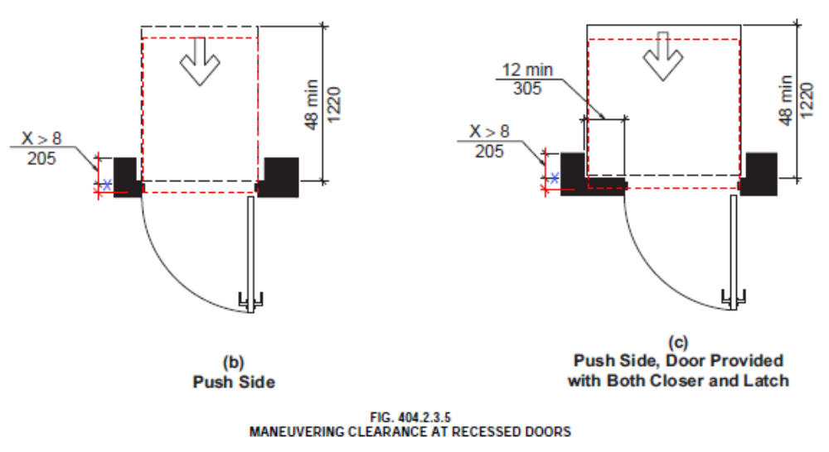

Reason: When the door is in a frame and the door swings toward you, the face of the door is typically the same as the closest edge of the frame. However, when the door swings away from you, it is on the far side of the frame and the nearest face of the door is already recessed from the edge of the frame. The modified Figure shows the proper method. Although not shown, obviously the 48 inch dimension would need to be revised to show the distance from the face of the maneuvering space to its perpendicular extent.
The illustration shows the clear floor space in front of the door to be measured from the nearest side of the frame - not the door face as the standard states in Section 404.2.3.5:

“404.2.3.5 Recessed Doors. Where any obstruction within 18 inches (455 mm) of the latch side of a doorway projects more than 8 inches (205 mm) beyond the face of the door, measured perpendicular to the face of the door, maneuvering clearances for a forward approach shall be provided.”

The revision would show the correct method for assessing recess. This has caused a number of incorrect applications and resulted in doors often being located too far from the face of the adjoining wall.
0000.doc

Committee Action

The proposal was judged to be editorial and referred to the Editorial Task Group.

4-17 – 12
Figure 404.2.3.5

Proposed Change as Submitted

Proponent: Carroll Lee Pruitt, FAIA, APA, representing Accessibility Professionals Association

Revise as the Figure 404.2.3.5 (c) as follows:

Relocate the arrows and call dimension for the 8 inch depth from the left side of the figure to the location shown below.

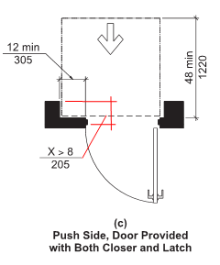
Reason: The text for this section states that the dimension is to the “face of the door” measured perpendicular to the “face of the door”. The Figure shows the 8” recess from the face of the wall of the door.
0000.doc

Committee Action

The Committee concluded that correcting the figure was editorial and this proposal was referred to the Editorial Task Group.

4-18 – 12
404.2.5, Figure 404.2.5

Proposed Change as Submitted

Proponent: Edward Steinfeld, IDEA Center, School of Architecture and Planning, University at Buffalo, State University of New York

Revise as follows:

404.2.5 Two Doors in a Series. Distance between two hinged or pivoted doors in series shall be 48 54 inches (1220 1370 mm) minimum plus the width of any door swinging into the space. The space between the doors shall provide a turning space complying with Section 304.

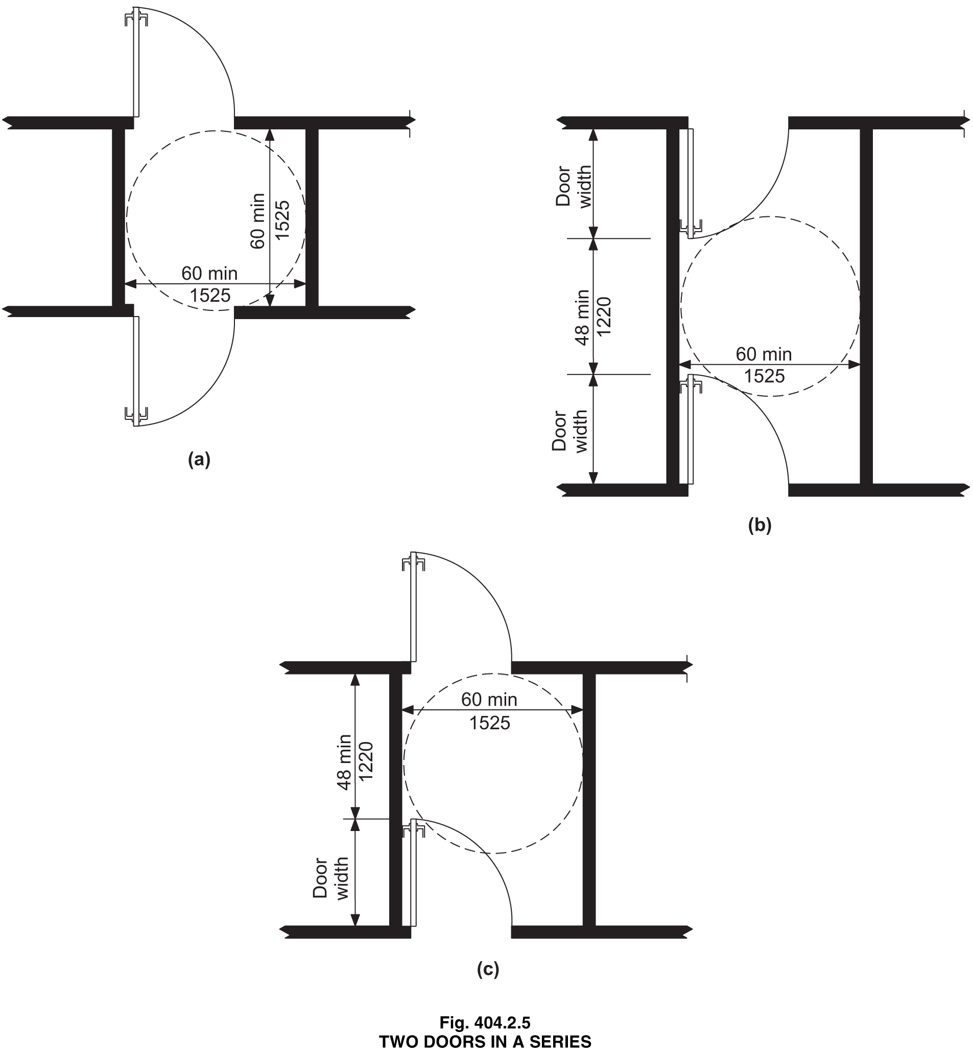

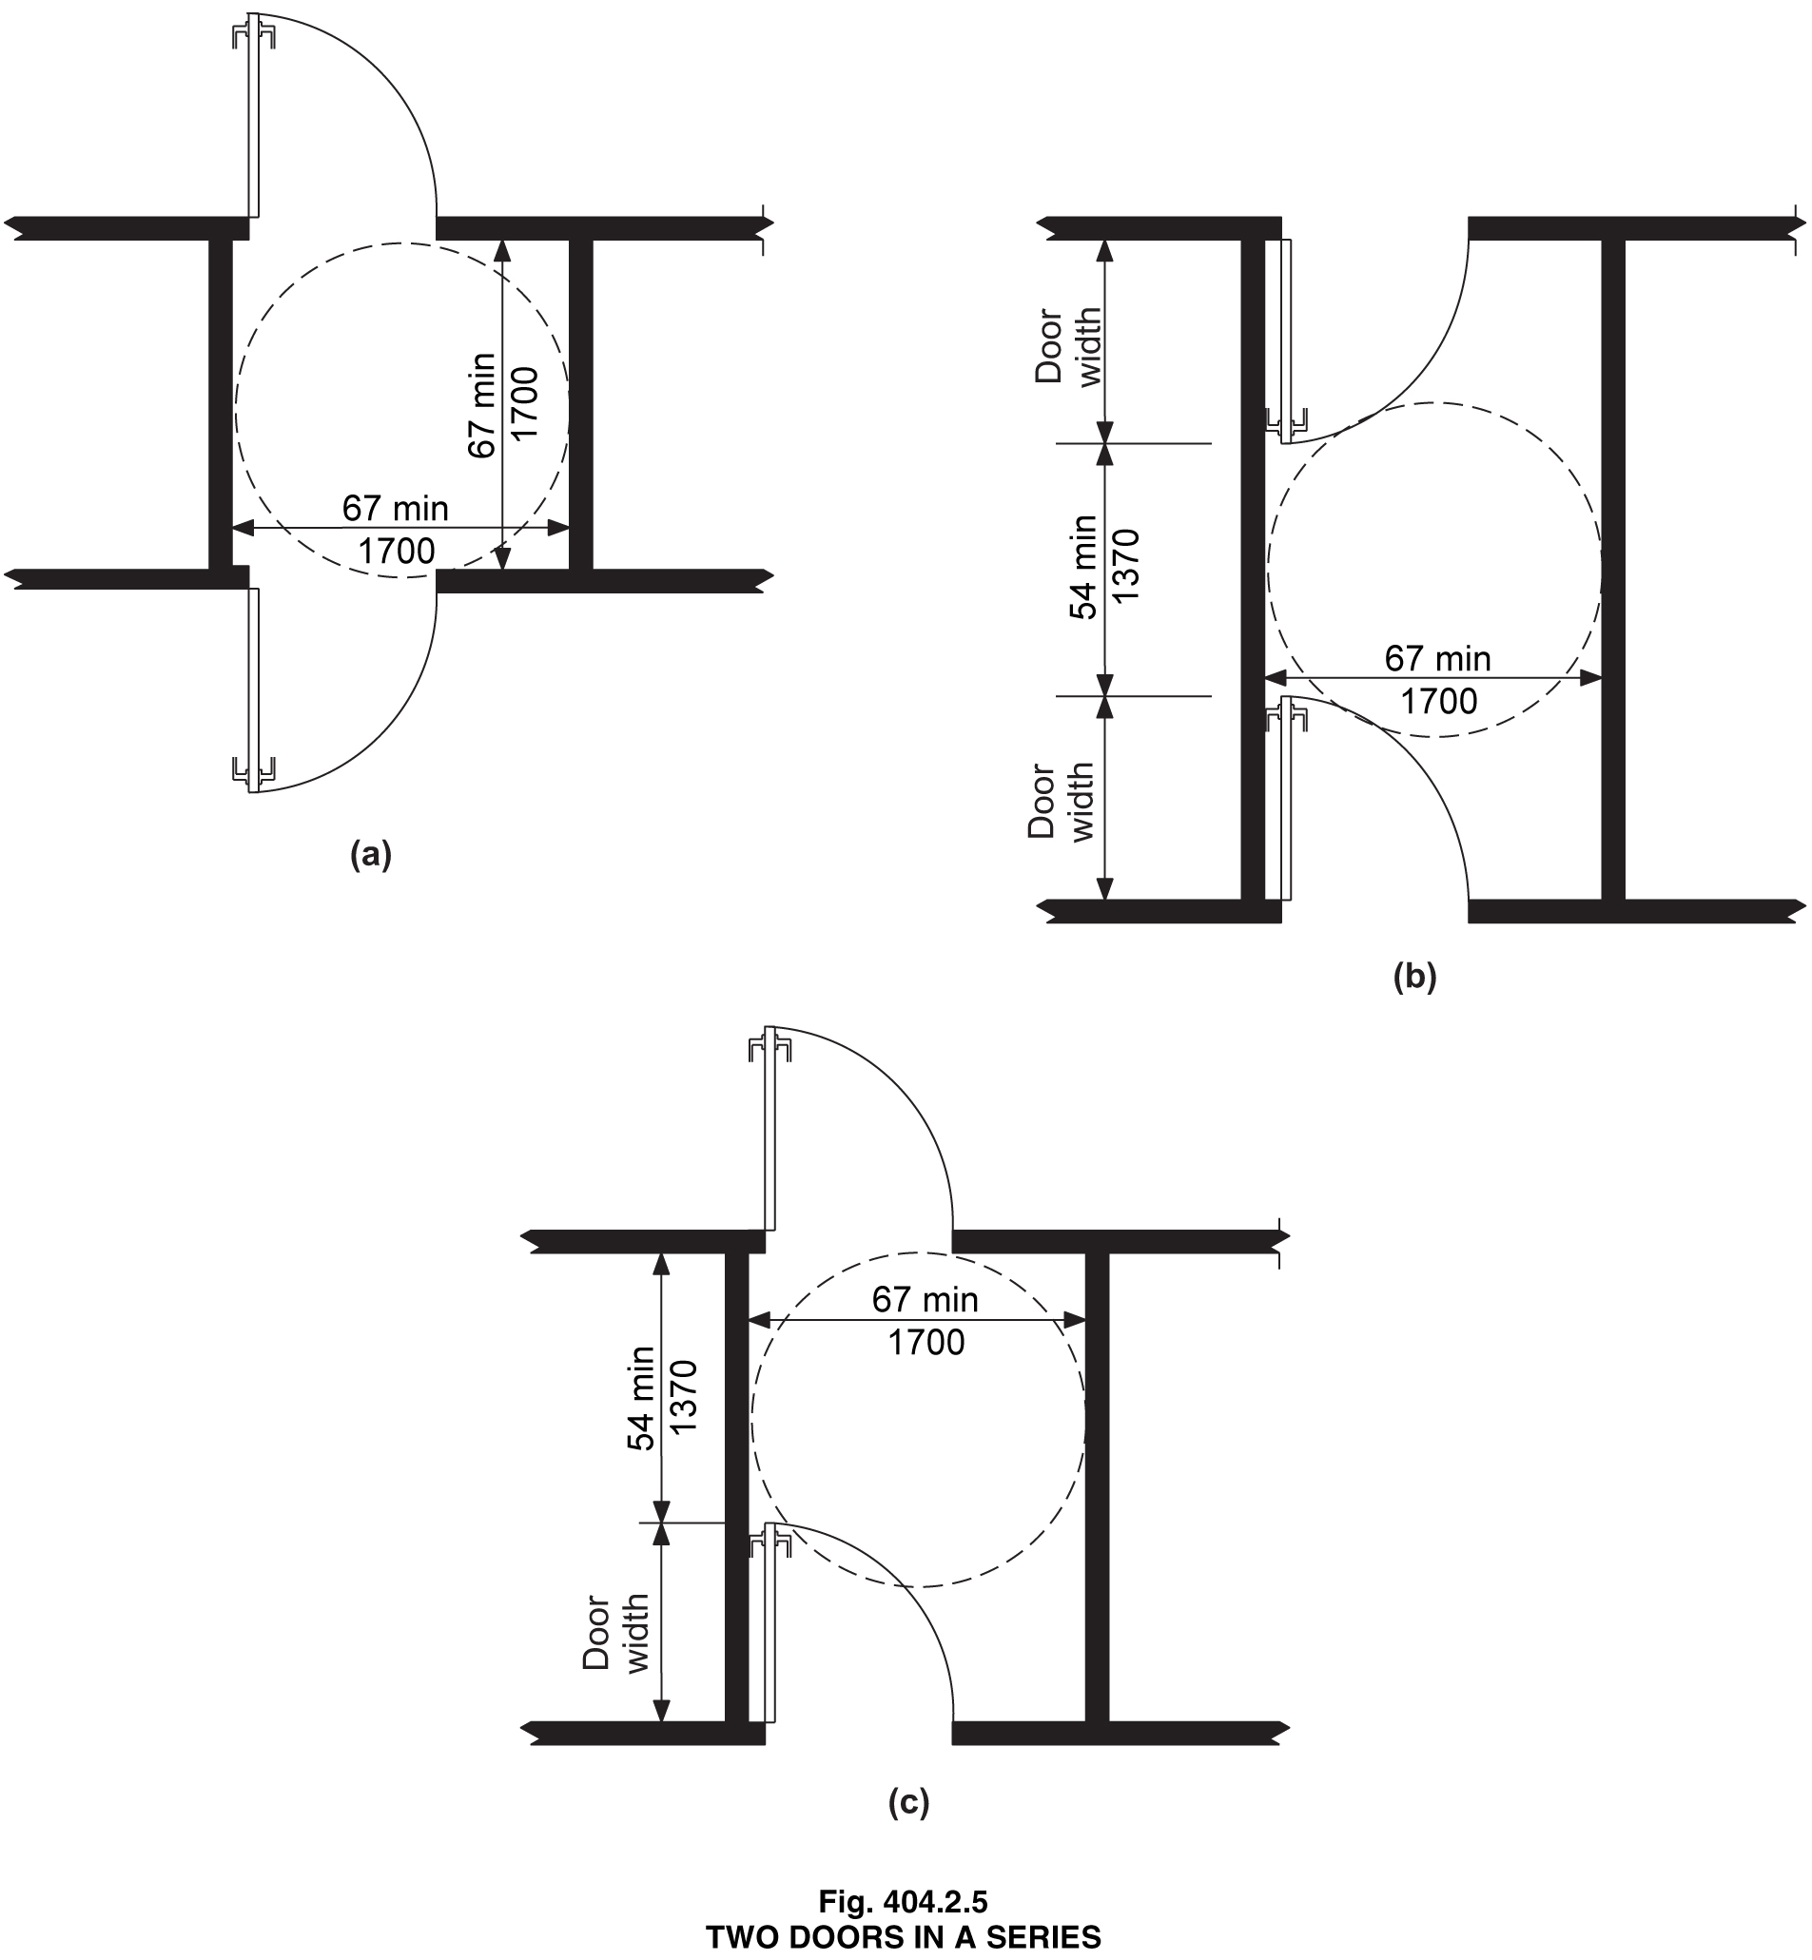

Reason: Many of the technical requirements of the ICC/ANSI A117.1 (2009) Accessible and Usable Buildings and Facilities (ICC/ANSI) designed to accommodate wheeled mobility users are based on research completed from 1974 to 1978 using a research sample that included about 60 individuals who used manual wheelchairs (Steinfeld et al., 1979).
The Center for Inclusive Design and Environmental Access (IDeA) at the University at Buffalo, SUNY recently completed an anthropometric study of 500 wheeled manual and powered mobility device users (Steinfeld, et al., 2010). Measurements of body and device size were captured in three dimensions. The functional anthropometric measurements required measuring reaching ability, grip strength and the minimum space needed for turning. It is the most extensive anthropometric study of wheeled mobility device users in the United States. Additional information about the study can be found at http://www.udeworld.com/ansi-standards-review. The proposed revisions are based on new anthropometric information that was generated from the database of anthropometric measurements developed as part of the study.

Analysis

Clear floor space represents the space required for a stationary wheeled mobility device. This area is typically depicted as a rectangular space the dimensions of which are based on measurements of occupied length and occupied breadth of wheeled mobility devices, which are defined as follows:
- Occupied length: measured as the horizontal distance between the forward-most point and the rear-most point on the wheelchair or occupant.
- Occupied width: measured as the horizontal distance between the side-most points of the wheelchair or participant on the right and left sides.
The results of our analysis suggest that the existing standard on clear floor space (48” length, 30” width) does not accommodate the occupied lengths and widths of the wheeled mobility user population and excludes powered wheeled mobility device users disproportionately as compared to manual device users. A length of 48” accommodates the occupied length of 75% of manual wheelchair users and only about 50% of powered chair and scooter users. A width of 30” accommodates the occupied width of 90% of manual wheeled mobility device users and only 75% of powered chair users. The 180-degree turning diameter accommodates only 75% of manual and power wheelchair users.
We have taken the position that the clear floor space standards should accommodate the occupied lengths and widths of at least 90% of manual and powered wheeled mobility device users. A length of 54” accommodates the occupied lengths of 95% of manual chair users, and 90% of the powered chair users. A width of 32” accommodates the occupied widths of over 95% of manual wheeled mobility device users and 90% of the powered wheelchair users. A 180-degree turn diameter of 67 inches would accommodate 95% of manual and power wheelchair users. Proposed changes to subsection 404 (Doors and Doorways) would accommodate an occupied length of 54 inches and occupied width of 32 inches for those parts of the standard based on occupied length and width. It would also allow for a 180-degree turn at two-doors in a series.
The analysis was summarized in the Final Project Report to the U.S. Access Board and in a memorandum entitled “Evaluation of Clear Floor Space Requirements,” that was submitted to the ICC/ANSI A117 Task Force on Anthropometry of Wheeled Mobility Subcommittee on Clear Floor Space Clearances and in a memorandum entitled “Summary of Turning Discussion and Responses and Recommended Dimensions for Turning Spaces” that was submitted to the ICC/ANSI A117 Task Force on Anthropometry of Wheeled Mobility Subcommittee on Turning Spaces.

References (See http://www.udeworld.com/ansi-standards-review)

Paquet, V. (2012). Evaluation of Clear Floor Space Requirements. A memorandum submitted to the ICC/ANSI A117 Task Force on Anthropometry of Wheeled Mobility Subcommittee on Clear Floor Space Clearances.

Steinfeld, E. (2012). Summary of Turning Discussion and Responses and Recommended Dimensions for Turning Spaces. A memorandum submitted to the ICC/ANSI A117 Task Force on Anthropometry of Wheeled Mobility Subcommittee on Turning Spaces.

Steinfeld, E., Paquet, V., D’Souza, C., Joseph, C, and Maisel, J. (2010). Final Report: Anthropometry of Wheeled Mobility Project. Washington, DC: U.S. Access Board.

Steinfeld, E. Schroeder, S. and Bishop, M. (1979). Accessible buildings for people with walking and reaching limitations. Washington, DC: U.S. Department of Housing and Urban Development.
0000.doc

Committee Action

Disapproved

Committee Reason: The Committee concluded that with the provision of the turning space between the doors that the 48 inch distance between the open doors did not need to be increased to reflect the larger clear floor space. As the turning space was increased by approval of proposal 3-6-12 to a 67 inch diameter circle, the existing 48 inches is sufficient.

Note: It was suggested that the Editorial Task Group consider putting the maneuvering clearances in the figures – either instead of – or as a complement to the existing figures.

4-19 – 12
404.2.5
Proposed Change as Submitted

Proponent: Kim Paarlberg, International Code Council

Revise as follows:

404.2.5 Two Doors in Series. Distance between two hinged or pivoted doors in series shall be 48 inches (1220 mm) minimum plus the width of any door swinging into the space. Where the doors in a series form a vestibule and where one of the doors is an exterior door, the space between the doors shall provide a turning space complying with Section 304.

Reason: The quantity of change proposals submitted by International Code Council is reflective of three elements of our work: 1. ICC is the Secretariat for the Standard and some changes reflect inconsistencies or improvements suggested by staff; 2. ICC develops and publishes a Commentary on the standard and writing the commentary illuminates issues of the text and figures; and 3. ICC provides an interpretation service for the standard which results in the observation of provisions the users find most confusing.
The original intent of the last sentence was to stop entrapment in vestibules where the exterior door may be locked or the force may be so great that a person with limited mobility could not open it. It was not anticipated that someone would believe that doors across the hall from one another would be considered doors in a series. This added language should limit this requirement to locations where it was intended.
0000.doc

Committee Action

Disapproved

Committee Reason: The Committee acknowledged that the proponent was trying to address a common misunderstanding of this provision which is partially a result of there not being a definition of doors in a series. Adding ‘vestibule’ was not seen as improving the clarity. Vestibules are also inside a building and could have the same issue. The Committee felt the figure provided sufficient clarity to limit misinterpretation.

4-20 – 12
404.2.7.1
Proposed Change as Submitted

Proponent: Robert D. Feibleman, HAND Construction, representing self

Revise as follows:

404.2.7.1 Door Closers. Door closers shall be adjusted so that from an open position of 90 degrees, the time required to move the door to an open position of 12 degrees shall be 5 seconds minimum.

Exception: Closers on toilet compartment doors are not required to be adjustable.

Reason: Section 604.9.3 requires toilet compartment doors to comply with Section 404, and Section 404.2.7 closing speed defines for closers and springs. The speed of closing should not be relevant to a toilet partitions. Hydraulic closers aren’t used. The hinges are designed to self-close, but the speed of this mechanism isn’t adjustable enough to accomplish the requirements of Section 4042.7. I don’t believe it’s intended to be applicable to toilet partitions.
0000.doc

Committee Action

Disapproved

Committee Reason: The Committee did not feel that the exception was addressing the issue in the proper place of the Standard. The issue may be definitional in that the things on toilet compartment doors aren’t closers so much as gravity hinges. It would be better to address in a way that eliminates these from being considered closers.

4-21 – 12
404.2.7.2

Proposed Change as Submitted

Proponent: Robert D. Feibleman, HAND Construction, representing self

Revise as follows:

404.2.7.2 Spring Hinges. Door spring hinges shall be adjusted so that from an open position of 70 degrees, the door shall move to the closed position in 1.5 seconds minimum.

Exception: Spring hinges on toilet compartment doors are not required to be adjustable .

Reason: Section 604.9.3 requires toilet compartment doors to comply with Section 404, and Section 404.2.7 closing spded defines for closers and springs. The speed of closing should not be relevant to a toilet partitions. Hydraulic closers aren’t used. The hinges are designed to self-close but the speed of this mechanism isn’t adjustable enough to accomplish the requirements of Section 404.2.7. I don’t believe it’s intended to be applicable to toilet partitions.
0000.doc

Committee Action

Disapproved

Committee Reason: The Committee disapproved this proposal because of it similarity with proposal 4-20-12. It was suggested that perhaps a provision be added to Section 604 addressing the doors to toilet compartments.

4-22 – 12
404.2.8
Proposed Change as Submitted

Proponent: Anthony Alarid, New Mexico Governor’s Commission on Disability (NMGCD)

Revise as follows:

404.2.8 Door Opening Force. Fire doors shall have the minimum opening force allowable by the appropriate administrative authority. The force for pushing or pulling open doors other than fire doors shall be as follows:

1. Interior hinged door: 5.0 pounds (22.2 N) maximum
2. Sliding or folding door: 5.0 pounds (22.2 N) maximum
3. Exterior hinged door: 8.5 pounds (37.7 N) minimum to 10 (44.4 N) pounds maximum.

These forces do not apply to the force to retract latch bolts or disengage other devices that hold the door in a closed position.

Reason: Exterior doors must be usable by individuals who are able-bodied, ambulatory, or disabled. Just as interior doors are, the opening force on exterior doors should also be regulated to make them usable. When elements within a facility are required to, and do comply with accessibility standards, it becomes irrelevant if an individual cannot get past the exterior entry door to access these elements.
0000.doc

Committee Action

Disapproved

Committee Reason: The Committee discussed the many issues with trying to establish a standard for exterior doors. Previously the Standard listed a maximum force. There wasn’t comfort with what a minimum force would do. Door closing and opening is very climate sensitive. If it’s the doorway at the bottom of a tall stairway enclosure, the forces are affected. Exterior doors are difficult to open (and close) in many situations. Some members felt that the Standard needs to be written such that more automatic doors would be provided. The Committee also acknowledged that these provisions only address the accessible route, and not all exterior doors.

4-23 – 12
404.2.8
Proposed Change as Submitted

Proponent: Gene Boecker, Code Consultants, Inc

Revise as follows:

404.2.8 Door-Opening Force. Fire doors shall have the minimum opening force allowable by the appropriate administrative authority. The force for pushing or pulling open doors other than fire doors shall be as follows:

1. Interior hinged door: 5.0 pounds (22.2 N) maximum
2. Sliding or folding door: 5.0 pounds (22.2 N) maximum

These forces do not shall also apply to the force required to retract latch bolts or disengage other devices that hold the door in a closed position.

EXCEPTION: The 5.0 pounds force to retract latch bolts or disengage other devices that hold the door in a closed position shall not apply to panic hardware, delayed egress devices or fire-rated hardware.

Reason: The usability of doors depends on the functionality of all aspects of door usage including retracting the bolt. However, certain types of doors require additional force to open. These types of door hardware are those which the various building and fire codes prescribe for user safety. Panic hardware is used in higher occupancy locations to avoid occupant crush. Where a number of people could press on the door, a force parallel to the door may not be possible if there is sufficient force jamming the door against the frame. Panic devices require operation in the direction of travel, obviating the possible binding of the door hardware. Because if this single operation to open the door, it must be able to resist casual contact and therefore requires an operating force greater than 5.0 pounds
Delayed egress doors are provided where security or protection of the occupants is necessary. In Alzheimer’s wings in the hospitals and nursing homes, delayed egress devices are often used to slow down the person’s ability to walk out. This delay allows staff to intercept the individual and bring them back into the building, avoiding possible injury outside due to traffic or other potential hazards. These types of hardware also need to avoid casual contact, similar to that noted for panic hardware.
0000.doc

Committee Action

Approval as Modified

Modification

404.2.8 Door-Opening Force. Fire doors and doors required to be equipped with panic hardware, break away features or other factors requiring higher opening force for safety reasons shall have the minimum opening force allowable by the appropriate administrative authority. For other doors, the The force for pushing or pulling open doors other than fire doors shall be as follows:

1. Interior hinged door: 5.0 pounds (22.2 N) maximum
2. Sliding or folding door: 5.0 pounds (22.2 N) maximum

These forces do not shall also apply to the force required to retract latch bolts or disengage other devices that hold the door in a closed position.

Committee Reason: The modification establishes 2 groups of standards: Those addressed in the first sentence which will have opening forces set by the jurisdiction; those ‘others’ addressed in the 2nd sentence. The revision clarifies the force requirements for all doors.

4-24 – 12
404.2.8
Proposed Change as Submitted

Proponent: Gail Himes, City of Tacoma, Washington

Revise as follows:

404.2.8 Door-Opening Force. Fire doors shall have the minimum opening force allowable by the appropriate administrative authority. The force for pushing or pulling open doors other than fire doors shall be as follows:

1. Interior hinged door: 5.0 pounds (22.2 N) maximum
2. Sliding or folding door: 5.0 pounds (22.2 N) maximum
These are static forces measured at the lever or handle. These forces do not apply to the force required to retract latch bolts or disengage other devices that hold the door in a closed position.
Door force shall be measured so that from a closed position of 12 degrees, the time required to move the door to an open position of 90 degrees shall be 5 seconds minimum

Reason: These changes are to standardize the location and method of measuring the door force. Currently there is no consistent way to measure the forces. The location at the lever or handle replicates the normal point of pushing or pulling on the door. The time is designated as 5 seconds minimum so that dynamic/impact forces are not added to the static force. Therefore, two or more people testing the force of a door should get the same readings.
0000.doc

Committee Action

Disapproved

Committee Reason: The proposal raised questions not answered by the proponent’s reason statement. Since the user of the door is deciding how much pressure to apply to the door, doesn’t that affect the opening speed more than the door itself? Regarding the suggested last paragraph, where would the pressure/force be measured?

4-25 – 12
404.2.8
Proposed Change as Submitted

Proponent: Joseph R. Hetzel, P.E., Thomas Associates, Inc, representing American Association of Automatic Door Manufacturers (AAADM)

Revise as follows:

404.2.8 Door Opening Force. Fire doors shall have the minimum opening force allowable by the appropriate administrative authority. The force for pushing or pulling open doors other than fire doors shall be as follows:

- Interior hinged door: 5.0 pounds (22.2 N) maximum
- Sliding or folding door: 5.0 pounds (22.2 N) maximum

These forces do not apply to the force required to retract latch bolts or disengage other devices that hold the door in a closed position.

EXCEPTION: Where 1 of every 8 door leafs at a single location is a full power automatic door, all doors at the same location, serving the same space, shall be permitted an opening force of 8.5 pounds (37.7 N) maximum.

Reason: Individuals needing accessibility normally seek an accessible route, and an automatic door is proposed to be the door closest to the accessible route. Thus, the minimum opening force for other manual doors at the single location can be increased to non-accessibility requirements without compromising accessibility. This proposal will assist some building owners who struggle with stack pressures by providing an alternative, superior means of providing accessibility.
0000.doc

Committee Action

Disapproved

Committee Reason: The Committee expressed concerns regarding the lack of statement about battery back up or other safeguard in case of a power failure. While an increase in pressure was addressed, why was 8.5 pounds proposed. Some members of the Committee expressed support for the concept.

4-26– 12
404.2.8
Proposed Change as Submitted

Proponent: Proponent: Joseph R. Hetzel, P.E., Thomas Associates, Inc., representing Door & Access Systems Manufacturers Association (DASMA)

Revise as follows:

404.2.8 Door-Opening Force. Fire doors shall have the minimum opening force allowable by the appropriate administrative authority. The force for pushing or pulling open doors other than fire doors shall be as follows:

1. Interior hinged door: 5.0 pounds (22.2 N) maximum
2. Sliding or folding door: 5.0 pounds (22.2 N) maximum

For manually operated upward acting doors, the opening force for manual operation shall 15 pounds (66.6 N) maximum. During a loss of power, the opening force for manual operation of a motor operated upward acting door shall be 25 pounds (111 N) maximum.
These forces do not apply to the force required to retract latch bolts or disengage other devices that hold the door in a closed position.

Reason: Buildings such as those used for self-service storage often use upward acting doors as the sole means of accessing storage space. When a particular storage space is required to be accessible, in some cases another type of door meeting accessibility requirements cannot be practically provided. Currently, ICC/ANSI A117.1 does not address upward acting doors. The maximum force limitations for opening a door are based on operational characteristics inherent in upward acting doors. Manually opening a motorized upward acting door is typically performed only in a situation involving a loss of power.
0000.doc

Committee Action

Disapproved

Committee Reason: The proposal describes doors commonly referred to as overhead doors. Such doors will not be usable by most people using a wheelchair. Such doors unless automatic probably are not appropriate in an accessible route of travel unless automatic. Manually operated doors need not be addressed in the Standard.

4-27– 12
404.2.9
Proposed Change as Submitted

Proponent: : Kim Paarlberg, International Code Council

Revise as follows:

404.2.9 Door Surface. Door surfaces within 10 inches (255 mm) of the floor, measured vertically, shall be a smooth surface on the push side extending the full width of the door. Door hardware, or any other obstruction or protrusion shall not be mounted in nor extend into the area within 10 inches (255 mm) of the floor. Parts creating horizontal or vertical joints in such the smooth surface shall be within ¹/₁₆ inch (1.6 mm) of the same plane as the other. Cavities created by added kick plates shall be capped.

EXCEPTIONS:

- Sliding doors shall not be required to comply with Section 404.2.9.
- Tempered glass doors without stiles and having a bottom rail or shoe with the top leading edge tapered at no less than 60 degrees from the horizontal shall not be required to comply with the 10-inch (255 mm) bottom rail height requirement.

Doors that do not extend to within 10 inches (255 mm) of the floor shall not be required to comply with Section 404.2.9.

Reason: The quantity of change proposals submitted by International Code Council is reflective of three elements of our work: 1. ICC is the Secretariat for the Standard and some changes reflect inconsistencies or improvements suggested by staff; 2. ICC develops and publishes a Commentary on the standard and writing the commentary illuminates issues of the text and figures; and 3. ICC provides an interpretation service for the standard which results in the observation of provisions the users find most confusing.
This proposal is intended to address an issue that has come up on several interpretation requests. The added language should provide better clarity as to how the provision is to be applied and enforced. While the person raising the question knew the intent of the provision, they were being challenged on the issue because of a literal reading of what the standard says it is regulating.
As currently written, the provision regulates the “door surface” but does not indicate whether it also includes items like the door hardware or any other type of object that may not be on the “door surface”. An example of the question I received dealt with a decorative door pull that went the full height of the door. The question was whether the “door surface” requirement only applied to the door itself or whether the hardware was also regulated.
Clearly the intent of the existing provision is to provide a minimum 10 inch smooth surface that would allow the footrest of a wheelchair or some other type of mobility device to slide along the door as the user opened it. A door pull or any other object which prevents this free movement along the lower 10 inches should be prohibited.
The attached figure illustrates the two door pulls that were being proposed. The first example shows the door hardware being attached within the 10 inch vertical distance. The second shows the hardware being attached above the 10 inch vertical height but with the door pull still extending to within 10 inches of the floor. Therefore, while the “door surface” is smooth the obstruction would prevent free movement along the bottom of the door.
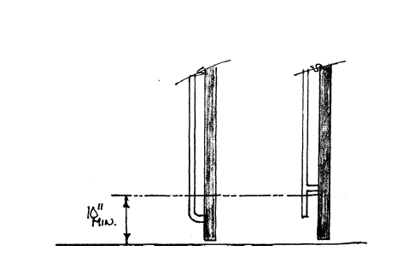
0000.doc

Committee Action

Approved

Committee Reason: The bottom 10 inches of a door, on its push side, is to be a smooth surface to prevent the toes and feet of persons pushing the door from being caught or restricted. The proposal clarifies that even door hardware should not be in this 10 inch range.

4-28– 12
404.2.9
Proposed Change as Submitted

Proponent: Joseph R. Hetzel, P.E., Thomas Associates, Inc, representing Door & Access Systems manufacturers Association (DASMA)

Revise as follows:

404.2.9 Door Surface. Door surfaces within 10 inches (255 mm) of the floor, measured vertically, shall be a smooth surface on the push side extending the full width of the door. Parts creating horizontal or vertical joints in such surface shall be within ¹/₁₆ inch (1.6 mm) of the same plane as the other. Cavities created by added kick plates shall be capped.

EXCEPTIONS:

- Sliding doors and upward acting doors shall not be required to comply with Section 404.2.9.
- Tempered glass doors without stiles and having a bottom rail or shoe with the top leading edge tapered at no less than 60 degrees from the horizontal shall not be required to comply with the 10-inch (255 mm) bottom rail height requirement.
- Doors that do not extend to within 10 inches (255 mm) of the floor shall not be required to comply with Section 404.2.9.

Reason: Currently, ICC/ANSI A117.1 does not address upward acting doors. Such doors have inherent design features similar to those of sliding doors such that an exception to 404.2.9 is also warranted.
0000.doc

Committee Action

Disapproved

Committee Reason: Consistent with the action on Proposal 4-26-12, upward acting doors (overhead doors) are not accessible because they move out of the reach ranges. They should not be part of an accessible route. There is no reason to exempt them from this door surface requirement.

4-29– 12
404.2.9
Proposed Change as Submitted

Proponent: Ed Roether, representing the ADA/A117 Harmonization Task Group

Revise as follows:

404.2.9 Door Surface. Door surfaces within 10 inches (255 mm) of the floor, measured vertically, shall be a smooth surface on the push side extending the full width of the door . Parts creating horizontal or vertical joints in such surface shall be within ¹/₁₆ inch (1.6 mm) of the same plane as the other. Cavities created by added kick plates shall be capped.

EXCEPTIONS:

(Exceptions 1 through 3 are not changed)

4. Existing doors and gates without smooth surfaces within 10 inches (255 mm) of the finish floor or ground shall not be required to provide smooth surfaces complying with 404.2.9 provided that if added kick plates are installed, cavities created by such kick plates are capped,

Reason: The ADA/A117 Harmonization Task Group (HTG) was created as a task group of the A117.1 Committee to compare the 2010 ADA with the 2009 A117.1 Standard. The HTG has recommend a series of changes through a set of change proposals. The HTG is recommending changes, for the most part, address where the ADA was viewed as more stringent than the A117. Where the A117 contained provisions not addressed in the ADA, these were not considered a conflict needing action to amend the A117. In addition there are a number of places where the ADA and A117.1 are different as a result of specific actions, by the A117.1 Committee during the development of the 2009 edition, to remain or create a difference where, in the judgment of the committee the ADA was deficient.

Reason for 404.2.9: Exception number 4 is new text in ADA not in the 2009 A117.1.
0000.doc

Committee Action

Approval as Modified

Modification Replace the original proposal with the following:

404.2.9 Door Surface. Door surfaces within 10 inches (255 mm) of the floor, measured vertically, shall be a smooth surface on the push side extending the full width of the door. Parts creating horizontal or vertical joints in such surface shall be within ¹/₁₆ inch (1.6 mm) of the same plane as the other. Cavities created by added kick plates shall be capped.

EXCEPTIONS:

(Exceptions 1 through 3 are not changed)

4. The installation of kick plates on existing doors and gates without a smooth surface within 10 inches (255 mm) of the floor shall be permitted. The kick plates shall extend to 10 inches (255 mm) above the floor and no more than 1 inch (26 mm) from the sides and bottom of the door. Cavities created by such kickplates shall be capped.

Committee Reason: The change provides consistency between the Standard and the ADA. The modification was to provide a more clear statement regarding when kickplates are installed on existing doors.

4-30– 12
404.3, 404.3.2, 4043.5

Proposed Change as Submitted

Proponent: Ed Roether, representing the ADA/A117 Harmonization Task Group

Revise as follows:

404.3 Automatic Doors and Power-Assisted Doors and Gates. Automatic doors and automatic gates shall comply with Section 404.3. Full powered automatic doors shall comply with ANSI/BHMA A156.10 listed in Section 105.2.4. Power–assist and low–energy doors shall comply with ANSI/BHMA A156.19 listed in Section 105.2.3.

EXCEPTION: Doors, doorways, and gates designed to be operated only by security personnel shall not be required to comply with Sections 404.3.2, 404.3.4, and 404.3.5.

404.3.2 Maneuvering Clearances. Maneuvering clearances at power–assisted doors shall comply with Section 404.2.3. Clearances at swinging automatic doors and gates without standby power and serving an accessible means of egress shall comply with Section 404.2.3.

EXCEPTION: Where automatic doors and gates remain open in the power-off condition, compliance with Section 404.2.3 shall not be required.

404.3.5 Controls Switches. Manually operated controls switches shall comply with Section 309. The clear floor space adjacent to the control switch shall be located beyond the arc of the door swing.

Reason: The ADA/A117 Harmonization Task Group (HTG) was created as a task group of the A117.1 Committee to compare the 2010 ADA with the 2009 A117.1 Standard. The HTG has recommend a series of changes through a set of change proposals. The HTG is recommending changes, for the most part, address where the ADA was viewed as more stringent than the A117. Where the A117 contained provisions not addressed in the ADA, these were not considered a conflict needing action to amend the A117. In addition there are a number of places where the ADA and A117.1 are different as a result of specific actions, by the A117.1 Committee during the development of the 2009 edition, to remain or create a difference where, in the judgment of the committee the ADA was deficient.

Reason: for 404.3.2: ADA specifies that automatic doors without standby power need to provide maneuvering clearances. Such is not currently in A117. In Section 404.3.5, the controls are not limited to switches.
0000.doc

Committee Action

Approved

Committee Reason: Approved to provide consistency with the ADA and to provide for controls which aren’t traditional ‘switches’.

4-31– 12
404.3, 404.3.2, 404.3.4, 404.3.5, 404.3.6 (NEW)

Proposed Change as Submitted

Proponent: Kim Paarlberg, International Code Council

Revise as follows:

404.3 Automatic Doors. Automatic doors and automatic gates shall comply with Section 404.3. Full powered automatic doors shall comply with ANSI/BHMA A156.10 listed in Section 105.2.4. Power-assist doors and low-energy automatic doors shall comply with ANSI/BHMA A1 56.19 listed in Section 105.2.3.

EXCEPTION: Doors, doorways, and gates designed to be operated only by security personnel shall not be required to comply with Sections 404.3.2, 404.3.4, and 404.3.5.

404.3.2 Maneuvering Clearances. Maneuvering clearances at power-assisted doors shall comply with Section 404.2.3. Maneuvering clearances shall be provided on the egress side of low-energy automatic doors and full power automatic doors that serve as part of the accessible means of egress.

EXCEPTIONS:

- Low-energy automatic doors and full power automatic doors that have standby power or battery back-up shall not be required to comply with this section.
- Low-energy automatic doors and full power automatic doors that remain open in the power-off condition shall not be required to comply with this section.
- Full power automatic sliding doors that include a break-away feature shall not be required to comply with this section.

404.3.4 Two Doors in Series. Doors in series shall comply with Section 404.2.5.

EXCEPTION: Where both doors are power assist doors, low energy automatic doors or full power automatic doors, two doors in a series shall not be required to provide a turning space between the doors.

404.3.5 Controls Switches. Manually operated controls switches shall comply with Section 309. The clear floor space adjacent to the control switch shall be located beyond the arc of the door swing.

404.3.6 Break Out Opening. Where full power automatic sliding doors and gates are equipped with a break out feature, the clear break out opening shall be 32 inches (815 mm) minimum when operated in emergency mode.

Reason: The quantity of change proposals submitted by International Code Council is reflective of three elements of our work: 1. ICC is the Secretariat for the Standard and some changes reflect inconsistencies or improvements suggested by staff; 2. ICC develops and publishes a Commentary on the standard and writing the commentary illuminates issues of the text and figures; and 3. ICC provides an interpretation service for the standard which results in the observation of provisions the users find most confusing.
The purpose for the change is to align the standard content with terminology common to the automatic door industry, its products, and the standards that govern them.
There is confusion in the requirements for doors addressed by BHMA A156.10 and A156.19. The following information was provided by Joe Hetzel representing the American Association of Automatic Door Manufacturers (AAADM).

* A low energy automatic door is different from a power assist door
* A power assist door is more like a manual door that employs power to assist the user in manually operating the door
* An automatic door can be either a full power door or a low energy door
* Full power doors are addressed in BHMA A156.10
* Low energy doors are addressed in BHMA A156.19
* Power assist doors are also addressed in BHMA A156.19, but they are separate from low energy

Definitions from A156.19:

Low Energy Power Operated Door: A door with (a) power mechanism(s) that opens and closes the door upon receipt of an actuating signal and does not generate more kinetic energy than specified in this Standard.
Power Assist Door: A door with a power mechanism that reduces the opening resistance of a self closing door.

The reasons for the changes are as follows:
- 404.3 – this clarifies what is an automatic door and what is power assist regardless of the referenced standard
- 404.3.2 – clarify that means of egress is only maneuvering clearance is only on one side; exceptions are for when there is there is power or options that swing free
- 404.3.4 – Automatic doors do not need the extra turning space that is required in A117.1.
- 404.3.5 – controls can be other than switches
- 404.3.6 – trying to address ADA 404.3.6 where break out options are actually used, but not sure this is not addressed already in 404.3.1.
0000.doc

Committee Action

Approved

Committee Reason: The Committee expressed concern that elements of this proposal were inappropriate to be located in the A117.1 Standard and perhaps should be located within the scoping document such as the International Building Code. It uses terms such as standby power and accessible means of egress that are defined in the IBC, not the Standard. The Committee voted to approve the change because it does coordinate better with industry terms. It enhances the information in the ADA, and therefore is not in conflict.

4-32– 12
404.3
Proposed Change as Submitted

Proponent: Joseph R. Hetzel, P.E., Thomas Associates Inc, Door & Access Systems Manufacturers Association (DASMA)

Revise as follows:

404.3 Automatic Doors. Automatic doors and automatic gates shall comply with Section 404.3. Full powered automatic doors, other than upward acting doors, shall comply with ANSI/BHMA A156.10 listed in Section 105.2.4. Power-assist and low-energy doors, other than upward acting doors, shall comply with ANSI/BHMA A156.19 listed in Section 105.2.3.

EXCEPTION: Doors, doorways, and gates designed to be operated only by security personnel shall not be required to comply with Sections 404.3.2, 404.3.4, and 404.3.5.

Reason: ANSI/BHMA A156 is not applicable to upward acting doors. The sentence on automatic doors and automatic gates is repetitive and unnecessary.
0000.doc

Committee Action

Disapproved

Committee Reason: Consistent with actions taken on other proposal addressing upward acting doors. As such doors can not be in an accessible route, there is no reason to address them in the Standard.

4-33– 12
404.3
Proposed Change as Submitted

Proponent: Joseph R. Hetzel, P.E., Thomas Associates, Inc., representing American Association of Automatic Door Manufacturers (AAADM)

Revise as follows:

404.3 Automatic Doors. Automatic doors and automatic gates shall comply with Section 404.3. Full powered automatic doors shall comply with ANSI/BHMA A156.10 listed in Section 105.2.4. Power-assist and low-energy doors shall comply with ANSI/BHMA A156.19 listed in Section 105.2.3.

Exception: Doors, doorways, and gates designed to be operated only by security personnel shall not be required to comply with Sections 404.3.2, 404.3.4 and 404.3.5.

A door that provides a barrier-free path of travel through a pedestrian entrance, and a door in a pedestrian entrance leading from a vestibule into the floor area, shall be a full power automatic door where the entrance serves a hotel, a government building, a building containing a care or detention occupancy, or a building more than 3225 square feet (300 m²) containing an assembly occupancy, a business occupancy or a mercantile occupancy.

EXCEPTIONS:

- These requirements shall not apply to an individual suite having an area of less than 3225 square feet (300 m²) where located within a building classified as an assembly occupancy, a business occupancy, or a mercantile occupancy, where such suite is completely separated from the remainder of the building.
- A non-active door leaf in a multiple leaf door in a barrier-free path of travel shall not be required to comply with these requirements.

Reason: The proposed language is based on code language currently in existence, and successfully used, in the province of Ontario, Canada. The occupancies cited as requiring automatic doors are associated with locations where a high degree of public use would be anticipated, and would maximize accessibility in these locations.
0000.doc

Committee Action

Disapproved

Committee Reason: While members of the Committee expressed support of the concept, the proposal was not appropriate for the Standard, but should be located in a scoping document such as the International Building Code. The term ‘barrier-free path of travel’ is not consistent with the Standard. ‘Government building’ is a form of ownership and not an occupancy category. The choice of 3,225 sq. ft. was not justified.

4-34– 12
404.3.4, 404.3.5, 404.3.6 (New)

Proposed Change as Submitted

Proponent: Kim Paarlberg, International Code Council

Revise as follows:

404.3.4 Two Doors in Series. Doors in series shall comply with Section 404.2.5.

EXCEPTION: Automatic doors in a series are not required to provide a turning space complying with Section 304.

404.3.5 Control Switches. Manually operated control switches shall comply with Section 309. The clear floor space adjacent to the control switch shall be located beyond the arc of the door swing. Where automatic doors are doors in a series, the clear floor space for the control switches shall be located outside the arc of both doors.

404.3.6 Door Hardware. Handles, pulls, latches, locks, and other operable parts on accessible doors shall have a shape that is easy to grasp with one hand and does not require tight grasping, pinching, or twisting of the wrist to operate. Operable parts of such hardware shall be 34 inches (865 mm) minimum and 48 inches (1220 mm) maximum above the floor. Where sliding doors are in the fully open position, operating hardware shall be exposed and usable from both sides.

EXCEPTION: Locks and control switches used only for security purposes and not used for normal operation are not required to comply with Section 404.3.6.

Reason: The quantity of change proposals submitted by International Code Council is reflective of three elements of our work: 1. ICC is the Secretariat for the Standard and some changes reflect inconsistencies or improvements suggested by staff; 2. ICC develops and publishes a Commentary on the standard and writing the commentary illuminates issues of the text and figures; and 3. ICC provides an interpretation service for the standard which results in the observation of provisions the users find most confusing.
There is not an entrapment issue in vestibules with automatic doors on both sides. Therefore the turning space in the vestibule is should not be required. This exception may be appropriate for both automatic and power assist door.
In a two doors in a series situation, if a 2nd button for the 2nd door is provided inside the vestibule, it should be outside the swing of the 1st door as well as the 2nd. If someone outside hits the button for the 1st door, you do not want it to swing open and hit the person trying to reach the 2nd button.
Power assisted doors should have the same hardware requirements as manual doors. Power doors have switched on top of the door that is used to turn the power operation and/or sensor on and off at the beginning and end of the business day. Therefore the exception is needed for automatic door.
0000.doc

Committee Action
Approval as Modified

Modification – Replace the original proposal with the following:

404.3.4 Two Doors in Series. Doors in series shall comply with Section 404.2.5.

EXCEPTION: Automatic doors in a series are not required to provide a turning space complying with Section 304.

404.3.5 Control Switches. Manually operated control switches shall comply with Section 309. The clear floor space adjacent to the control switch shall be located beyond the arc of the door swings.

404.3.6 Door Hardware. Handles, pulls, latches, locks, and other operable parts shall comply with Section 404.2.6,

Committee Reason: The proposal addressed issues which need to be clarified, however the Committee approved a version which does the clarification more simply and eliminates the repetition of requirements found elsewhere.

4-35– 12
404.3.5

Proposed Change as Submitted

Proponent: Gail Himes, City of Tacoma, Washington

Revise as follows:
404.3.5 Control Switches. Manually operated control switches shall comply with Section 309. The control switch shall be along the path of travel and within of 10 feet of the door. The clear floor space shall be located adjacent to and centered on the control switch and shall be located beyond the arc of the door swing.

Reason: There is currently no requirement to have manually operated control switches along the path of travel or within a reasonable distance from the door. According to the Manual for Uniform Traffic Control Devices, the average walking speed of an individual is 3.5 feet per second. Once the average individual operates the control switch, it will take them nearly 3 seconds to reach the door threshold. People with more severe disabilities can take much longer to reach the door. Door timing can be adjusted; however, many building owners/managers are reluctant to let doors stay open very long due to energy loss, insects, etc.

0000.doc

Committee Action

Disapproved

Committee Reason: The standard which applies to this type of door already addresses the placement of the controls. Placing this requirement in the A117.1 Standard could result in a conflict.

4-36– 12
404.3.6 (New)
Proposed Change as Submitted

Proponent: Joseph R. Hetzel, P.E., Thomas Associates, Inc., representing American Association of Automatic Door Manufacturers (AAADM)

Add new text as follows:

404.3.6 Multiple Exterior Doors At The Same Location. Where multiple exterior doors at the same location serve the same interior space, 1 of every 8 exterior door leafs shall be a full power automatic door, subject to the following

- The automatic door shall be closest to the accessible route.
- The automatic door shall be provided with back-up battery or generator for occupancies of 150 or more.

Reason: The proposal will provide true accessibility. Individuals needing accessibility normally seek an accessible route, and an automatic door is proposed to be the door closest to the accessible route. The proposed language is based on code language currently in existence, and successfully used, in the province of Ontario, Canada.
0000.doc

Committee Action

Disapproved

Committee Reason: While the Committee expressed support of the concept of requiring an automatic door, the proposal verges on being scoping and as such may be better placed in the International Building Code. The 150 occupant load implied by item 2 does not result in multiple doors, therefore it may not be a reasonable threshold for the requirement. The proposal needs to be better connected to the location of the accessible route.

4-37– 12
405.1

Proposed Change as Submitted

Proponent: Kim Paarlberg, International Code Council

Revise as follows:

405.1 General. Ramps along accessible routes shall comply with Section 405.

EXCEPTIONS:

- In assembly areas, aisle ramps adjacent to seating and not serving elements required to be on an accessible route shall not be required to comply with Section 405.
- Exterior sidewalks that are a minimum of 48 inches wide and slope with grade are not required to comply with Section 405.

Reason: The quantity of change proposals submitted by International Code Council is reflective of three elements of our work: 1. ICC is the Secretariat for the Standard and some changes reflect inconsistencies or improvements suggested by staff; 2. ICC develops and publishes a Commentary on the standard and writing the commentary illuminates issues of the text and figures; and 3. ICC provides an interpretation service for the standard which results in the observation of provisions the users find most confusing.
In hilly sites, sidewalks that move up with the grade may be sloped enough to be considered a ramp. However, to put curb protection and handrails on these sidewalks will block access to street parking and adjacent building entrances. This exception is consistent with Access Board’s proposal- Public Right-of-way.
0000.doc

Committee Action

Disapproved

Committee Reason: The Committee was unsure that this was consistent with the draft ADA standards on public rights of way. The proposal could result in the elimination of accessible routes to facilities.

4-38– 12
106.5, 405.5, 405.8

Proposed Change as Submitted

Proponent: Ed Roether, representing the ADA/A117 Harmonization Task Group

Revise as follows:

405.5 Clear Width. The clear width of a ramp run shall be 36 inches (915 mm) minimum. Handrails and handrail supports that are provided on the ramp run shall not project into the required clear width of the ramp run.

EXCEPTION: Within employee work areas, the required clear width of ramps that are a part of common use circulation paths shall be permitted to be decreased by work area equipment provided that the decrease is essential to the function of the work being performed.

405.8 Handrails. Ramp runs with a rise greater than 6 inches (150 mm) shall have handrails complying with 505.

EXCEPTION: Within employee work areas, handrails shall not be required where ramps that are part of common use circulation paths, and which are used for the movement of equipment, are designed to permit the installation of handrails complying with 505. Ramps not subject to the exception to 405.5 shall be designed to maintain a 36 inch (915 mm) minimum clear width when handrails are installed.

106.5 Defined terms

circulation path. An exterior or interior way of passage provided for pedestrian travel, including but not limited to, walks, hallways, courtyards, elevators, platform lifts, ramps, stairways, and landings.

common use. Interior or exterior circulation paths, rooms, spaces, or elements that are not for public use and are made available for the shared use of two or more people.

employee work area. All or any portion of a space used only by employees and used only for work. Corridors, toilet rooms, kitchenettes and break rooms are not employee work areas.

Reason: The ADA/A117 Harmonization Task Group (HTG) was created as a task group of the A117.1 Committee to compare the 2010 ADA with the 2009 A117.1 Standard. The HTG has recommend a series of changes through a set of change proposals. The HTG is recommending changes, for the most part, address where the ADA was viewed as more stringent than the A117. Where the A117 contained provisions not addressed in the ADA, these were not considered a conflict needing action to amend the A117. In addition there are a number of places where the ADA and A117.1 are different as a result of specific actions, by the A117.1 Committee during the development of the 2009 edition, to remain or create a difference where, in the judgment of the committee the ADA was deficient.
Reason for Sections 405.5 and 405.8. These are two exceptions added to the ADA to address issues in facilities where ramps are frequently used for movement of goods and equipment. Often this is accomplished by motorized means such as forklifts as well as non-motorized devices. In order to incorporate the definitions in the A117.1 and make sure they are limited in application to employee work areas, the 3 definitions are needed.
0000.doc

Committee Action

Approved

Committee Reason: To allow the same exceptions for employee work areas as allowed by the ADA.

4-39– 12
405.7.1
Proposed Change as Submitted

Proponent: Francine Wai, Executive Director, Disability & Communication Access Board

Revise as follows:

405.7.1 Slope. Landings shall have a slope not steeper than 1:48 and shall comply with Section 302. Changes in level are not permitted.

Reason: As originally written it can be argued that changes in level if compliant with section 302 would be allowed at ramp landings.
Adding the sentence would be consistent with the Department of Justice’s 2010 ADA Standards which states:
405.7.1 Slope. Landings shall comply with 302. Changes in level are not permitted.
EXCEPTION: Slopes not steeper than 1:48 shall be permitted.
0000.doc

Committee Action

Disapproved

Committee Reason: The issues of change of level have been consistently address by the acceptance of Proposal 3-5-12. This proposal is inconsistent with that action. The new sentence proposed is in conflict with the existing text that allows a slope – which can me a change in level.

4-40– 12
405.7.4
Proposed Change as Submitted

Proponent: Ed Roether, representing the ADA/A117 Harmonization Task Group

Revise as follows:

405.7.4 Change in Direction. Ramps that change direction between runs at ramp landings shall be sized to provide a turning space complying with Section 304.3 shall have a clear landing 60 inches (1525 mm) minimum by 60 inches (1525 mm) minimum.

Reason: The ADA/A117 Harmonization Task Group (HTG) was created as a task group of the A117.1 Committee to compare the 2010 ADA with the 2009 A117.1 Standard. The HTG has recommend a series of changes through a set of change proposals. The HTG is recommending changes, for the most part, address where the ADA was viewed as more stringent than the A117. Where the A117 contained provisions not addressed in the ADA, these were not considered a conflict needing action to amend the A117. In addition there are a number of places where the ADA and A117.1 are different as a result of specific actions, by the A117.1 Committee during the development of the 2009 edition, to remain or create a difference where, in the judgment of the committee the ADA was deficient.

Reason for 405.7.4: ADA specifies a 60 by 60 space at ramp landings where a change of direction occurs. A117.1 language would allow a T-turn not allowed by ADA.
0000.doc

Committee Action

Approved

Committee Reason: The change de-couples the landing from the concept of a turning space because of the allowance of a T-shaped turn. The intent of the standard has consistently been that these landings simply be an open 60 by 60 inches.

4-41– 12
Figure 405.9.2
Proposed Change as Submitted

Proponent: Ed Roether, representing the ADA/A117 Harmonization Task Group

Revise as follows:

Figure 405.9.2
Ramp Edge Protection
– revise graphic for bottom bars – harmonize graphics

Reason for Figure 405.9.2:
ADA and A117.1 figures show different sections but both illustrate the edge protection..

Reason: The ADA/A117 Harmonization Task Group (HTG) was created as a task group of the A117.1 Committee to compare the 2010 ADA with the 2009 A117.1 Standard. The HTG has recommend a series of changes through a set of change proposals. The HTG is recommending changes, for the most part, address where the ADA was viewed as more stringent than the A117. Where the A117 contained provisions not addressed in the ADA, these were not considered a conflict needing action to amend the A117. In addition there are a number of places where the ADA and A117.1 are different as a result of specific actions, by the A117.1 Committee during the development of the 2009 edition, to remain or create a difference where, in the judgment of the committee the ADA was deficient.
0000.doc

Committee Action

The Committee has determined this to be editorial and referred it to the Editorial Task Group.

4-42– 12
406, 406.1, 406.2, 406.3, 406.4, 406.5, 406.6, 406.7, 406.8, 406.9, 406.10, 406.11

Proposed Change as Submitted

Proponent: Kim Paarlberg, International Code Council

Revise as follows:

406 Curb Ramps

406.1 General. Curb ramps on accessible routes shall comply with Sections 406, 405.2, 405.3, and 405.10.

406.2 Counter Slope. Counter slopes of adjoining gutters and road surfaces immediately adjacent to the curb ramp shall not be steeper than 1:20. The adjacent surfaces at transitions at curb ramps to walks, gutters and streets shall be at the same level.

406.3 Sides of Curb Ramps. Where provided, curb ramp flares shall comply with Section 406.3.

406.3.1 Slope. Flares shall not be steeper than 1:10.

406.4 Width. Curb ramps shall be 36 inches (915 mm) minimum in width, exclusive of flared sides.

406.5 Floor Surface. Floor surfaces of curb ramps shall comply with Section 302.

406.7 Landings. Landings shall be provided at the tops of curb ramps. The clear length of the landing shall be 36 inches (915 mm) minimum. The clear width of the landing shall be at least as wide as the curb ramp, excluding flared sides, leading to the landing.

EXCEPTION: In alterations, where there is no landing at the top of curb ramps, curb ramp flares shall be provided and shall not be steeper than 1:12.

406.10 Diagonal Curb Ramps. Diagonal or corner- type curb ramps with returned curbs or other well- defined edges shall have the edges parallel to the direction of pedestrian flow. The bottoms of diagonal curb ramps shall have 48 inches (1220 mm) minimum clear space outside active traffic lanes of the roadway. Diagonal curb ramps provided at marked crossings shall provide the 48 inches (1220 mm) minimum clear space within the markings. Diagonal curb ramps with flared sides shall have a segment of curb 24 inches (610 mm) minimum in length on each side of the curb ramp and within the marked crossing.

406.11 Islands. Raised islands in crossings shall be a cut-through level with the street or have curb ramps at both sides. Each curb ramp shall have a level area 48 inches (1220 mm) minimum in length and 36 inches (915 mm) minimum in width at the top of the curb ramp in the part of the island intersected by the crossings. Each 48-inch (1220 mm) by 36-inch (915 mm) area shall be oriented so the 48-inch (1220 mm) length is in the direction of the running slope of the curb ramp it serves. The 48-inch (1220 mm) by 36-inch (915 mm) areas and the accessible route shall be permitted to overlap.

406 Curb Ramps and Blended Transitions

406.1 General. Curb ramps and blended transitions on accessible route shall comply with Section 406

406.2 Perpendicular Curb Ramps. Perpendicular curb ramps shall comply with Sections 406.2 and 406.5.

406.2.1 Turning Space. A turning space 48 inches (1220 mm) minimum by 48 inches (1220 mm) minimum shall be provided at the top of the curb ramp and shall be permitted to overlap other turning spaces and clear spaces. Where the turning space is constrained at the back-of-sidewalk, the turning space shall be 48 inches (1220 mm) minimum by 60 inches (1525 mm) minimum. The 60 inches (1525 mm) dimension shall be provided in the direction of the ramp run.

406.2.2 Running Slope. The running slope of the curb ramp shall cut through or shall be built up to the curb at right angles or shall meet the gutter grade break at right angles where the curb is curved. The running slope of the curb ramp shall be 5 percent minimum and 8.3 percent maximum but shall not require the ramp length to exceed 15 feet (4573 mm). The running slope of the turning space shall be 2 percent maximum.

406.3 Parallel Curb Ramps. Parallel curb ramps shall comply with Sections 406.3 and 406.5.

406.3.1 Turning Space. A turning space 48 inches (1220 mm) minimum by 48 inches (1220 mm) minimum shall be provided at the bottom of the curb ramp and shall be permitted to overlap other turning spaces and clear spaces. If the turning space is constrained on 2 or more sides, the turning space shall be 4 feet (1.2 m) minimum by 60 inches (1525 mm) . The 60 inches (1525 mm) dimension shall be provided in the direction of the pedestrian street crossing.

406.3.2 Running Slope. The running slope of the curb ramp shall be in-line with the direction of sidewalk travel. The running slope of the curb ramp shall be 5 percent minimum and 8.3 percent maximum but shall not require the ramp length to exceed 15 feet (4573 mm). minimum. The running slope of the turning space shall be 2 percent maximum.

406.4 Blended Transitions. Blended transitions shall comply with Sections 406.4 and 406.5.

406.4.1 Running Slope. The running slope of blended transitions shall be 5 percent maximum.

406.5 Common Requirements. Curb ramps and blended transitions shall comply with Section 406.5.

406.5.1 Width. The clear width of curb ramp runs (excluding any flared sides), blended transitions, and turning spaces shall be 48 inches (1220 mm) minimum.

406.5.2 Grade Breaks. Grade breaks at the top and bottom of curb ramp runs shall be perpendicular to the direction of the ramp run. Grade breaks shall not be permitted on the surface of ramp runs and turning spaces. Surface slopes that meet at grade breaks shall be flush.

406.5.3 Cross Slope. The cross slope of curb ramps, blended transitions, and turning spaces shall be 2 percent maximum. At pedestrian street crossings without yield or stop control and at midblock pedestrian street crossings, the cross slope shall be permitted to equal the street or highway grade.

406.5.4 Counter Slope. The counter slope of the gutter or street at the foot of curb ramp runs, blended transitions, and turning spaces shall be 5 percent maximum.

406.5.5 Clear Space. Beyond the bottom grade break, a clear space 48 inches (1220 mm) minimum by 48 inches (1220 mm) minimum shall be provided within the width of the pedestrian street crossing and wholly outside the parallel vehicle travel lane.

406.5.6 406.3.2 Marking. If curbs adjacent to the ramp flares are painted, the painted surface shall extend along the flared portion of the curb.

406.5.7 406.6 Location. Curb ramps and the flared sides of curb ramps shall be located so they do not project into vehicular traffic lanes, parking spaces, or parking access aisles. Curb ramps at marked crossings shall be wholly contained within the markings, excluding any flared sides.

406.5.9 406.8 Obstructions. Curb ramps shall be located or protected to prevent their obstruction by parked vehicles.

406.5.10 406.9 Handrails. Handrails shall not be required on curb ramps.

Reason: The quantity of change proposals submitted by International Code Council is reflective of three elements of our work: 1. ICC is the Secretariat for the Standard and some changes reflect inconsistencies or improvements suggested by staff; 2. ICC develops and publishes a Commentary on the standard and writing the commentary illuminates issues of the text and figures; and 3. ICC provides an interpretation service for the standard which results in the observation of provisions the users find most confusing.
This proposal is using the proposed regulations for curb cuts in Section R304 in the Access Board’s proposal: Public right-or-way. Items currently in A117.1 that still seemed relevant are proposed to be maintained. The issue of detectable warnings is addressed in a separate proposal.
0000.doc

Committee Action

Approved

Committee Reason: The proposal replaces existing curb cut/curb ramp standards with the updated provisions and terminology being developed in the Access Board’s Public right of way. These are used within a large development where street like features are developed within a larger property. See also Proposal 4-44-12.

4-43– 12
406.5

Proposed Change as Submitted

Proponent: Gina Hilberry, United Cerebral Palsy Association and the City of St. Louis, Office on the Disabled Advisory Council

Revise as follows:

406.5 Floor Surface. Floor surfaces of curb ramps shall comply with 302. Surfaces shall not be constructed of semi-permeable or porous asphalt or concrete paving materials.

Reason: In the current edition of the Public Right-of-Way Guidelines, Advisory R302.7.1 includes the following statement: "Pedestrian access route surfaces must be generally planar and smooth. Surfaces should be chosen for easy rollability. Surfaces that are heavily textured, rough, or chamfered and paving systems consisting of individual units that cannot be laid in plane will greatly increase rolling resistance and subject pedestrians who use wheelchairs, scooters and rolling walkers to the stressful and often painful effects of vibration. Such materials should be reserved for borders and decorative accents located outside of or only occasionally crossing the pedestrian access route. Surfaces should be designed, constructed, and maintained according to appropriate industry standards, specifications, and recommendations for best practice."
The City of St. Louis has experimented with semi-permeable and porous asphalt and concrete paving materials in a variety of locations. In addition, a series of videos were taken with a group of people with disabilities using several surfaces that were installed using specifications and methods beyond industry standards. Current standards as applied to porous and semi-permeable asphalt and concrete paving do not result in surfaces with easy rollability. This is particularly problematic when applied to curb ramps where rolling resistance and changes in level are particularly difficult for people using wheelchairs or rolling walkers. It should be noted, that people with visual impairments using long canes commented repeatedly that the rough porous surfaces also caught their cane tips and decreased their ability to move quickly and smoothly.
Semi-permeable rubber surfaces are specifically excluded from these comments. These surfaces tested out to be smooth, planar and very useable by all user experts.
0000.doc

Committee Action
Disapproved

Committee Reason: The Committee recognized the issue that such surfaces can result in the loss of accessibility if they are not maintained. The language was too broad for a complete prohibition of such materials.

4-44– 12
406.12, 406.13, 406.13.1, 406.13.2, 406.14, 705.6 (New), 705.7 (New), 805.10

Proposed Change as Submitted

Proponent: Kim Paarlberg, International Code Council

Revise as follows:

406.12 Detectable Warnings at Raised Marked Crossings. Marked crossings that are raised to the same level as the adjoining sidewalk shall be preceded by a detectable warning 24 inches (610 mm) in depth complying with Section 705. The detectable warning shall extend the full width of the marked crossing.

406.12 Where detectable warnings are required. Detectable warning surfaces complying with Section 705 shall be provided at the following locations on pedestrian access routes and at transit stops:

1. Curb ramps and blended transitions at pedestrian street crossings;
2. Pedestrian refuge islands;
3. Pedestrian at-grade rail crossings not located within a street or highway;
4. Boarding platforms at transit stops for buses and rail vehicles where the edges of the boarding platform are not protected by screens or guards; and
5. Boarding and alighting areas at sidewalk or street level transit stops for rail vehicles where the side of the boarding and alighting areas facing the rail vehicles is not protected by screens or guards.

Exception: Detectable warning surfaces are not required at pedestrian refuge islands that are cut-through at street level and are less than 6 feet (1829 mm) in length in the direction of pedestrian travel.

406.13 Detectable Warnings at Curb Ramps. Where detectable warnings are provided on curb ramps, they shall comply with Sections 406.13 and 705.

406.13.1 Area Covered. Detectable warnings shall be 24 inches (610 mm) minimum in depth in the direction of travel. The detectable warning shall extend the full width of the curb ramp or flush surface.

406.13.2 Location. The detectable warning shall be located so the edge nearest the curb line is 6 inches (150 mm) minimum and 8 inches (205 mm) maximum from the curb line.

406.14 Detectable Warnings at Islands or Cut-through Medians. Where detectable warnings are provided on curb ramps or at raised marked crossings leading to islands or cut-through medians, the island or cut-through median shall be provided with detectable warnings complying with Section 705, that are 24 inches (610 mm) in depth, and extend the full width of the pedestrian route or cut-through. Where such island or cut-through median is less than 48 inches (1220 mm) in depth, the entire width and depth of the pedestrian route or cut-through shall have detectable warnings.

705.6 Size. Detectable warning surfaces shall extend 24 inches (610 mm) minimum in the direction of pedestrian travel. At curb ramps and blended transitions, detectable warning surfaces shall extend the full width of the curb ramp run excluding any flared sides or blended transition. At pedestrian at-grade rail crossings not located within a street or highway, detectable warnings shall extend the full width of the crossing. At boarding platforms for buses and rail vehicles, detectable warning surfaces shall extend the full length of the public use areas of the platform. At boarding and alighting areas at sidewalk or street level transit stops for rail vehicles, detectable warning surfaces shall extend the full length of the transit stop.

705.7 Placement. The placement of detectable warning surfaces shall comply with Section 705.7.

705.7.1 Perpendicular Curb Ramps. On perpendicular curb ramps, detectable warning surfaces shall be placed as follows:

- Where the ends of the bottom grade break are in front of the back of curb, detectable warning surfaces shall be placed at the back of curb.

- Where the ends of the bottom grade break are behind the back of curb and the distance from either end of the bottom grade brake to the back of curb is 60 inches (1525 mm) or less, detectable warning surfaces shall be placed on the ramp run within one dome spacing of the bottom grade break.

- Where the ends of the bottom grade break are behind the back of curb and the distance from either end of the bottom grade brake to the back of curb is more than 60 inches (1525 mm), detectable warning surfaces shall be placed on the lower landing at the back of curb.

705.7.2 Parallel Curb Ramps. On parallel curb ramps, detectable warning surfaces shall be placed on the turning space at the flush transition between the street and sidewalk.

705.7.3 Blended Transitions. On blended transitions, detectable warning surfaces shall be placed at the back of curb. Where raised pedestrian street crossings, depressed corners, or other level pedestrian street crossings are provided, detectable warning surfaces shall be placed at the flush transition between the street and the sidewalk.

705.7.4 Pedestrian Refuge Islands. At cut-through pedestrian refuge islands, detectable warning surfaces shall be placed at the edges of the pedestrian island and shall be separated by a 24 inches (610 mm) minimum length of surface without detectable warnings.

705.7.5 Pedestrian At-Grade Rail Crossings. At pedestrian at-grade rail crossings not located within a street or highway, detectable warning surfaces shall be placed on each side of the rail crossing. The edge of the detectable warning surface nearest the rail crossing shall be 72 inches (1829) minimum and 15 feet (4679 mm) maximum from the centerline of the nearest rail. Where pedestrian gates are provided, detectable warning surfaces shall be placed on the side of the gates opposite the rail.

705.7.6 Boarding Platforms. At boarding platforms for buses and rail vehicles, detectable warning surfaces shall be placed at the boarding edge of the platform.

705.7.7 Boarding and Alighting Areas. At boarding and alighting areas at sidewalk or street level transit stops for rail vehicles, detectable warning surfaces shall be placed at the side of the boarding and alighting area facing the rail vehicles.

805.10 Track Crossings. Where a circulation path crosses tracks, it shall comply with Section 402 and shall have a detectable warning 24 inches (610 mm) in depth complying with Section 705 extending the full width of the circulation path. The detectable warning surface shall be located so that the edge nearest the rail crossing is 6 foot (1830 mm) minimum and 15 foot (4570 mm) maximum from the centerline of the nearest rail.

EXCEPTION: Openings for wheel flanges shall be permitted to be 2¹/₂ inches (64 mm) maximum.

Reason: The quantity of change proposals submitted by International Code Council is reflective of three elements of our work: 1. ICC is the Secretariat for the Standard and some changes reflect inconsistencies or improvements suggested by staff; 2. ICC develops and publishes a Commentary on the standard and writing the commentary illuminates issues of the text and figures; and 3. ICC provides an interpretation service for the standard which results in the observation of provisions the users find most confusing.
This language for where detectable warnings are required and how to size and locate them is consistent with R208.1 and R305 of the Access Board’s Proposal: Public Right-of-way. The location and size is not in 705 and more specifically addressed.
0000.doc

Committee Action

Approved

Committee Reason: The provisions were accepted to address street like development which was on private property such as large campus facilities such as universities, office complexes, government centers and large multiple building residential complexes.

4-45– 12
407.2.1.1, Figure 407.2.1.1

Proposed Change as Submitted

Proponent: Hale Zukas, representing World Institute on Disability

Revise as follows:

407.2.1.1 Height. Call buttons and keypads shall be located 42 inches (965 mm) above the floor within one of the reach ranges specified in Section 308, measured to the centerline of the highest operable part.

EXCEPTION: Existing call buttons and existing keypads shall be permitted to be located 54 inches (1370 mm) maximum above the floor, measured to the centerline of the highest operable part.

Delete Figure 407.2.1.1

Reason:

1, This proposal merely reinstates a standard which had been in effect for decades and with which almost all existing call buttons comply.
- By requiring call buttons to be at a single absolute height (rather than anywhere within one of the very wide reach ranges in Section 308), this proposal makes them easier to find for people with impaired or no vision.
- Dr. Steinfeld has stated that, given his group’s research findings, 42 inches is the optimum height for accommodating the needs both of standing adults and of wheeled mobility device users.
- Specifying 42 inches as the height for call buttons eliminates need for a figure.
0000.doc

Committee Action

Disapproved

Committee Reason: The proposal is a previous elevator industry standard which is not reflected in the current ASME Standard. The current text allows flexibility to place the buttons appropriate for each design. A single measurement is too restrictive.

4-46– 12
407.2.1.4.1 (New)

Proposed Change as Submitted

Proponent: Anthony Alarid, New Mexico Governor’s Commission on Disability (NMGCD)

Revise as follows:

407.2.1.4.1 Distance from Elevator Door. Call buttons shall be located a distance of 36 inches (915 mm) maximum from the elevator door opening.

Reason: The height of the call button is currently regulated in 407.2.1.1. The standards do not address the distance that a call button can be mounted from the elevator door opening. If the mounting distance is too far removed from the elevator door, it can present a problem for individuals who are blind, for the elderly who may move slowly, or for individuals who use mobility aids. The call button may not be located if the user is blind or has low vision, or the door can open and close before a caller with limited mobility is able to respond to the door that opens, not having sufficient time to safely enter the elevator before the door closes. See photos on Page 2 of “before” and “after” relocated call buttons where the relocation created access issues due to the increased distance of travel.

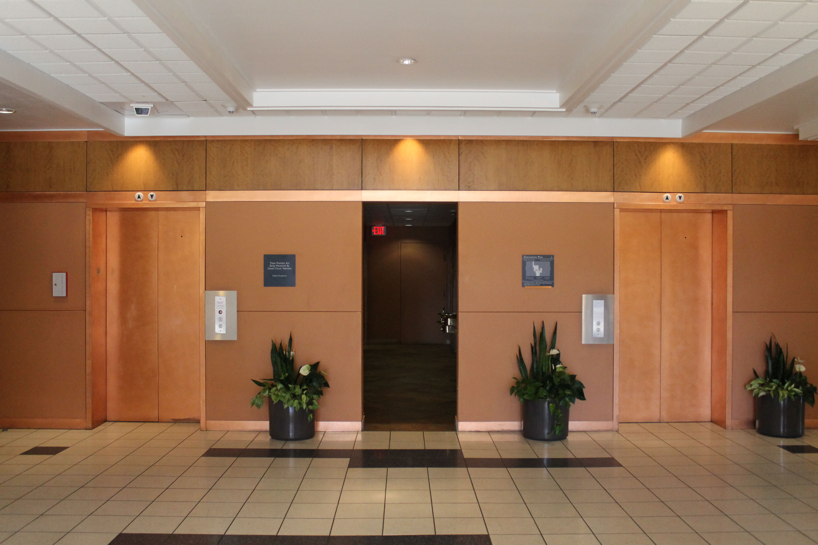
BEFORE
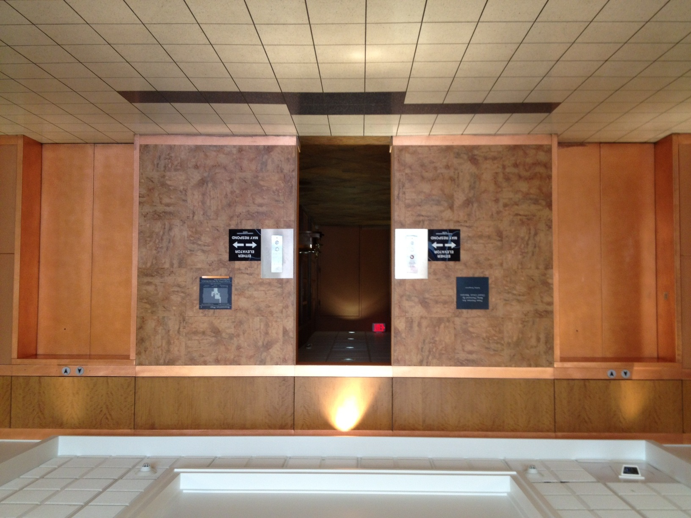

AFTER

0000.doc

Committee Action

Disapproved

Committee Reason: The proposal would be problematic for multiple elevator lobbies. There does need to be improved understanding between the location of the call buttons and the coordination between signals and door operations.

4-47– 12
407.2.1.6

Proposed Change as Submitted

Proponent: Brian Black, BDBlack & Associates, representing National Elevator Industry Inc.

Withdrawn: The proposal was withdrawn by the proponent. No further action is required.

4-48– 12
407.2.4

Proposed Change as Submitted

Proponent: Brian Black, BDBlack & Associates, representing National Elevator Industry Inc.

Delete with substitution as follows:

407.2.4 Destination Signs. Where signs indicate that elevators do not serve all landings, signs in raised characters and braille complying with Sections 703.3 and 703.4 shall be provided above the hall call button or keypad.

EXCEPTION: Destination oriented elevator systems shall not be required to comply with Section 407.2.4.

Reason: ASME A17.1/CSA B44 includes Nonmandatory Appendix E: Elevator Requirements for Persons with Physical Disabilities in Jurisdictions enforcing the National Building Code of Canada. In 2011 the Appendix E Subcommittee of the Canadian Standards Association (CSA) B44 Technical Committee undertook an effort to harmonize its document with ICC/ANSI A117.1-2009. This item was identified as a requirement that should be removed to a building code (e.g, the ICC International Building Code or National Building Code of Canada).
Compliance with Section 407 is under the control of the elevator contractor installing the elevator system. Accessible building directional signs are the responsibility of a subcontractor that is providing signs for the building. Adding this requirement to the accessible sign requirements of the building code will ensure that the proper contractor will be responsible for these signs.
0000.doc

Committee Action

Disapproved

Committee Reason: The Committee felt that the loss of these signs would be a loss of information which is helpful to the disability community.

4-49– 12
407.4.6.1

Proposed Change as Submitted

Proponent: Kim Paarlberg, International Code Council

Revise as follows:

407.4.6.1 Location. Controls shall be located within one of the reach ranges specified in Section 308.

EXCEPTIONS:

- Where the elevator panel complies with Section 407.4.8.
- In existing elevators, where a parallel approach is provided to the controls, car control buttons with floor designations shall be permitted to be located 54 inches (1370 mm) maximum above the floor. Where the panel is changed, it shall comply with Section 407.4.6.1 308.

Reason: The quantity of change proposals submitted by International Code Council is reflective of three elements of our work: 1. ICC is the Secretariat for the Standard and some changes reflect inconsistencies or improvements suggested by staff; 2. ICC develops and publishes a Commentary on the standard and writing the commentary illuminates issues of the text and figures; and 3. ICC provides an interpretation service for the standard which results in the observation of provisions the users find most confusing.
The current reference accomplishes nothing other than referring back to the base paragraph and therefore to Section 308. It seemingly will also create a circular reference because as you work through 407.4.6.1 you end up back at exception 2 and then get sent right back up to the beginning. Why not just reference 308 directly at this point?
This issue came up based upon a revision that was made in the exception to Section 308.3.1 in the 2009 code. The 2009’s revised exception says “existing elements that are not altered shall be permitted at 54 inches (1370 mm) above the floor.” It seems that with the “that are not altered” text being added in 2009 it will now allow a direct reference to Section 308 and it will still coordinate with the exception in 407.4.6.1 that says “where the panel is changed.”
0000.doc

Committee Action

Disapproved

Committee Reason: The proposal would appear to eliminate options for elevator numbering.

4-50– 12
407.4.6.2.2, 407.4.7.1.2 (New)

Proposed Change as Submitted

Proponent: Gene Boecker, Code Consultants, Inc.

Revise as follows:
407.4.6.2.2 Arrangement. Buttons shall be arranged with numbers in ascending order. Floors shall be designated . . . -4, -3, -2, -1, 0, 1, 2, 3, 4, etcetera, with floors below the main entry floor designated with minus numbers. Numbers shall be permitted to be omitted, provided the remaining numbers are in sequence. Where a telephone keypad arrangement is used, the number key (“#”) shall be utilized to enter the minus symbol (“-”). When two or more columns of buttons are provided they shall read from left to right.

407.4.7.1.2 Designation. Floors shall be designated . . . -4, -3, -2, -1, 0, 1, 2, 3, 4, etcetera, with floors below the main entry floor designated with minus numbers. Numbers shall be permitted to be omitted, provided the remaining numbers are in sequence. Where a telephone keypad arrangement is used, the number key (“#”) shall be utilized to enter the minus symbol (“-”). Ancillary letters shall be permitted to be used in conjunction with the numbers provided the letters are located to the right of the numbers and not more than two letters are used for each floor designation.

Reason: The intent is two-fold: first, to relocate the designation information to the section which requires car control designations; and second, to clarify the intent that numbers must be used but letters can accompany the numbers to assist in the designation.
Relocation. The current text is in the section of the standard which deals with the arrangement of the buttons on the car control panel. The text which addresses the numbers to be in ascending order is appropriate in here as is the text relating to left/right arrangement where there are columns. The rest of the information deals with the actual content of what is supposed to be designated. The proposal moves this text to a new section in the existing section titled “Designations. . . .” The title of the new section is “Designation” to make it clear that the intent is that the arrangement is addressed in the arrangement section and the designation on the car buttons is in the designation section of the standard.
Numbers/Letters. The text is copied from the prior location beginning with the phrase “Floors shall be. . .” and ending with “the minus symbol (“-“).” An additional sentence is added to indicate that letters may be used in conjunction with the numbers but that the primary designation is numeric while letters can be used to help identify levels based on local culture. For example, the negative floors are known as basements in some parts of the country but referred to as cellars in other parts. This would allow the “-1” level to be designated “-1B” (first basement) or “-1C” (first cellar) as well as the “-1” intended by the original text. Alternately, two letters could be used in a manner such as “-1LL” to indicate the Lower Level - common language for conference centers. However, the proposal is specific in that not more than two letters can be used. Otherwise, the size of the designation text and Braille grows and the subsequent length becomes too great to be able to quickly identify the desired floor.
The section is intended to be inserted near the beginning of the section so the subsection “Location” should be renumbered as will subsequent subsections.
0000.doc

Committee Action
Approved

Committee Reason: The proposal improves the clarity of the requirement.

4-51– 12
407.4.6.4, 407.4.6.4.1, 407.4.6.4.2

Proposed Change as Submitted

Proponent: Brian Black, BDBlack & Associates, representing National Elevator Industry Inc.

Withdrawn: The proposal was withdrawn by the proponent. No further action is required.

4-52– 12
407.4.7.2, 407.4.7.2.1 (New), 407.4.7.2.2 (New), 407.4.7.2.3 (New), 407.4.7.2.4 (New), 407.4.7.2.5 (New)

Proposed Change as Submitted

Proponent: Brian Black, BDBlack & Associates, representing National Elevator Industry Inc.

Withdrawn: The proposal was withdrawn by the proponent. No further action is required.

4-53– 12
407.4.9.1.1

Proposed Change as Submitted

Proponent: Brian Black, BDBlack & Associates, representing National Elevator Industry Inc.

Revise as follows:

407.4.9.1.1 Size. Characters shall be 1/2 5/8 inch (13 16 mm) minimum in height.

Reason: ASME A17.1/CSA B44 includes Nonmandatory Appendix E: Elevator Requirements for Persons with Physical Disabilities in Jurisdictions enforcing the National Building Code of Canada. In 2011 the Appendix E Subcommittee of the Canadian Standards Association (CSA) B44 Technical Committee undertook an effort to harmonize its document with ICC/ANSI A117.1-2009. This item was identified as a Canadian requirement that the US standard should adopt. Note that it provides greater accessibility than the existing text.
0000.doc

Committee Action

Approved

Committee Reason: Provides consistency between the American and Canadian standards.

4-54– 12
407.4.10

Proposed Change as Submitted

Proponent: Hansel Bauman, Architect, representing National Association of the Deaf

Revise as follows:

407.4.10 Emergency Communications. Visual and audible emergency two-way communication systems between the elevator car and a point outside the hoistway shall comply with Section 407.4.10 and ASME A17.1/CSA B44 listed in Section 105.2.5.

Reason: The addition of the term visual and audible is recommended to stress the need for emergency visual communication in elevators for deaf and hard of hearing individuals. In order to provide deaf and hard of hearing individuals with clear and immediate communication during emergency situations in elevators a text screen pad is recommended to be included in public elevators and at a location outside the hoistway.
0000.doc

Committee Action

Disapproved

Committee Reason: Were this change made to the Standard, the resulting changes to the communication systems is unclear. The original intent of the requirement was to simply provide notification.

4-55– 12
407.4.10.3 (New)

Proposed Change as Submitted

Proponent: Brian Black, BDBlack & Associates, representing National Elevator Industry Inc.

Add new text as follows:

407.4.10.3 Instructions. If instructions for use are provided, essential information shall be presented in both visual form and raised characters and braille complying with Sections 703.3 and 703.4.

Reason: ASME A17.1/CSA B44 includes Nonmandatory Appendix E: Elevator Requirements for Persons with Physical Disabilities in Jurisdictions enforcing the National Building Code of Canada. In 2011 the Appendix E Subcommittee of the Canadian Standards Association (CSA) B44 Technical Committee undertook an effort to harmonize its document with ICC/ANSI A117.1-2009. This item was identified as a Canadian requirement that should be added to the US standard.
This proposed change would ensure an equivalent level of accessibility for persons who are blind or visually impaired where visual instructions on the use of the emergency communications is provided.
0000.doc

Committee Action

Approval as Modified

Modification

407.4.10.3 Instructions. If Where instructions for use are provided, essential information they shall be presented in both visual form and raised characters and braille complying with Sections 703,2, 703.3 and 703.4.

Committee Reason: The change provides consistency between American and Canadian standards. The phrasing ‘essential information’ was not needed because such judgment assumes that some of the instructions are less important than others.

4-56– 12
408.4.1
Proposed Change as Submitted

Proponent: Kim Paarlberg, International Code Council

Revise as follows:

408.4.1 Inside Dimensions. Elevator cars shall provide a clear floor width of 42 inches (1065 mm) minimum. The clear floor area shall not be less than 15.75 square feet (1.46 m²). The elevator car shall provide a clear floor space complying with Section 305.3.

EXCEPTION: For installations in existing buildings, elevator cars that provide a clear floor area of 15 square feet (1.4 m²) minimum, and provide a clear inside dimension of 36 inches (915 mm) minimum in width and 54 inches (1370 mm) minimum in depth, shall be permitted. This exception shall not apply to cars with doors on adjacent sides.

Reason: This proposal is intended to ensure that the depth of the elevator car can accommodate the 48 inch depth requirement for a clear floor space. It will really have a fairly limited application but will close a loophole that exists when the elevator car is built to the minimum area requirements.
As it is currently written a 47.62 inch by 47.62 inch car would meet the currently imposed 42 inch minimum width and 15.75 sq. ft. size. However, it would not accommodate the 48 inch depth required for a clear floor space. Once the “width” goes over 47.25 inches, they would no longer get the 48 inch depth unless the car does exceed the 15.75 sq. ft. minimum area.
The possibility of a 47.62 by 47.62 inch elevator car would represent the worst case scenario for the minimum depth. This new text would address the situation where the width is between 47.25 and 47.62 inches and the car is exactly 15.75 square feet in area. If the car gets “wider” and is not “deep” enough, the door location provisions of Section 408.3.3 will kick in and move the door to the “narrow end” of the car.
Because this proposal does have a very limited range of application (minimum area elevator car with width between 47.25 and 47.62 inches) it may not be worth making this change; but approving it does close an apparent loophole which could allow the LULA elevator to have a depth which could not accommodate the generally required 48 inch clear floor space.
0000.doc

Committee Action

Disapproved

Committee Reason: The Committee preferred its action to approve as modified Proposal 4-57-12

4-57– 12
408.4.1

Proposed Change as Submitted

Proponent: Francine Wai, Executive Director, Disability & Communication Access Board

Revise as follows:

408.4.1 Inside Dimensions. Elevator cars shall provide a clear floor width of 42 inches (1065 mm) minimum and a clear depth 54 inches (1370 mm) minimum. The clear floor area shall not be less than 15.75 square feet (1.46 m2).

EXCEPTIONS:

- For installations in existing buildings, elevator cars that provide a clear floor area of 15 square feet (1.4 m2) minimum, and provide a clear inside dimension of 36 inches (915 mm) minimum in width and 54 inches (1370 mm) minimum in depth, shall be permitted. This exception shall not apply to cars with doors on adjacent sides.

- Cars that provide a clear width 51 inches (1295 mm) minimum shall be permitted to provide a clear depth 51 inches (1295 mm) minimum provided that car doors provide a clear opening 36 inches (915 mm) wide minimum.

Reason: The Department of Justice’s 2010 ADA Standards requires a minimum depth of 54 inches. As currently written it is possible to achieve a minimum clear floor area of 15.75 square feet with a depth that may be less than 54 inches if the width is greater than 42 inches, which would not be compliant with the 2010 ADA Standards.
In addition, the 2010 Standards allow an exception that existing cars are permitted to have a clear width of 51 inches minimum
and a clear depth of 51 inches minimum if the doors provide a minimum clear opening of 36 inches. For consistency with the
2010 ADA Standards, it is proposed that an additional exception mirroring the 2010 Standards be added.
The 2010 ADA Standards states:
408.4.1 Car Dimensions and Doors. Elevator cars shall provide a clear width 42 inches (1065 mm) minimum and a clear
depth 54 inches (1370 mm) minimum. Car doors shall be positioned at the narrow ends of cars and shall provide 32 inches
(815 mm) minimum clear width.
EXCEPTIONS:
1. Cars that provide a clear width 51 inches (1295 mm) minimum shall be permitted to provide a clear depth 51 inches
(1295 mm) minimum provided that car doors provide a clear opening 36 inches (915 mm) wide minimum.
2. Existing elevator cars shall be permitted to provide a clear width 36 inches (915 mm) minimum, clear depth 54 inches
(1370 mm) minimum, and a net clear platform area 15 square feet (1.4 m2) minimum.
0000.doc

Committee Action

Approval as Modified

Modification

408.4.1 Inside Dimensions. Elevator cars shall provide a clear floor width of 42 inches (1065 mm) minimum and a clear depth 54 inches (1370 mm) minimum. The clear floor area shall not be less than 15.75 square feet (1.46 m²).
(No change to the exception – no added exception)

Committee Reason: The changes to Sec. 408.4.1 provides consistency with the ADA 2010. The Committee felt that the second exception was not needed in the Standard.

4-58– 12
409.3.1

Proposed Change as Submitted

Proponent: : Francine Wai, Executive Director, Disability & Communication Access Board

Revise as follows:

409.3.1 Power Operation. Elevator car doors and gates shall be power operated and shall comply with ANSI/BHMA A156.19 listed in Section 105.2.3. Elevator cars with a single opening shall have low energy power operated hoistway doors and gates.

EXCEPTION: Hoistway doors or gates shall be permitted to be of the self-closing, manual type, where that door or gate provides access to a narrow end of the car that serves only one landing. more than one opening is provided in the elevator car.

Reason: The 2010 ADA Standards only allow hoistway doors or gates to be self-closing, manual type where more than one opening is provided. As currently written, there may be only one opening that is a self-closing manual type, which would make the elevator
non-compliant with the 2010 ADA Standards.
Most new construction and alterations must comply with the Department of Justice’s 2010 ADA Standards or the Department of
Transportation’s ADA Standards. To ensure elevators comply with both Standards, it is recommended that the exception mirror
the 2004 ADAAG that was adopted by both enforcing agencies. The 2004 ADAAG states:
409.3.1 Power Operation.
EXCEPTION: In elevator cars with more than one opening, hoistway doors and gates shall be permitted to be of the manual open,
self-close type.
0000.doc

Committee Action

Disapproved

Committee Reason: This proposal would return the Standard to historic language which provided less accessibility than the current Standard. Manual gates are not practical in an accessibility situation.

