June 30, 2005

From: Thomas B. Zuzik Jr.
VP of Sales & Design
Artistic Railings, Inc.
500 River Drive
Garfield, NJ 07026

973-772-8540
973-772-4395 fax
tbz@artisticrail.com
www.artisticrail.com

TO: ICC Code Technology Committee (CTC)
C/O Mr. Mike Pfeiffer, P.E.
Committee Secretary
Vice President, Codes & Standards Development
Chicago District Office
708-799-2300 ext:4338
708-799-0320 fax
e-mail:mpfeiffer@iccsafe.org

The International Code Council has come a long way since the Big Three put forth the concept of a uniform, standard set of codes for the towns, cities, counties and states throughout the United States – as well as a model for the world. The goal being to reduce structural failures resulting in injury to the general public.

Over the past 50 years, my family has designed, fabricated and installed a product that has seen many transformations through the years, but has always had one function – to minimize the possibility of a fall from the walking surface to the lower level.

This definition is taken from the ICC definition of GUARD -- a building component or a system of building components located near the open sides of elevated walking surfaces that minimizes the possibility of a fall from the walking surface to the lower level.

Guards would not be necessary if we instead replace them with walls. It would logically follow that if we remove guards from existence we can make sure no one will ever fall off the edge, right?

Well, let’s look at this some more.

The IRC Code’s Appendix “G” (page 545 of my IRC 2000 loose leaf code book), AG105 Barrier Requirements states that the minimum height for a pool barrier is 48 inches and there must be at least 45 inches between the horizontals.

Appendix G also states under AG102 definitions: Barrier. A fence, wall, building wall or combination thereof which completely surrounds the swimming pool and obstructs access to the swimming pool.

It is safe to say that the goal is to prevent intentional acts by young children who may be tempted to go swimming without proper supervision.

Let’s compare this to the requirements for a guard – a building component or a system of building components located near the open sides of elevated walking surfaces that minimizes the possibility of a fall from the walking surface to the lower level.

When these areas of the building codes were developed, they had two distinct goals with two totally different justifications. No guard – no matter how well you design it or build it – will prevent the intentional act of climbing. The main proponent of the term ladder effect has proven in his own published articles that anything is climbable.

It is critical that we look at the building codes as minimum standards – a point where the majority of the public will be protected from accidentally harming themselves. The key word being: accidentally.

It helps to review the DATA or more simply look at the findings in the CTC library. Childhood injuries due to falls from apartment balconies and windows
G R Istre¹, M A McCoy², M Stowe², K Davies⁴, D Zane³, R J Anderson⁵ and R Wiebe⁶
¹ Injury Prevention Center of Greater Dallas and PID Associates, Dallas, Texas
² Injury Prevention Center of Greater Dallas
³ Texas Department of Health
⁴ Children’s Medical Center of Dallas
⁵ Parkland Health and Hospitals System and University of Texas Southwestern Medical Center, Dallas
⁶ Children’s Medical Center of Dallas and University of Texas Southwestern Medical Center, Dallas

This report points out the real threat to small children is when guards are fabricated with large openings between the balusters. The 4” sphere spacing standard has shown great success such that instances of falls from balconies, it is most commonly a result of a rail that does not meet present codes regarding opening limitations.

Some may wish you to believe that the elimination of horizontals and what would be interpreted as climbable guards will result in safer guards. However this is a false assumption since you will no longer have guards, you will have barriers.

There simply is no epidemic of children climbing guards as ladder effect proponents will lead you to believe. If these injuries were occurring, we – as installers of guards – would certainly be aware of the events since the litigation costs would have put ornamental railing manufacturers out of business years ago.

Let the standards remain as they are. They serve the ICC purpose of providing minimum standards. Should an individual choose to go beyond that standard and build an impossible to climb barrier – let that be an individual choice.

I will be attending all the CTC meetings and will have research documents and guard samples for the committee to review. You will be able to see that any guard is climbable no matter if it is a flat solid wall or horizontal cables. In fact, as shown by the photos here, even a solid wall or barrier height fence is not a guarantee of safety.

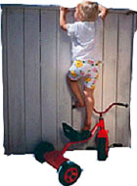 | 

The pictures below are examples of railings that would no longer be permitted should the ladder effect wording be returned to the building code.

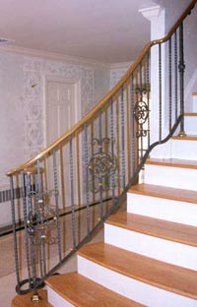 | 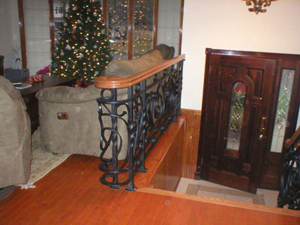
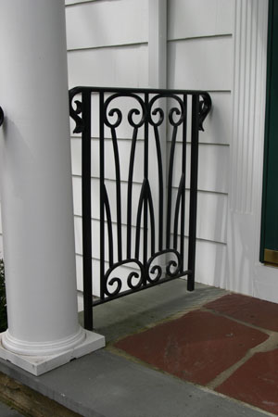 | 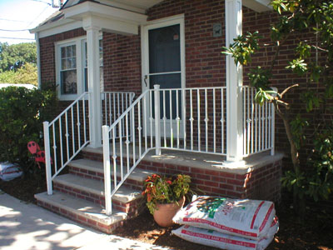
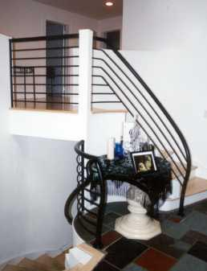 | 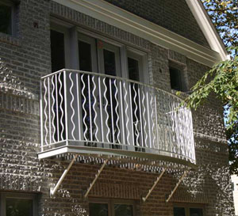
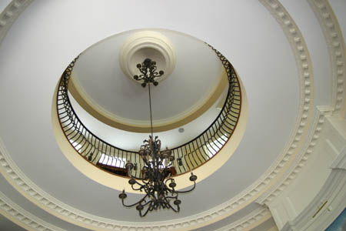 | 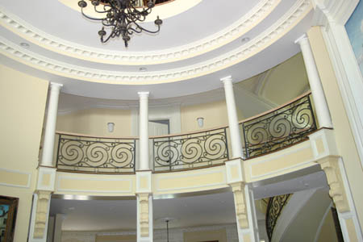

I wish to thank you for your time and look forward to discussing this issue further with you in July in Chicago.

Respectfully yours,

Thomas B Zuzik Jr.
VP Sales & Design
Artistic Railings Inc.

