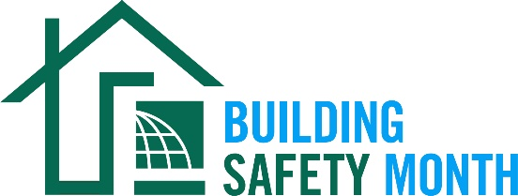
Sample Letter to the Editor
Dear Friend: To help promote Building Safety Month and the important role you play in your community, the International Code Council is providing this draft letter to the editor to promote your company through local newspapers. Fill in the appropriate information and send it in early April to your newspaper’s editorial page editor. Be sure to list any special events you will be holding in conjunction with Building Safety Month.
Dear Editor:
The world will celebrate Building Safety Month during May 2022 for the 42nd year. Building codes save lives by incorporating the latest technology and providing the safest, most resilient structures for our families and communities. The International Codes, developed by the Code Council and adopted by our community, are the most widely used and adopted set of building safety codes in the world.
(Insert a quote from a jurisdiction official about what Building Safety Month means to you, your participation in Building Safety Month, or the importance of building codes.)
First observed in 1980, Building Safety Month raises awareness of critical safety issues from structural to fire prevention, plumbing and mechanical systems, and energy efficiency. Each week of Building Safety Month spotlights a specific area of building safety, including Planning for a Safe and Sustainable Tomorrow, May 1–8; Exploring Careers in Building Safety May 9-15; Understanding Disaster Mitigation, May 16-22; and Creating a Safe and Abundant Water Supply, May 23-31.
The (name of jurisdiction/department/company), a member of the Code Council, is a Building Safety Month supporter and participant. (Insert a reference to recently adopted codes, Building Safety Month plans, or other examples that illustrate the value of building safety in your community.)
Among the hardworking members of the International Code Council who created Building Safety Month are code officials, plan reviewers, fire inspectors, architects, builders, engineers, design professionals, contractors and others in the construction industry, including employees of the (name of jurisdiction/department/company) who work to ensure the safety of the buildings where we live, work and play. These professionals provide the first line of defense against building disasters; working vigilantly to ensure the safety of our communities.
(Insert brief summaries of your department/company accomplishments. If you work for a building department, remind the community how it obtains permits and for what projects they are required.)
Local activities during Building Safety Month include (insert any activities you have planned including date, time and location). Educational materials are available for schools and the community at large including brochures about flood cleanup, mold prevention, pool and spa safety, green building and preparing for natural disasters. Everyone is encouraged to participate and learn about the essential safety work of the (name of jurisdiction/department/company).
Your Name
Your Title
Your Office Phone Number

