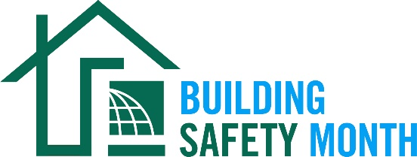
Sample Letter to the Editor

To help promote Building Safety Month and the important role you play in your community, the International Code Council is providing this draft letter to the editor to feature your company in local newspapers. Fill in the appropriate information and send it in early April to your newspaper’s editorial page editor. Be sure to list any special events you will be holding in conjunction with Building Safety Month.
Dear Editor:
The 43rd annual Building Safety Month will be celebrated internationally during the month of May to raise awareness about building safety. This celebration reinforces the need for the adoption of modern, regularly updated building codes, and helps individuals, families and businesses understand what it takes to create safe and sustainable structures. Everyone is encouraged to participate in the celebration and learn about the essential work of the (name of jurisdiction/department/company).

The 2023 Building Safety Month theme is “It Starts with You!”

Building Safety Month uses weekly themes to highlight how building safety issues impact each of us on a personal, local, and global level.

- Week One: Building Safety Starts at Home, May 1–7
- Week Two: Building Safety Professionals and You, May 8-14
- Week Three: Prepare Your Community, May 15-21
- Week Four: Advocate for Your Community, May 22-28
- Week Five: Solving Challenges Together, May 29-31

The (name of jurisdiction/department/company), a member of the International Code Council, is a Building Safety Month supporter and participant. (Insert a reference to recently adopted codes, Building Safety Month plans, or other examples that illustrate the value of building safety in your community.)

(Insert a quote from a jurisdiction official about what Building Safety Month means to you, your participation in Building Safety Month, or the importance of building codes.)

Local activities during Building Safety Month include (insert any activities you have planned including date, time and location). Educational materials are available for schools and the community at large including brochures and lesson plans.

Among the hardworking members of the Code Council who created Building Safety Month are code officials, plan reviewers, fire inspectors, architects, builders, engineers, design professionals, contractors and others in the construction industry, including employees of the (name of jurisdiction/department/company) who work to ensure the safety of the buildings where we live, work and play. These professionals provide the first line of defense against building disasters; working vigilantly to ensure the safety of our communities.

(Insert brief summaries of your department/company accomplishments. If you work for a building department, remind the community how it obtains permits and for what projects they are required.)

Your Name
Your Title
Your Office Phone Number

