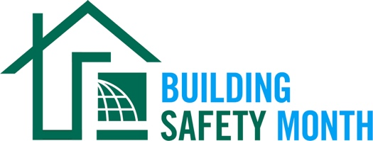

Sample Press Release
This news release template will help promote your community’s involvement with Building Safety Month. Fill in the appropriate information. Be sure to include any special events being held in conjunction with Building Safety Month and, if available to you, seek assistance from your municipality’s or company’s Public Information Officer. Distribute the release in April or early May to your local media. You can also post it on your website and social media channels.

For Immediate Release | Contact: Name Here
Month Day, 2023 | Contact Phone Number
Website URL | Contact Email

(Municipality/Company name) joins International Code Council for the celebration of Building Safety Month 2023
(Insert subtitle about your local event/activities – ex. City XYZ is hosting an in-person event for kids on May XX to promote building safety)

CITY, STATE – Throughout the month of May, (Name of municipality/department/company) will participate in the 43rd annual Building Safety Month, a worldwide campaign presented by the International Code Council, its members and partners to promote building safety. This year’s campaign, “It Starts with YOU”, raises awareness about the role we all play in ensuring safety in the spaces in which we live, work and learn. The campaign also makes the connection between building codes and our personal safety, as well as the important work done by building safety professionals in our communities.

This year’s campaign addresses how building safety impacts everyone on a personal, local, and global level.

- Week One: Building Safety Starts at Home, May 1–7, highlights how building safety impacts our everyday life as family members, friends and individuals at home.
- Week Two: Building Safety Professionals and You, May 8-14, shares a glimpse into the world of building safety professionals by outlining different roles and their responsibilities.
- Week Three: Prepare Your Community, May 15-21, focuses on how to protect not just your home, but your community at large, from disaster.
- Week Four: Advocate for Your Community, May 22-28, provides the tips and tools needed to advocate for building safety in your community.
- Week Five: Solving Challenges Together, May 29-31, elevates Building Safety Month to a global scale by addressing how we can work together internationally to tackle the world's most important issues.

Local events to celebrate Building Safety Month include (list any activities you have planned, including date, time and location).

(Insert a quote from your local, city or state leader about the significance of Building Safety Month, your municipality’s participation in Building Safety Month, or the importance of building codes.)

Learn more about Building Safety Month at www.buildingsafetymonth.org or join the conversation on social media using #BuildingSafety365.

###

About (Insert Municipality Name)
(Insert boilerplate language about your municipality)

