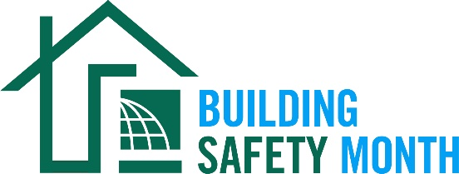
Sample Letter to the Editor

To help promote Building Safety Month and the important role you play in your community, the International Code Council is providing this draft letter to the editor to feature your company/organization in local newspapers. Fill in the appropriate information and send it in early April to your newspaper’s editorial page editor. Be sure to list any special events you will be holding in conjunction with Building Safety Month.
Dear Editor:
The 45th annual Building Safety Month will be celebrated internationally during the month of May to raise awareness about building safety. This celebration reinforces the need for the adoption of modern, regularly updated building codes, and helps individuals, families and businesses understand what it takes to create safe and sustainable structures. Everyone is encouraged to participate in the celebration and learn about the essential work of the (name of jurisdiction/department/company).

The 2025 Building Safety Month theme is “Game On!”

Building Safety Month uses weekly themes to highlight how everyone can get in the game and take part in learning about and practicing building safety.

- Week One: The Warm Up, May 1-3
- Week Two: Build Your Offense, May 4-10
- Week Three: Build Your Defense, May 11-17
- Week Four: The Starting Lineup, May 18-24
- Week Five: Going Into Overtime, May 25-31

The (name of jurisdiction/department/company) is a proud Building Safety Month supporter and participant. (Insert a reference to recently adopted International Codes®, Building Safety Month plans or other examples that illustrate the value of building safety in your community.)

(Insert a quote from a jurisdiction official about what Building Safety Month means to you, your participation in Building Safety Month or the importance of building codes.)

Local activities during Building Safety Month include (insert any activities you have planned including date, time and location). Educational materials are available for schools and the community at large including brochures and lesson plans on the Code Council’s dedicated webpage.

Among the hardworking members of the Code Council who created Building Safety Month are code officials, plan reviewers, fire inspectors, architects, builders, engineers, design professionals, contractors and others in the construction industry, including employees of the (name of jurisdiction/department/company) who work to ensure the safety of the buildings where we live, work and play. These professionals provide the first line of defense against building disasters; working vigilantly to ensure the safety of our communities.

(Insert brief summaries of your department/company accomplishments. If you work for a building department, remind the community how it obtains permits and for what projects they are required.)

Your Name
Your Title
Your Office Phone Number

