Annual Conference email template #2

Below is an email template to share with your chapter that highlights the benefits of attending

Suggested subject line: Top 3 Reasons to attend the ICC Annual Conference in Long Beach

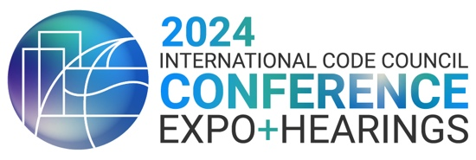
October 20–31 | Long Beach Convention Center


Hosted by
Top 3 Reasons to attend the 2024 International Code Council Annual Conference, Expo and Hearings
October 20–31 at the Long Beach Convention Center

#1 Learn more
A variety of educational opportunities offer you the chance to earn more CEU opportunities than ever—up to 41.5 hours or 4.15 CEUs!
- 10 education tracks
- Building tours
- Insight sessions
- Panels of industry experts
- Annual Business Meeting
- In-person participation or attendance at the code hearings
- Day of Service volunteer outing

#2 Network more
Make connections that can last a lifetime and help your career, brainstorm with colleagues, and participate in key events!

#3 Attend the Committee Action Hearings (Group A #2)
Participate in the code hearings and make an impact on the International Codes and your profession! This year’s code hearings offer building safety professionals the opportunity to provide input on proposed code changes to the Group A I-Codes. The code development process for the 2027 I-Codes introduces a restructured process starting in 2024.

Join the fun in Long Beach while you strengthen your skills and advance your career!
To register or view the full agenda, visit www.iccsafe.org/welcome.

