ICC A117.1 STANDARD

FOURTH PUBLIC REVIEW DRAFT

SUPPLEMENT

August 25, 2016

ICC/ANSI A117.1 STANDARD
DEVELOPMENT - 2015 EDITION

A117.1 Standard Committee

2012 Cycle Changes to review for

2015 Edition of the A117.1 Standard
Copyright ©2016 International Code Council, Inc.

ICC A117.1 Standard – Accessible and Usable Buildings and Facilities
Fourth Public Review Draft - Supplement

This document is an informational companion to the Fourth Public Review Draft of the 2015 edition of the ICC A117.1 Standard. The intent of the Supplement is to show the approved changes in context with the balance of the standard. The Fourth Public Review Draft – Supplement is an unofficial merging of the approved changes into the Standard as reflected in the First through Fourth Public Review Drafts. Where there are multiple changes to one section, they are shown merged as would eventually occur in the final standard when published.

Font color:
- Text shown in the blue font reflects changes approved by the A117.1 Committee that were included in the First, Second and Third Public Review Drafts. Where text is completely removed versus revised, such text is shown crossed out. Otherwise the text is shown without underlines or crossouts.

- Text shown in green font reflects changes approved by the Committee and are the changes of the Fourth Public Review Draft. These changes are shown in a legislative format. (Text being removed is crossed out; text being added is underlined.) Public Comments can be submitted on the Fourth Public Review Draft – see that document.

- Text shown in red font reflects editorial revisions.

Figures: This is a working document provided for information purposes. For the first time we have included many ‘working’ figures being developed for the 2015 edition. Such figures are not technically part of the standard, but interpretation of the text of the standard. They are essentially editorial. If you wish to make suggestions on these working figures; or suggest other locations where you feel a figure would be helpful, please send an email direction to Kermit Robinson @ krobinson@iccsafe.org.

For further information please see the following documents. The documents are found the A117.1 Standard page of the ICC website. http://www.iccsafe.org/icc-asc-a117/

- Fourth Public Review Draft
- Fourth Public Review Draft- Background report
- Third Public Review Draft – Background Report
- Second Public Review Draft – Background Report
- First Public Review Draft - Background Report.

Proposal Numbers: Each change is based on one of the original set of proposals considered by the committee in 2012. The proposal number, for example (9-7-12), is placed after the text created by the proposal. Public comments on those original changes will be followed by PC designation, for example (9-7-12 PC2) or (9-7.12 PC2.1). To find information in the related background reports, use the proposal number and public comment numbers to find the relevant information.

Providing Public Comment.

Comments on the Fourth Public Review draft will be accepted through Tuesday, October 11, 2016. Comments on the review draft must be provided on the ICC Standards Public Comment Form. The form can be found at the ICC website as follows: http://www.iccsafe.org/standards-public-forms/

Comments will only be accepted on the changes shown in the Fourth Public Review Draft. Public comments on this Supplemental document are limited to the working figures. Comments on the figures do not need to be on the form, just send an email to address below. For further information regarding submitting comments, please see the Fourth Public Review Draft document.

If you have questions, please direct them to Kermit Robinson, krobinson@iccsafe.org

Closing Date for Public Comments on the Third Public Review Draft: Tuesday, October 11, 2016

ICC/ANSI A117.1-2015 Chapter 1. Application and Administration

Chapter 1. Application and Administration

101 Title

This document shall be known as Accessible and Usable Buildings and Facilities, hereinafter referred to as ‘this standard’. (1-1-12)

102 Purpose

The technical criteria in Chapters 3 through 10, Sections 1102, 1103 and 1106 of this standard make sites, facilities, buildings and elements accessible to and usable by people with such physical disabilities as the inability to walk, difficulty walking, reliance on walking aids, blindness and visual impairment, deafness and hearing impairment, incoordination, reaching and manipulation disabilities, lack of stamina, difficulty interpreting and reacting to sensory information, and extremes of physical size. The intent of these sections is to allow a person with a physical disability to independently get to, enter, and use a site, facility, building, or element.

Section 1104 of this standard provides criteria for Type B units. These criteria are intended to be consistent with the intent of the criteria of the U.S. Department of Housing and Urban Development (HUD) Fair Housing Accessibility Guidelines. The Type B units are intended to supplement, not replace, Accessible units or Type A units as specified in this standard.

Section 1105 of this standard provides criteria for minimal accessibility features for one and two family dwelling units and townhouses which are not covered by the U.S. Department of Housing and Urban Development (HUD) Fair Housing Accessibility Guidelines.

This standard is intended for adoption by government agencies and by organizations setting model codes to achieve uniformity in the technical design criteria in building codes and other regulations.

102.1 Applicability. Sites, facilities, buildings, and elements required to be accessible by the scoping provisions adopted by the administrative authority shall comply with the applicable provisions of Chapters 3 through 10. Dwelling units and sleeping units shall comply with the applicable provisions of Chapter 11. (ed.)

103 Human Factor Provisions

The technical criteria in this standard are based on body sizes and functional abilities of adults and, in those sections where specifically noted, children (1-4-12) (1-4-12 PC1)

104 Compliance Alternatives

Nothing in this standard is intended to prevent the use of designs, products, or technologies as alternatives to those prescribed by this standard, provided they result in equivalent or greater accessibility and such equivalency is approved by the administrative authority adopting this standard. (ed.)

105 Conventions

105.1 General. Where specific criteria of this standard differ from the general criteria of this standard, the specific criteria shall apply.

105.2 Calculation of Percentages. Where the determination of the required size or dimension of an element or facility involves ratios or percentages, rounding down for values less than one half shall be permitted. (1-7-12)

105.3 Dimension tolerances. All dimensions are subject to conventional industry tolerances except where the requirement is a range with stated minimum and maximum end points. (1-5-12)

105.4 Figures. Unless specifically stated, figures included herein are provided for informational purposes only and are not considered part of this standard.

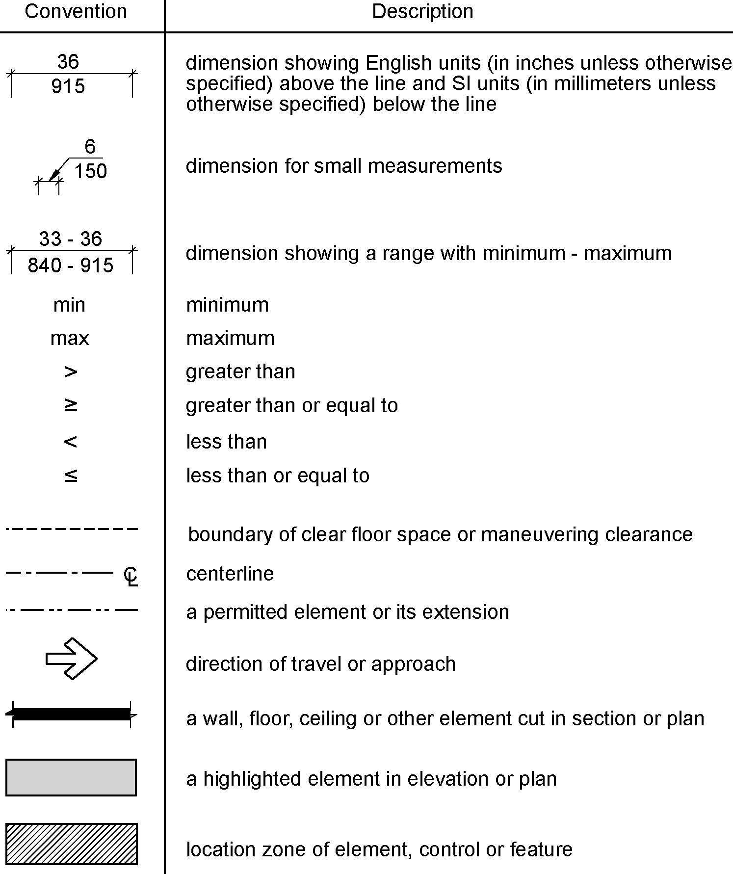
Figure 105.4 – Graphic convention for figures

105.5 Floor or Floor Surface. The terms floor or floor surface refer to the finish floor surface or ground surface, as applicable.

105.6 Referenced Sections. Unless specifically stated otherwise, a reference to another section or subsection within this standard includes all subsections of the referenced section or subsection.

106 Referenced Documents

106.1 General. The documents listed in Section 106.2 shall be considered part of this standard to the prescribed extent of each such reference. Where criteria in this standard differ from those of these referenced documents, the criteria of this standard shall apply.

106.2 Documents.
Staff note: When the standard is published – these referenced documents will be placed in alphabetical order with section numbers accordingly.

106.2.1 Americans with Disabilities Act (ADA) Accessibility Guidelines for Transportation Vehicles 36 CFR 1192 published in 56 Federal Register 45558, September 6, 1991 (United States Access Board, 1331 F Street, NW, Suite 1000, Washington, DC 20004-1111)

106.2.2 Hearing aids – Magnetic field strength in audio-frequency induction loops for hearing aids operating with an induction pickup coil IEC 60118.4-2007 (International Electrotechnical Commission, 3 rue de Varenbe, PO Box 131, 1211 Geneva 20, Switzerland.) (7-19-12)

106.2.3 Light reflectance value (LRV) of a surface. Method of Test. BS 8493:2008 + A1: 2010 (British Standards Institution, 389 Chiswick High Road, London W4 4AL, United Kingdom). (7-1-12 -PC3. 7-1-12/3.1/ PC3.3)

106.2.4 Manual on Uniform Traffic Control Devices: MUTCD-2009 (The Federal Highway Administration, Office of Transportation Operations, Room 3408, 400 7th Street, S.W., Washington, DC 20590). (1-8-12)

106.2.5 National Fire Alarm and Signaling Code: NFPA 72-2010 (National Fire Protection Association, 1 Batterymarch Park, Quincy, MA 02269-9101). (1-8-12)

106.2.6 Performance Criteria for Accessible Communications Entry Systems. DASMA 303-2006. (Door and Access Systems Manufacturers Association, 1300 Sumner Avenue, Cleveland, OH 44115-2851)

106.2.7 Power Assist and Low Energy Power Operated Doors: BHMA A156.19- 2007 (Builders Hardware Manufacturers’ Association, 355 Lexington Avenue, 15th Floor, New York, NY 10017)

106.2.8 Power Operated Pedestrian Doors: ANSI/ BHMA A156.10-2011(Builders Hardware Manufacturers’ Association, 355 Lexington Avenue, 15th Floor, New York, NY 10017). (1-8-12)

106.2.9 Safety Code for Elevators and Escalators: ASME A17.1- 2013/CSA B44-13 (American Society of Mechanical Engineers International, Three Park Avenue, New York, NY 10016-5990) (1-9-12)

106.2.10 Safety Standard for Platform Lifts and Stairway Chairlifts: ASME A18.1-2011 (American Society of Mechanical Engineers International, Three Park Avenue, New York, NY 10016-5990). (1-8-12)

106.2.11 Standard Consumer Safety Performance Specification for Playground Equipment for Public Use ASTM F 1487-01 (ASTM International, 100 Barr Harbor Drive, PO Box C700, West Conshohocken, PA, 19428-2959)

106.2.12 Standard Specification for Impact Attenuation of Surfacing Materials Within the Use Zone of Playground Equipment ASTM F 1292-04 (ASTM International, 100 Barr Harbor Drive, PO Box C700, West Conshohocken, PA, 19428-2959).

106.2.13 Standard Laboratory Test Method for Determination of Forces and Motions Required to Activate Operable Parts of Operable Windows and Doors in Accessible Spaces, AAMA 513 - 14 (AAMA, 1827 Walden Office Square, Suite 550, Schaumburg, IL 60173-4268). (4-23-12 PC2.2)

106.2.14 Standard Test Method for Determination of Decay Rates for Use in Sound Insulation Test Methods ASTM E 2235-04(2012) (ASTM International, 100 Barr Harbor Drive, PO Box C700, West Conshohocken, PA 19428-2959). (8-15-12 PC5)

107 Definitions

107.1 General. For the purpose of this standard, the terms listed in Section 107.5 have the indicated meaning.

107.2 Terms Defined in Referenced Documents. Terms specifically defined in a referenced document, and not defined in this section, shall have the specified meaning from the referenced document.

107.3 Undefined Terms. The meaning of terms not specifically defined in this standard or in a referenced document shall be as defined by collegiate dictionaries in the sense that the context implies.

107.4 Interchangeability. Words, terms, and phrases used in the singular include the plural, and those used in the plural include the singular.

107.5 Defined Terms.

accessible: Describes a site, building, facility, or portion thereof that complies with this standard.

administrative authority: A jurisdictional body that adopts or enforces regulations and standards for the design, construction, or operation of buildings and facilities.

amusement attraction: Any facility, or portion of a facility, located within an amusement park or theme park which provides amusement without the use of an amusement device. Amusement attractions include, but are not limited to, fun houses, barrels, and other attractions without seats.

amusement ride: A system that moves persons through a fixed course within a defined area for the purpose of amusement.

amusement ride seat: A seat that is built-in or mechanically fastened to an amusement ride intended to be occupied by one or more passengers.

area of sport activity: That portion of a room or space where the play or practice of a sport occurs.

assembly area. A building or facility, or portion thereof, used for the purpose of entertainment, worship, educational or civic gatherings, or similar purposes. For the purposes of these requirements, assembly areas include, but are not limited to, classrooms, lecture halls, courtrooms, public meeting rooms, public hearing rooms, legislative chambers, spaces utilized for viewing motion picture projections, auditoria, theaters, playhouses, dinner theaters, concert halls, centers for the performing arts, amphitheaters, arenas, stadiums, grandstands, places of religious worship or convention centers. (1-10-12)

assistive listening system (ALS). An amplification system utilizing transmitters, receivers, and coupling devices to bypass the acoustical space between a sound source and a listener by means of induction loop, radio frequency, infrared, or direct-wired equipment. (1-10-12)

blended transition. A raised pedestrian street crossing, depressed corner, or similar connection between the pedestrian access route at the level of the sidewalk and the level of the pedestrian street crossing that has a grade of 1:20 or less. (4-42-12)

boarding pier: A portion of a pier where a boat is temporarily secured for the purpose of embarking or disembarking.

boat launch ramp: A sloped surface designed for launching and retrieving trailered boats and other water craft to and from a body of water.

boat slip: That portion of a pier, main pier, finger pier, or float where a boat is moored for the purpose of berthing, embarking, or disembarking.

catch pool: A pool or designated section of a pool used as a terminus for water slide flumes.

characters: Letters, numbers, punctuation marks, and typographic symbols.

children’s use: Spaces and elements specifically designed for use primarily by people 12 years old and younger.

circulation path: An exterior or interior way of passage provided for pedestrian travel, including but not limited to, walks, hallways, courtyards, elevators, platform lifts, ramps, stairways, and landings. (4-38-12)

common use. Interior or exterior circulation paths, rooms, spaces, or elements that are not for public use and are made available for the shared use of two or more people. (4-38-12)

counter slope: Any slope opposing the running slope of a curb ramp.

cross slope: The slope that is perpendicular to the direction of travel (see running slope).

curb line. A line at the face of the curb that marks the transition between curb and the gutter, street or highway. (4-42-12)

curb ramp. A short ramp cutting through a curb or built up to it. (4-42-12 PC2)

destination-oriented elevator system: An elevator system that provides lobby controls for the selection of destination floors, lobby indicators designating which elevator to board, and a car indicator designating the floors at which the car will stop.

detectable warning: A standardized surface feature built in or applied to floor surfaces to warn of hazards on a circulation path.

dwelling unit: A single unit providing complete, independent living facilities for one or more persons including permanent provisions for living, sleeping, eating, cooking and sanitation.

element: An architectural or mechanical component of a building, facility, space, or site.

elevated play component: A play component that is approached above or below grade and that is part of a composite play structure consisting of two or more play components attached or functionally linked to create an integrated unit providing more than one play activity.

elevator car call sequential step scanning: A technology used to enter a car call by means of an up or down floor selection button.

employee work area. All or any portion of a space used only by employees and used only for work. Corridors, toilet rooms, kitchenettes and break rooms are not employee work areas. (4-38-12)

existing building. A building erected prior to the date of adoption of this standard, or one for which a legal building permit has been issued. (3-6-12 PC2) (ETG 8-9-16)

facility: All or any portion of a building, structure, site improvements, elements, and pedestrian routes or vehicular ways located on a site.

gangway: A variable-sloped pedestrian walkway that links a fixed structure or land with a floating structure. Gangways that connect to vessels are not addressed by this document.

golf car passage: A continuous passage on which a motorized golf car can operate.

grade break. The line where two surface planes with different grades meet. (4-42-12)

ground level play component: A play component that is approached and exited at the ground level.

habitable: A space in a building for living, sleeping, eating or cooking. Bathrooms, toilet rooms, closets, halls, storage or utility spaces and similar areas are not considered habitable spaces.

key surface: The surface or plane of any key or button that must be touched to activate or deactivate an operable part or a machine function or enter data.

marked crossing: A crosswalk or other identified path intended for pedestrian use in crossing a vehicular way.

operable part: A component of an element used to insert or withdraw objects, or to activate, deactivate, or adjust the element.

pictogram: A pictorial symbol that represents activities, facilities, or concepts.

play area: A portion of a site containing play components designed and constructed for children.

play component: An element intended to generate specific opportunities for play, socialization, or learning. Play components are manufactured or natural; and are stand-alone or part of a composite play structure.

ramp: A walking surface that has a running slope steeper than 1:20.

running slope: The slope that is parallel to the direction of travel (see cross slope).

sign: An architectural element composed of displayed textual, symbolic, tactile, or pictorial information.

site: A parcel of land bounded by a property line or a designated portion of a public right-of-way.

sleeping unit: A room or space in which people sleep that can also include permanent provisions for living, sleeping, eating, and either sanitation or kitchen facilities but not both. Such rooms and spaces that are also part of a dwelling unit are not sleeping units.

soft contained play structure: A play structure made up of one or more play components where the user enters a fully enclosed play environment that utilizes pliable materials, such as plastic, netting, or fabric.

teeing ground: In golf, the starting place for the hole to be played.

transfer device: Equipment designed to facilitate the transfer of a person from a wheelchair or other mobility aide to and from an amusement ride seat.

transition plate. A sloping pedestrian walking surface located at the ends of a gangway. (1-10-12)

TTY: An abbreviation for teletypewriter. Equipment that employs interactive, text-based communications through the transmission of coded signals across the standard telephone network. The term TTY also refers to devices known as text telephones and TDDs.

use zone: The ground level area beneath and immediately adjacent to a play structure or play equipment that is designated by ASTM F 1487 listed in Section 106.2.11, for unrestricted circulation around the play equipment and where it is predicted that a user would land when falling from or exiting the play equipment.

variable message signs (VMS): Electronic signs that have a message with the capacity to change by means of scrolling, streaming, or paging across a background.

variable message sign (VMS) characters: Characters of an electronic sign are composed of pixels in an array. High resolution VMS characters have vertical pixel counts of 16 rows or greater. Low resolution VMS characters have vertical pixel counts of 7 to 15 rows.

vehicular way. A route provided for vehicular traffic, such as in a street, driveway, or parking facility.
(1-10-12)

walk: An exterior pathway with a prepared surface for pedestrian use.

wheelchair charging area: A clear floor area where people with disabilities can recharge their wheelchair batteries.(10-10-12)

wheelchair space: A space for a single wheelchair and its occupant.

wheelchair space locations: A space for a minimum of a single wheelchair and the associated companion seating. Wheelchair space locations can contain multiple wheelchair spaces and associated companion seating.
ICC A117.1-2015 Chapter 2. Scoping

Chapter 2. Scoping

201 General

This standard provides technical criteria for making sites, facilities, buildings, and elements accessible. The administrative authority shall provide scoping provisions to specify the extent to which these technical criteria apply. These scoping provisions shall address the application of this standard to: each building and occupancy type; new construction, alterations, temporary facilities, and existing buildings; specific site and building elements; and to multiple elements or spaces provided within a site or building.

**202 Dwelling and Sleeping Units

Chapter 11 of this standard contains dwelling unit and sleeping unit criteria for Accessible units, Type A units, Type B units, Type C (Visitable) dwelling units and units with communication features. The administrative authority shall specify, in separate scoping provisions, the extent to which these technical criteria apply. These scoping provisions shall address the types and numbers of units required to comply with each set of unit criteria. (ed.)

203 Administration

The administrative authority shall provide an appropriate review and approval process to ensure compliance with this standard.

