Chapter 6. Plumbing Elements and Facilities

601 General

601.1 Scope. Plumbing elements and facilities required to be accessible by scoping provisions adopted by the administrative authority shall comply with the applicable provisions of Chapter 6.

602 Drinking Fountains and Bottle Filling Stations. (6-2-12)

602.1 General. Drinking fountains for persons using wheelchairs shall comply with Sections 602.2 and 307. (ed.)

Drinking fountains for standing persons shall comply with Section 602.3 and 307. (6-1-12)

602.2 Drinking Fountains for Persons Using Wheelchairs. Drinking fountains for persons using wheelchairs shall comply with Section 602.2.1 through 602.2.5. (6-1-12) (ed.)

602.2.1 Clear Floor Space. A clear floor space complying with Section 305, positioned for a forward approach to the drinking fountain, shall be provided. Knee and toe space complying with Section 306 shall be provided. The clear floor space shall be centered on the drinking fountain.

EXCEPTION: Drinking fountains for persons using wheelchairs and primarily for children’s use shall be permitted where a parallel approach complying with Section 305 is provided and the clear floor space is centered on the drinking fountain. (6-1-12) (ed.)

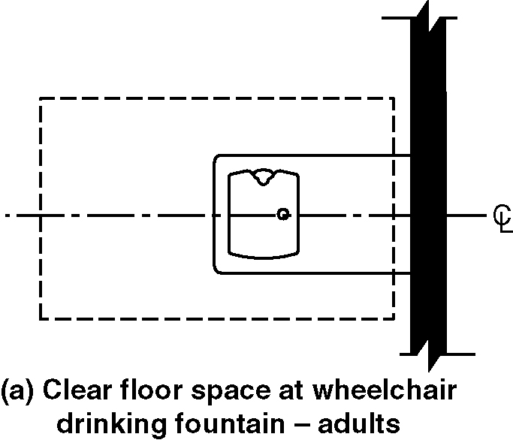
Figure 602.2.1(a) Clear floor space at drinking fountains for persons using wheelchairs

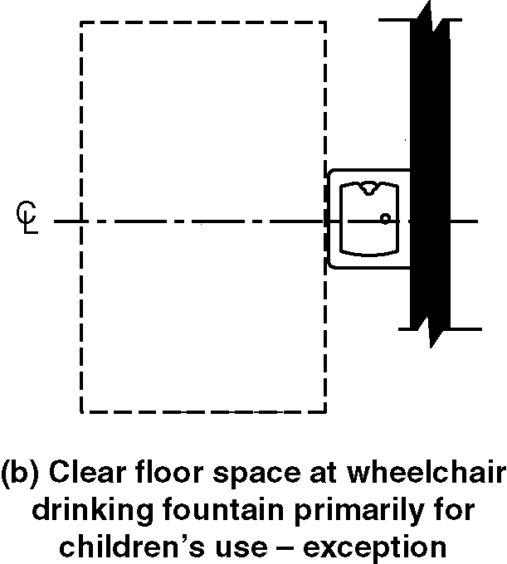
Figure 602.2.1(b) Clear floor space as drinking fountains for persons using wheelchairs and primarily for children’s use

602.2.2 Operable Parts. Operable parts shall comply with Section 309.

602.2.3 Spout Outlet Height. Spout outlets of wheelchair accessible drinking fountains shall be 36 inches (915 mm) maximum above the floor. (ed.)

EXCEPTION: At drinking fountains for persons using wheelchairs and primarily for children’s use, the spout outlet shall be 30 inches (760 mm) maximum above the floor. (6-1-12) (ed.)

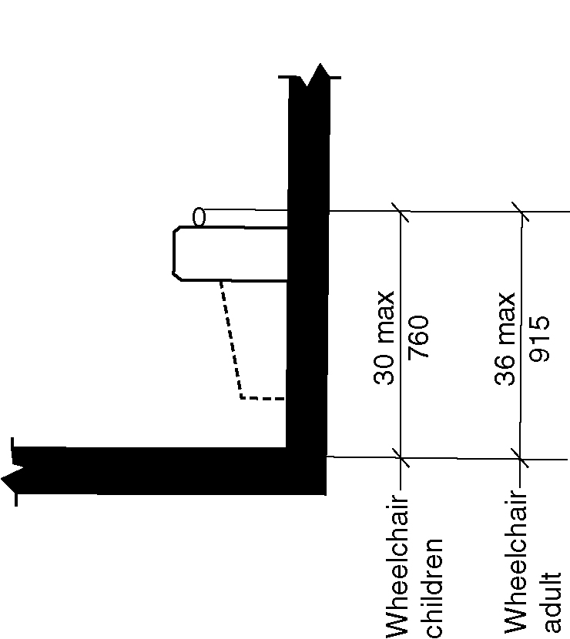
Figure 602.2.3 Spout height and location at drinking fountain for persons using wheelchairs

602.2.4 Spout Location. The spout shall be located 15 inches (380 mm) minimum from the vertical support and 5 inches (125mm) maximum from the front edge of the drinking fountain, including bumpers.

EXCEPTION: At drinking fountains primarily for children’s use, the spout shall be located 3 1/2 inches (89 mm) maximum from the front edge of the drinking fountain, including bumpers. (6-1-12)

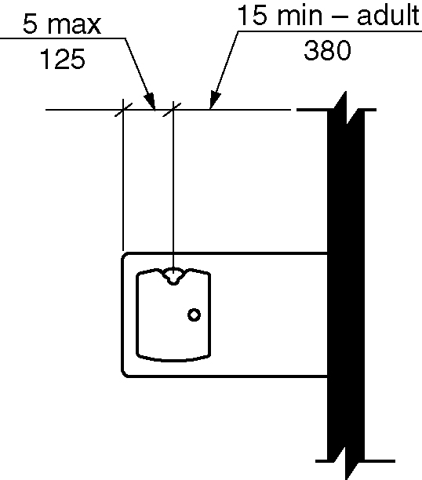
Figure 602.2.4 Spout location at drinking fountains for persons using wheelchairs

602.2.5 Water Flow. The spout shall provide a flow of water 4 inches (100 mm) minimum in height. The angle of the water stream from spouts within 3 inches (76 mm) of the front of the drinking fountain shall be 30 degrees maximum, and from spouts between 3 inches (76 mm) and 5 inches (125 mm) from the front of the drinking fountain shall be 15 degrees maximum, measured horizontally relative to the front face of the drinking fountain.

602.3 Drinking fountains for persons who are standing. Drinking fountains for persons who are standing shall comply with Section 602.3.1 through 602.3.4. (6-1-12) (ed.)

602.3.1 Operable Parts. Operable parts shall comply with Section 309.3 and 309.4. (6-1-12)

602.3.2 Spout Outlet Height. Spout outlets of drinking fountains for standing persons shall be 38 inches (965 mm) minimum and 43 inches (1090 mm) maximum above the floor. (6-1-12) (ed.)

EXCEPTION: Drinking fountains for persons who are standing and primarily for children’s use shall be permitted where the spout outlet is 30 inches (760 mm) minimum and 43 inches (1090 mm) maximum above the floor. (ed.) (6-1-12)

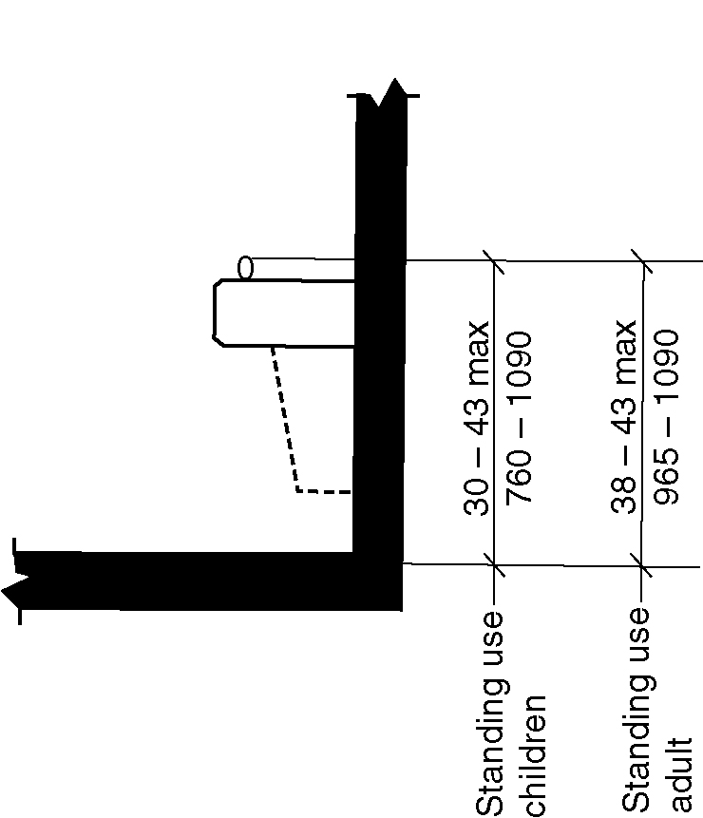
Figure 602.3.2 – Spout height and location at drinking fountains for persons who are standing

602.3.3 Spout location. The spout shall be located 5 inches (125 mm) maximum from the front edge of the drinking fountain, including bumpers. (6-1-12)

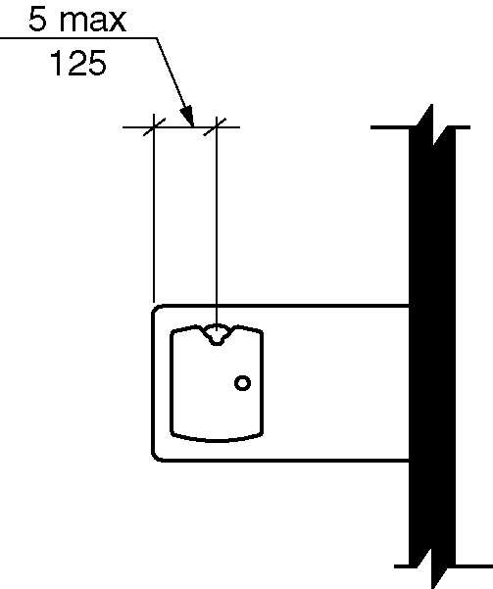
Figure 602.3.3 – Spout location at drinking fountains for persons who are standing

602.3.4 Water Flow. The spout shall provide a flow of water 4 inches (100 mm) minimum in height. The angle of the water stream from spouts within 3 inches (76 mm) of the front of the drinking fountain shall be 30 degrees maximum, and from spouts between 3 inches (76 mm) and 5 inches (125 mm) from the front of the drinking fountain shall be 15 degrees maximum, measured horizontally relative to the front face of the drinking fountain. (6-1-12)

602.4 Bottle Filling Stations. Bottle filling stations which shall comply with Sections 602.4.1 and 602.4.2.

Exception: Where bottle filling stations are part of the drinking fountain for persons who are standing, the bottle filling station is not required to comply with this section provided a bottle filling station is located at the wheelchair accessible drinking fountain for persons using wheelchairs. (6-2-12) (ed.)

602.4.1 Clear Floor Space. A clear floor space complying with Section 305, positioned for a forward or side approach, shall be provided. (6-2-12)

602.4.2 Controls. Controls for bottle filling stations shall be hand operated or automatic. Hand operated controls shall comply with Section 309. (6-2-12)

603 Toilet and Bathing Rooms

603.1 General. Accessible toilet and bathing rooms shall comply with Section 603. (ed.)

603.2 Clearances.

603.2.1 Turning Space. A turning space complying with Section 304 shall be provided within the room. The required turning space shall not be provided within a toilet compartment.

603.2.2 Door Swing. Doors shall not swing into the clear floor space or clearance for any fixture.

EXCEPTIONS:

- Doors to a toilet or bathing room for a single occupant, accessed only through a private office and not for common use or public use shall be permitted to swing into the clear floor space, provided the swing of the door can be reversed to comply with Section 603.2.2.

- Where the room is for individual use and a clear floor space complying with Section 305.3 is provided within the room beyond the arc of the door swing, the door shall not be required to comply with Section 603.2.2.

603.3 Mirrors. Where mirrors are located above lavatories, a mirror shall be located over the accessible lavatory complying with Section 606 and shall be mounted with the bottom edge of the reflecting surface 40 inches (1015 mm) maximum above the floor. Where mirrors are located above counters that do not contain lavatories, the mirror shall be mounted with the bottom edge of the reflecting surface 40 inches (1015 mm) maximum above the floor. (ed.)

EXCEPTION: Other than within Accessible dwelling or sleeping units, mirrors shall not be required over the lavatories or counters if a mirror is located within the same toilet or bathing room and mounted with the bottom edge of the reflecting surface 35 inches (890 mm) maximum above the floor. (ed.)

603.4 Coat Hooks and Shelves. Coat hooks shall be located within one of the reach ranges specified in Section 308. Shelves shall be 40 inches (1015 mm) minimum and 48 inches (1220 mm) maximum above the floor.

603.5 Diaper Changing Tables. Diaper changing tables shall comply with Sections 309 and 902

603.6 Operable Parts. Operable parts on towel dispensers and hand dryers serving accessible lavatories complying with Section 606 shall comply with Table 603.6. (ed.)

Table 603.6
Maximum Reach Depth and Height
Maximum  Reach Depth | 0.5 inch  (13 mm) | 2 inches  (50 mm) | 5 inches  (125 mm) | 6 inches  (150 mm) | 9 inches  (230 mm) | 11 inches  (280 mm)
Maximum  Reach Height | 48 inches  (1220 mm) | 46 inches  (1170 mm) | 42 inches  (1065 mm) | 40 inches  (1015 mm) | 36 inches  (915 mm) | 34 inches  (865 mm)

604 Water Closets and Toilet Compartments

604.1 General. Accessible water closets and toilet compartments shall comply with Section 604. Compartments containing more than one plumbing fixture shall comply with Section 603. Wheelchair accessible toilet compartments shall comply with Section 604.9. Ambulatory accessible toilet compartments shall comply with Section 604.10. (ed.)

EXCEPTION: Water closets and toilet compartments primarily for children’s use shall be permitted to comply with Section 604.11 as applicable.

604.2 Location. The water closet shall be located with a wall or partition to the rear and to one side. The centerline of the water closet shall be 16 inches (405 mm) minimum and 18 inches (455 mm) maximum from the side wall or partition. Water closets located in ambulatory accessible toilet compartments specified in Section 604.10 shall have the centerline of the water closet 17 inches (430 mm) minimum and 19 inches (485 mm) maximum from the side wall or partition. (ed.)

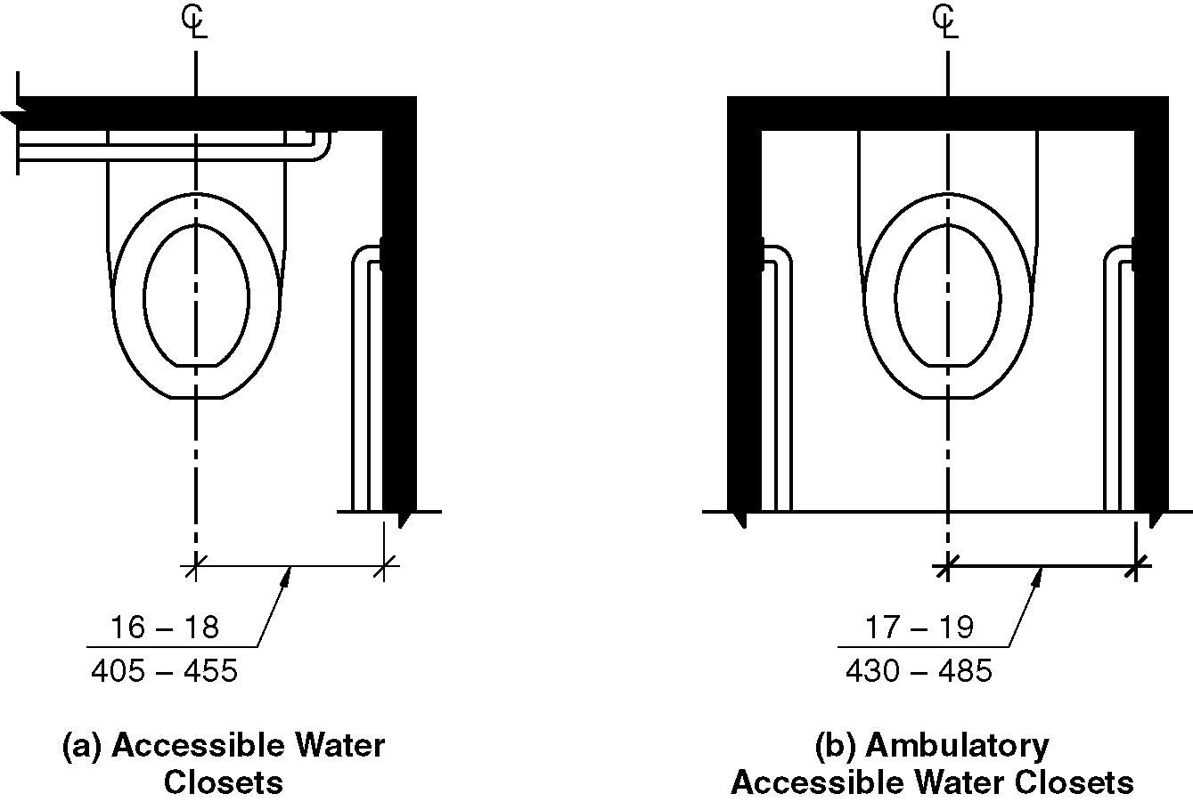
Figure 604.2 Water closet location

604.3 Clearance.

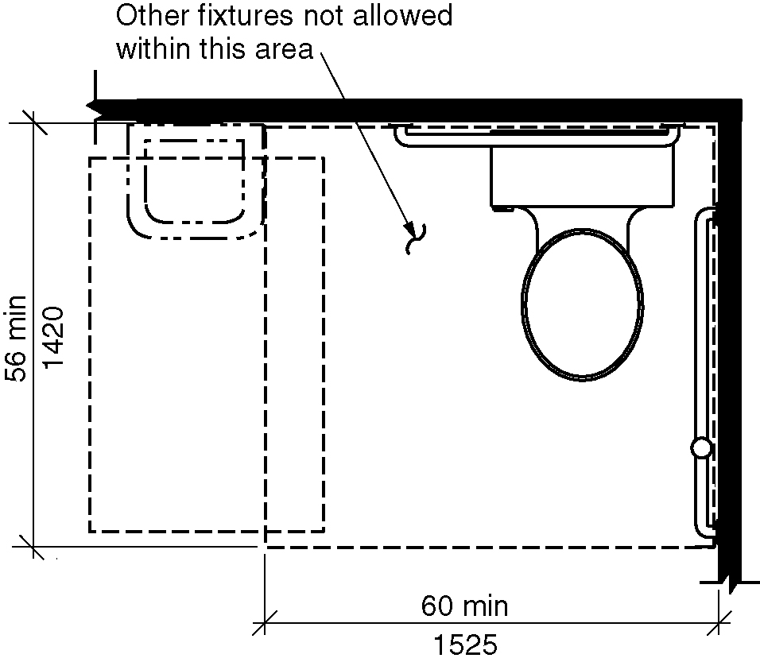
Figure 604.3 Size of clearance for water closet

604.3.1 Clearance width. A clearance around a water closet shall be 60 inches (1525 mm) minimum in width, measured perpendicular from the sidewall.

604.3.2 Clearance Depth. Clearance around the water closet shall be 56 inches (1420 mm) minimum in depth, measured perpendicular from the rear wall.

604.3.3 Clearance Overlap. The required clearance around the water closet shall be permitted to overlap the water closet, associated grab bars, paper dispensers, sanitary napkin receptacles, coat hooks, shelves, accessible routes, clear floor space at other fixtures and the turning space. No other fixtures or obstructions shall be within the required water closet clearance.

604.4 Height. The height of water closet seats shall be 17 inches (430 mm) minimum and 19 inches (485 mm) maximum above the floor, measured to the top of the seat. Seats shall not be sprung to return to a lifted position.

EXCEPTIONS:

1. An accessible A water closet which is adjustable in height by the user is permitted provided that at least one adjustment setting provides a seat within the range specified in Section 604.4. (6-5-12) (ed.)

2. A water closet in a toilet room for a single occupant, accessed only through a private office and not for common use or public use, shall not be required to comply with Section 604.4

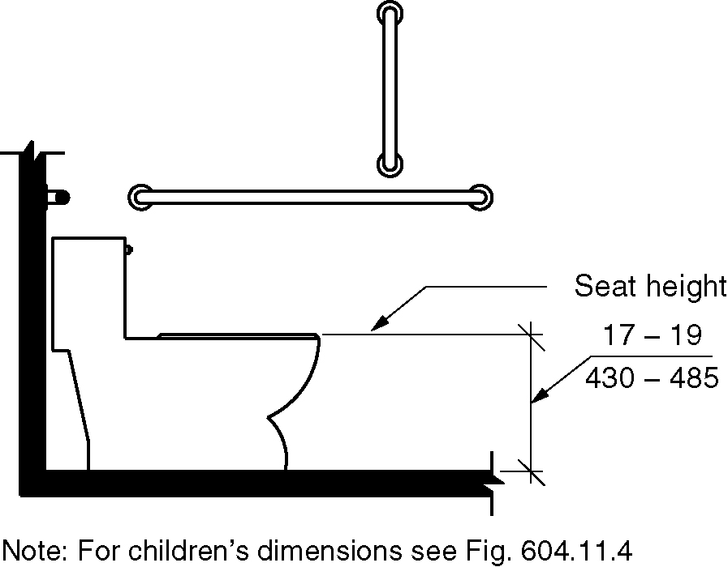
Figure 604.4 - Water closet seat height

604.5 Grab Bars. Grab bars for water closets shall comply with Section 609 and shall be provided in accordance with Sections 604.5.1 and 604.5.2. Grab bars shall be provided on the rear wall and on the side wall closest to the water closet.

EXCEPTIONS:

- Grab bars shall not be required to be installed in a toilet room for a single occupant, accessed only through a private office and not for common use or public use, provided reinforcement has been installed in walls and located so as to permit the installation of grab bars complying with Section 604.5. (ed.)

- In detention or correction facilities, grab bars shall not be required to be installed in housing or holding cells or rooms that are specially designed without protrusions for purposes of suicide prevention. (ed.)

604.5.1 Fixed Side Wall Grab Bars. Fixed side wall grab bars shall include a horizontal bar complying with Section 604.5.1.1 and a vertical grab bar complying with Section 604.5.1.2. The vertical grab bar at water closets primarily for children’s use shall comply with Section 609.4.2. (6-7-12)

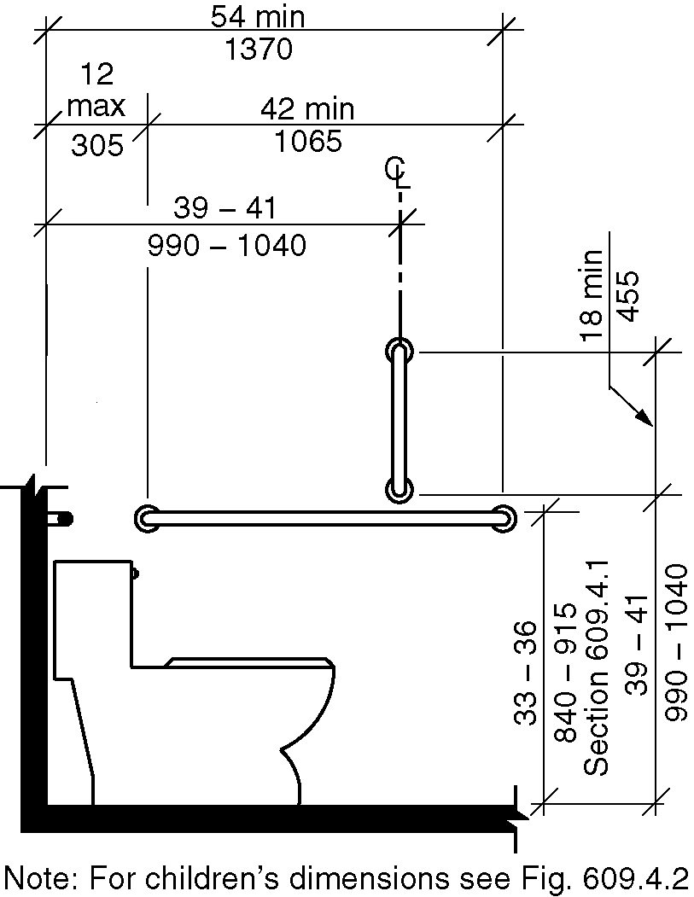
Figure 604.5.1 - Side wall grab bar for water closet

604.5.1.1 Horizontal Grab Bar. A horizontal grab bar 42 inches (1065 mm) minimum in length shall be located 12 inches (305 mm) maximum from the rear wall and extend 54 inches (1370 mm) minimum from the rear wall. (6-7-12)

604.5.1.2 Vertical Grab Bar. A vertical grab bar 18 inches (455 mm) minimum in length shall be mounted with the bottom of the bar located 39 inches (990 mm) minimum and 41 inches (1040 mm) maximum above the floor, and with the center line of the bar located 39 inches (990 mm) minimum and 41 inches (1040 mm) maximum from the rear wall. (6-7-12)

    - Rear Wall Grab Bars. The fixed rear wall grab bar shall be:

- 36 inches (915 mm) minimum in length,
- Located 6 inches maximum (150 mm) from the side wall, and
- Extend 42 inches (1065 mm) minimum from the side wall. (6-10-12)

EXCEPTIONS:

1. The rear grab bar shall be permitted to be 24 inches (610 mm) minimum in length, centered on the water closet, where wall space does not permit a grab bar 36 inches (915 mm) minimum in length due to the location of a recessed fixture adjacent to the water closet.

- Where an administrative authority requires flush controls for flush valves to be located in a position that conflicts with the location of the rear grab bar, that grab bar shall be permitted to be split or shifted to the open side of the toilet area.

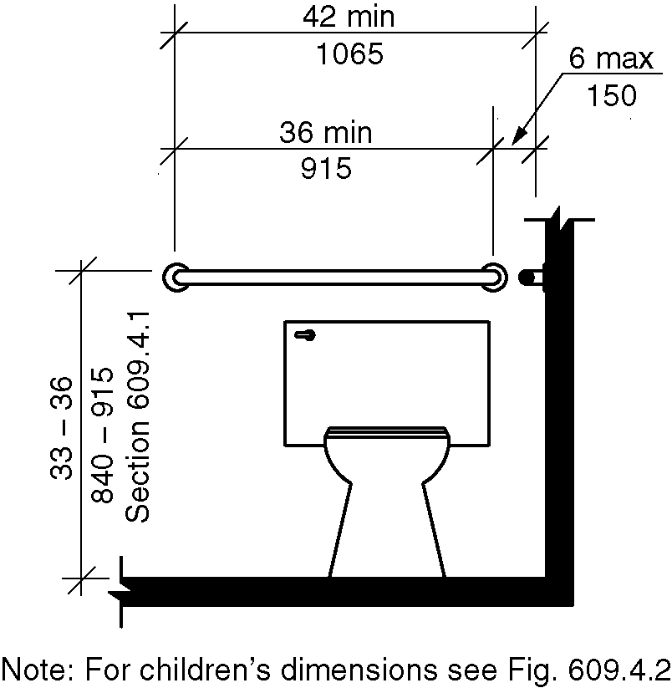
Figure 604.5.2 - Rear wall grab bar for water closet

604.6 Flush Controls. Flush controls shall be hand operated or automatic. Hand operated flush controls shall comply with Section 309. Flush controls shall be located on the open side of the water closet.

EXCEPTION: In ambulatory accessible toilet compartments complying with Section 604.10, flush controls shall be permitted to be located on either side of the water closet. (ed.)

604.7 Dispensers. Toilet paper dispensers shall comply with Section 309.4. Dispensers shall comply with Section 609.3. Dispensers shall not be of a type that control delivery, or do not allow continuous paper flow. (6-14-12 PC2)

604.7.1 Location. Where the dispenser is located above the grab bar, the outlet of the dispenser shall be located within an area 24 inches (610 mm) minimum and 36 inches (915 mm) maximum from the rear wall. Where the dispenser is located below the grab bar, the outlet of the dispenser shall be located within an area 24 inches (610 mm) minimum and 42 inches (1065 mm) maximum from the rear wall. The outlet of the dispenser shall be located 18 inches (455 mm) minimum and 48 inches (1220 mm) maximum above the floor. (6-14-12 PC2)

EXCEPTION: Toilet paper dispensers that accommodate a maximum of 2 toilet paper rolls of not more than 5 inch (125 mm) diameter each shall be permitted to be located 7 inches (180 mm) minimum and 9 inches (230 mm) maximum in front the of the water closet measured to the centerline of the dispenser. The outlet of the dispenser shall be 15 inches (380 mm) minimum and 48 inches (1220 mm) maximum above the floor. (6-14-12) (6-14-12 PC2)

Figure 604.7.1(a) thru (d) dispenser outlet location

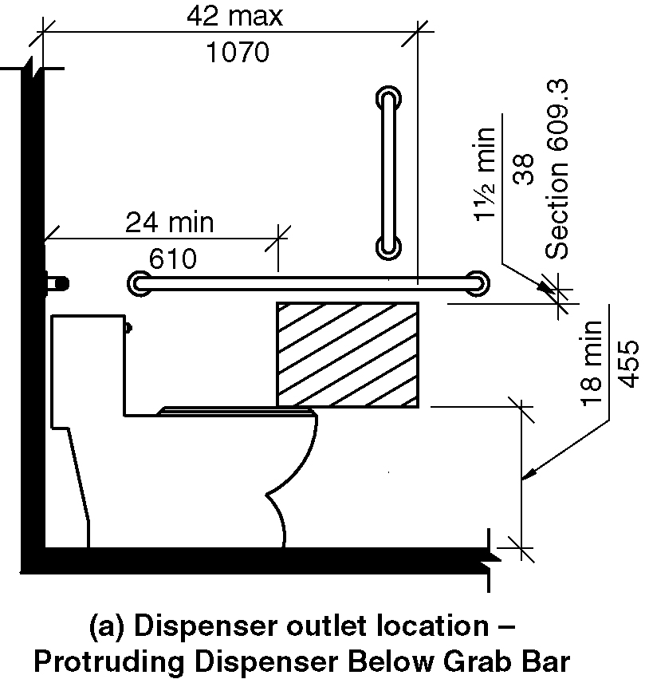
a) Protruding dispenser below grab bar

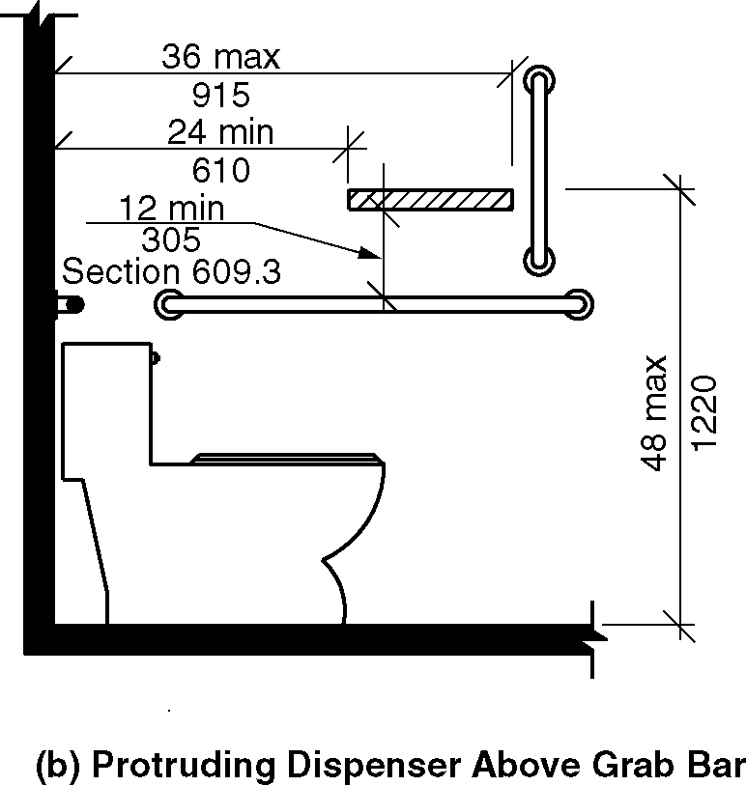
b) Protruding dispenser above grab bar

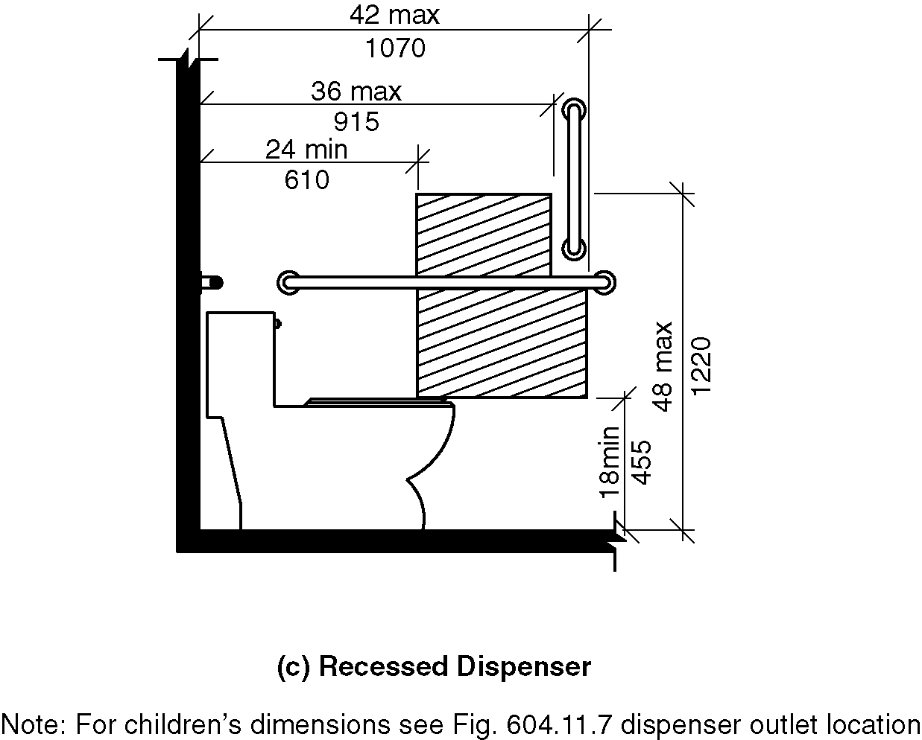
c) Recessed dispenser

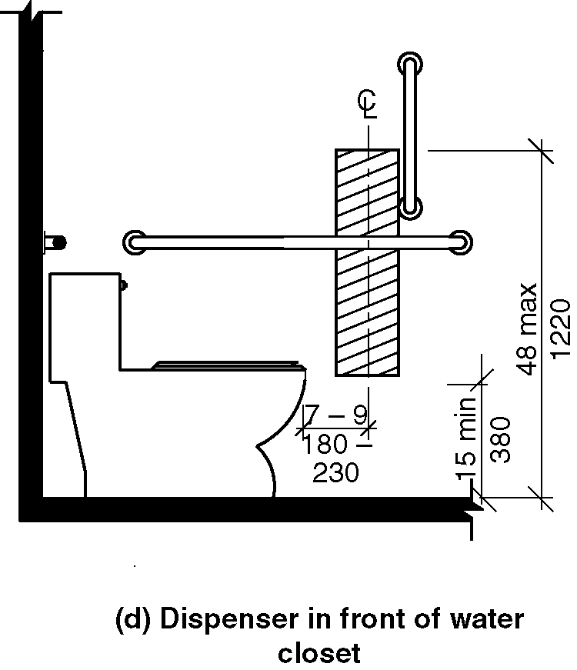
d) Dispenser in front of water closet - exception

604.8 Coat Hooks and Shelves. Coat hooks provided within toilet compartments shall be 48 inches (1220 mm) maximum above the floor. Shelves shall be 40 inches (1015 mm) minimum and 48 inches (1220 mm) maximum above the floor.

604.9 Wheelchair Accessible Toilet Compartments.

604.9.1 General. Wheelchair accessible toilet compartments shall comply with Section 604.9.

604.9.2 Size. Wheelchair accessible toilet Compartments shall comply with Section 604.9.2.1, 604.9.2.2 or 604.9.2.3 as applicable.

Figure 604.9.2(a) thru (c) – Wheelchair accessible toilet compartments
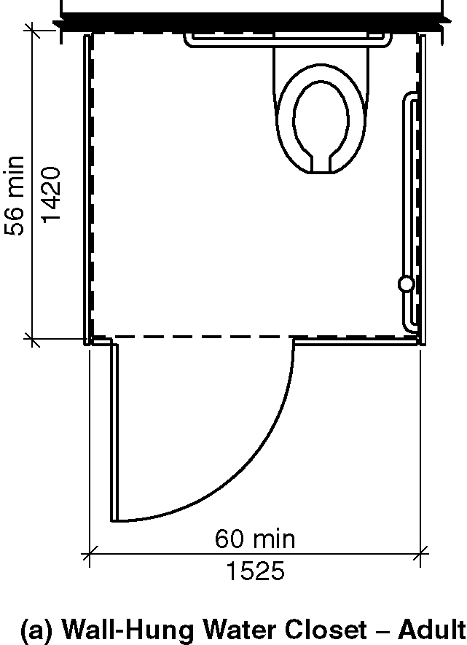
a) Wall hung closet - adult
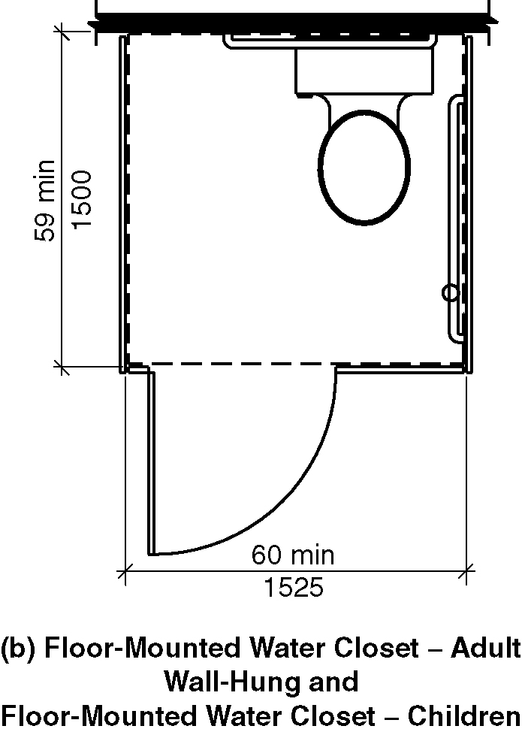
b) Floor mounted water closet – adult; Wall hung and floor mounted water closet – children
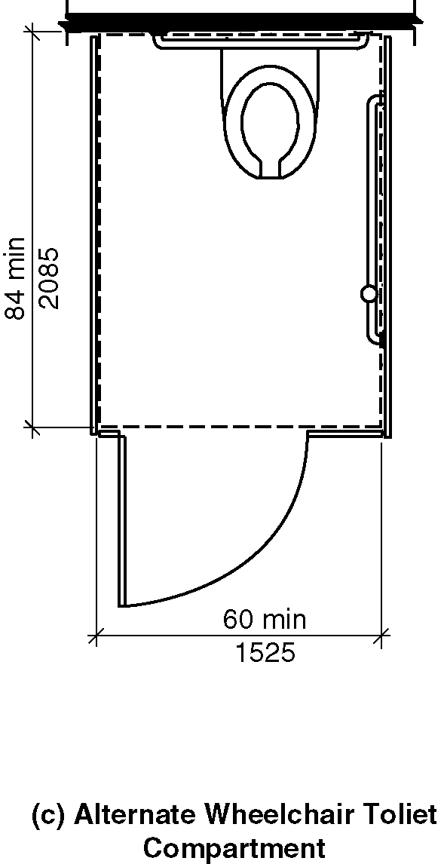
c) Alternate wheelchair accessible toilet compartment

604.9.2.1 Minimum area. The minimum area of a wheelchair accessible toilet compartment shall be 60 inches (1525 mm) minimum in width measured perpendicular to the side wall, and 56 inches (1420 mm) minimum in depth for wall hung water closets, and 59 inches (1500 mm) minimum in depth for floor mounted water closets measured perpendicular to the rear wall. (ed.)

604.9.2.2 Compartment for children’s use. The minimum area of a wheelchair accessible toilet compartment primarily for children’s use shall be 60 inches (1525 mm) minimum in width measured perpendicular to the side wall, and 59 inches (1500 mm) minimum in depth for wall hung and floor mounted water closets measured perpendicular to the rear wall. (ed.)

604.9.2.3 Alternate wheelchair accessible toilet Compartments. Where an alternate wheelchair accessible toilet compartment is provided, the minimum area of the compartment shall be 60 inches (1525 mm) minimum in width, measured perpendicular to the side wall, and 84 inches (2135 mm) minimum in depth, measured perpendicular to the rear wall.(6-18-12) (ed.)

604.9.3 Doors. Wheelchair accessible toilet compartment doors, including door hardware, shall comply with Section 404. The door shall be self-closing. A door pull complying with Section 404.2.6 shall be placed on both sides of the door near the latch. Wheelchair accessible toilet compartment doors shall not swing into the required minimum area of the compartment. (6-19-12) (ed.)

EXCEPTIONS:

1. Outside of the compartment, where the approach is to the latch side of the wheelchair accessible toilet compartment door clearance between the door side of the compartment and any obstruction shall be 42 inches (1065 mm) minimum. (6-19-12) (ed.)

2. Within the wheelchair accessible toilet compartment, maneuvering clearances at the door shall not be required to comply with Section 404. (6-19-12) (ed.)

3. In an alternate wheelchair accessible toilet compartment, the door can shall be permitted to swing into the stall where a clear floor space complying with Section 305.3 is provided within the stall beyond the arc of the door swing. (6-18-12) (ed.)

Figure 604.9.3– Wheelchair accessible toilet compartment doors
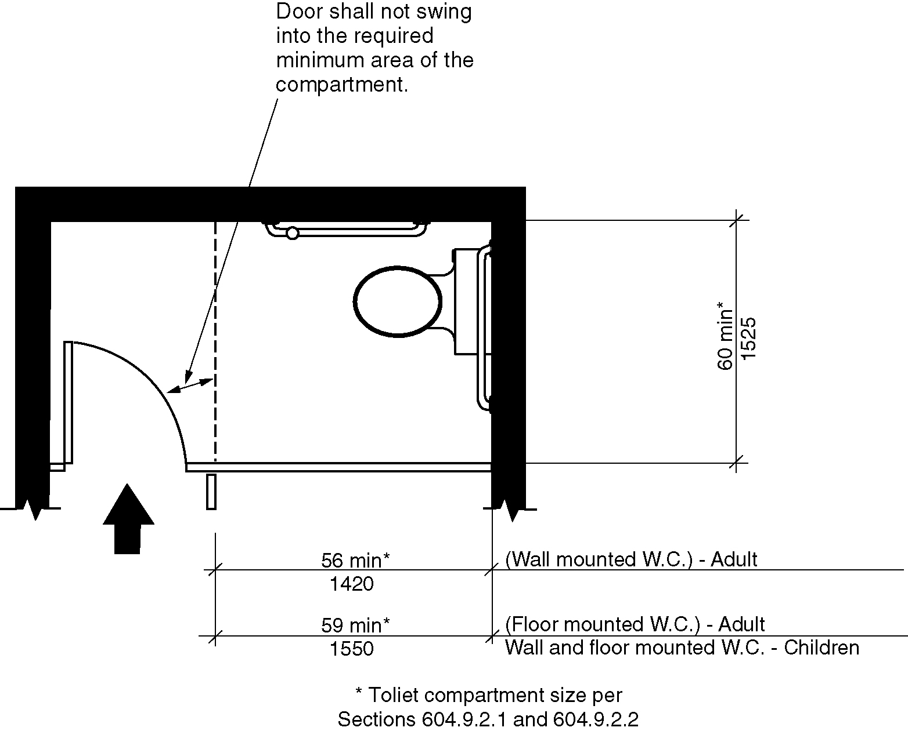
(a) door swinging into the wheelchair accessible toilet compartment
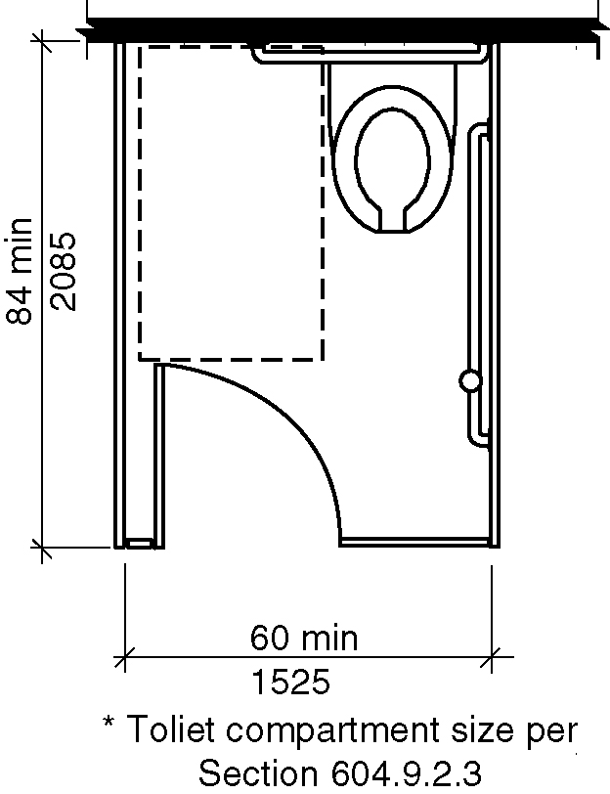
(b) Exception 3 – alternate wheelchair accessible toilet compartment

604.9.3.1 Door Opening Location. The farthest edge of the wheelchair accessible toilet compartment door opening shall be located in the front wall or partition or in the side wall or partition as required by Table 604.9.3.1. (ed.)

Figure 604.9.3.1– Wheelchair accessible toilet compartment door opening locations
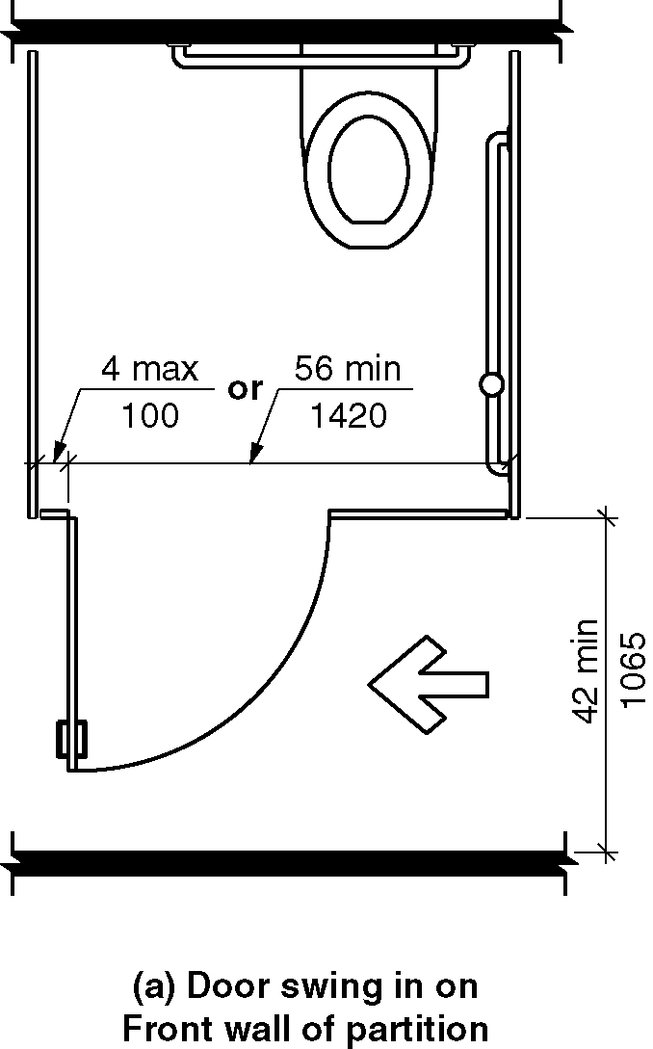
(a) door swinging out on front wall of partition

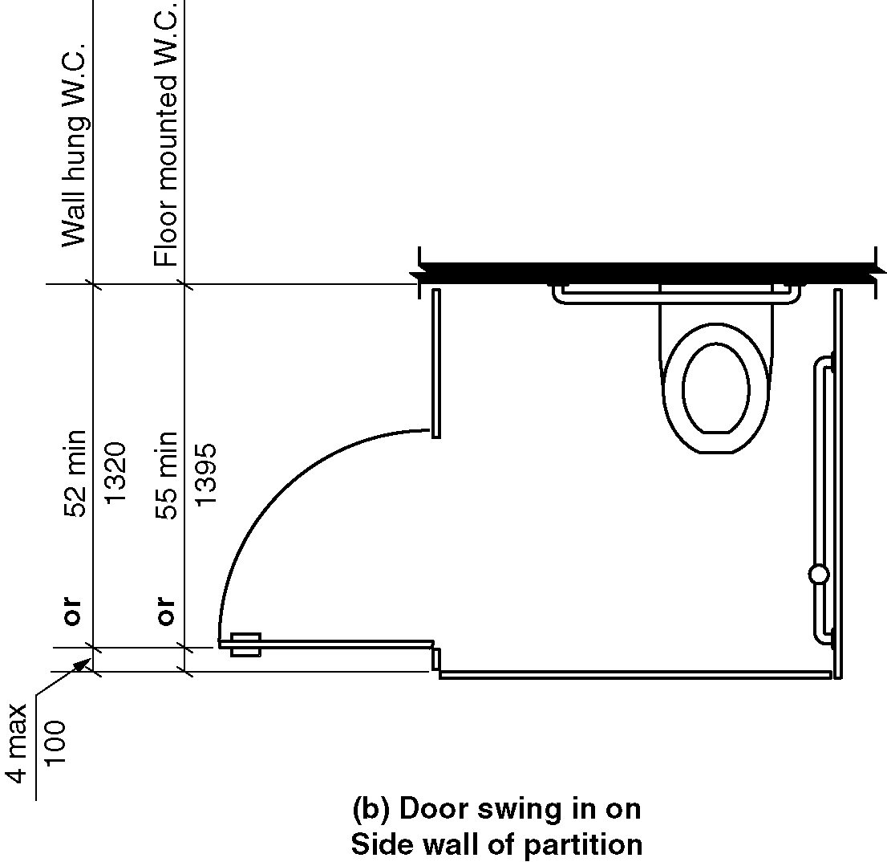
(b) door swinging out on side wall of partition

Table 604.9.3.1 – Door Opening Location
Door Opening Location | Measured From | Dimension
Front Wall or Partition | From the side wall or partition closest to the water closet | 56 inches (1420 mm) minimum
 | Or
 | From the side wall or partition farthest from the water closet | 4 inches (100 mm) maximum
Side Wall or Partition  -  Wall-Hung Water Closet | From the rear wall | 52 inches (1320 mm) minimum
 | Or
 | From the front wall or partition | 4 inches (100 mm) maximum
Side Wall or Partition  -  Floor-Mounted Water Closet | From the rear wall | 55 inches (1395 mm) minimum
 | Or
 | From the front wall or partition | 4 inches (100 mm) maximum
(6-20-12) (6-20-12 PC2.1)

604.9.4 Approach. Wheelchair accessible toilet compartments shall be arranged for left-hand or right-hand approach to the water closet.

604.9.5 Toe Clearance at Accessible Compartments. Toe clearance for wheelchair accessible toilet compartments primarily for children’s use shall comply with Section 604.9.5.2. Toe clearance for other wheelchair accessible toilet compartments shall comply with Section 604.9.5.1. (6-22-12) (ed.)

Figure 604.9.5 Wheelchair accessible toilet compartment toe clearance
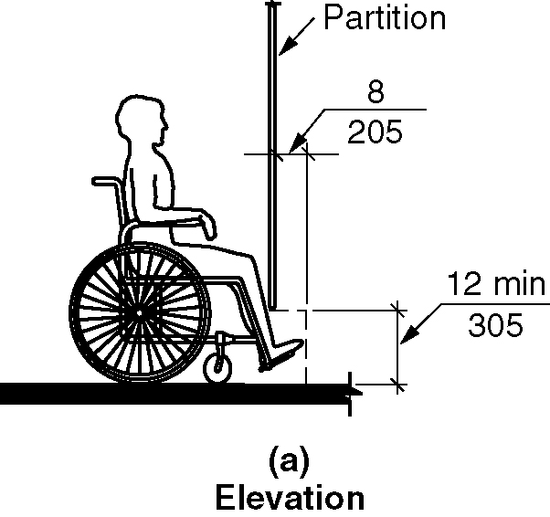
(a) elevation
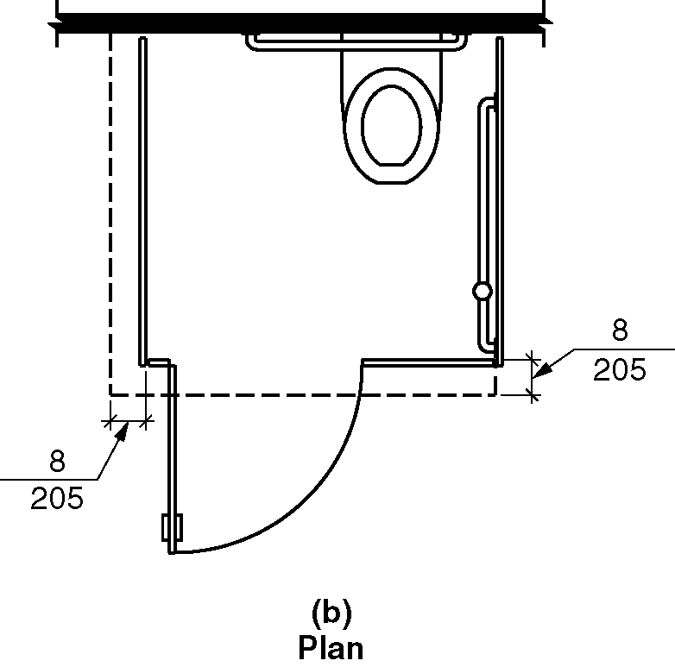
(b) plan

604.9.5.1 Toe Clearance at Wheelchair Accessible Toilet Compartments. The front partition and at least one side partition of wheelchair accessible toilet compartments shall provide a toe clearance of 12 inches (305 mm) minimum above the floor and extending 8 inches (205 mm) beyond the compartment side face of the partition, exclusive of partition support members. (6-22-12) (ed.)

EXCEPTIONS:

1. Toe clearance at the front partition is not required in a wheelchair accessible toilet compartment greater than 64 inches (1625 mm) in depth with a wall-hung water closet, or greater than 67 inches (1700 mm) in depth with a floor-mounted water closet. (6-22-12)

2. Toe clearance at the side partition is not required in a wheelchair accessible toilet compartment greater than 68 inches (1730 mm) in width. (6-22-12) (ed.)

604.9.5.2 Toe Clearance at Wheelchair accessible Toilet Compartments for Children’s Use. The front partition and at least one side partition of wheelchair accessible toilet compartments primarily for children’s use shall provide a toe clearance of 12 inches (305 mm) minimum above the floor and extending 8 inches (205 mm) beyond the wheelchair accessible toilet compartment side face of the partition, exclusive of partition support members. (6-22-12) (ed.)

EXCEPTIONS:

1. Toe clearance at the front partition is not required in a wheelchair accessible toilet compartment greater than 67 inches (1700 mm) in depth. (6-22-12)

2. Toe clearance at the side partition is not required in a wheelchair accessible toilet compartment greater than 68 inches (1730 mm) in width. (6-22-12) (ed.)

604.9.6 Grab Bars. Grab bars shall comply with Section 609. Side wall grab bars complying with Section 604.5.1 located on the wall closest to the water closet, and a rear wall grab bar complying with Section 604.5.2, shall be provided.

604.10 Ambulatory Accessible Toilet Compartments.

604.10.1 General. Ambulatory accessible toilet compartments shall comply with Section 604.10. (ed.)

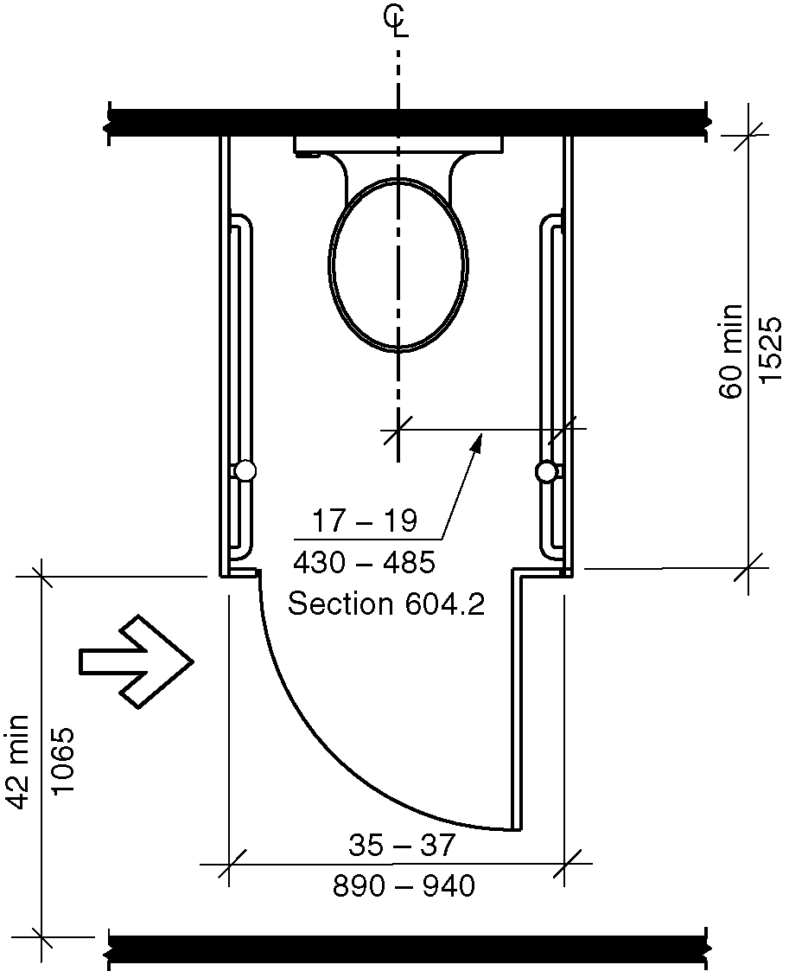
Figure 604.10.1 Ambulatory accessible toilet compartment

604.10.2 Size. The minimum area of an ambulatory accessible toilet compartment shall be 60 inches (1525 mm) minimum in depth and a width of 35 inches (890 mm) minimum and 37 inches (940 mm) maximum. (6-24-12) (ed.)

604.10.3 Doors. Ambulatory accessible toilet Compartment doors, including door hardware, shall comply with Section 404. The door shall be self- closing. A door pull complying with Section 404.2.6 shall be placed on both sides of the door near the latch. Compartment doors shall not swing into the required minimum area of the compartment. (6-19-12) (ed.)

EXCEPTIONS:

1. Outside of the ambulatory accessible toilet compartment, where the approach is to the latch side of the compartment door, clearance between the door side of the compartment and any obstruction shall be 42 inches (1065 mm) minimum. (6-19-12) (ed.)

2. Within the ambulatory accessible toilet compartment, maneuvering clearances at the door shall not be required to comply with Section 404. (6-19-12) (ed.)

604.10.4 Grab Bars. Grab bars shall comply with Section 609. Side wall grab bars complying with Section 604.5.1 shall be provided on both sides of the compartment.

604.11 Water Closets and Toilet Compartments for Children’s Use.

604.11.1 General. Accessible water closets and wheelchair and ambulatory accessible toilet compartments primarily for children’s use shall comply with Section 604.11. (ed.)

604.11.2 Location. The water closet primarily for children’s use shall be located with a wall or partition to the rear and to one side. The centerline of the water closet shall be 12 inches (305 mm) minimum and 18 inches (455 mm) maximum from the side wall or partition. Water closets located in ambulatory accessible toilet compartments specified in Section 604.10 shall be located as specified in Section 604.2. (6-24-12 PC1)

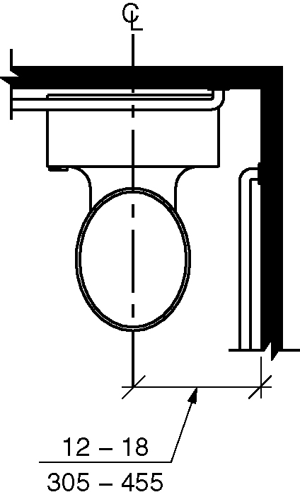
Figure 604.11.2 Children’s water closet location

604.11.3 Clearance. A clearance around the water closet primarily for children’s use complying with Section 604.3 shall be provided. (ed.)

604.11.4 Height. The height of water closet seats primarily for children’s use shall be 11 inches (280 mm) minimum and 17 inches (430 mm) maximum above the floor, measured to the top of the seat. Seats shall not be sprung to return to a lifted position. (ed.)

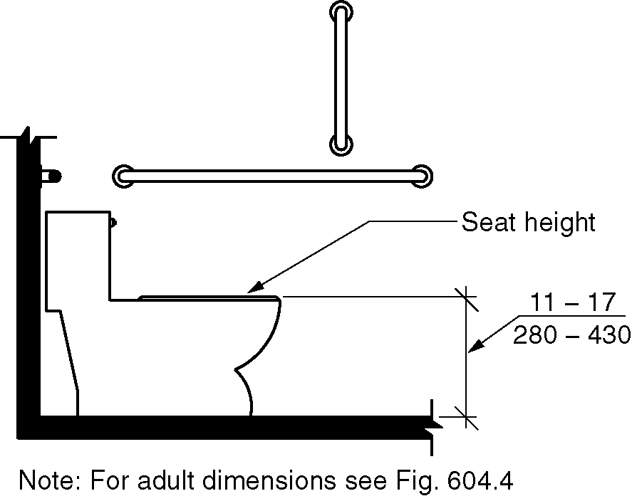
Figure 604.11.4 Children’s water closet height

604.11.5 Grab Bars. Grab bars for water closets primarily for children’s use shall comply with Section 604.5. (ed.)

604.11.6 Flush Controls. Flush controls primarily for children’s use shall be hand operated or automatic. Hand operated flush controls shall comply with Sections 309.2 and 309.4 and shall be installed 36 inches (915 mm) maximum above the floor. Flush controls shall be located on the open side of the water closet.

EXCEPTION: In ambulatory accessible toilet compartments complying with Section 604.10, flush controls shall be permitted to be located on either side of the water closet. (ed.)

604.11.7 Dispensers. Toilet paper dispensers primarily for children’s use shall comply with Section 309.4. There shall be a clearance of 1 1/2 inches (38 mm) minimum below the grab bar. Dispensers shall not be of a type that control delivery or do not allow continuous paper flow. (6-14-12 PC 2)

Figure 604.11.7 – Children’s dispenser outlet location
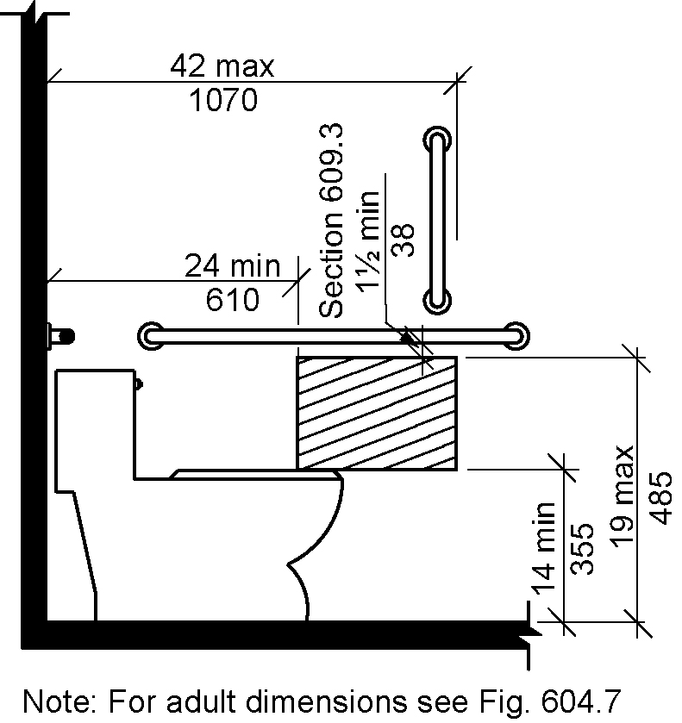
(a)Below grab bar
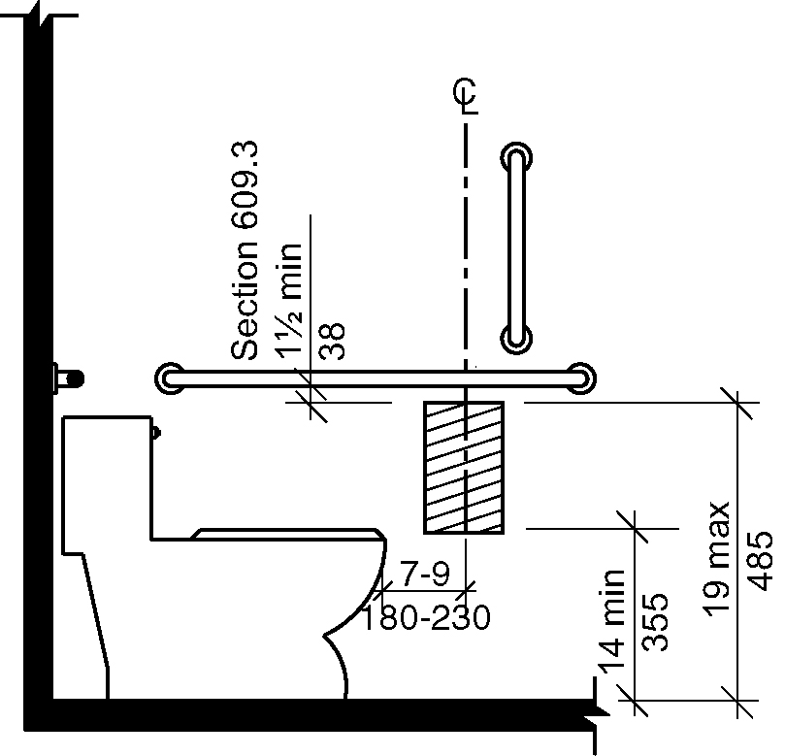
(b) exception

604.11.7.1 Location. The outlet of toilet paper dispensers primarily for children’s use shall be located within an area 24 inches (610 mm) minimum and 42 inches (1065 mm) maximum from the rear wall. The outlet of the dispenser shall be 14 inches (355 mm) minimum and 19 inches (485 mm) maximum above the floor. There shall be a clearance of 1 1/2 inches (38 mm) minimum below the grab bar. (ed.) (6-14-12 PC 2)

EXCEPTION: Toilet paper dispensers that accommodate a maximum of 2 toilet paper rolls of not more than 5 inch diameter each shall be permitted to be located 7 inches minimum and 9 inches maximum in front of the of the water closet measured to the centerline of the dispenser. The outlet of the dispenser shall be 14 inches (355 mm) minimum and 19 inches (485 mm) maximum above the floor. (6-11-12) (6-14-12 PC 2)

604.11.8 Toilet Compartments. Wheelchair and ambulatory accessible Toilet compartments primarily for children’s use shall comply with Sections 604.9 and 604.10, as applicable. (ed.)

605 Urinals

605.1 General. Accessible urinals shall comply with Section 605. (ed.)

605.2 Height and Depth. Urinals shall be of the stall type or shall be of the wall hung type with the rim at 17 inches (430 mm) maximum above the floor. Urinals shall be 13 ½ inches (345 mm) minimum in depth measured from the outer face of the urinal rim to the finished wall surface. (6-24-12)

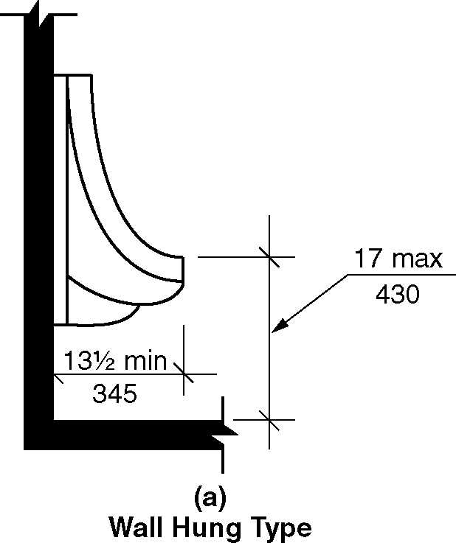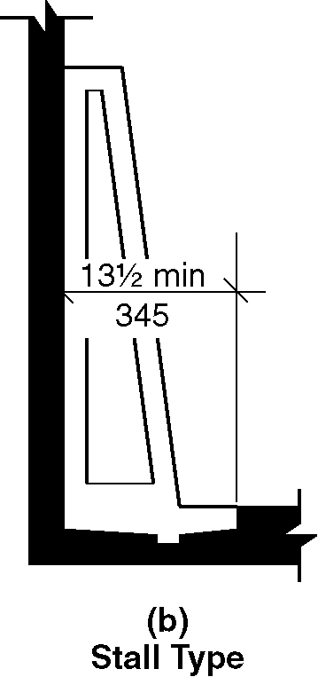
Figure 605.2 Height and depth of urinals (a & b)

605.3 Clear Floor Space. A clear floor space complying with Section 305, positioned for forward approach, shall be provided.

605.4 Flush Controls. Flush controls shall be hand operated or automatic. Hand operated flush controls shall comply with Section 309.

606 Lavatories and Sinks

606.1 General. Accessible lavatories and sinks shall comply with Section 606. (ed.)

606.2 Clear Floor Space. A clear floor space complying with Section 305.3, positioned for forward approach, shall be provided. Knee and toe clearance complying with Section 306 shall be provided. The dip of the overflow shall not be considered in determining knee and toe clearances.

EXCEPTIONS:

- A parallel approach complying with Section 305, shall be permitted to a kitchen sink in a space where a cook top or conventional range is not provided. (3-13-12 PC5)

- The requirement for knee and toe clearance shall not apply to a lavatory in a toilet or bathing facility for a single occupant, accessed only through a private office and not for common use or public use.

- A knee clearance of 24 inches (610 mm) minimum above the floor shall be permitted at lavatories and sinks used primarily by children ages 6 through 12 where the higher of the rim or counter surface is 31 inches (785 mm) maximum above the floor. (6-33-12)

- A parallel approach complying with Section 305, shall be permitted at lavatories and sinks used primarily by children ages 5 and younger. (3-13-12 PC5)

- The requirement for knee and toe clearance shall not apply to more than one bowl of a multibowl sink.

- A parallel approach complying with Section 305, shall be permitted at wet bars. (3-13-12 PC5)

606.3 Height. The front of lavatories and sinks shall be 34 inches (865 mm) maximum above the floor, measured to the higher of the rim or counter surface.

EXCEPTION: A lavatory in a toilet or bathing facility for a single occupant, accessed only through a private office and not for common use or public use, shall not be required to comply with Section 606.3.

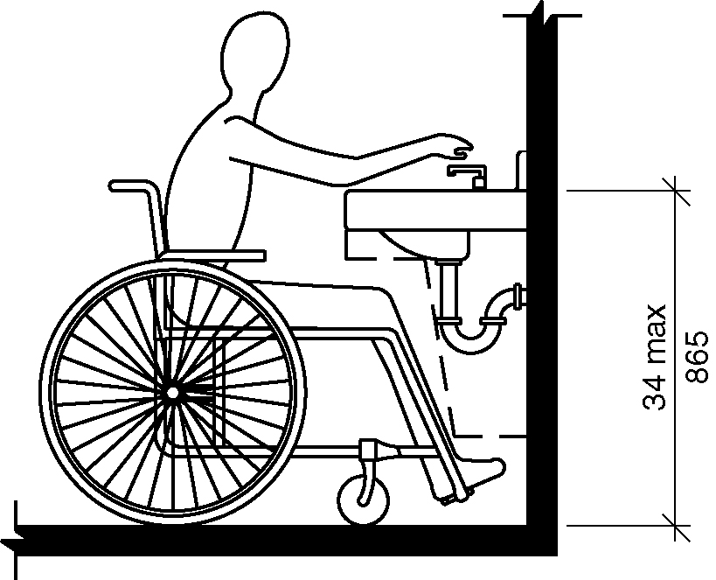
Figure 606.3 - Height of lavatories and sinks

606.4 Faucets. Faucets shall comply with Section 309. Hand-operated metering faucets shall remain open for 10 seconds minimum.

EXCEPTION: Automatic faucets shall not be required to comply with Section 309 provided that the reach depth to activate the faucets and the reach depth to the water flow is 11 inches maximum. (6-36-12) (ed.)

606.5 Basin Location. The interior edge of the rim of the lavatory basin shall be located 3 ½ inches (90 mm) maximum from the front edge of the fixture or countertop.(6-37-12 PC1.1 #24B)

606.5 Lavatories with Enhanced Reach Range. Where enhanced reach range is required at lavatories, faucets and soap dispenser controls shall have a reach depth of 11 inches (280 mm) maximum. Water and soap outlet shall be provided with a reach depth of 11 inches (280 mm) maximum. The lavatory shall be 34 inches maximum above the floor, measured to the higher of the rim or counter surface. (6-36-12)

EXCEPTIONS:

- Enhanced reach range faucets shall not be required on lavatories provided with automatic faucets where the reach depth to activate the faucets and the reach depth to the water outlet is 11 inches (280 mm) maximum. (6-36-12) (ed.)

- Enhanced reach range soap dispensers shall not be required on lavatories provided with automatic dispensers where the reach depth to activate the soap dispensers and the reach depth to the soap outlet is 11 inches (280 mm) maximum. (6-36-12) (ed.)

606.6 Exposed Pipes and Surfaces. Water supply and drainpipes under lavatories and sinks shall be insulated or otherwise configured to protect against contact. There shall be no sharp or abrasive surfaces under lavatories and sinks.

607 Bathtubs

607.1 General. Accessible bathtubs shall comply with Section 607. (ed.)

607.2 Clearance. A clearance in front of bathtubs extending the length of the bathtub and 30 inches (760 mm) minimum in depth shall be provided. Where a permanent seat is provided at the head end of the bathtub, the clearance shall extend 12 inches (305 mm) minimum beyond the wall at the head end of the bathtub.

Figure 607.2 (a) & (b) - Clearance for bathtubs
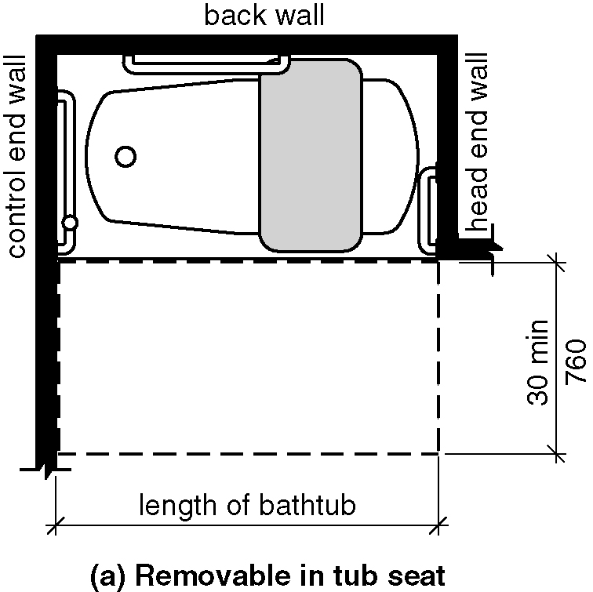
a) Without permanent Removable in-tub seats
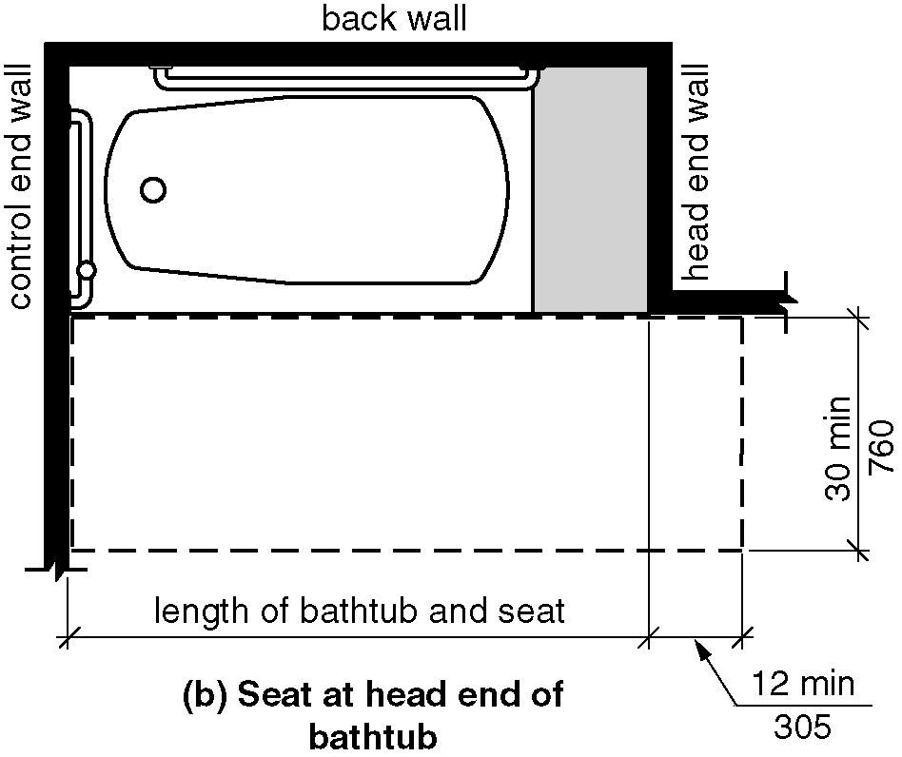
b) With permanent seat at the head end of bathtub

607.3 Seat. A permanent seat at the head end of the bathtub or a removable in-tub seat shall be provided. Seats shall comply with Section 610.

607.4 Grab Bars. Grab bars shall comply with Section 609 and shall be provided in accordance with Section 607.4.1 or 607.4.2.

EXCEPTION: Grab bars shall not be required to be installed in a bathing facility for a single occupant accessed only through a private office and not for common use or public use, provided reinforcement has been installed in walls and located so as to permit the installation of grab bars complying with Section 607.4.

607.4.1 Bathtubs with Permanent Seats. For bathtubs with permanent seats, grab bars complying with Section 607.4.1 shall be provided. (ed.)

Figure 607.4.1 (a) and (b) Grab bars for bathtubs with permanent seats at head end of bathtub
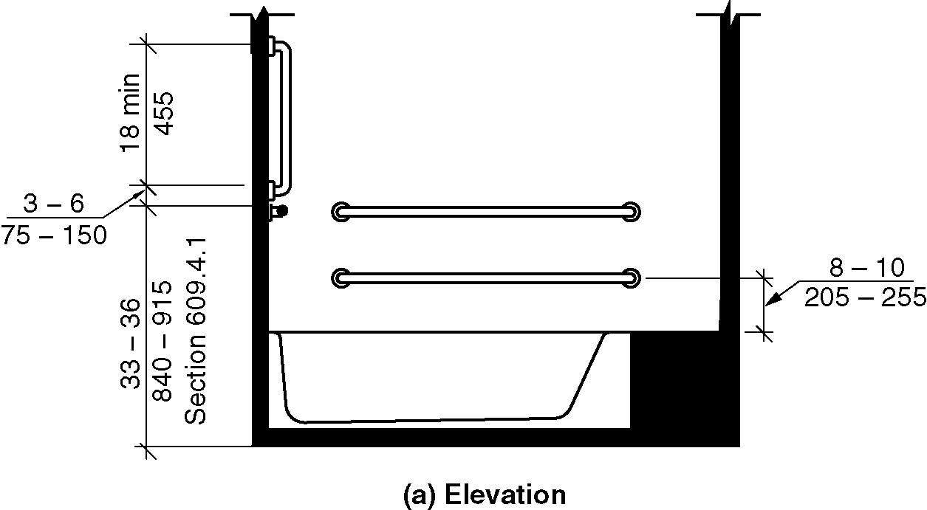
a) Elevation
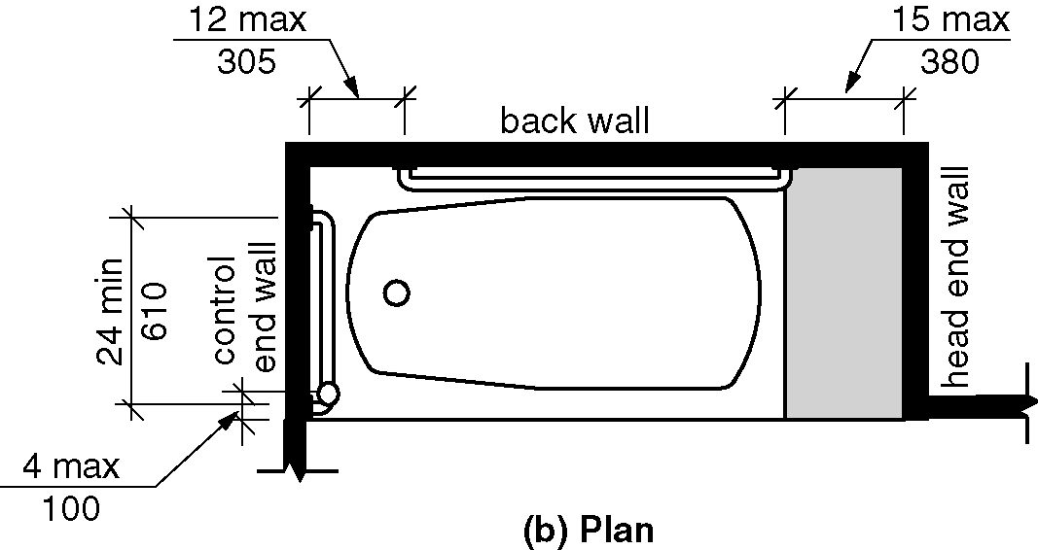
b) Plan

607.4.1.1 Back Wall. Two horizontal grab bars shall be provided on the back wall, one complying with Section 609.4 and the other located 8 inches (205 mm) minimum and 10 inches (255 mm) maximum above the rim of the bathtub. Each grab bar shall be located 15 inches (380 mm) maximum from the head end wall and extend to 12 inches (305 mm) maximum from the control end wall.

607.4.1.2 Control End Wall. Control end wall grab bars shall comply with Section 607.4.1.2.

EXCEPTION: An L-shaped continuous grab bar of equivalent dimensions and positioning shall be permitted to serve the function of separate vertical and horizontal grab bars.

607.4.1.2.1 Horizontal Grab Bar. A horizontal grab bar 24 inches (610 mm) minimum in length shall be provided on the control end wall beginning near the front edge of the bathtub and extending toward the inside corner of the bathtub.

607.4.1.2.2 Vertical Grab Bar. A vertical grab bar 18 inches (455 mm) minimum in length shall be provided on the control end wall 3 inches (75 mm) minimum and 6 inches (150 mm) maximum above the horizontal grab bar, and 4 inches (100 mm) maximum inward from the front edge of the bathtub.

607.4.2 Bathtubs with removable Seats. For bathtubs with removable seats, grab bars complying with Section 607.4.2 shall be provided. (ed.)

Figure 607.4.2(a) and (b) - Grab bars for bathtubs with removable seats
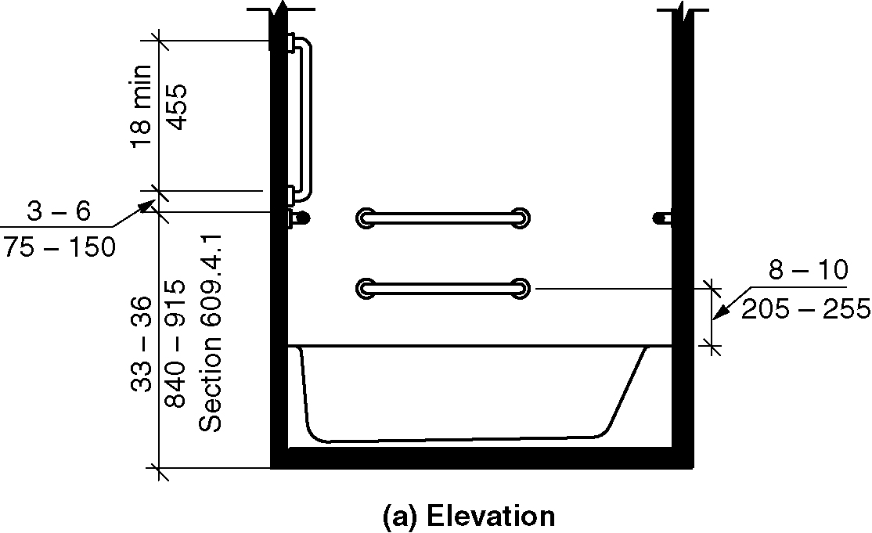
a) Elevation
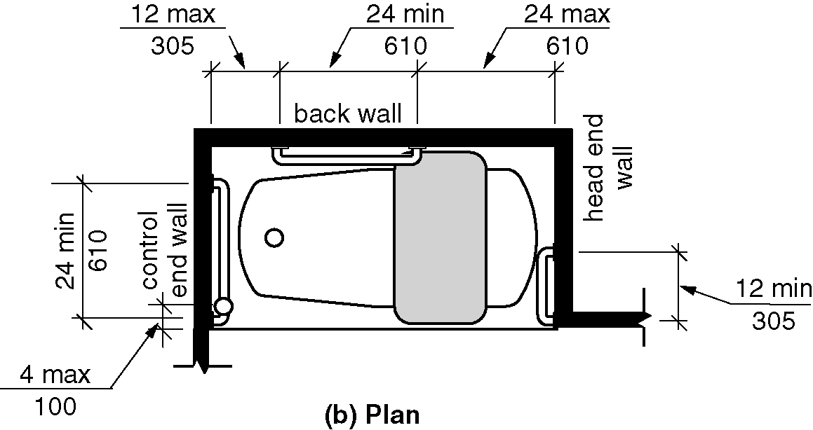
b) Plan

607.4.2.1 Back Wall. Two horizontal grab bars shall be provided on the back wall, one complying with Section 609.4 and the other located 8 inches (205 mm) minimum and 10 inches (255 mm) maximum above the rim of the bathtub. Each grab bar shall be 24 inches (610 mm) minimum in length, located 24 inches (610 mm) maximum from the head end wall and extend to 12 inches (305 mm) maximum from the control end wall.

607.4.2.2 Control End Wall. Control end wall grab bars shall comply with Section 607.4.1.2.

607.4.2.3 Head End Wall. A horizontal grab bar 12 inches (305 mm) minimum in length shall be provided on the head end wall at the front edge of the bathtub.

607.5 Controls. Controls, other than drain stoppers, shall be provided on an end wall, located between the bathtub rim and grab bar, and between the open side of the bathtub and the centerline of the width of the bathtub. Controls shall comply with Section 309.4.

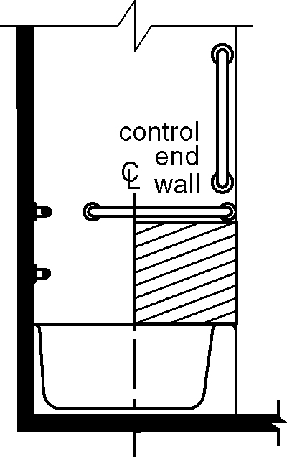
Figure 607.5 – Location of bathtub controls

607.6 Hand Shower. A hand shower with a hose 59 inches (1500 mm) minimum in length, that can be used as both a fixed shower head and as a hand shower, shall be provided. The hand shower shall have a control with a nonpositive shut-off feature. Where provided, an adjustable-height hand shower mounted on a vertical bar shall be installed so as to not obstruct the use of grab bars.

607.7 Bathtub Enclosures. Enclosures for bathtubs shall not obstruct controls, faucets, shower and spray units or obstruct transfer from wheelchairs onto bathtub seats or into bathtubs. Enclosures on bathtubs shall not have tracks installed on the rim of the bathtub.

607.8 Water Temperature. Bathtubs shall deliver water that is 120 degrees F (49 degrees C) maximum.

608 Shower Compartments

608.1 General. Accessible shower compartments shall comply with Section 608. (ed.)

608.2 Size, Clearance and Seat. Shower compartments shall have sizes, clearances and seats complying with Section 608.2.

608.2.1 Transfer-Type Shower Compartments. Transfer-type shower compartments shall comply with Section 608.2.1.

608.2.1.1 Size. Transfer-type shower compartments shall have a clear inside dimension of 36 inches (915 mm) in width and 36 inches (915 mm) in depth, measured at the center point of opposing sides. An entry 36 inches (915 mm) minimum in width shall be provided.

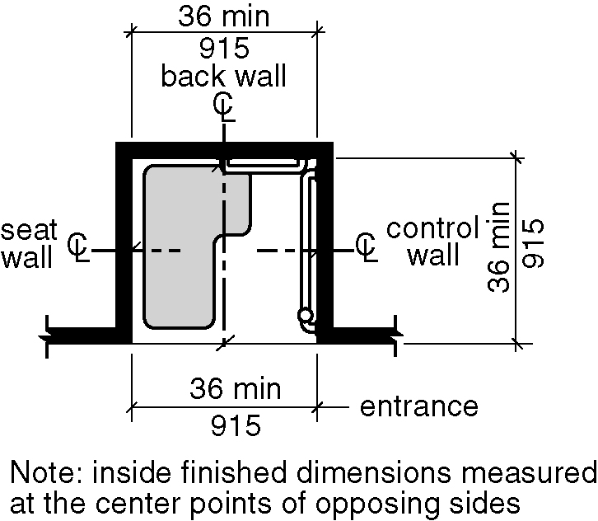
Figure 608.2.1.1 – Transfer type shower compartment size

Figure 608.2.1.2 (a) thru (c) - Transfer type shower compartment clearances
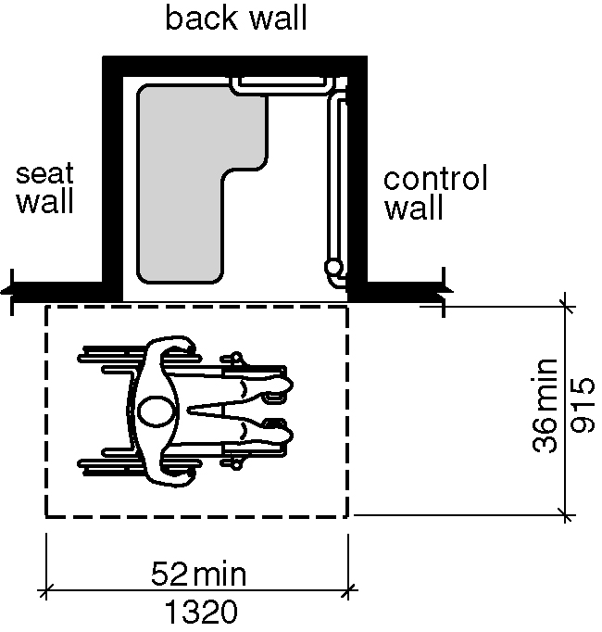
a) new buildings – option 1
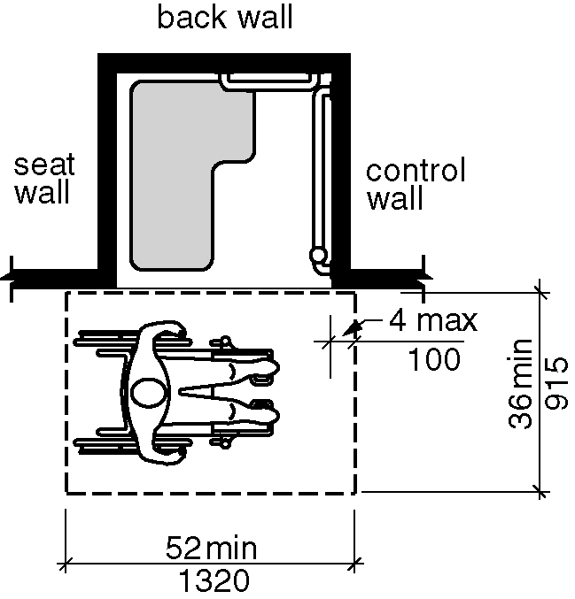
b) new buildings – option 2
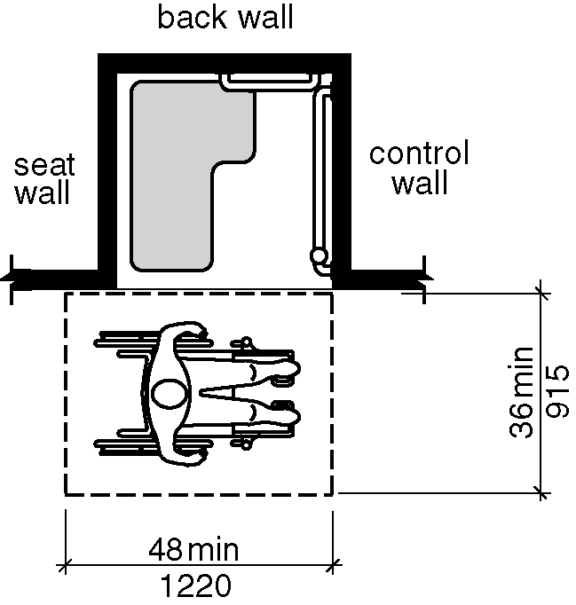
c) existing buildings

608.2.1.2 Clearance.

608.2.1.2.1 New buildings . In new buildings, a clearance of 52 inches (1320 mm) minimum in length, and 36 inches (915 mm) minimum in depth shall be provided adjacent to the open face of the compartment. The length of the clear floor space shall be measured perpendicular from either 1) the control wall or 2) from 4 inches (100 mm) behind the control wall. The seat wall shall align with the wheelchair seat back in accordance with Section 305.8 or be 4 inches (100 mm) maximum behind the seat wall. (6-46-12 PC2.1) (6-46-12/2.1-PC2.1 Agenda #25.1)

608.2.1.2.2 Existing buildings and within new Type B units. In existing buildings and within new Type B units, a clearance of 48 inches (1220 mm) minimum in length measured perpendicular from the control wall, and 36 inches (915 mm) minimum in depth shall be provided adjacent to the open face of the compartment. (3-6-12 PC2) (ed.)

608.2.1.3 Seat. A folding or non-folding seat complying with Section 610 shall be provided on the wall opposite the control wall.

Exception: A seat is not required to be installed in a shower for a single occupant, accessed only through a private office and not for common use or public use, provided reinforcement has been installed in walls and located so as to permit the installation of a shower seat.

608.2.2 Standard Roll-in-Type Shower Compartments. Standard roll-in-type shower compartments shall comply with Section 608.2.2.

608.2.2.1 Size. Standard roll-in-type shower compartments shall have a clear inside dimension of 60 inches (1525 mm) minimum in width and 30 inches (760 mm) minimum in depth, measured at the center point of opposing sides. An entry 60 inches (1525 mm) minimum in width shall be provided.

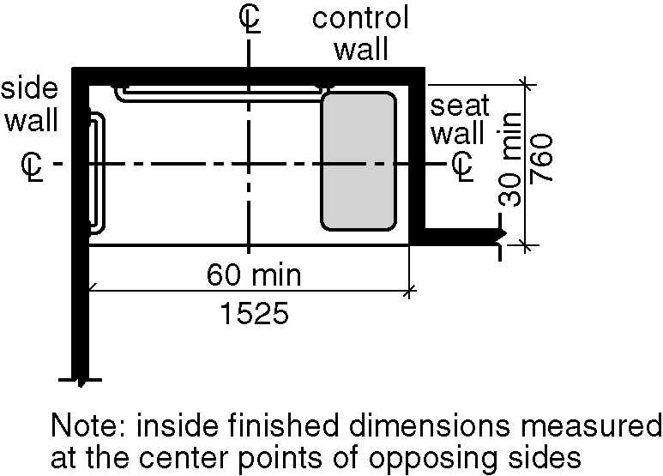
Figure 608.2.2.1 - Standard roll-in-type shower compartment size

608.2.2.2 Clearance. A clearance of 60 inches (1525 mm) minimum in length adjacent to the 60-inch (1525 mm) width of the open face of the shower compartment, and 30 inches (760 mm) minimum in depth, shall be provided.

EXCEPTION: A lavatory complying with Section 606 shall be permitted at the end of the clearance opposite the seat.

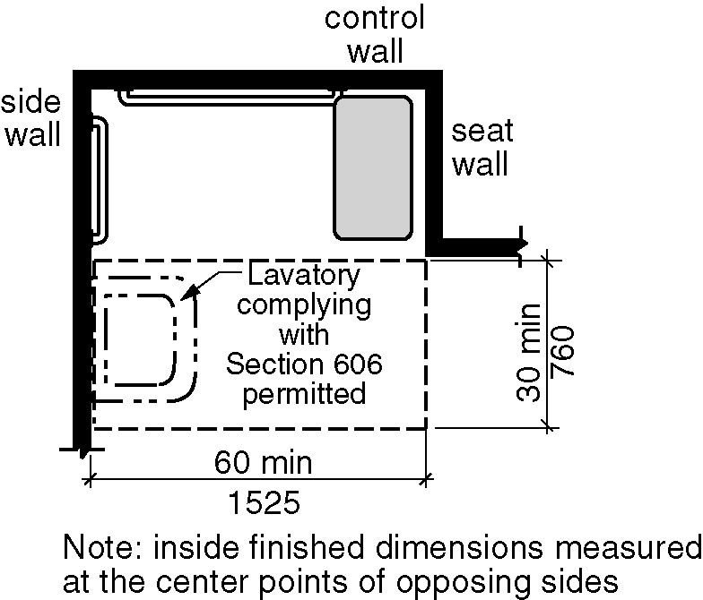
Figure 608.2.2.2 - Standard roll-in-type shower compartment clearance

608.2.2.3 Seat. A folding seat complying with Section 610 shall be provided on an end wall.

EXCEPTIONS:

1. A seat is not required to be installed in a shower for a single occupant accessed only through a private office and not for common use or public use, provided reinforcement has been installed in walls and located so as to permit the installation of a shower seat.

2. A fixed seat shall be permitted where the seat does not overlap the minimum clear inside dimension required by Section 608.2.2.1.

608.2.3 Alternate Roll-in-Type Shower Compartments. Alternate roll-in-type shower compartments shall comply with Section 608.2.3.

608.2.3.1 Size. Alternate roll-in shower compartments shall have a clear inside dimension of 60 inches (1525 mm) minimum in width, and 36 inches (915 mm) in depth, measured at the center point of opposing sides. An entry 36 inches (915) mm) minimum in width shall be provided at one end of the 60-inch (1525 mm) width of the compartment. A seat wall, 24 inches (610 mm) minimum and 36 inches (915 mm) maximum in length, shall be provided on the entry side of the compartment.

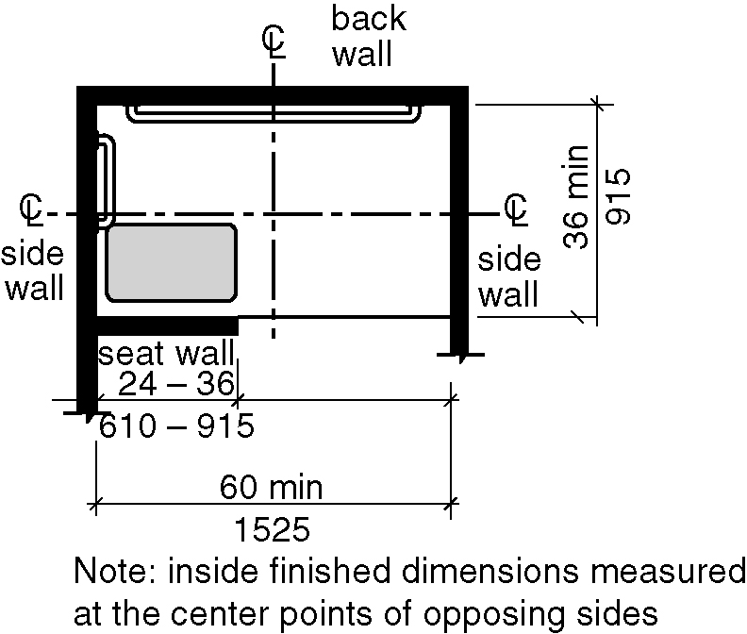
Figure 608.2.3.1 Alternate roll-in shower compartment size

608.2.3.2 Seat. A folding seat complying with Section 610 shall be provided on the seat wall opposite the back wall.

EXCEPTION: A seat is not required to be installed in a shower for a single occupant, accessed only through a private office and not for common use or public use, provided reinforcement has been installed in walls and located so as to permit the installation of a shower seat.

608.3 Grab Bars. Grab bars shall comply with Section 609 and shall be provided in accordance with Section 608.3. Where multiple grab bars are used, required horizontal grab bars shall be installed at the same height above the floor.

EXCEPTION: Grab bars shall not be required to be installed in a shower for a single occupant, accessed only through a private office and not for common use or public use, provided reinforcement has been installed in walls and located so as to permit the installation of grab bars complying with Section 608.3. (ed.)

608.3.1 Transfer-Type Showers. Grab bars for transfer type showers shall comply with Section 608.3.1.

Figure 608.3.1 – Grab bars in transfer-type shower

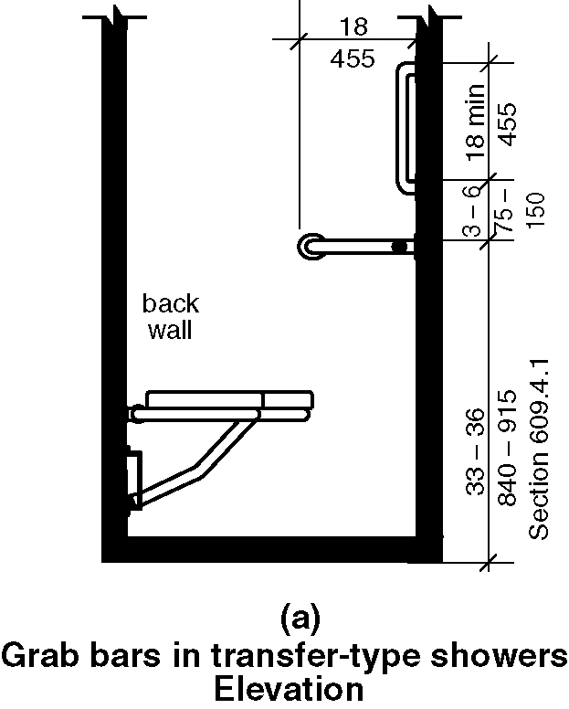
a)elevation
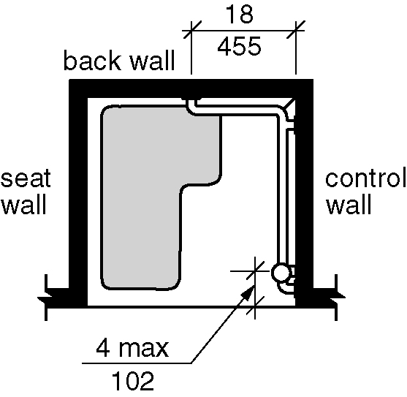
b)plan

608.3.1.1 Horizontal Grab Bars. Horizontal grab bars shall be provided across the control wall and on the back wall to a point 18 inches (455 mm) from the control wall.

608.3.1.2 Vertical Grab Bar. A vertical grab bar 18 inches (455 mm) minimum in length shall be provided on the control end wall 3 inches (75 mm) minimum and 6 inches (150 mm) maximum above the horizontal grab bar, and 4 inches (100 mm) maximum inward from the front edge of the shower.

608.3.2 Standard Roll-in-Type Showers. Grab bars in standard roll-in showers shall comply with Sections 608.3.2.1 through 608.3.2.3. (6-55-12 PC1)

Figure 608.3.2 – Grab bars in standard roll-in-type shower

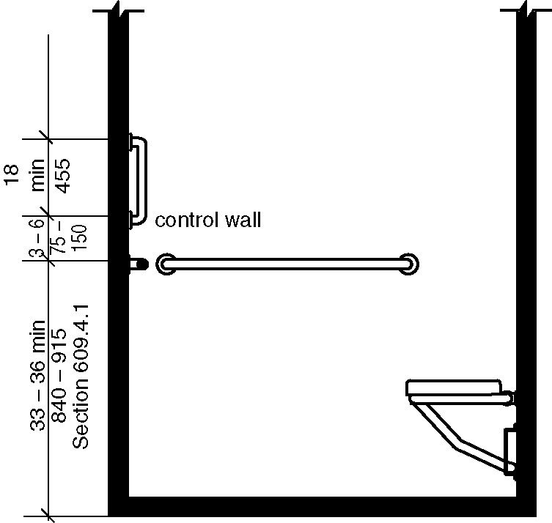
a)elevation

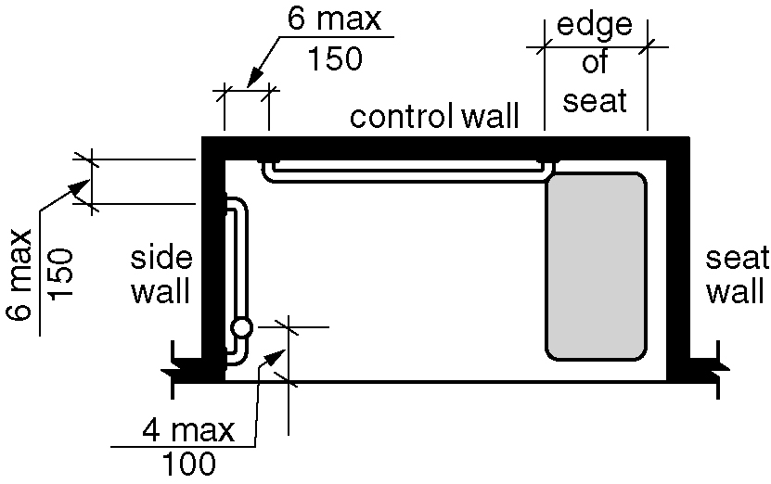
b)plan

608.3.2.1 Back wall grab bar. In standard roll-in type showers, a grab bar shall be provided on the back wall beginning at the edge of the seat. The grab bars shall not be provided above the seat. The back wall grab bar shall extend the length of the wall and extend within 6 inches (150 mm) maximum from the adjacent side wall opposite the seat.

Exceptions:
1. The back wall grab bar but shall not be required to exceed 48 inches (1220 mm) in length.

2. The back wall grab bar is not required to extend within 6 inches (150 mm) of the adjacent side wall opposite the seat if it would require the grab bar length to exceed 48 inches (1220 mm) in length. (6-55-12/3.1-PC3.2 – Agenda item #28.2)

608.3.2.1 Back wall grab bar. In standard roll-in type showers, a grab bar shall be provided on the back wall beginning at the edge of the seat. The grab bars shall not be provided above the seat. The back wall grab bar shall extend the length of the wall and extend within 6 inches (150 mm) maximum from the adjacent side wall opposite the seat.

Exceptions:
1. The back wall grab bar but shall not be required to exceed 48 inches (1220 mm) in length.
608.3.2.2 Side wall grab bars. Where a side wall is provided opposite the seat within 72 inches (1830 mm) of the seat wall, a grab bar shall be provided on the side wall opposite the seat. The side wall grab bar shall extend the length of the wall and extend within 6 inches (150 mm) maximum from the adjacent back wall. (6-55-12 PC1)

Exception: The side wall grab bar shall not be required to exceed 30 inches (760 mm) in length. (6-55-12 PC1)

608.3.2.3 Vertical Grab Bar. Where a side wall is provided opposite the seat within 72 inches (1830 mm) of the seat wall a vertical grab bar shall be provided. A vertical grab bar 18 inches (450 mm) minimum in length shall be provided on the end wall 3 inches (75 mm) minimum and 6 inches (150 mm) maximum above the horizontal grab bar, and 4 inches (100 mm) maximum inward from the front edge of the shower. (6-61-12 PC1.2)

608.3.3 Alternate Roll-in-Type Showers. In alternate roll-in type showers, grab bars shall be provided on the back wall and the side wall adjacent to the seat. Grab bars shall not be provided above the seat. Grab bars shall be 6 inches (150 mm) maximum from the adjacent wall. (ed.)

Figure 608.3.3 – Grab bars in alternate roll-in-type shower
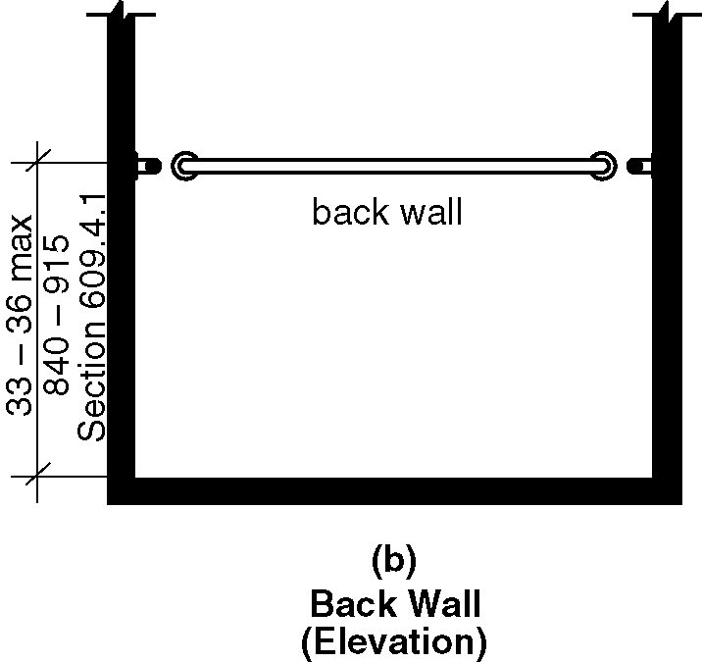
a)elevation
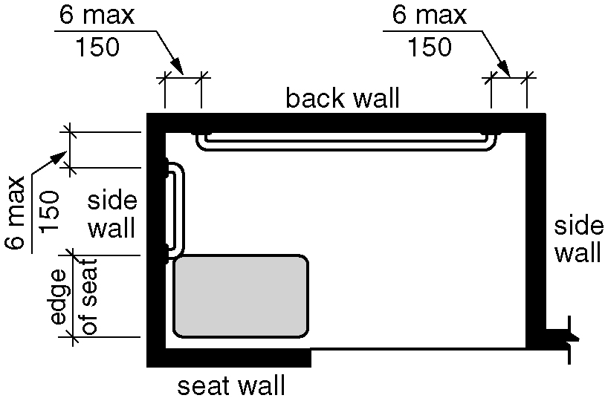
b)plan
.

608.4 Controls and Hand Showers. Controls and hand showers shall comply with Sections 608.4 and 309.4.

608.4.1 Transfer-Type Showers. In transfer-type showers, the controls and hand shower shall be located:

1. On the control wall opposite the seat.
2. At a height of 38 inches (965 mm) minimum and 48 inches (1220 mm) maximum above the shower floor, and
3. 15 inches (380 mm) maximum, from the centerline of the control wall toward the shower opening.

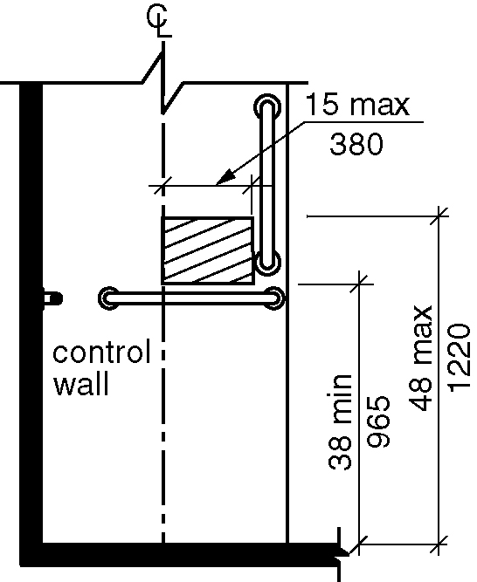
Figure 608.4.1 - Transfer type shower controls and handshower location

608.4.2 Standard Roll-in Showers. In standard roll-in showers, the controls and hand shower shall not be located above the seat. Controls and hand showers shall be located according to the following: (6-61-12) (6-61-12 PC1.2)

1. On the back wall,
2. At a height 38 inches (965 mm) minimum and 48 inches (1220 mm) maximum above the shower floor, and
3. 16 inches (405 mm) minimum and 27 inches (685 mm) maximum from the wall behind the seat. (6-60-12)

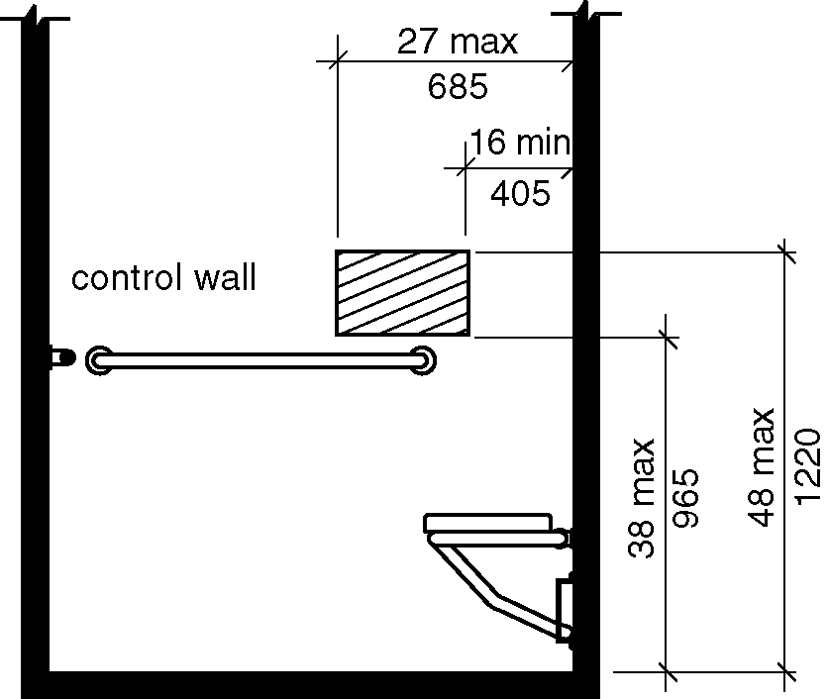
Figure 608.4.2 – Standard roll-in-type shower controls and handshower location

608.4.3 Alternate Roll-in Showers. In alternate roll-in showers, the controls and hand shower shall be located:

- At a height of 38 inches (965 mm) minimum and 48 inches (1220 mm) maximum above the shower floor., and
- Where the controls and hand shower are located on the end wall adjacent to the seat, the controls and hand shower shall be 16 inches (405 mm) minimum and 27 inches (685 mm) maximum from the wall behind the seat wall., or
- Where the controls and hand shower are located on the back wall opposite the seat, the controls and hand shower shall be located within 15 inches (380 mm) maximum from, left or right, of the centerline of the seat toward the transfer space. (6-60-12)(6-62-12) (ed.)

Figure 608.4.3 – Alternate roll-in-type shower controls and handshower location
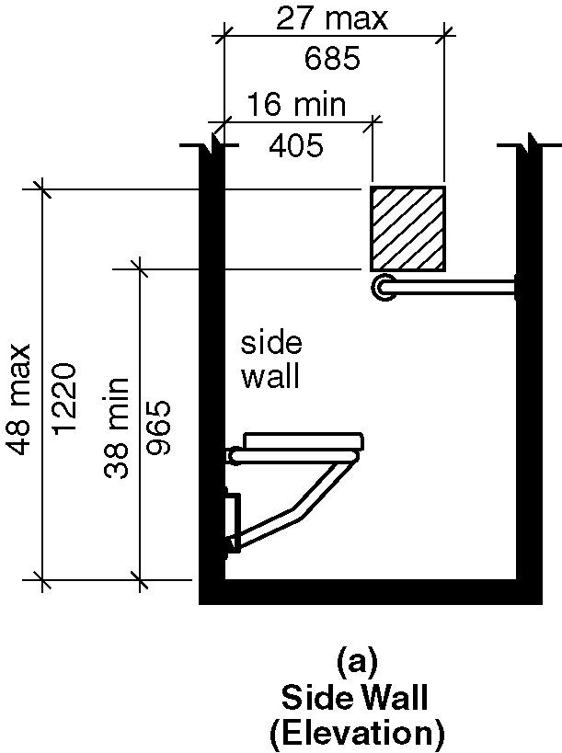
a) side wall elevation
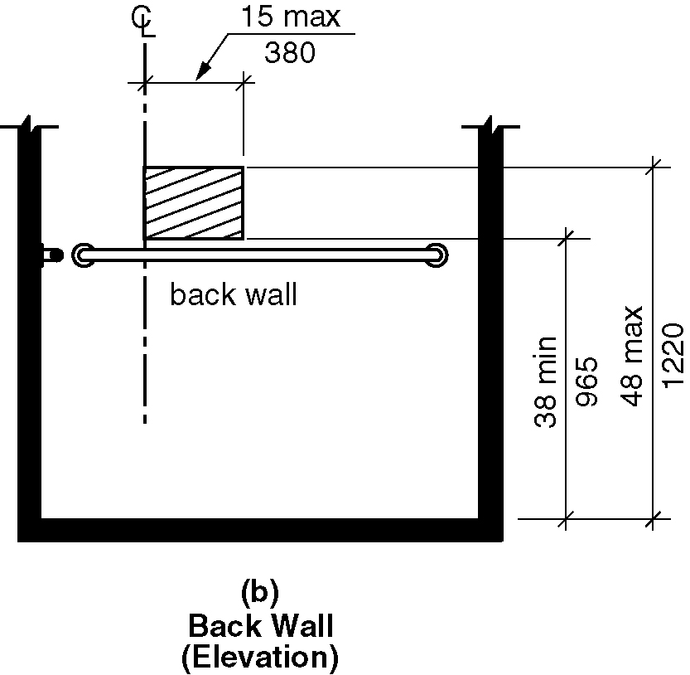
b)back wall elevation

608.5 Hand Showers. A hand shower with a hose 59 inches long (1500 mm) minimum in length, that can be used both as a fixed shower head and as a hand shower, shall be provided. The hand shower shall have a control with a nonpositive shut-off feature. Where provided, an adjustable-height hand shower mounted on a vertical bar shall be installed so as to not obstruct the use of grab bars. A means to hold the hand shower wand while in the on or off position shall be located at a height of 38 inches minimum and 48 inches maximum above the shower finish floor. (6-65-12)

EXCEPTION: In other than Accessible units and Type A units, a fixed shower head located 48 inches (1220 mm) maximum above the shower floor shall be permitted in lieu of a hand shower.

608.6 Thresholds. Thresholds in roll-in-type shower compartments shall be ¹/2 inch (13 mm) maximum in height in accordance with Section 303. In transfer-type shower compartments, thresholds ¹/2 inch (13 mm) maximum in height shall be beveled, rounded, or vertical.

EXCEPTION: In existing facilities, in transfer-type shower compartments where provision of a threshold ¹/2 inch (13 mm) in height would disturb the structural reinforcement of the floor slab, a threshold 2 inches (51 mm) maximum in height shall be permitted.

608.7 Shower Enclosures. Shower compartment enclosures for shower compartments shall not obstruct controls or obstruct transfer from wheelchairs onto shower seats.

608.8 Water Temperature. Showers shall deliver water that is 120 degrees F (49 degrees C) maximum.

609 Grab Bars

609.1 General. Grab bars in accessible toilet or bathing facilities shall comply with Section 609. (ed.)

609.2 Cross Section. Grab bars shall have a cross section complying with Section 609.2.1 or 609.2.2.

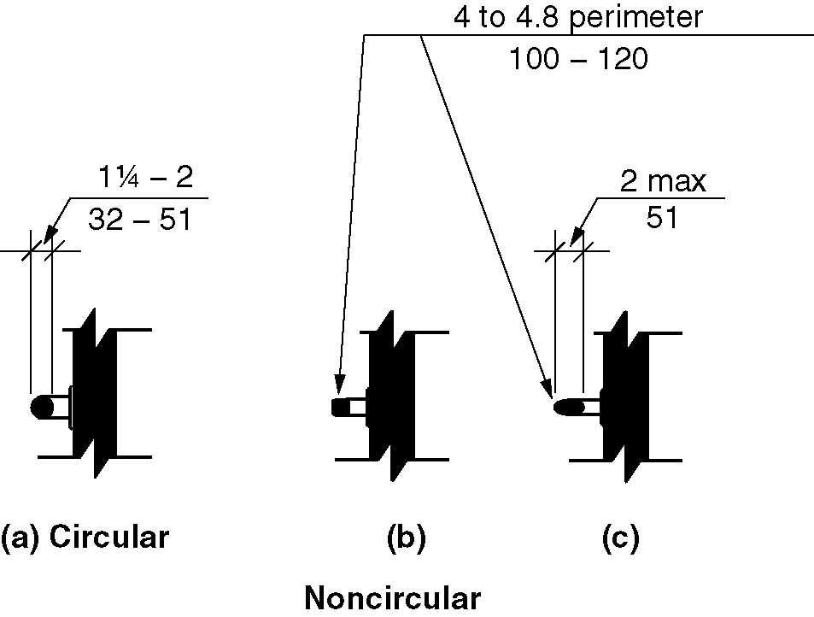
Figure 609.2 - Size of grab bars

609.2.1 Circular Cross Section. Grab bars with a circular cross section shall have an outside diameter of 1 ¹/₄ inch (32 mm) minimum and 2 inches (51 mm) maximum.

609.2.2 Noncircular Cross Section. Grab bars with a noncircular cross section shall have a cross section dimension of 2 inches (51 mm) maximum, and a perimeter dimension of 4 inches (100 mm) minimum and 4.8 inches (122 mm) maximum.

609.3 Spacing. The space between the wall and the grab bar shall be 1¹/2 inches (38 mm). The space between the grab bar and projecting objects below and at the ends of the grab bar shall be 1¹/2 inches (38 mm) minimum. The space between the grab bar and projecting objects above the grab bar shall be 12 inches (305 mm) minimum.

EXCEPTIONS:

1. The space between the grab bars and shower controls, shower fittings, and other grab bars above the grab bar shall be permitted to be 1¹/2 inches (38 mm) minimum.

2. Recessed dispensers projecting from the wall ¼ inch (6.3 mm) maximum measured from the face of the dispenser and complying with Section 604.7 shall be permitted within the 12-inch (305 mm) space above and the 1 ½ inch (38 mm) spaces below and at the ends of the grab bar.

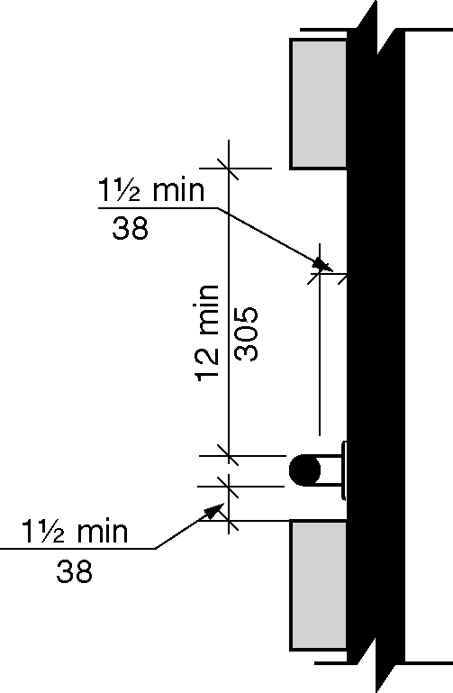
Figure 609.3 – Spacing of grab bars

609.4 Position of Grab Bars.

609.4.1 General. Grab bars shall be installed in a horizontal position, 33 inches (840 mm) minimum and 36 inches (915 mm) maximum above the floor measured to the top of the gripping surface or shall be installed as required by Items 1 through 3.

- The lower grab bar on the back wall of a bathtub shall comply with Section 607.4.1.1 or 607.4.2.1.

- Vertical grab bars shall comply with Sections 604.5.1, 607.4.1.2.2, 607.4.2.2, and 608.3.1.2.

- Grab bars at water closets primarily for children’s use shall comply with Section 609.4.2

609.4.2 Position of Children’s Grab Bars. At water closets primarily for children's use complying with Section 604.11, grab bars shall be installed in a horizontal position 18 inches (455 mm) minimum and 27 inches (685 mm) maximum above the floor measured to the top of the gripping surface. A vertical grab bar shall be mounted with the bottom of the bar located between 21 inches (533 mm) minimum and 30 inches (760 mm) maximum above the floor and with the centerline of the bar located between 34 inches (865 mm) minimum and 36 inches (915 mm) maximum from the rear wall.

Figure 609.4.2 – Positions of children’s grab bars
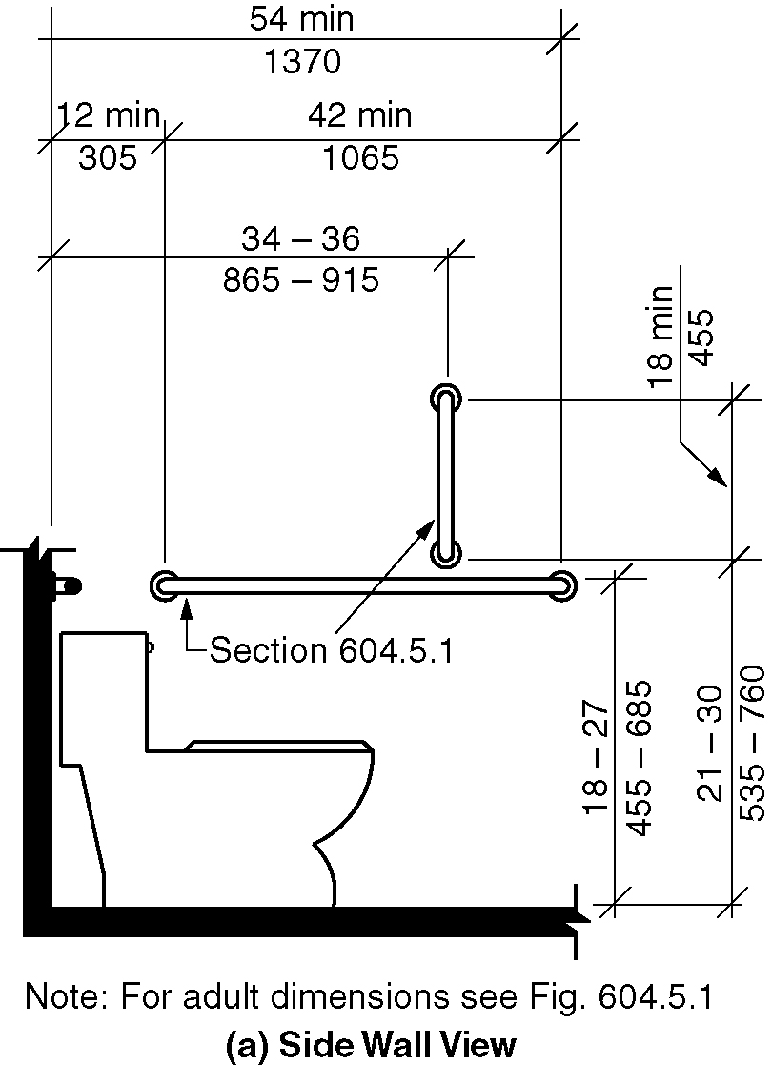
a) Side wall view
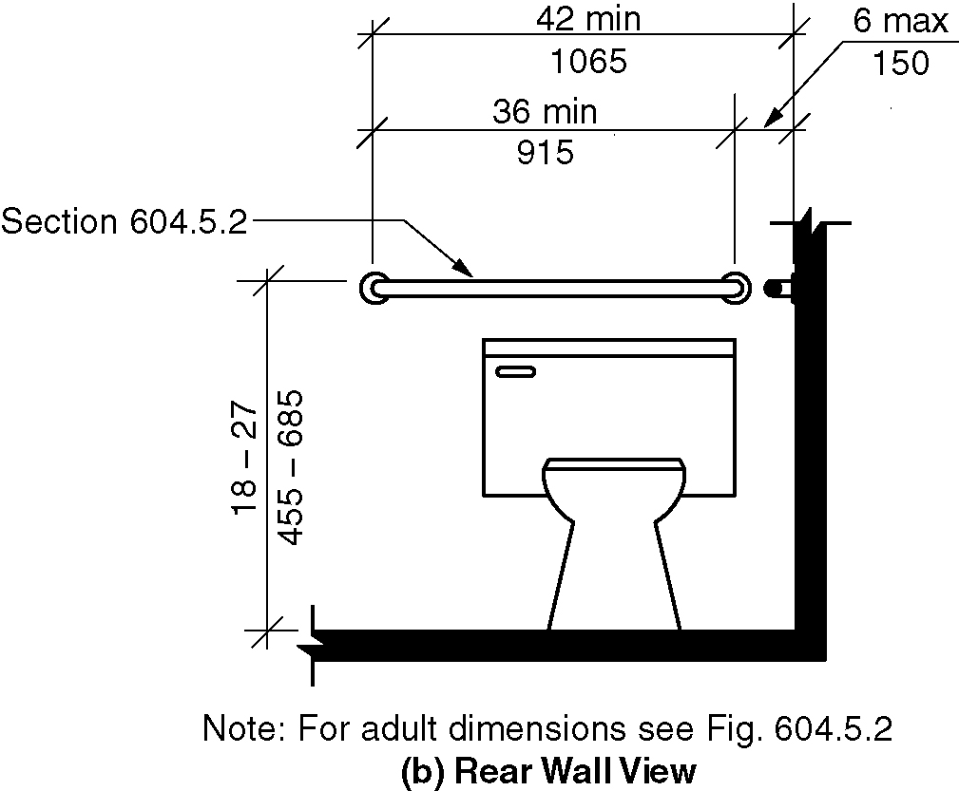
b) Rear wall view

609.5 Surface Hazards. Grab bars, and any wall or other surfaces adjacent to grab bars, shall be free of sharp or abrasive elements. Edges shall be rounded.

609.6 Fittings. Grab bars shall not rotate within their fittings.

609.7 Installation and Configuration. Grab bars shall be installed in any manner that provides a gripping surface at the locations specified in this standard and does not obstruct the clear floor space. Horizontal and vertical grab bars shall be permitted to be separate bars, a single piece bar, or combination thereof.

609.8 Structural Strength. Allowable stresses shall not be exceeded for materials used where a
vertical or horizontal force of 250 pounds (1112 N) is applied at any point on the grab bar, fastener mounting device, or supporting structure.

610 Seats

610.1 General. Seats in accessible bathtubs and shower compartments shall comply with Section 610. (ed.)

610.2 Bathtub Seats. The height of bathtub seats shall be 17 inches (430 mm) minimum and 19 inches (485 mm) maximum above the bathroom floor, measured to the top of the seat. Removable in-tub seats shall be 15 inches (380 mm) minimum and 16 inches (405 mm) maximum in depth. Removable in-tub seats shall be capable of secure placement. Permanent seats shall be 15 inches (380 mm) minimum in depth and shall extend from the back wall to or beyond the outer edge of the bathtub. Permanent seats shall be positioned at the head end of the bathtub.

Figure 610.2 – Bathtub seats
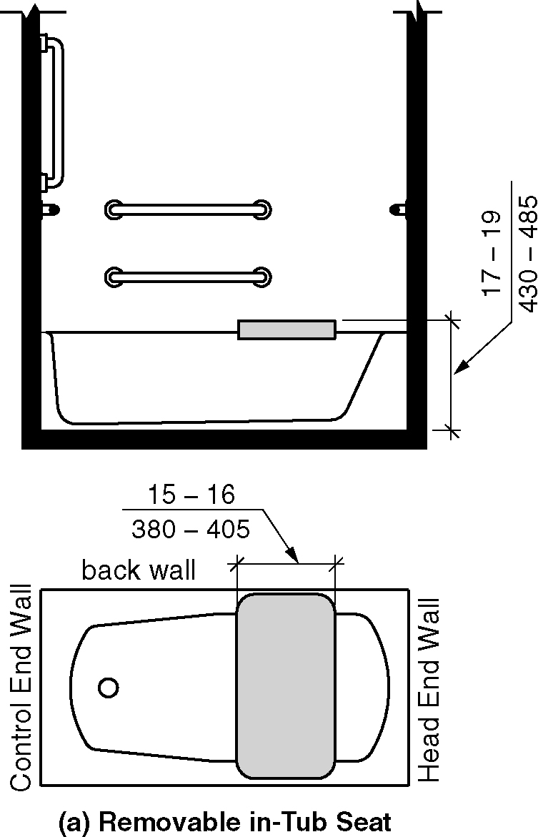
a) Removable in-tub seats
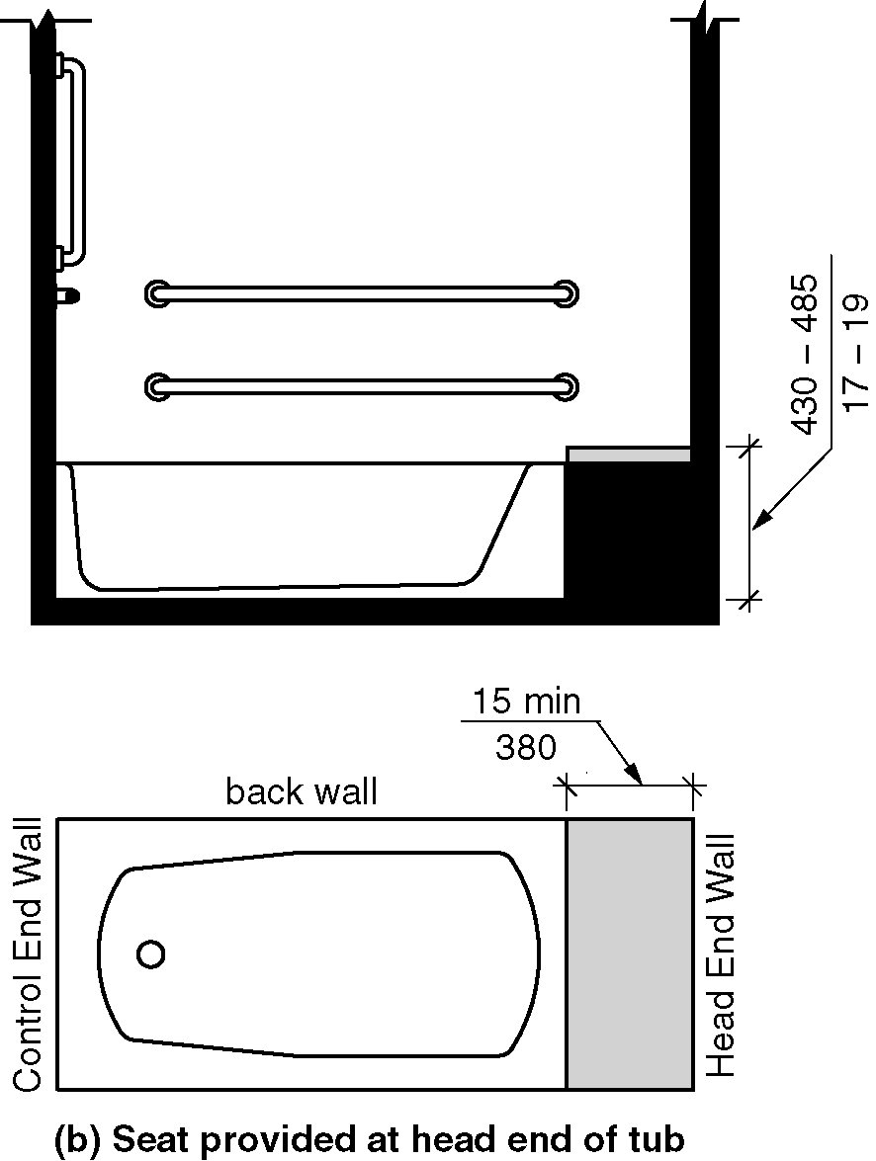
b) Permanent Seats provided at the head end of the bathtub

610.3 Shower Compartment Seats. The height of shower compartment seats shall be 17 inches (430 mm) minimum and 19 inches (485 mm) maximum above the bathroom floor, measured to the top of the seat. In transfer-type and alternate roll-in-type showers, the seat shall extend along the seat wall to a point within 3 inches (75 mm) of the compartment entry. In standard roll-in-type showers, the seat shall extend from the control wall to a point within 3 inches (75 mm) of the compartment entry. Seats shall comply with Section 610.3.1 or 610.3.2.

610.3.1 Rectangular Seats. The rear edge of a rectangular seat shall be 2¹/₂ inches (64 mm) maximum and the front edge 15 inches (380 mm) minimum and 16 inches (405 mm) maximum from the seat wall. The side edge of the seat shall be 1 ¹/₂ inches (38 mm) maximum from the back wall of a transfer-type shower and 1¹/₂ inches (38 mm) maximum from the control wall of a roll-in-type shower.

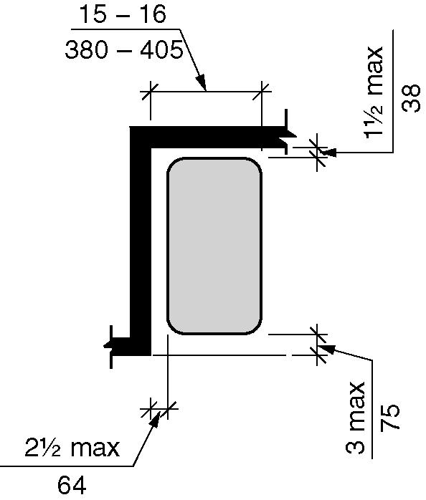
Figure 610.3.1 – Rectangular shower compartment seats

610.3.2 L-Shaped Seats. The rear edge of an L-shaped seat shall be 2¹/₂ inches (64 mm) maximum and the front edge 15 inches (380 mm) minimum and 16 inches (405 mm) maximum from the seat wall. The rear edge of the “L” portion of the seat shall be 1 1/2 inches (38 mm) maximum from the wall and the front edge shall be 14 inches (355 mm) minimum and 15 inches (380 mm) maximum from the wall. The end of the “L” shall be 22 inches (560 mm) minimum and 23 inches (585 mm) maximum from the main seat wall.

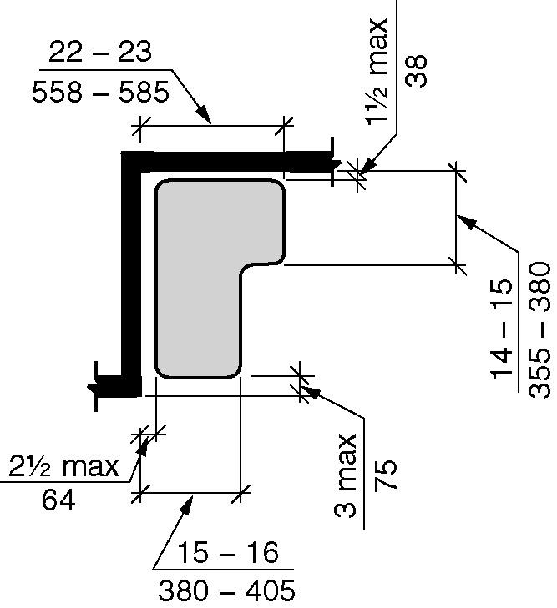
Figure 610.3.2 – L-shaped shower compartment seats

610.4 Structural Strength. Allowable stresses shall not be exceeded for materials used where a vertical or horizontal force of 250 pounds (1112 N) is applied at any point on the seat, fastener mounting device, or supporting structure.

611 Washing Machines and Clothes Dryers

611.1 General. Accessible washing machines and clothes dryers shall comply with Section 611. (ed.)

611.2 Clear Floor Space. A clear floor space complying with Section 305, positioned for parallel approach, shall be provided. For top loading machines, the clear floor space shall be centered on the appliance. For front loading machines, the centerline of the clear floor space shall be offset 24 inches (610 mm) maximum from the centerline of the door opening.

Figure 611.2 - Clear floor space
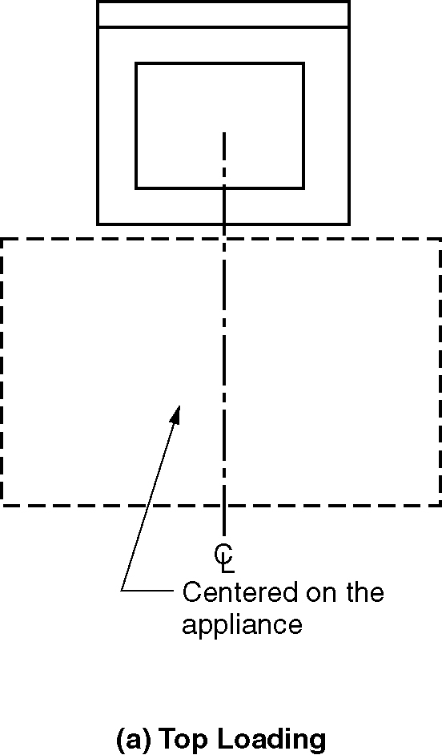
a) top loading
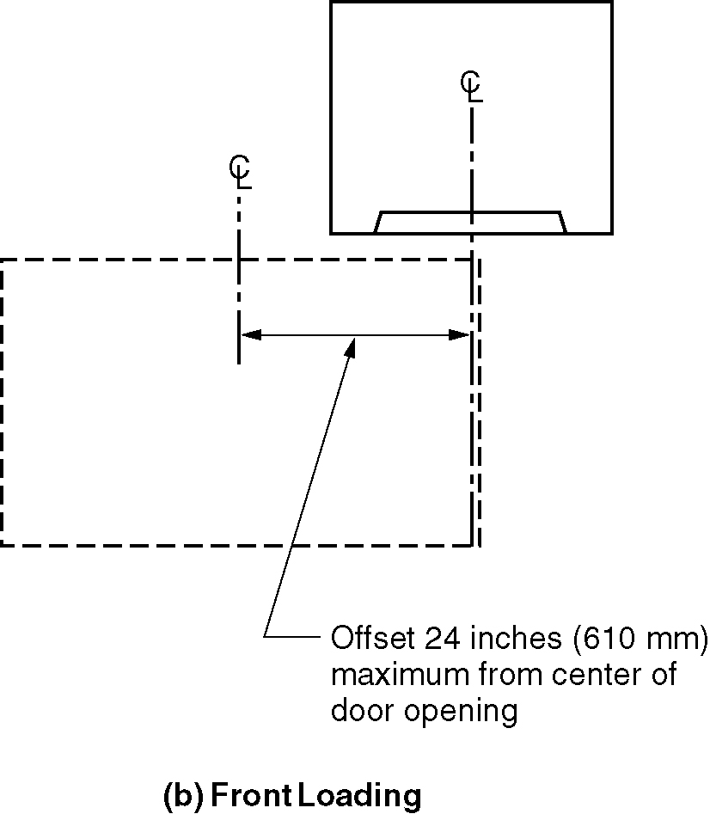
b) front loading

611.3 Operable Parts. Operable parts, including doors, lint screens, detergent and bleach compartments, shall comply with Sections 308 and 309.

EXCEPTION: The height of the obstruction in Section 308.3.2 shall be permitted to be 36 inches (915 mm) maximum above the floor. (6-69-12)

611.4 Height. Top loading machines shall have the door to the laundry compartment 36 inches (915 mm) maximum above the floor. Front loading machines shall have the bottom of the opening to the laundry compartment 15 inches (380 mm) minimum and 36 inches (915 mm) maximum above the floor.

Figure 611.4- Height of the laundry equipment
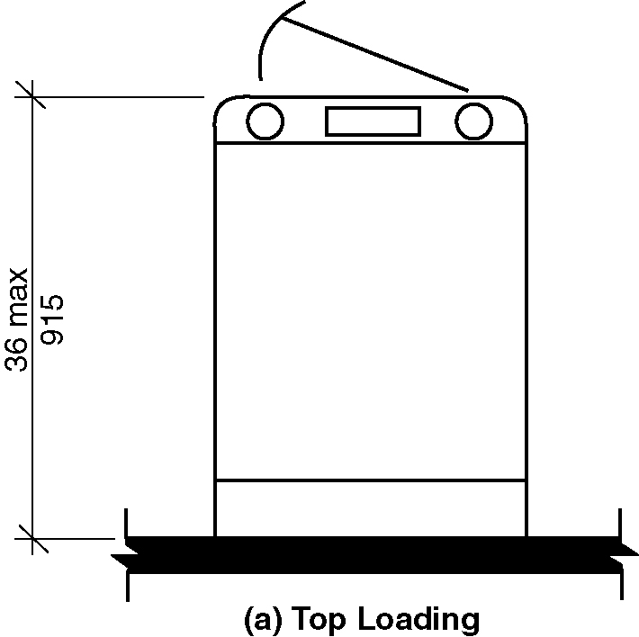
a) top loading
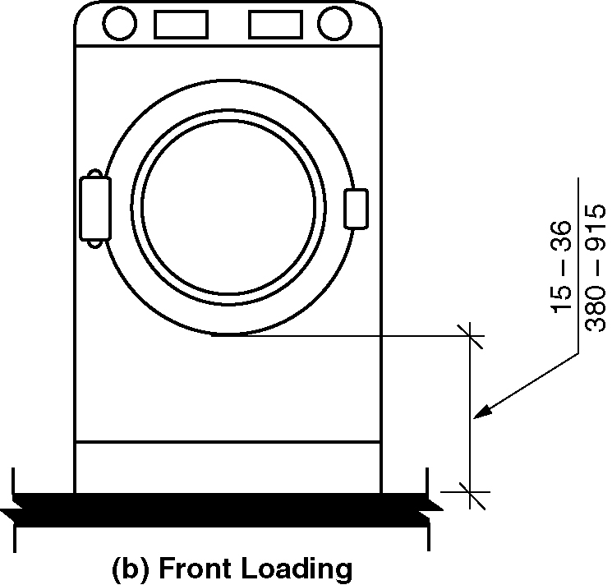
b) front loading

612 Saunas and Steam Rooms

612.1 General. Saunas and steam rooms shall comply with Section 612.

612.2 Bench. Where seating is provided in saunas and steam rooms, at least one bench shall comply with Section 903. Doors shall not swing into the clear floor space required by Section 903.2.

EXCEPTION: Where the room is for individual use and a clear floor space complying with Section 305.3 is provided within the room beyond the arc of the door swing, the door shall not be required to comply with Section 612.2 this section. (6-70-12) (ed.)

612.3 Turning space. A turning space complying with Section 304 shall be provided within saunas and steam rooms.

