Chapter 8. Special Rooms and Spaces

801 General
801.1 Scope. Special rooms and spaces required to be accessible by the scoping provisions adopted by the administrative authority shall comply with the applicable provisions of Chapter 8.

802 Assembly Areas

802.1 General. Wheelchair spaces and wheel chair space locations in assembly areas with spectator seating shall comply with Section 802. Where tiered seating includes dining surfaces or work surfaces, wheelchair spaces and wheelchair space locations shall comply with Section 802.6, 802.7, 802.9, 802.10 and 902. Team and player seating shall comply with Sections 802.2 through 802.7. (8-1-12). (8-2-12)

802.2 Floor Surfaces. The floor surface of wheelchair space locations shall have a slope not steeper than 1:48 and shall comply with Section 302.

802.3 Width. A single wheelchair space shall be 36 inches (915 mm) minimum in width. Where two adjacent wheelchair spaces are provided, each wheelchair space shall be 33 inches (840 mm) minimum in width.

Figure 802.3 – Width of wheelchair space in assembly area
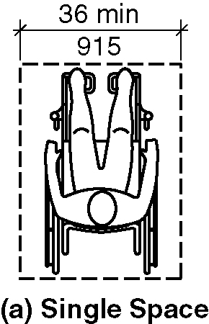
a) single space
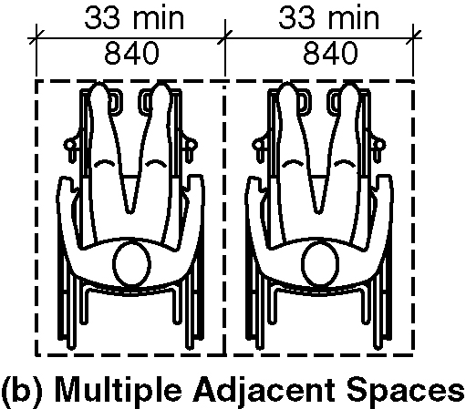
b) multiple adjacent space

802.4 Depth.

Figure 802.4 Depth of wheelchair space in assembly areas
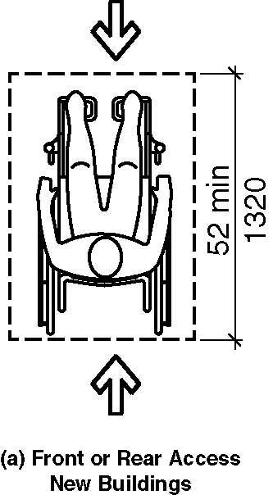
a) front or rear access, new buildings
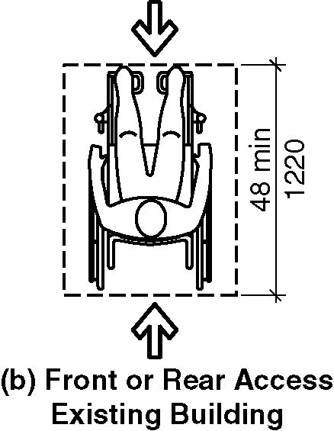
b) front or rear access, existing buildings
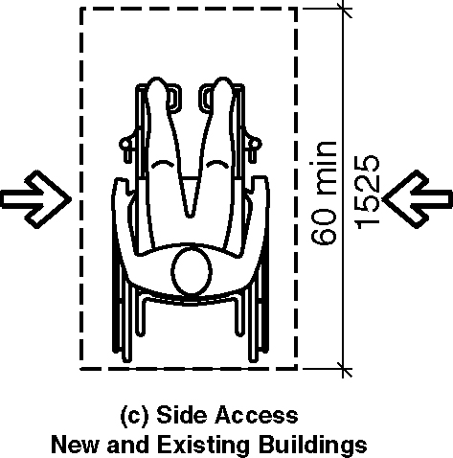
c) side access, new and existing buildings

802.4.1 New buildings. In new buildings, where a wheelchair space is entered from the front or rear, the wheelchair space shall be 52 inches (1320 mm) minimum in depth. Where a wheelchair space is only entered from the side, the wheelchair space shall be 60 inches (1525 mm) minimum in depth. (8-3-12) (ed.)

802.4.2 Existing buildings. In existing buildings, where a wheelchair space is entered from the front or rear, the wheelchair space shall be 48 inches (1220 mm) minimum in depth. Where a wheelchair space is only entered from the side, the wheelchair space shall be 60 inches (1525 mm) minimum in depth. (3-6-12 PC2) (ed.)

802.5 Approach. The wheelchair space shall adjoin an accessible route. The accessible route shall not overlap the wheelchair space.

802.5.1 Overlap. A wheelchair space location shall not overlap the required width of an aisle.

Exception: In new buildings the depth of the wheelchair space shall be permitted to overlap the required aisle width a maximum of 4 inches (100 mm). (3-13D-12) (3-6-12 PC2) (ed.)

Figure 802.5.1 Wheelchair space location Overlap
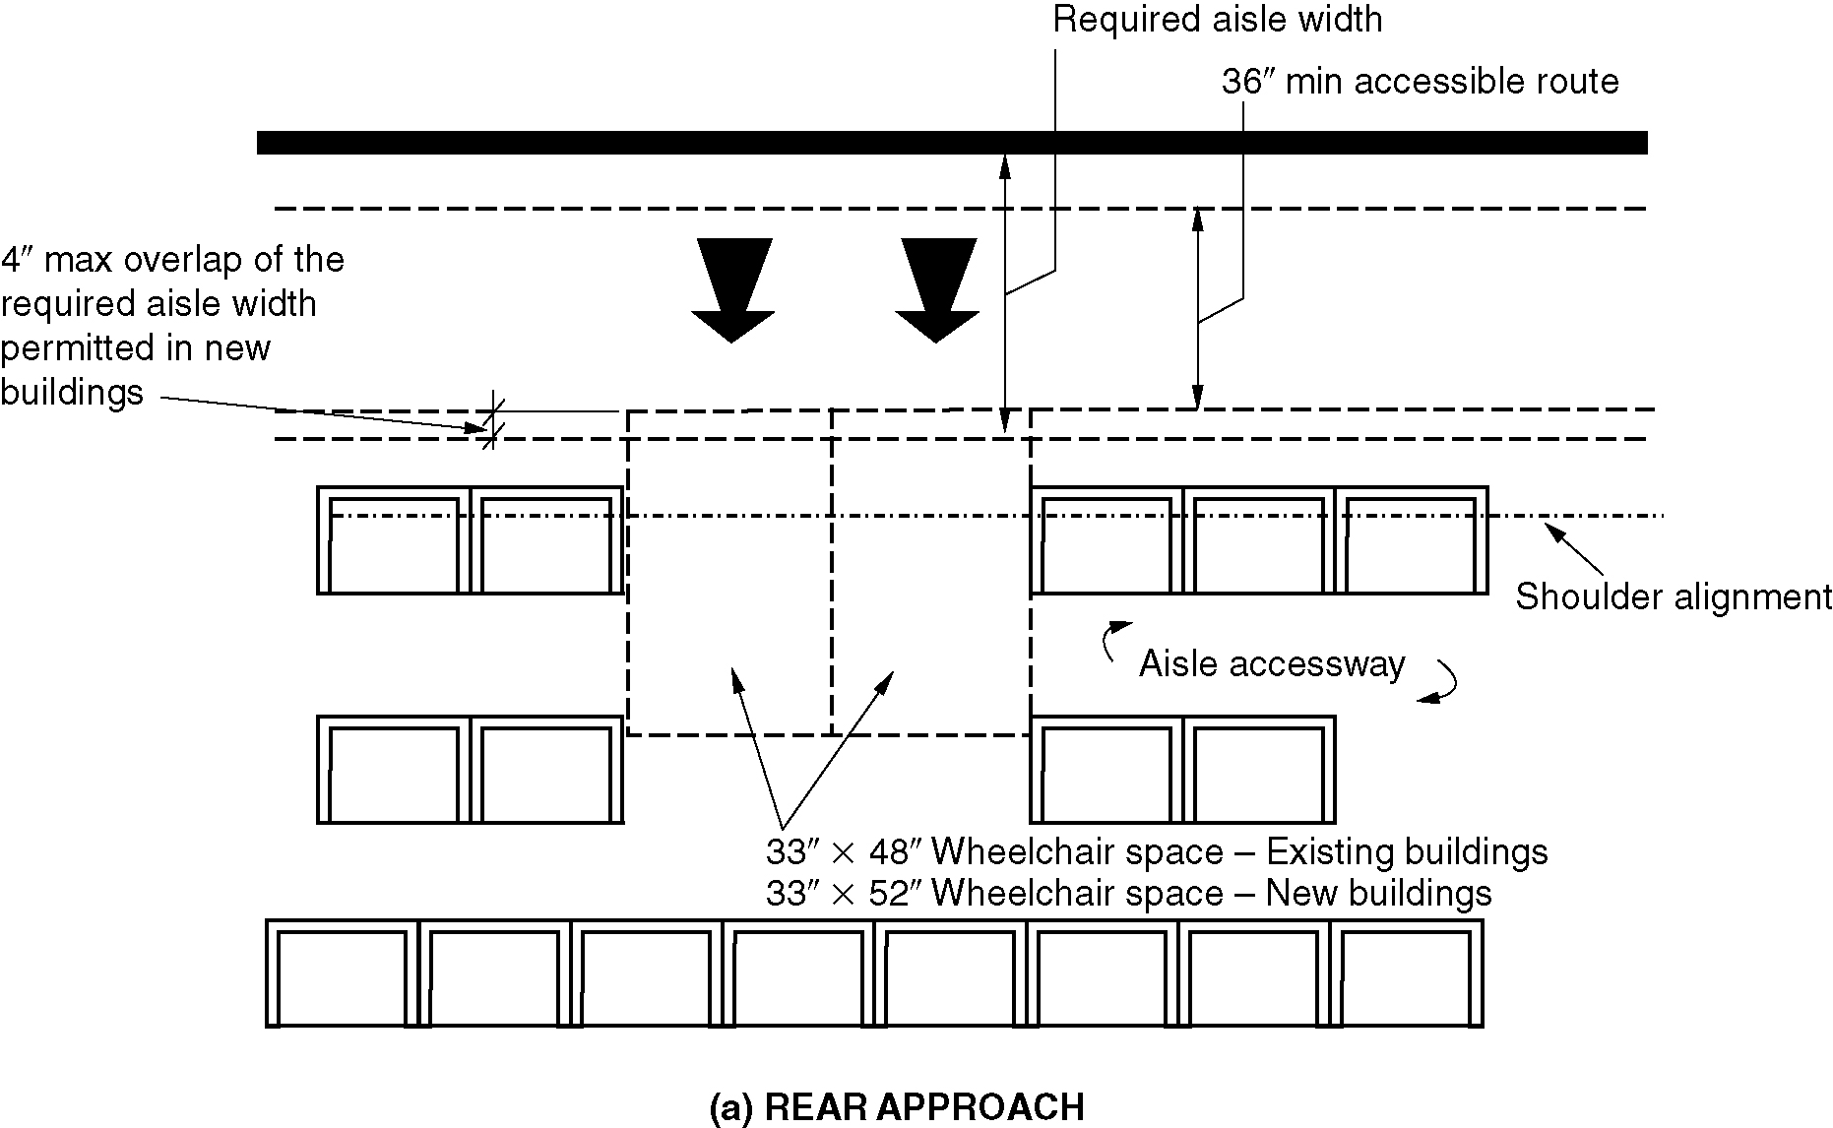
a) rear approach
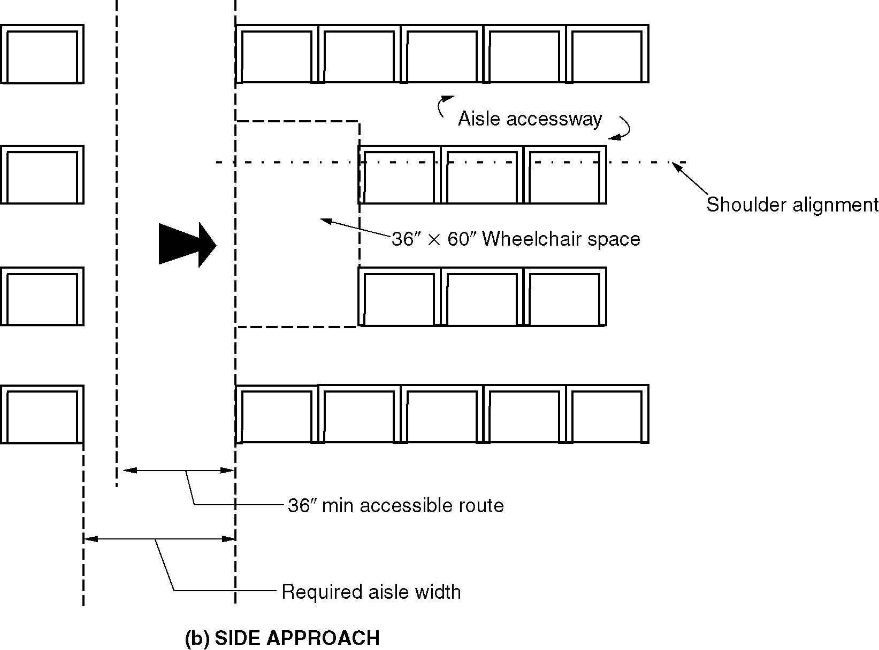
b) side approach

802.6 Integration of Wheelchair Space Locations. Wheelchair space locations shall be an integral part of any seating area.

802.7 Companion Seat. A companion seat, complying with Section 802.7, shall be provided beside each wheelchair space.

802.7.1 Companion Seat Type. The companion seat shall be equivalent in size, quality, comfort and amenities to the seats in the immediate area to the wheelchair space location. Companion seats shall be permitted to be moveable.

802.7.2 Companion Seat Alignment. In row seating, the companion seat shall be located to provide shoulder alignment with the wheelchair space occupant. The floor surface for the companion seat shall be at the same elevation as the wheelchair space floor surface. (3-13E-12)

EXCEPTION: Companion seat alignment shall not be required in tiered seating that includes dining surfaces or work surfaces. (8-2-12) (ed.)

Figure 802.7.2 Companion seat alignment
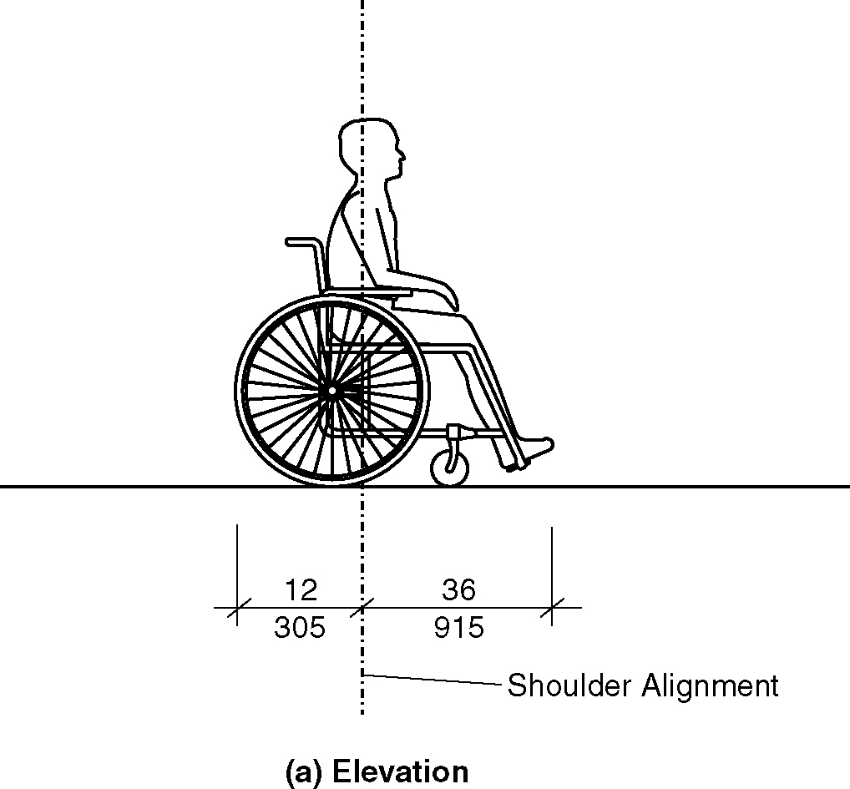
a) elevation
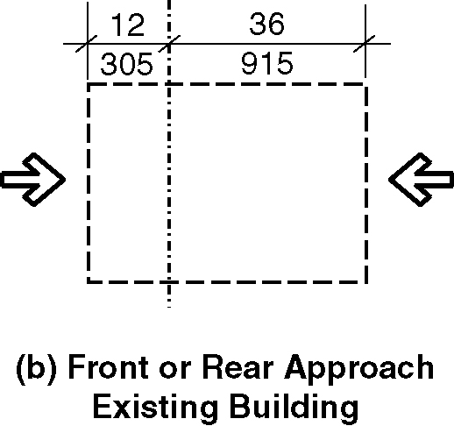
b) Front or rear approach Existing buildings
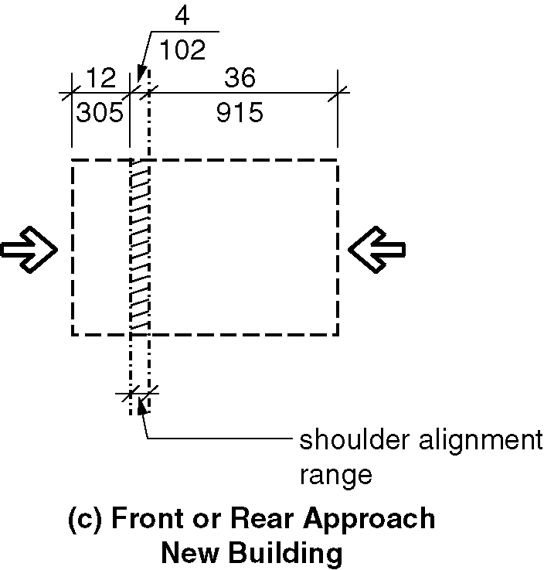

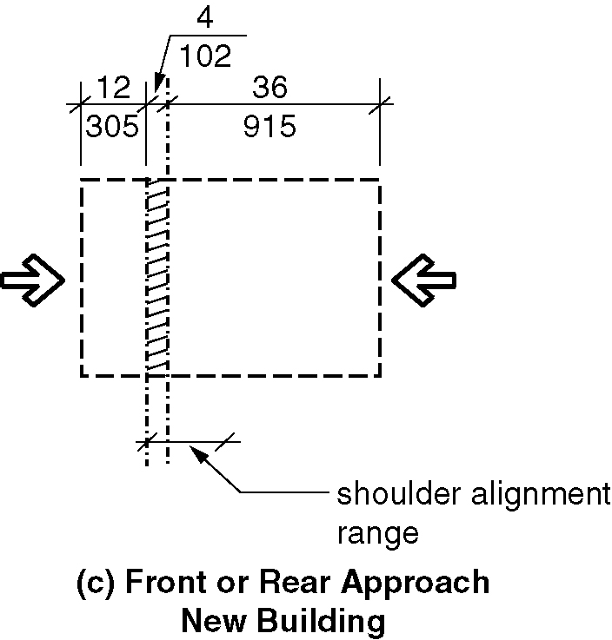
c) Front or rear approach New buildings

6)
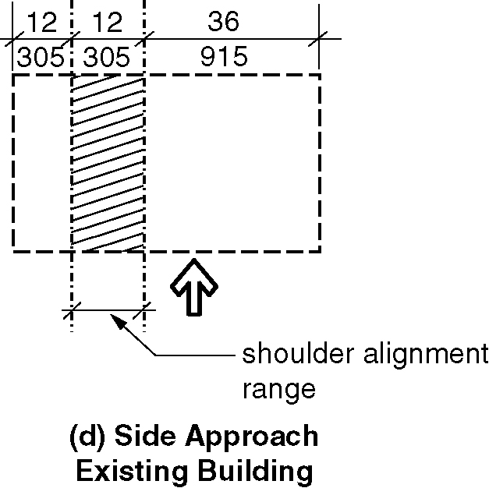
d) Side approach

d) Side approach

802.7.2.1 New buildings. In new buildings, the shoulder of the wheelchair space occupant is considered to be 36 inches (915 mm) or more from the front or 12 inches (305 mm) or more from the rear of the wheelchair space. (ed.)(3-6-12 PC2)

802.7.2.2 Existing buildings. In existing buildings, The shoulder of the wheelchair space occupant is considered to be 36 inches (915 mm) or more from the front or 12 inches (305 mm) or more from the rear of the wheelchair space. (3-6-12 PC2) (ed.)

802.8 Designated Aisle Seats. Designated aisle seats shall comply with Section 802.8.

802.8.1 Armrests. Where armrests are provided on seating in the immediate area of designated aisle seats, folding or retractable armrests shall be provided on the aisle side of the designated aisle seat.

802.8.2 Identification. Each designated aisle seat shall be identified by a sign or marker. (8-1-12)

802.9 Lines of Sight. Where spectators are expected to remain seated for purposes of viewing events, spectators in wheelchair space locations shall be provided with a line of sight in accordance with Section 802.9.1. Where spectators in front of the wheelchair space locations will be expected to stand at their seats for purposes of viewing events, spectators in wheelchair space locations shall be provided with a line of sight in accordance with Section 802.9.2.

802.9.1 Line of Sight over Seated Spectators. Where spectators are expected to remain seated during events, spectators seated in a wheelchair space shall be provided with lines of sight to the performance area or playing field comparable to that provided to seated spectators in closest proximity to the wheelchair space location. Where seating provides lines of sight over heads, spectators in wheelchair space locations shall be afforded lines of sight complying with Section 802.9.1.1. Where wheelchair space locations provide lines of sight over the shoulder and between heads, spectators in wheelchair space locations shall be afforded lines of sight complying with Section 802.9.1.2.

802.9.1.1 Lines of Sight over Heads. Spectators seated in a wheelchair space shall be afforded lines of sight over the heads of seated individuals in the first row in front of the wheelchair space location.

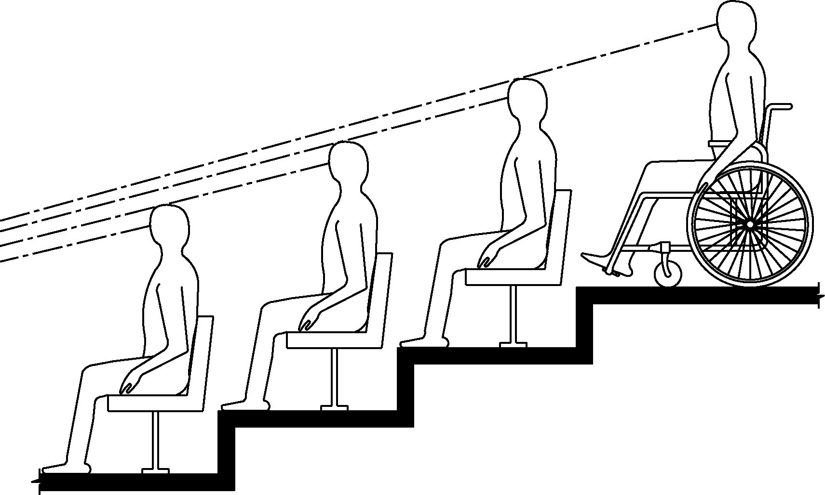
Figure 802.9.1.1 - Lines of sight over the heads of seated spectators

802.9.1.2 Lines of Sight between Heads. Spectators seated in a wheelchair space shall be afforded lines of sight over the shoulders and between the heads of seated individuals in the first row in front of the wheelchair space location.

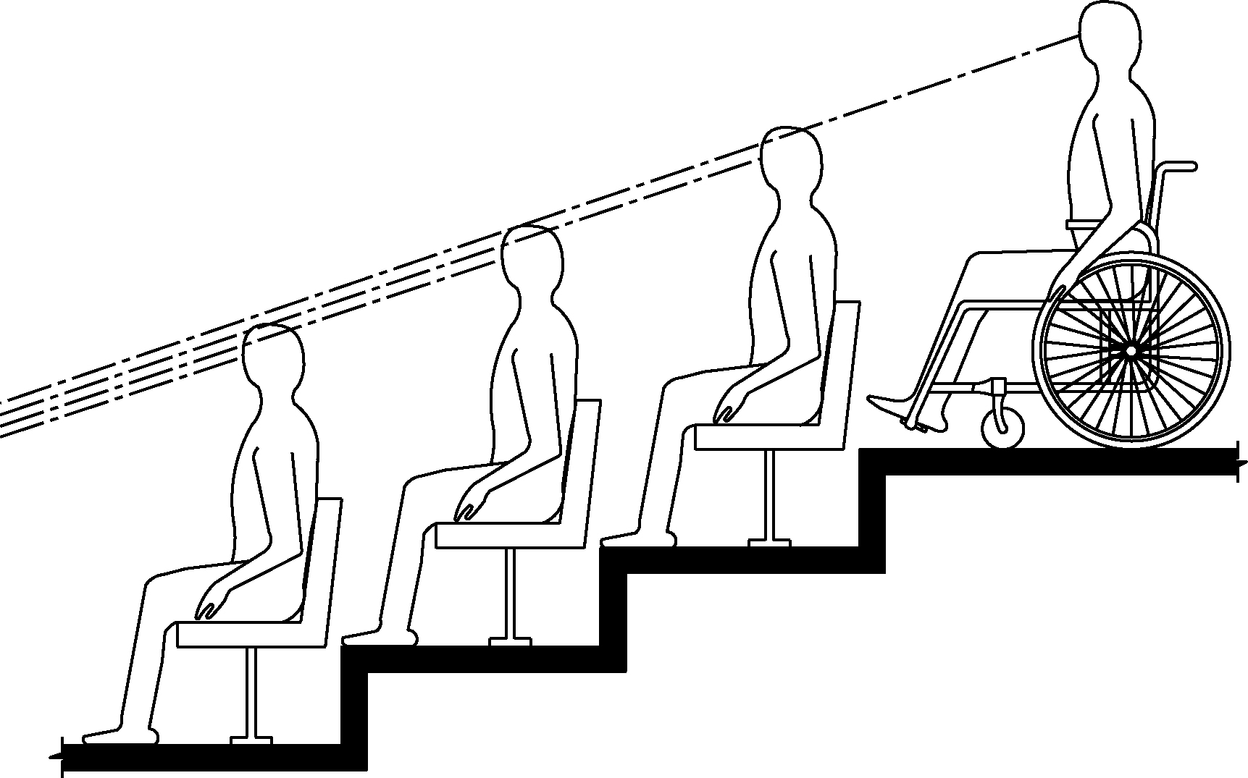
Figure 802.9.1.2 - Lines of sight between the heads of seated spectators

802.9.2 Line of Sight over Standing Spectators. Wheelchair spaces required to provide a line of sight over standing spectators shall comply with Section 802.9.2.

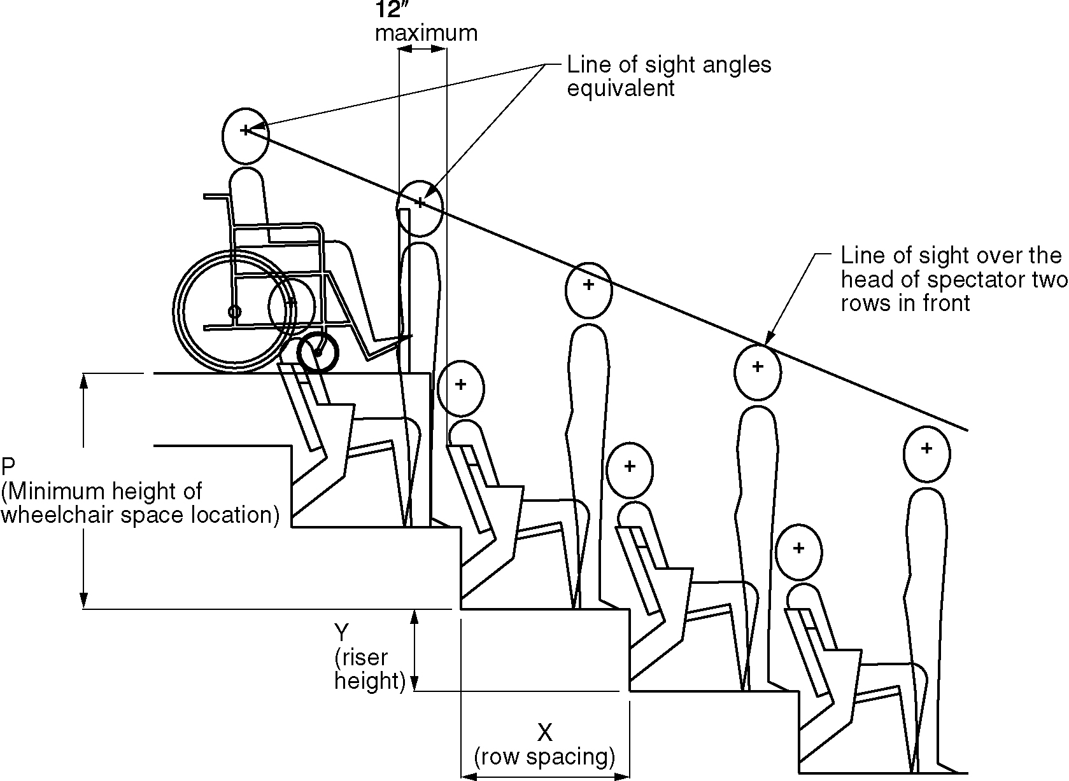
Figure 802.9.2- Lines of sight over standing spectators

802.9.2.1 Distance from Adjacent Seating. The front of the wheelchair space in a wheelchair space location shall be 12 inches (305 mm) maximum from the back of the chair or bench in front.

802.9.2.2 Height. The height of the floor surface at the wheelchair space location shall comply with Table 802.9.2.2. Interpolations shall be permitted for riser heights that are not listed in the table.

Table 802.9.2.2
Required Wheelchair Space Location Elevation Over Standing Spectators
Riser height | Minimum height of the wheelchair space  location based on row spacing¹
 | Rows less than 33  inches (840 mm)² | Rows 33 inches  (840 mm) to  44 inches (1120 mm)² | Rows over  44 inches (1120 mm)²
0 inch (0 mm) | 16 inches (405 mm) | 16 inches (405 mm) | 16 inches (405 mm)
4 inches (100 mm) | 22 inches (560 mm) | 21 inches (535 mm) | 21 inches (535 mm)
8 inches (205 mm) | 31 inches (785 mm) | 30 inches (760 mm) | 28 inches (710 mm)
12 inches (305 mm) | 40 inches (1015 mm) | 37 inches (940 mm) | 35 inches (890 mm)
16 inches (405 mm) | 49 inches (1245 mm) | 45 inches (1145 mm) | 42 inches (1065 mm)
20 inches (510 mm)³ | 58 inches (1475 mm) | 53 inches (1345 mm) | 49 inches (1245 mm)
24 inches (610 mm) | N/A | 61 inches (1550 mm) | 56 inches (1420 mm)
28 inches (710 mm)⁴ | N/A | 69 inches (1750 mm) | 63 inches (1600 mm)
32 inches (815 mm) | N/A | N/A | 70 inches (1780 mm)
36 inches (915 mm) and higher | N/A | N/A | 77 inches (1955 mm)
Footnotes to Table 802.9.2.2
¹The height of the wheelchair space location is the vertical distance from the tread of the row of seats directly in front of the wheelchair space location to the tread of the wheelchair space location.
²The row spacing is the back-to-back horizontal distance between the rows of seats in front of the wheelchair space location. ³Seating treads less than 33 inches (840 mm) in depth shall not be permitted with risers greater than 18 inches (455 mm) in height. (ed.)
⁴Seating treads less than 44 inches (1120 mm) in depth shall not be permitted with risers greater than 27 inches (685 mm) in height. (ed.)

NOTE: Table 802.9.2.2 is based on providing a spectator in a wheelchair a line of sight over the head of a spectator two rows in front of the wheelchair space location using average anthropometrical data. The table is based on the following calculation: [(2X+34)(Y-2.25)/X]+(20.2-Y) where Y is the riser height of the rows in front of the wheelchair space location and X is the tread depth of the rows in front of the wheelchair space location. The calculation is based on the front of the wheelchair space location being located 12 inches (305 mm) from the back of the seating tread directly in front and the eye of the standing spectator being set back 8 inches (205 mm) from the riser.

802.10 Wheelchair Space Dispersion. The minimum number of wheelchair space locations shall be in accordance with Table 802.10. Wheelchair space locations shall be dispersed in accordance with Sections 802.10.1, 802.10.2 and 802.10.3. In addition, wheelchair space locations shall be dispersed in accordance with Section 802.10.4 in spaces utilized primarily for viewing motion picture projection. Once the required number of wheelchair space locations has been met, further dispersion shall not be required.
(ed.)

Table 802.10
Wheelchair Space Location Dispersion

Total seating in Assembly Areas | Minimum required number of  wheelchair space locations
Up to 150 | 1
151 to 500 | 2
501 to 1000 | 3
1001 to 5,000 | 3, plus 1 additional space for each 1,000 seats or portions  thereof above 1,000
5,001 and over | 7, plus 1 additional space for each 2,000 seats or portions  thereof above 5,000

802.10.1 Horizontal Dispersion. Wheelchair space locations shall be dispersed horizontally to provide viewing options. Where seating encircles the stage or field, in whole or in part, horizontal dispersion shall include the entire seating area. Two wheelchair spaces shall be permitted to be located side-by-side. (8-4-12)

EXCEPTION: Horizontal dispersion shall not be required in assembly areas with 300 or fewer seats if the wheelchair space locations are located within the 2nd and 3rd quartile of the row length. Intermediate aisles shall be included in determining the total row length. If the row length in the 2nd and 3rd quartile of the row is insufficient to accommodate the required number of companion seats and wheelchair spaces, the additional companion seats and wheelchair spaces shall be permitted to extend into in the 1st and 4th quartile of the row.

802.10.2 Dispersion for Variety of Distances from the Event. Wheelchair space locations shall be dispersed at a variety of distances from the event to provide viewing options.

EXCEPTIONS:

- In bleachers, wheelchair space locations provided only in rows at points of entry to bleacher seating shall be permitted.

- Assembly areas utilized for viewing motion picture projections with 300 seats or less shall not be required to comply with Section 802.10.2.

- Assembly areas with 300 seats or less other than those utilized for viewing motion picture projections shall not be required to comply with Section 802.10.2 where all wheelchair space locations are within the front 50 percent of the total rows.

802.10.3 Dispersion by Type. Where assembly seating has multiple distinct seating areas with amenities that differ from other distinct seating areas, wheelchair space locations shall be provided within each distinct seating area.

802.10.3.1 Charging Stations. Where charging stations are provided at wheelchair space locations they shall comply with Section 906. (8-5-12)

802.10.4 Spaces Utilized Primarily for Viewing Motion Picture Projections. In spaces utilized primarily for viewing motion picture projections, wheelchair space locations shall comply with Section 802.10.4.

802.10.4.1 Spaces with Seating on Risers. Where tiered seating is provided, wheelchair space locations shall be integrated into the tiered seating area on a riser or a cross-aisle. (8-1-12)

802.10.4.2 Distance from the Screen. Wheelchair space locations shall be located in accordance with one of the following:

1. Within the rear 60 percent of the seats provided; or

2. Located within the area of an auditorium in which the vertical viewing angles, as measured to the top of the screen, are from the 40th to the 100th percentile of vertical viewing angles for all seats as ranked from the seats in the first row (1st percentile) to seats in the back row (100th percentile). (8-1-12)

802.11 Stage Lighting for Sign Language Interpreters (8-6-12 PC1)

802.11.1 General. Sign language interpreter stations shall comply with Section 802.11. (8-6-12 PC1)

802.11.2 Area. A sign language interpreter station shall provide a level and clear floor of with a minimum size of 24 inches (610 mm) deep and 36 inches (915 mm) wide that is located to provide a direct line of sight from the seating area identified in Section 802.11.3. (8-6-12 PC1.1)

802.11.3 Location. Sign language interpreter stations shall be located so that seating within an arc from the station and measured to the left and to the right 60 degrees within 65 feet (19.8 m) horizontal distance from the station is provided with sightlines providing a view of sign language station from a height of 36 inches (915 mm) to 72 (1830 mm) inches above the floor of the station. The vertical viewing angle from the person in the seat to the interpreter station shall not exceed 30 degrees measured to the front and center of the floor and center of the floor of the sign language station.
(8-6-12 PC1.1) (8.6.12/1.1-PC1.1 Agenda 42.1)

802.11.4 Illumination: The sign language interpreter station shall have lighting facilities capable of providing 10 footcandles (108 lux) of illuminance while signing is underway measured at the center of the floor of the sign language station at a height of 48 inches (1220 mm) above the floor. (8-6-12 PC1.1)

802.11.5 Backdrop. When a sign language interpreter station is located with a permanent wall less than 10 feet (3050 mm) in front of a permanent wall behind the sign language interpreter station, the permanent wall and to a height of 96 inches (2440 mm) from the finish floor shall be considered as a backdrop. The backdrop shall provide a flat, smooth surface with a monochromatic, low-luster finish treatment. . (8-6-12 PC1.1) (8.6.12/1.1-PC1.1 Agenda 42.1)

Exception: The wall shall not be required to comply with Section 802.11.4 where a backdrop with a monochromatic, low luster finish treatment is provided. (8-6-12 PC1.1) (ed.)

803 Dressing, Fitting, and Locker Rooms

803.1 General. Accessible dressing, fitting, and locker rooms shall comply with Section 803. (ed.)

803.2 Turning Space. A turning space complying with Section 304 shall be provided within the room.

803.3 Door Swing. Doors shall not swing into the room unless a clear floor space complying with Section 305.3 is provided within the room, beyond the arc of the door swing.

803.4 Benches. A bench complying with Section 903 shall be provided within the room.

803.5 Coat Hooks and Shelves. Accessible coat hooks provided within the room shall accommodate a forward reach or side reach complying with Section 308. Where provided, a shelf shall be 40 inches (1015 mm) minimum and 48 inches (1220 mm) maximum above the floor. (ed.)

804 Kitchens and Kitchenettes

804.1 General. Accessible kitchens and kitchenettes shall comply with Section 804. (ed.)

804.2 Clearance. Where a pass-through kitchen is provided, clearances shall comply with Section 804.2.1. Where a U-shaped kitchen is provided, clearances shall comply with Section 804.2.2. Kitchens where a cook top or conventional range is not provided shall comply with Section 804.2.3. (8-13-12)

804.2.1 Pass-through Kitchens. In pass-through kitchens where counters, appliances or cabinets are on two opposing sides, or where counters, appliances or cabinets are opposite a parallel wall, clearance between all opposing base cabinets, counter tops, appliances, or walls within kitchen work areas shall be 40 inches (1015 mm) minimum. Pass-through kitchens shall have two entries.

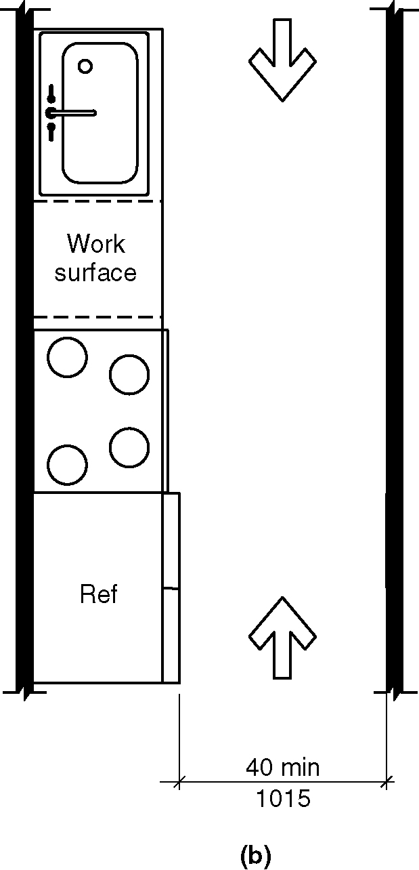
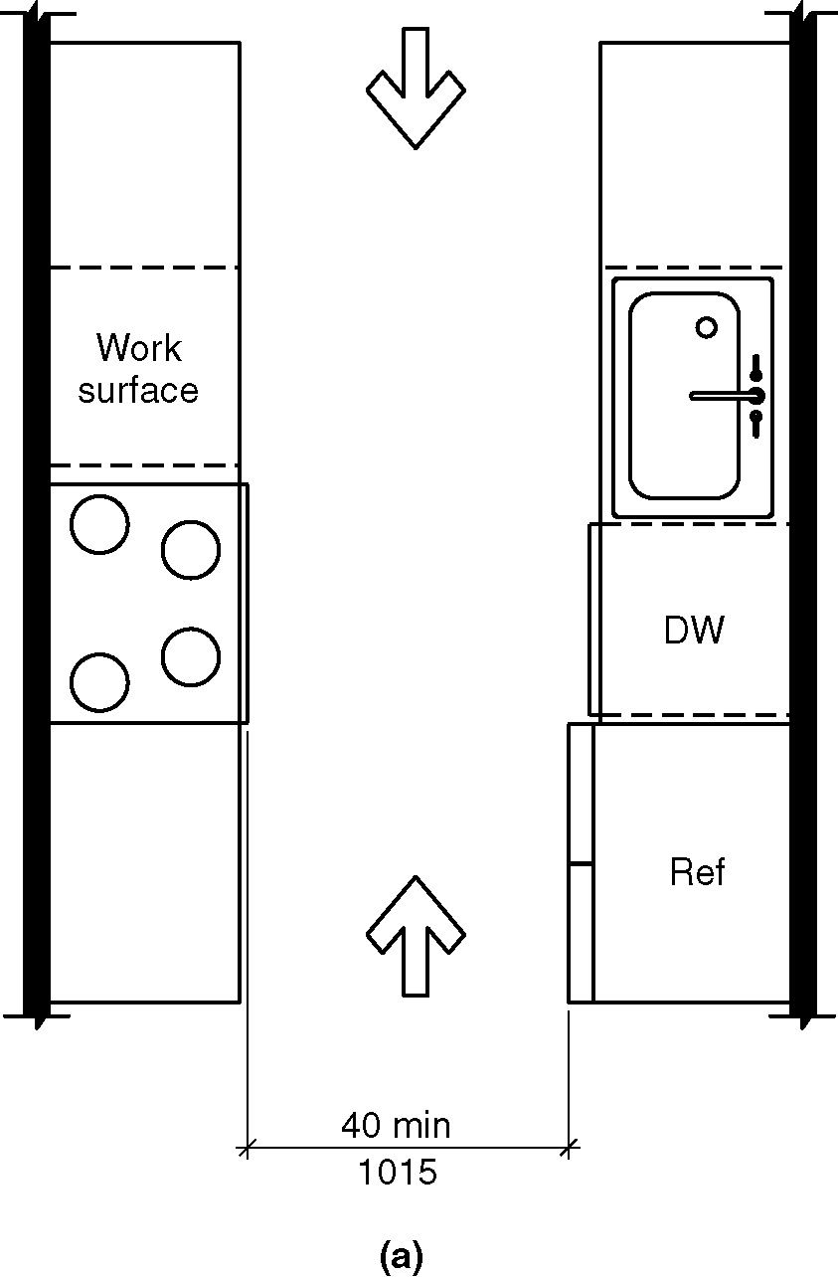
Figure 804.2.1 (a) & (b) Pass through kitchen clearance

804.2.2 U-Shaped Kitchens. In kitchens enclosed on three contiguous sides, clearance between all opposing base cabinets, countertops, appliances, or walls within kitchen work areas shall be 60 inches (1525 mm) minimum. (3-6E-12 PC4 through PC6) .(3-6-12 PC2.1)

EXCEPTION: U-shaped kitchens with an island shall be permitted to comply with Section 804.2.1. (8-9-12)

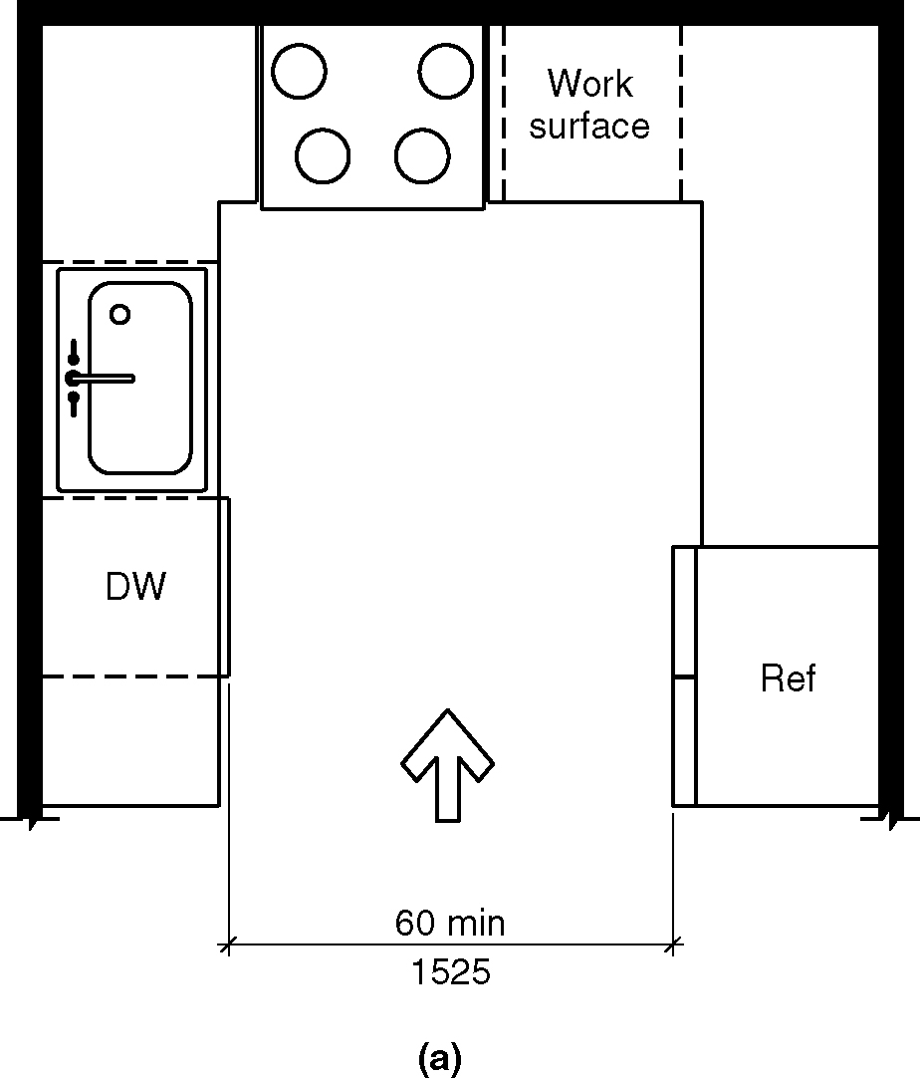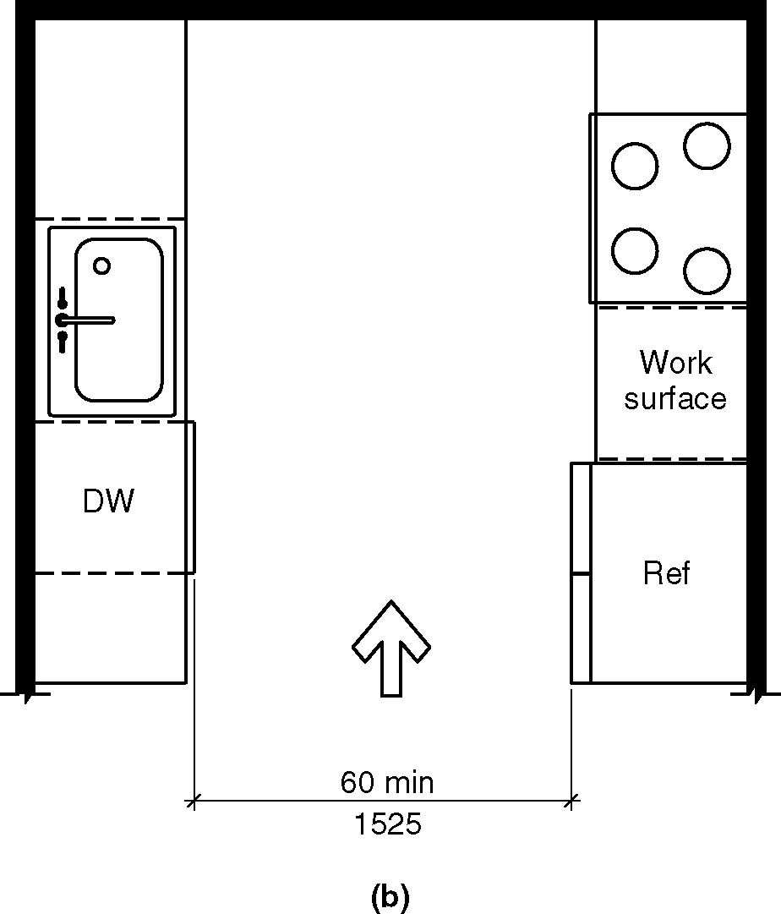
Figure 804.2.2 (a) & (b) U-shaped kitchen clearance
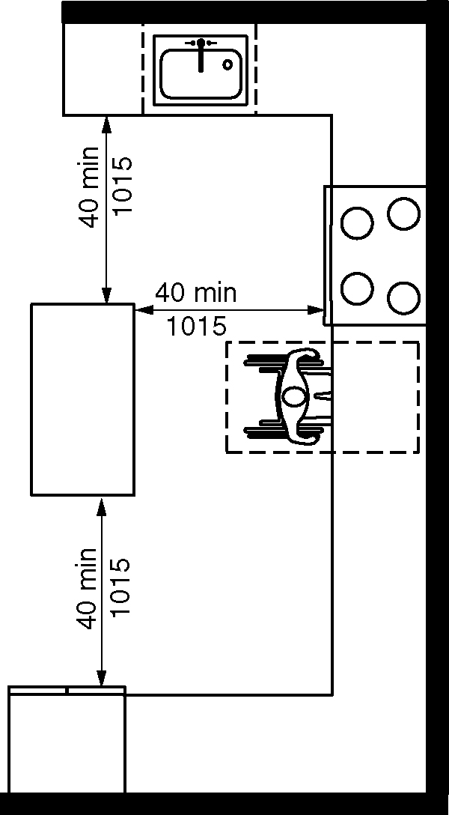
c) exception

804.2.3 Spaces where a cook top or conventional range is not provided. In a kitchen space where a cooktop or conventional range is not provided, clearance between all opposing base cabinets, counter tops, appliances and walls within kitchen work areas shall be 40-inch (1015 mm) minimum. (8-13-12)
(ed.)

804.3 Work Surface. At least one accessible work surface, 30 inches minimum in length shall be provided in accordance with Section 902. The work surface shall be located in accordance with Section 804.5.5.2 or 804.5.5.3. (8-10-12) (8-11-12)

EXCEPTION: Spaces that do not provide a cooktop or conventional range shall not be required to provide an accessible work surface.

804.4 Sinks. The sink shall comply with Section 606.

804.5 Appliances. Where provided, kitchen appliances shall comply with Section 804.5.

804.5.1 Clear Floor Space. A clear floor space complying with Section 305 shall be provided at each kitchen appliance.

804.5.2 Operable Parts. All appliance controls shall comply with Section 309.

EXCEPTIONS:

- Appliance doors and door latching devices shall not be required to comply with Section 309.4.

- Bottom-hinged appliance doors, when in the open position, shall not be required to comply with Section 309.3.

804.5.3 Dishwasher. A clear floor space positioned adjacent to the dishwasher door, shall be provided. The dishwasher door in the open position shall not obstruct the clear floor space for the dishwasher or an adjacent sink.

804.5.4 Cooktop. Cooktops shall comply with Section 804.5.4.

804.5.4.1 Approach. A clear floor space, positioned for a parallel or forward approach to the cooktop, shall be provided.

804.5.4.2 Forward approach. Where the clear floor space is positioned for a forward approach, knee and toe clearance complying with Section 306 shall be provided. The underside of the cooktop shall be insulated or otherwise configured to prevent burns, abrasions, or electrical shock.

804.5.4.3 Parallel approach. Where the clear floor space is positioned for a parallel approach, the clear floor space shall be centered on the appliance.

804.5.4.4 Controls. The location of controls shall not require reaching across burners.

804.5.5 Oven. Ovens shall comply with Section 804.5.5.

804.5.5.1 Clear floor space. A clear floor space shall be provided. The oven door in the open position shall not obstruct the clear floor space for the oven.

804.5.5.2 Side-Hinged Door Ovens. Side-hinged door ovens shall have a work surface complying with Section 804.3 positioned adjacent to the latch side of the oven door.

804.5.5.3 Bottom-Hinged Door Ovens. Bottom-hinged door ovens shall have a work surface complying with Section 804.3 positioned adjacent to one side of the door.

804.5.5.4 Controls. The location of controls shall not require reaching across burners.

804.5.6 Refrigerator/Freezer. Combination refrigerators and freezers shall have at least 50 percent of the freezer compartment shelves, including the bottom of the freezer, 54 inches (1370 mm) maximum above the floor when the shelves are installed at the maximum heights possible in the compartment. A clear floor space, positioned for a parallel approach to the refrigerator/freezer, shall be provided. The centerline of the clear floor space shall be offset 24 inches (610 mm) maximum from the centerline of the appliance.

805 Transportation Facilities

805.1 General. Transportation facilities shall comply with Section 805.

805.2 Bus Boarding and Alighting Areas. Bus boarding and alighting areas shall comply with Section 805.2.

805.2.1 Surface. Bus stop boarding and alighting areas shall have a firm, stable surface.

805.2.2 Dimensions.

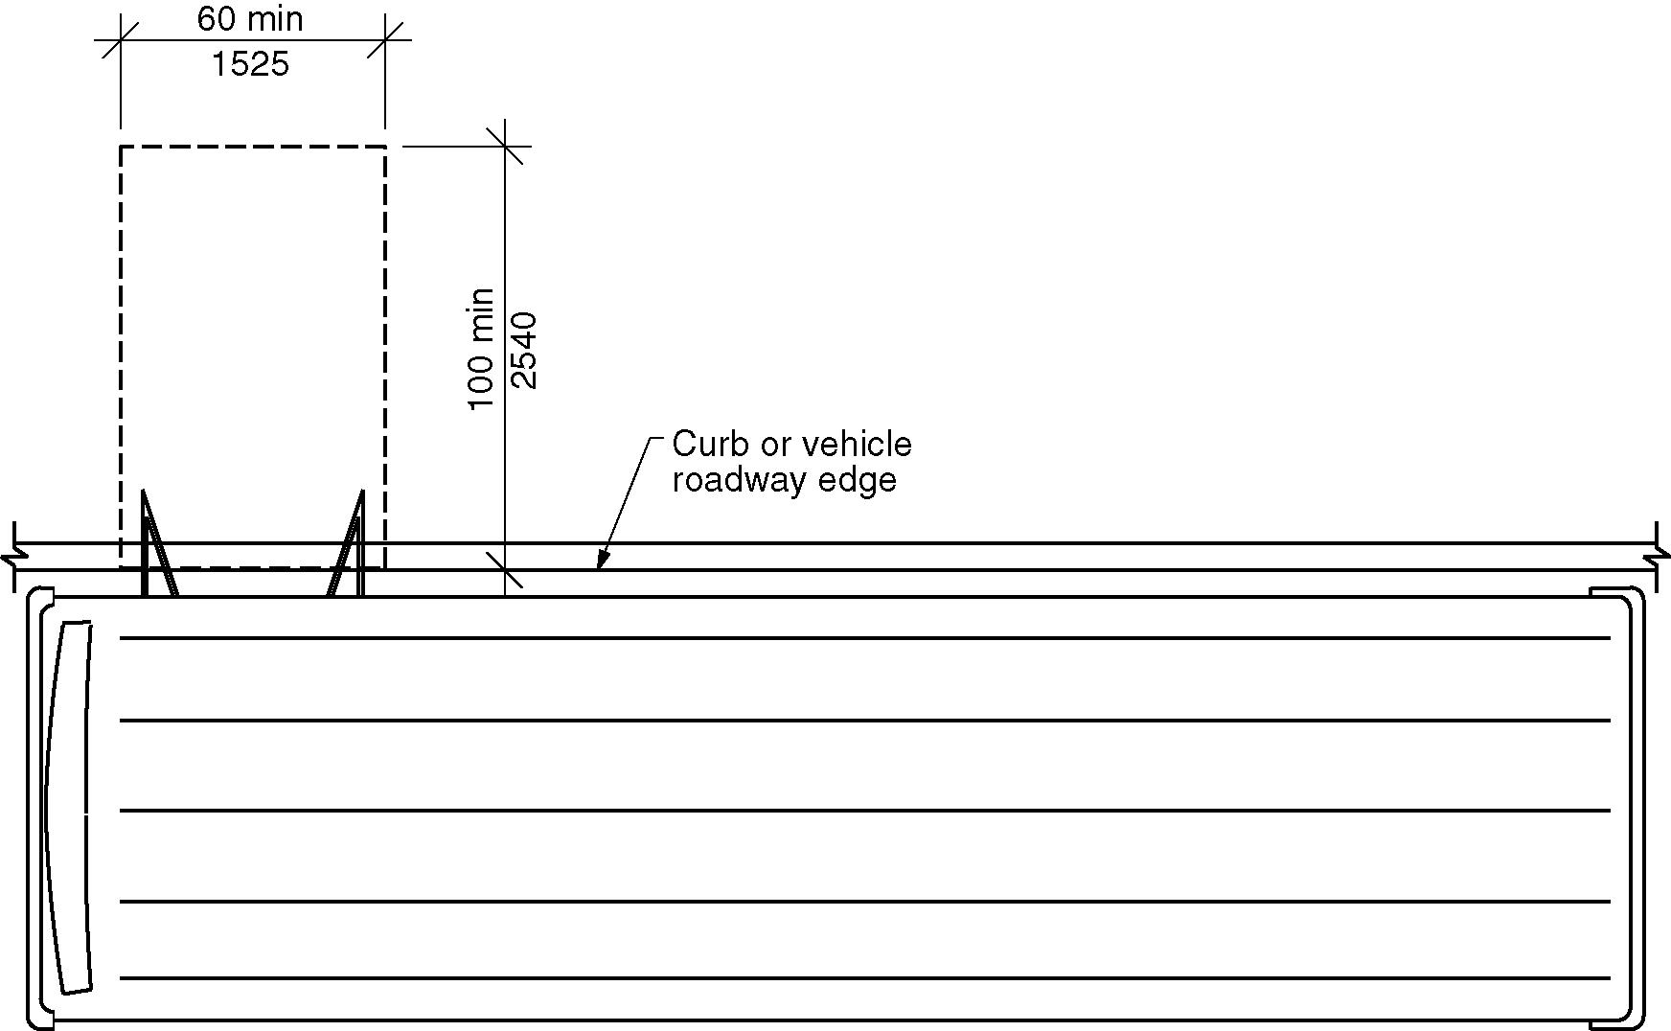
Figure 805.2.2(a) - Size of bus boarding and alighting area – New buildings
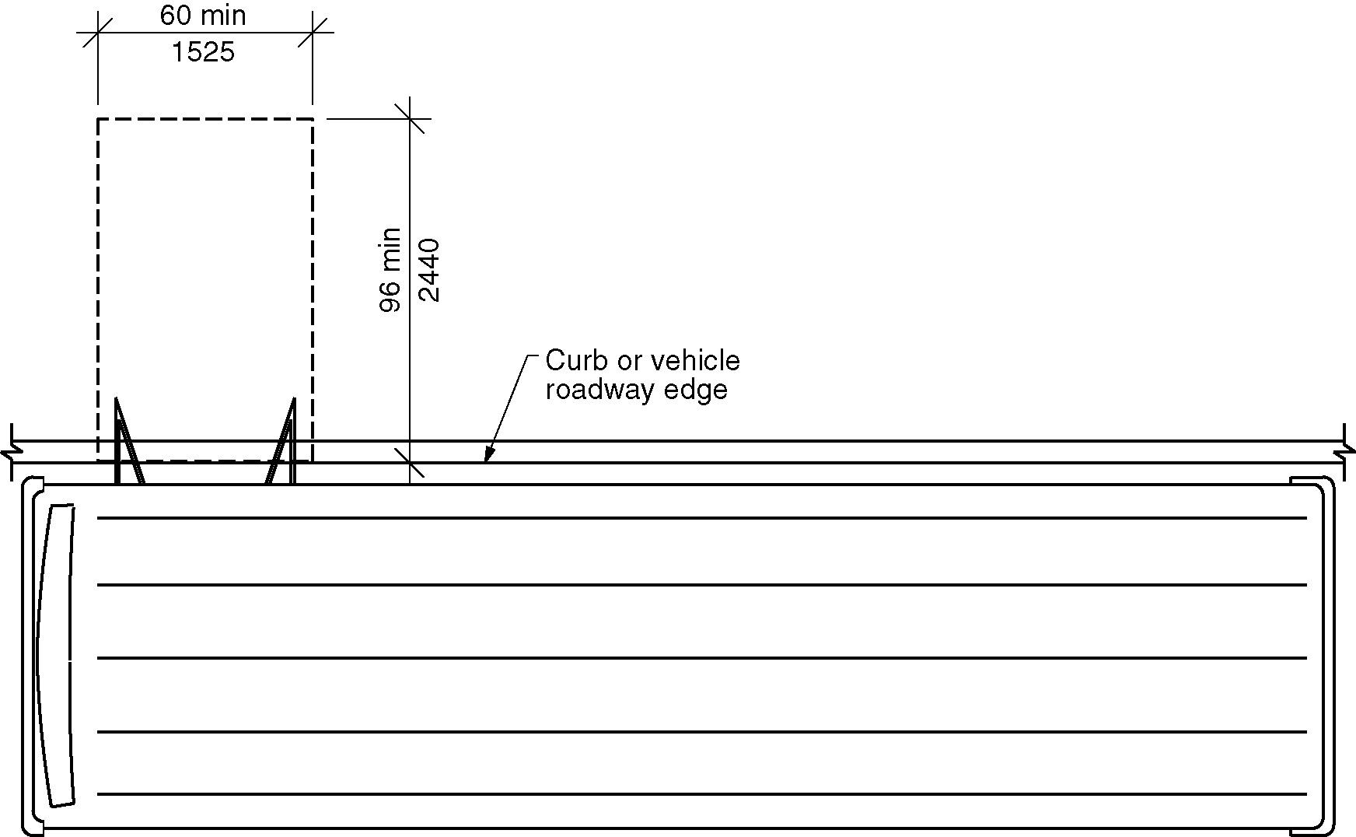
Figure 805.2.2(b) - Size of bus boarding and alighting area- Existing buildings

805.2.2.1 New buildings and sites. In new buildings and sites, bus stop boarding and alighting areas shall have a 100-inch (2540 mm) minimum clear length, measured perpendicular to the curb or vehicle roadway edge, and a 60-inch (1525 mm) minimum clear width, measured parallel to the vehicle roadway. (3-13F-12) .(3-6-12 PC2)

805.2.2.2 Existing buildings and sites. In existing buildings and sites, bus stop boarding and alighting areas shall have a 96 -inch (2540 mm) minimum clear length, measured perpendicular to the curb or vehicle roadway edge, and a 60-inch (1525 mm) minimum clear width, measured parallel to the vehicle roadway.(3-6-12 PC2)

805.2.3 Slope. The slope of the bus stop boarding and alighting area parallel to the vehicle roadway shall be the same as the roadway, to the maximum extent practicable. The slope of the bus stop boarding and alighting area perpendicular to the vehicle roadway shall be 1:48 maximum.

805.2.4 Connection. Bus stop boarding and alighting areas shall be connected to streets, sidewalks, or pedestrian paths by an accessible route complying with Section 402.

805.3 Bus Shelters. Bus shelters shall provide a minimum clear floor space complying with Section 305 entirely within the shelter. Bus shelters shall be connected by an accessible route complying with Section 402 to a boarding and alighting area complying with Section 805.2.

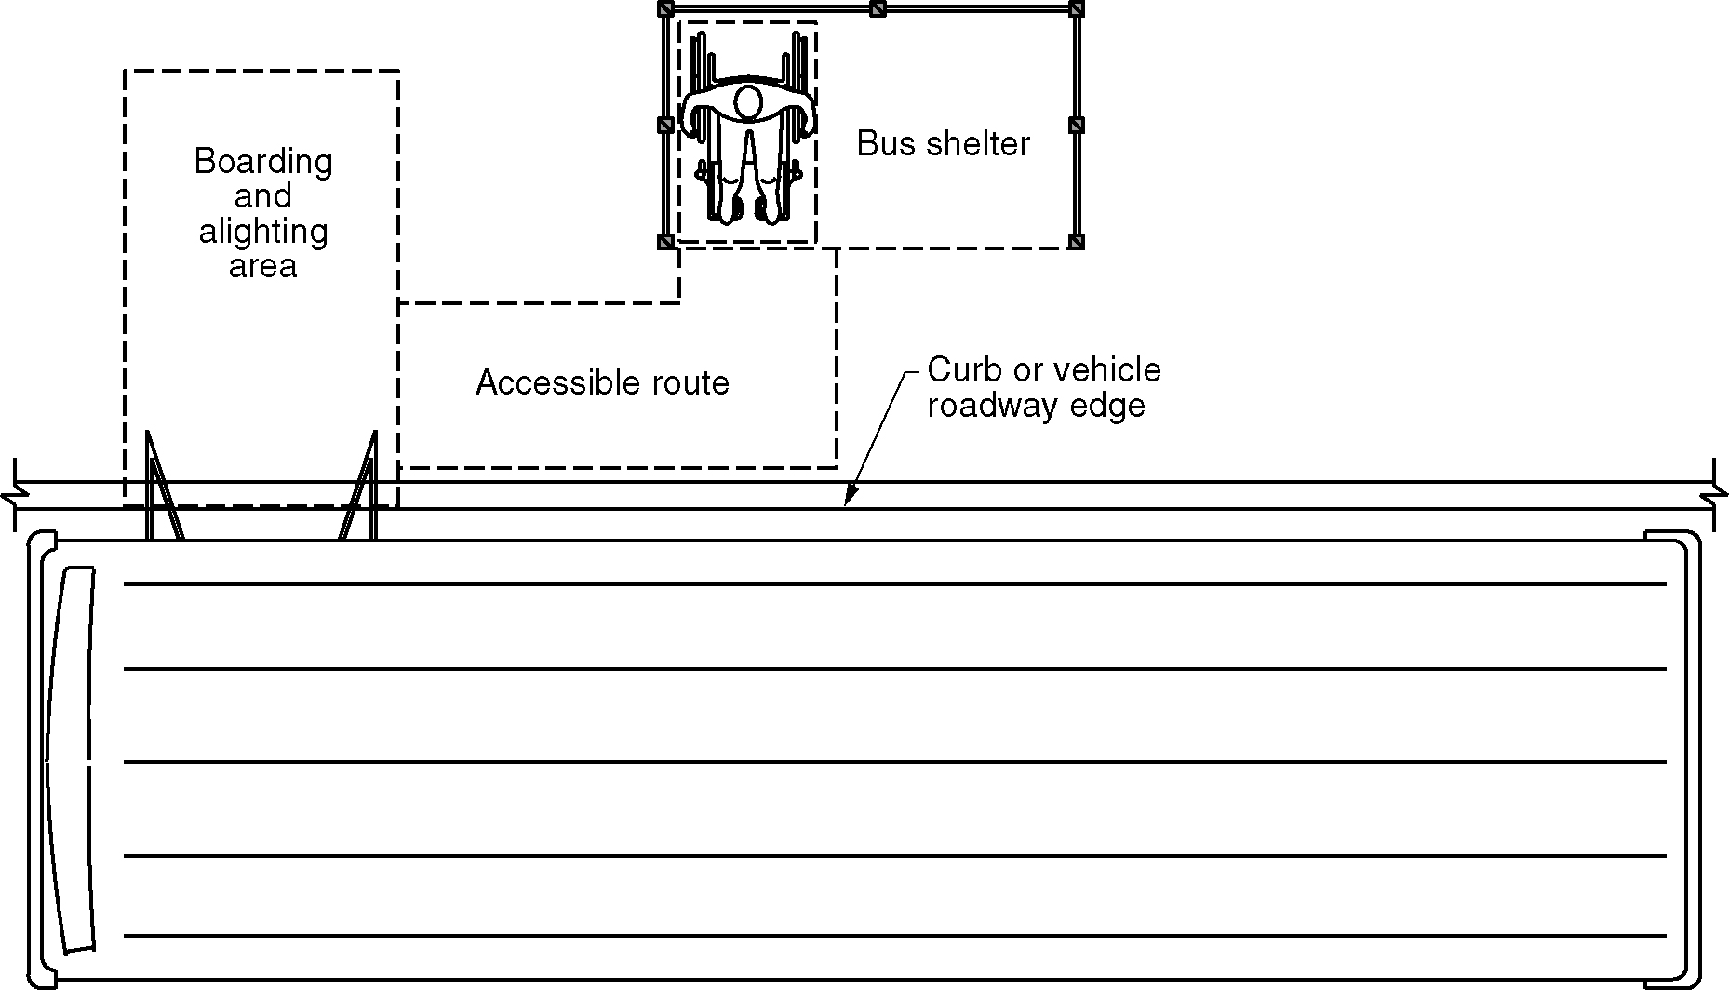
Figure 805.3 – Bus shelters

805.4 Bus Signs. Bus route identification signs shall have visual characters complying with Sections 703.2.2, 703.2.3, and 703.2.5 through 703.2.8. In addition, bus route identification numbers shall be visual characters complying with Section 703.2.4.

EXCEPTION: Bus schedules, timetables and maps that are posted at the bus stop or bus bay shall not be required to comply with Section 805.4.

805.5 Rail Platforms. Rail platforms shall comply with Section 805.5.

805.5.1 Slope. Rail platforms shall not exceed a slope of 1:48 in all directions.

EXCEPTION: Where platforms serve vehicles operating on existing track or track laid in existing roadway, the slope of the platform parallel to the track shall be permitted to be equal to the slope (grade) of the roadway or existing track.

805.5.2 Detectable Warnings. Platform boarding edges not protected by platform screens or guards shall have a detectable warning complying with Section 705.

805.6 Rail Station Signs. Rail station signs shall comply with Section 805.6.

EXCEPTION: Signs shall not be required to comply with Sections 805.6.1 and 805.6.2 where audible signs are remotely transmitted to hand-held receivers, or are user- or proximity-actuated.

805.6.1 Entrances. Where signs identify a station or a station entrance, at least one sign with raised characters and braille complying with Sections 703.3 and 703.4 shall be provided at each entrance.

805.6.2 Routes and Destinations. Lists of stations, routes and destinations served by the station that are located on boarding areas, platforms, or mezzanines shall have visual characters complying with Section 703.2. A minimum of one sign with raised characters and braille complying with Sections 703.3 and 703.4 shall be provided on each platform or boarding area to identify the specific station.

EXCEPTION: Where sign space is limited, characters shall not be required to exceed 3 inches (76 mm) in height.

805.6.3 Station Names. Stations covered by this section shall have identification signs with visual characters complying with Section 703.2. The signs shall be clearly visible and within the sight lines of a standing or sitting passenger from within the vehicle on both sides when not obstructed by another vehicle.

805.7 Public Address Systems. Where public address systems convey audible information to the public, the same or equivalent information shall be provided in a visual format.

805.8 Clocks. Where clocks are provided for use by the public, the clock face shall be uncluttered so that its elements are clearly visible. Hands, numerals and digits shall contrast with the background either light-on-dark or dark-on-light. Where clocks are installed overhead, numerals and digits shall be visual characters complying with Section 703.2.

805.9 Escalators. Where provided, escalators shall have a 32-inch (815mm) minimum clear width, and shall comply with Requirements 6.1.3.5.6 - Step Demarcations, and 6.1.3.6.5 - Flat Steps of ASME A17.1/CSA B44 listed in Section 106.2.9.

EXCEPTION: Existing escalators shall not be required to comply with Section 805.9.

805.10 Track Crossings. Where a circulation path crosses tracks, it shall comply with Section 402 and shall have a detectable warning complying with Section 705. (4-44-12)

EXCEPTION: Openings for wheel flanges shall be permitted to be 2¹/₂ inches (64 mm) maximum.

Figure 805.10 – Track crossing

806 Holding Cells and Housing Cells

806.1 General. Holding cells and housing cells shall comply with Section 806.

806.2 Features for People Using Wheelchairs or Other Mobility Aids. Cells required to have features for people using wheelchairs or other mobility aids shall comply with Section 806.2.

806.2.1 Turning Space. Turning space complying with Section 304 shall be provided within the cell.

806.2.2 Benches. Where benches are provided, at least one bench shall comply with Section 903.

806.2.3 Beds. Where beds are provided, clear floor space complying with Section 305 shall be provided on at least one side of the bed. The clear floor space shall be positioned for parallel approach to the side of the bed.

806.2.4 Toilet and Bathing Facilities. Toilet facilities or bathing facilities provided as part of a cell shall comply with Section 603.

806.3 Communication Features. Cells required to have communication features shall comply with Section 806.3.

806.3.1 Alarms. Where audible emergency alarm systems are provided to serve the occupants of cells, visible alarms complying with Section 702 shall be provided.

EXCEPTION: In cells where inmates or detainees are not allowed independent means of egress, visible alarms shall not be required.

806.3.2 Telephones. Where provided, telephones within cells shall have volume controls complying with Section 704.3.

807 Courtrooms

807.1 General. Courtrooms shall comply with Section 807.

807.2 Turning Space. Where provided, each area that is raised or depressed shall provide a turning space complying with Section 304.

EXCEPTION: Levels of jury boxes not required to contain wheelchair spaces shall not be required to comply this section. (ed.)

807.3 Clear Floor Space. Within the defined area of each jury box and witness stand, a clear floor space complying with Section 305 shall be provided.

EXCEPTION: In alterations, wheelchair spaces shall not be required to be located within the defined area of raised jury boxes or witness stands and shall be permitted to be located outside these spaces where ramps or platform lifts restrict or project into the means of egress required by the administrative authority. (ed.)

807.4 Courtroom Stations. Judges’ benches, clerks’ stations, bailiffs’ stations, deputy clerks’ stations, court reporters’ stations and litigants’ and counsel stations shall comply with Section 902.

807.5 Gallery seating. Gallery seating shall comply with Section 802.

808 Enhanced Acoustics for Classrooms

808.1 General. Classrooms not exceeding 20,000 cubic feet (565 m³) and required to provide enhanced acoustics shall comply with Section 808. (8-15-12 PC5.1)

808.2 Reverberation Time. Classroom reverberation times shall comply with either Section 808.2.1 or Section 808.2.2, depending on the size of the room. (8-15-12 PC4 and PC5)

808.2.1 Performance Method. For each of the octave frequency bands with center frequencies of 500, 1000, and 2000 Hz, the Reverberation Time (T60) shall not exceed the times specified below:

1. 0.6 seconds in classrooms with volumes up to and including 10,000 cubic feet (285 m³).

2. 0.7 seconds in classrooms with volumes of more than 10,000 cubic feet (285 m³), but less than 20,000 cubic feet (566 m³).

Reverberation times shall apply to fully-furnished, unoccupied classrooms. Reverberation times shall be field-verified via measurements made in accordance with ASTM E2235-04(2012) “Standard Test Method for Determination of Decay Rates for Use in Sound Insulation Test Methods” over a minimum 20 dB decay in each octave frequency band as listed in Section 106.2.15. (8-15-12 PC4 and PC5)

808.2.2 Prescriptive Method. The Noise reduction coefficient (NRC) ratings for floor, wall and ceiling surface finishes shall conform to the following equations:

For a classroom with a volume less than or equal to 10,000 cubic feet (285 cubic meters):

(NRC_{Floor} x S_{Floor})+ (NRC_{Ceiling} x S_{Ceiling}) + (NRC_{Wall} x S_{Wall}) ≥ Volume/12

For a classroom with a volume between 10,000 cubic feet (285 cubic meters) and 20,000 cubic feet (565 cubic meters):

(NRC_{Floor} x S_{Floor})+ (NRC_{Ceiling} x S_{Ceiling}) + (NRC_{Wall} x S_{Wall}) ≥ Volume/14

Where:

NRC_{Floor} = NRC rating of the floor finish material

S_{Floor} = floor area in square feet

NRC_{Ceiling} = NRC rating of the ceiling finish material

S_{Ceiling} = ceiling area in square feet

NRC_{Wall} = NRC rating of the wall acoustical treatment

S_{Wall} = wall treatment area in square feet

Volume = room volume in cubic feet

Where a floor, ceiling or wall has multiple surface finishes, the NRC x S product for each surface finish shall be added to the left side of the equation. (8-15-12 PC5)

808.3 Ambient Sound Level. Classroom ambient sound levels shall comply with Sections 808.3.1 and 808.3.2. Ambient sound levels from sound sources outside and inside the classroom shall be evaluated individually. The greatest one-hour averaged sound levels shall be evaluated at the loudest usable location in the room at a height of 36 inches (915 mm) to 42 inches (1065 mm) above the floor and no closer than 36 inches (915 mm) from any wall, window, or object. The ambient sound level limits shall apply to fully-furnished, unoccupied classrooms, and with only permanent HVAC, electrical and plumbing systems functioning. Classroom equipment, including, but not limited to, computers, printers, fish tank pumps shall be turned off during these measurements. (8-15-12 PC5)

808.3.1 Sound Sources Outside of the Classroom. Classroom ambient sound levels shall not exceed 35 dBA and 55 dBC due to intruding noise from sound sources outside of the classroom, whether from the exterior or from other interior spaces. (8-15-12 PC5)

808.3.2 Sound Sources Inside the Classroom. Classroom ambient sound levels shall not exceed 35 dBA and 55 dBC for noise from sound sources inside the classroom. (8-15-12 PC5)

ICC A117.1-2015 Chapter 9. Built-In Furnishings and Equipment

Chapter 9.Furnishings and Equipment
9-1-12 PC1

901 General

901.1 Scope. Furnishings and equipment required to be accessible by the scoping provisions adopted by the administrative authority shall comply with the applicable provisions of Chapter 9. (9-1-12)

902 Dining Surfaces and Work Surfaces

902.1 General. Accessible dining surfaces and work surfaces shall comply with Section 902.

EXCEPTION: Dining surfaces and work surfaces primarily for children’s use shall be permitted to comply with Section 902.5.

902.2 Clear Floor Space. A clear floor space complying with Section 305, positioned for a forward approach, shall be provided. Knee and toe clearance complying with Section 306 shall be provided.

EXCEPTIONS:

- At dining surfaces 12 inches (305 mm) or less in depth, knee and toe space shall not be required to extend beneath the surface beyond the depth of the drink surface provided.

- Dining surfaces that are 15 inches (380 mm) minimum and 24 inches (610 mm) maximum in height are permitted to have a clear floor space complying with Section 305 positioned for a parallel approach.

902.3 Exposed Surfaces. There shall be no sharp or abrasive surfaces under the exposed portions of dining surfaces and work surfaces.

902.4 Height. The tops of dining surfaces and work surfaces shall be 28 inches (710 mm) minimum and 34 inches (865 mm) maximum in height above the floor.

902.5 Dining Surfaces and Work Surfaces for Children’s Use. Accessible dining surfaces and work surfaces primarily for children’s use shall comply with Section 902.5.

EXCEPTION: Dining surfaces and work surfaces used primarily by children ages 5 and younger shall not be required to comply with Section 902.5 where a clear floor space complying with Section 305 is provided and is positioned for a parallel approach.

902.5.1 Clear Floor Space. A clear floor space complying with Section 305, positioned for forward approach, shall be provided. Knee and toe clearance complying with Section 306 shall be provided.

EXCEPTION: A knee clearance of 24 inches (610 mm) minimum above the floor shall be permitted.

902.5.2 Height. The tops of tables and counters shall be 26 inches (660 mm) minimum and 30 inches (760 mm) maximum above the floor.

903 Benches

903.1 General. Accessible benches shall comply with Section 903. (ed.)

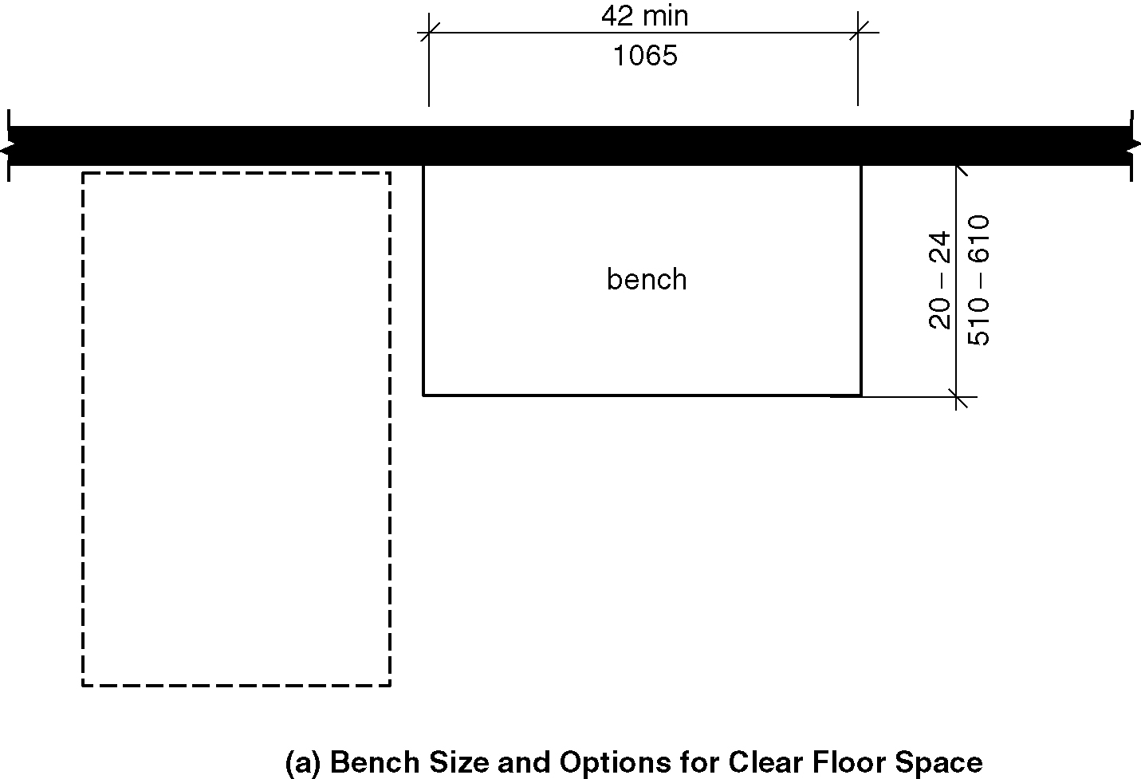
Figure 903 a) Benches – bench size and options for clear floor space
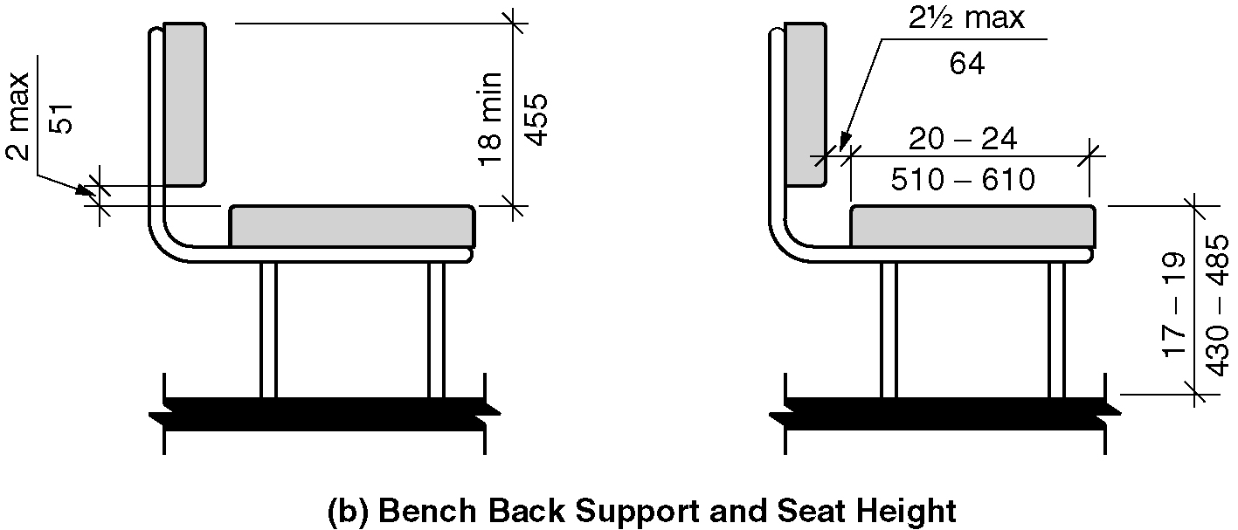
b) Benches – bench back support and seat height

903.2 Clear Floor Space. A clear floor space complying with Section 305, positioned at the end of the bench seat and parallel to the short axis of the bench shall be provided. (9-4-12)

903.3 Size. Benches shall have seats 42 inches (1065 mm) minimum in length, and 20 inches (510 mm) minimum and 24 inches (610 mm) maximum in depth.

903.4 Back Support. The bench shall provide for back support or shall be affixed to a wall. Back support shall be 42 inches (1065 mm) minimum in length and shall extend from a point 2 inches (51 mm) maximum above the seat surface to a point 18 inches (455 mm) minimum above the seat surface. Back support shall be 2¹/2 inches (64 mm) maximum from the rear edge of the seat measured horizontally.

903.5 Height. The top of the bench seat shall be 17 inches (430 mm) minimum and 19 inches (485 mm) maximum above the floor, measured to the top of the seat.

EXCEPTION: Benches primarily for children’s use shall be permitted to be 11 inches (280 mm) minimum and 17 inches (430 mm) maximum above the floor, measured to the top of the seat.

903.6 Structural Strength. Allowable stresses shall not be exceeded for materials used where a vertical or horizontal force of 250 pounds (1112 N) is applied at any point on the seat, fastener mounting device, or supporting structure.

903.7 Wet Locations. Where provided in wet locations the surface of the seat shall be slip resistant and shall not accumulate water.

904 Sales and Service Counters

904.1 General. Accessible sales and service counters and windows shall comply with Section 904 as applicable.

EXCEPTION: Drive up only sales or service counters and windows shall not be required to comply with Section 904.

904.2 Approach. All portions of counters required to be accessible shall be located adjacent to a walking surface complying with Section 403.

904.3 Sales and Service Counters and Windows. Sales and service counters and windows shall comply with Sections 904.3.1 and either 904.3.2 or Section 904.3.3. . Where counters are provided, the accessible portion of the countertop shall extend the same depth as the public portion of the sales and service countertop provided for standing customers. (9-7-12) (9-9-12)(9-10-12) (9-10-12 PC3)

EXCEPTION: In alterations, when the provision of a counter complying with Section 904.4 would result in a reduction of the number of existing counters at work stations or a reduction of the number of existing mail boxes, the counter shall be permitted to have a portion which is 24 inches (610 mm) long minimum complying with Section 904.4.1 provided that the required clear floor space is centered on the accessible length of the counter. (9-6-12)

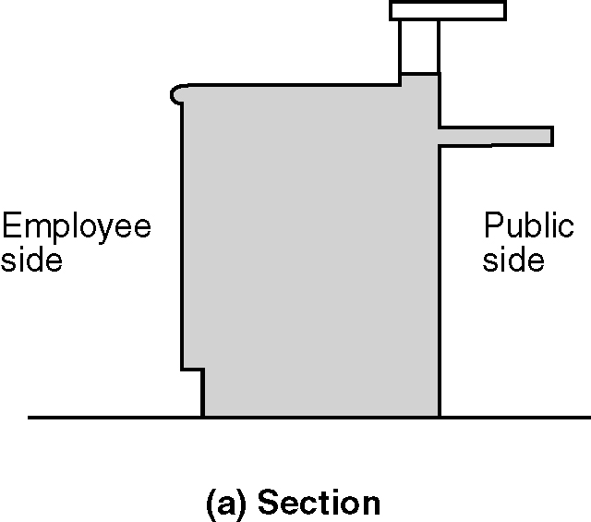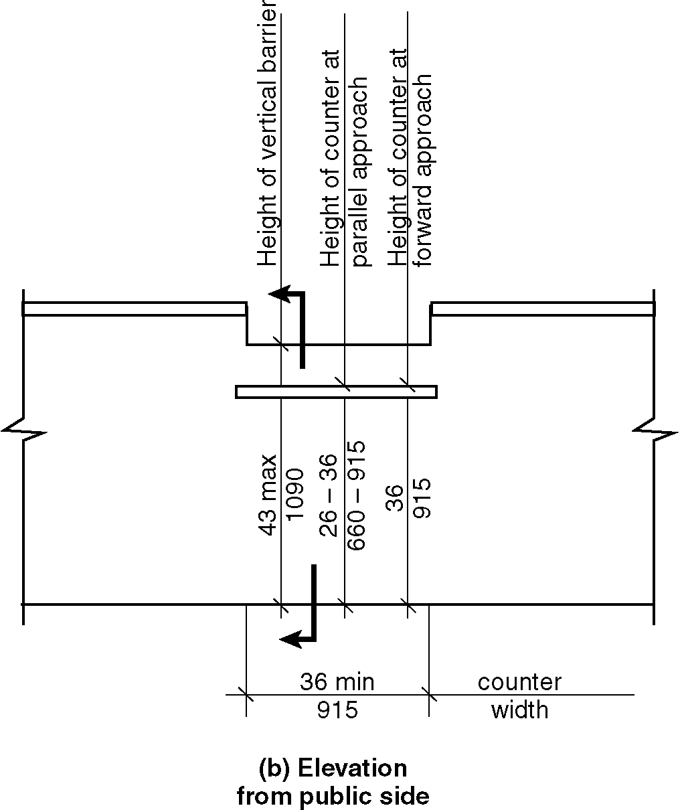
Figure 904.3 – Sales and service counters

904.3.1 Vertical Barriers. At service windows or service counters, any vertical barrier between service personnel and customers shall be at a height of 43 inches (1090 mm) maximum above the floor. (9-10-12)

Exception: Transparent security glazing shall be permitted above the 43 inches (1090 mm) maximum height. (9-10-12)

904.3.2 Parallel Approach. A portion of the public use side of the counter surface 36 inches (915 mm) minimum in length and 26 inches (660 mm) minimum to 36 inches (915 mm) maximum in height above the floor shall be provided. A clear floor space complying with Section 305, positioned for a parallel approach adjacent to the accessible counter, shall be provided. The space between the accessible counter surface and any projecting objects above the accessible counter shall be 12 inches (305 mm) minimum.

Exception: Where the counter surface is less than 36 inches (915 mm) in length, the entire counter surface shall be 26 inches (660 mm) minimum to 36 inches (915 mm) maximum in height above the floor. (9-10-12 PC2.3)

904.3.3 Forward Approach. A portion of the public use side of the counter surface 30 inches (760 mm) minimum in length and 36 inches (915 mm) maximum in height above the floor shall be provided. A clear floor space complying with Section 305, positioned for a forward approach to the accessible counter, shall be provided. Knee and toe clearance complying with Section 306 shall be provided under the accessible counter. The space between the accessible counter surface and any projecting objects above the accessible counter shall be 12 inches (305 mm) minimum. (9-10-12) (9-10-12 PC2)

904.4 Checkout Aisles. Checkout aisles shall comply with Section 904.4.

904.4.1 Aisle. Aisles shall comply with Section 403.

904.4.2 Counters. The checkout counter surface shall be 38 inches (965 mm) maximum in height above the floor. The top of the counter edge protection shall be 2 inches (51 mm) maximum above the top of the counter surface on the aisle side of the checkout counter.

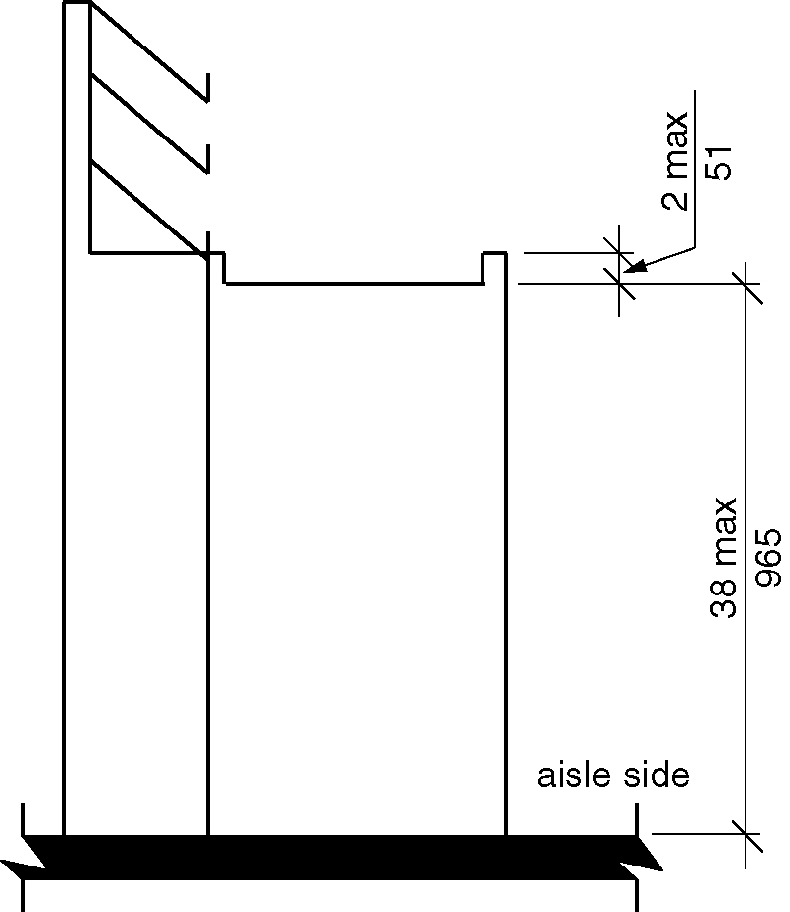
Figure 904.4.2 - Height of checkout counters

904.4.3 Check Writing Surfaces. Where provided, check writing surfaces shall comply with Section 902.4.

904.5 Food Service Lines. Counters in food service lines shall comply with Section 904.5.

904.5.1 Self-Service Shelves and Dispensing Devices. Self-service shelves and dispensing devices for tableware, dishware, condiments, food and beverages shall comply with Section 308.

904.5.2 Tray Slides. The tops of tray slides shall be 28 inches (710 mm) minimum and 34 inches (865 mm) maximum above the floor.

904.6 Security Glazing. Where counters or teller windows have security glazing to separate personnel from the public, a method to facilitate voice communication shall be provided. Telephone handset devices, if provided, shall comply with Section 704.3.

905 Storage Facilities

905.1 General. Accessible built-in storage facilities shall comply with Section 905. (9-1-12) (ed.)

EXCEPTION: Kitchen cabinets shall not be required to comply with this section (9-13-12) (ed.)

905.2 Clear Floor Space. A clear floor space complying with Section 305 shall be provided.

905.3 Height. Accessible storage elements shall comply with at least one of the reach ranges specified in Section 308. (ed.)

905.4 Operable Parts. Operable parts of storage facilities shall comply with Section 309.

906 Charging Stations. (8-5-12)

906.1 General. A charging station shall consist of a grounded duplex outlet.

906.2 Clear Floor Space. A clear floor space complying with Section 305 shall be provided at the charging station.

906.3 Height. Accessible charging stations shall comply with at least one of the reach ranges specified in Section 308. (ed.)

907 Gaming Machines and Tables (9-12-12)

907.1 Clear Floor Space. Accessible gaming machines and tables shall have a clear floor space complying with Section 305 positioned for transfer or for use by an individual seated in a wheelchair. Clear floor spaces required at gaming machines and tables shall be permitted to overlap. (9-12-12) (ed.)

